**TICKET TASK**

The tasks page consists of baskets. The baskets are divided to tasks and the tasks are divided into sub-tasks.

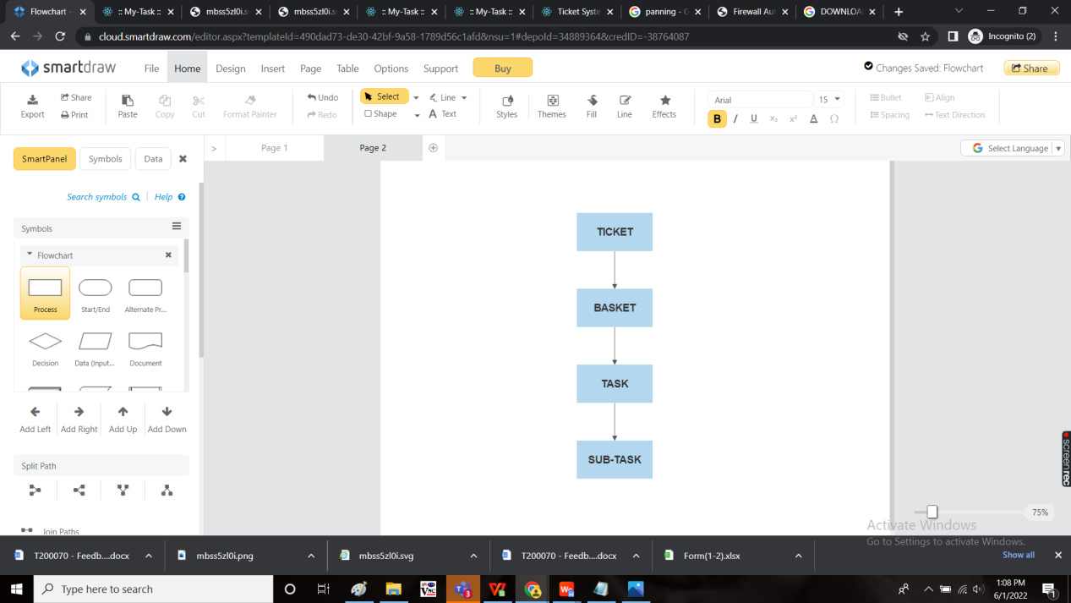

Initially, the action field shows basket instead of task as no baskets added yet.

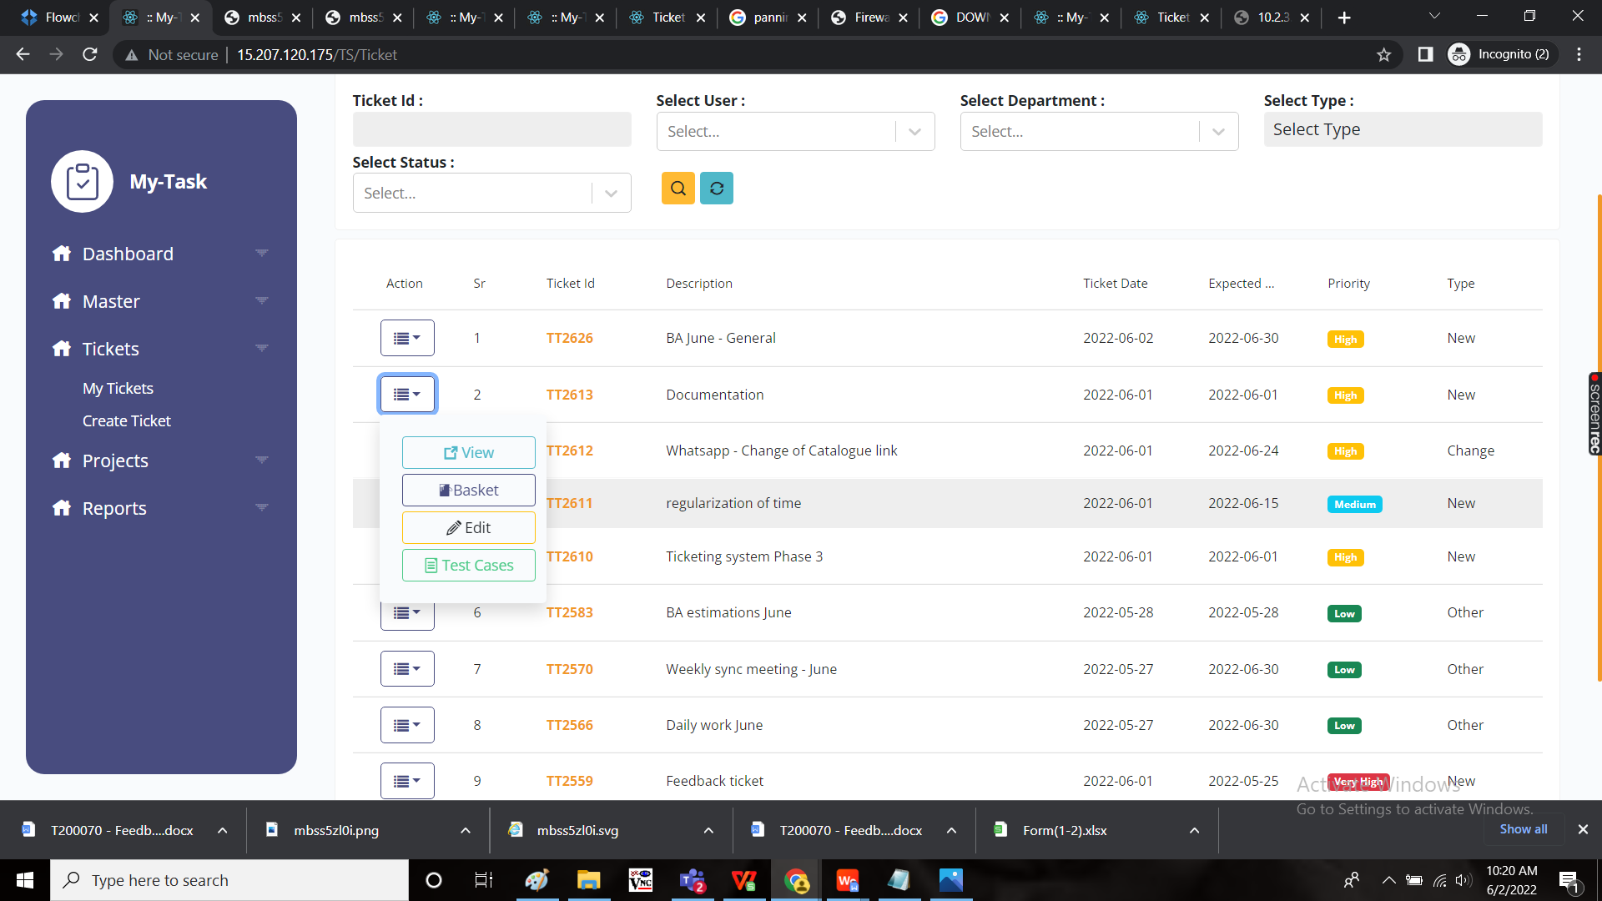

The following page opens when we click on the baskets page.

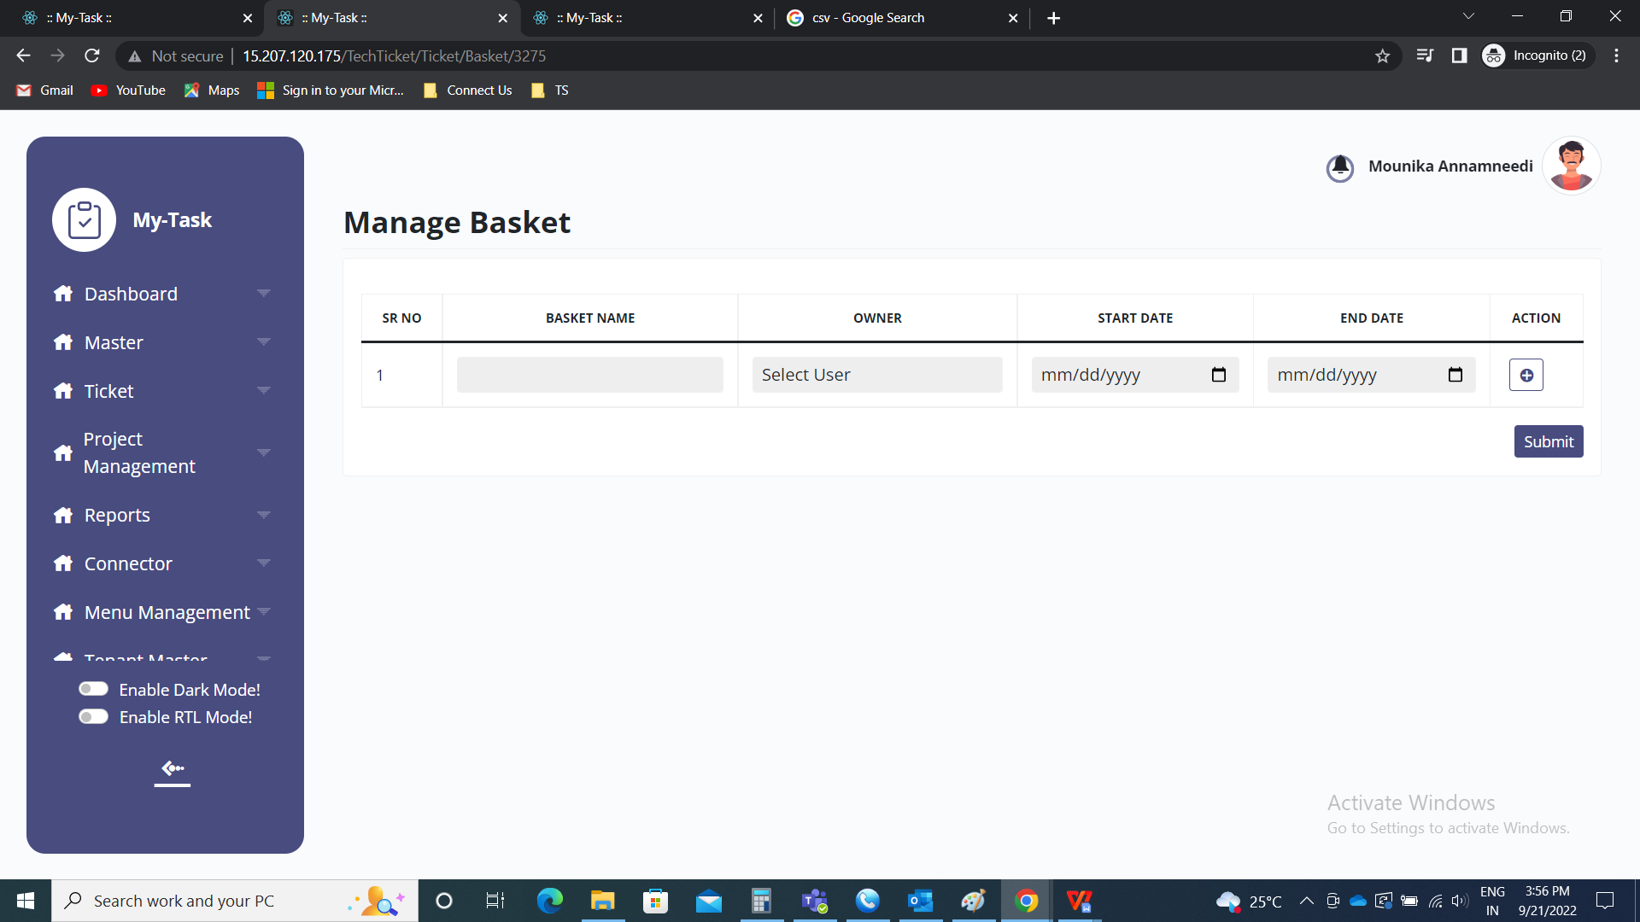

BASKET CREATION:

The basket is the terminology used for the departments or for particular bulk work. The following are the fields in basket creation.

* Sr no
* Basket name
* Owner
* Start date
* End date
* Action
* Submit

|  |  |
| --- | --- |
| Field | Description |
| Sr no | The serial no. Is mentioned |
| Basket name | The basket name is mentioned |
| Owner | The owner of the basket is mentioned |
| Start date | The start date of the basket is mentioned |
| End date | The end date of the basket is mentioned |
| Action | The action field consists of “+” button to add more baskets |
| Submit | The submit button to add the data |

|  |  |  |  |
| --- | --- | --- | --- |
| **FIELDS** | **INPUT TYPE** | **MANDATORY/ OPTIONAL** | **DESCRIPTION** |
| Basket name | Text | Mandatory | The basket name is mentioned |
| Owner | Drop down | Mandatory | The basket owner is selected from the drop down list. The drop down options are obtained from user master. |
| Start date | Calender | Mandatory | The start date of that basket. The start date should not be before the start date of the ticket. |
| End date | Calender | Mandatory | The end date of the basket. The end date should not be after the end date of the ticket. |
| Action | Button | Optional | To “+” button is used to add one more basket. |
| Submit | Button | Optional | To submit the data and create the basket. |
| Close | Button | Optional | To close the tab. |

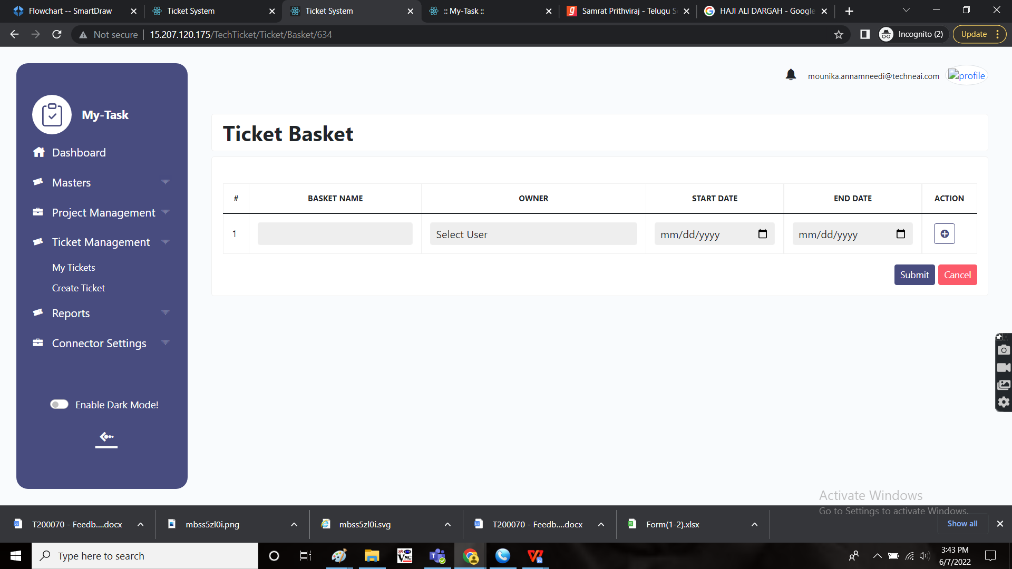

“+” Button:

The “+” button is used to add the another field in the ticket to create the basket.

|  |  |  |  |
| --- | --- | --- | --- |
| **FIELDS** | **INPUT TYPE** | **MANDATORY/ OPTIONAL** | **DESCRIPTION** |
| Basket name | Text | Mandatory | The basket name is mentioned |
| Owner | Drop down | Mandatory | The basket owner is selected from the drop down list. The drop down options are obtained from user master. |
| Start date | Calender | Mandatory | The start date of that basket. The start date should not be before the start date of the ticket. |
| End date | Calender | Mandatory | The end date of the basket. The end date should not be after the end date of the ticket. |
| Delete | Button | Optional | To delete the field |
| Submit | Button | Optional | To submit the data and create the basket. |
| Close | Button | Optional | To close the tab. |

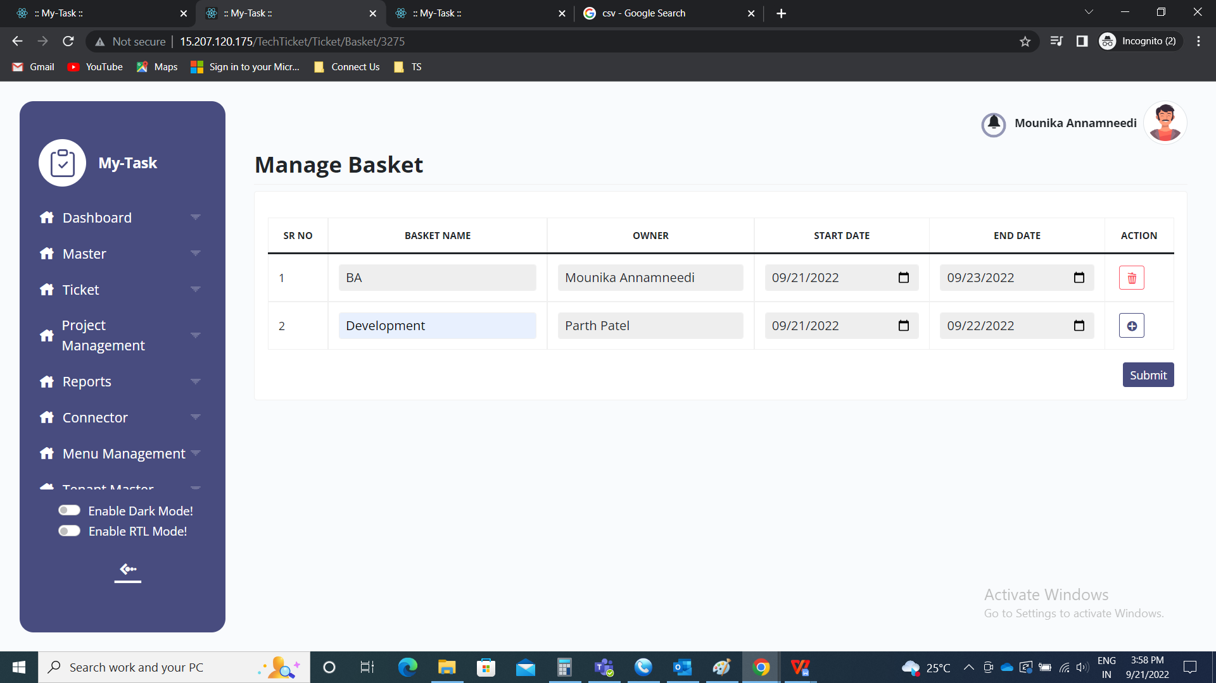

Basket view:

Once the basket the created, the basket is viewed in the following way with the following fields.

* Add task
* Edit button

|  |  |
| --- | --- |
| Field | Description |
| Ticket ID | The ticket ID is mentioned |
| Show details | When the show details button is clicked, then ticket description and any files attached are shown. |
| Add task | To add a task in the basket |
| Edit button | To edit the basket |
| Add basket | To add new basket |

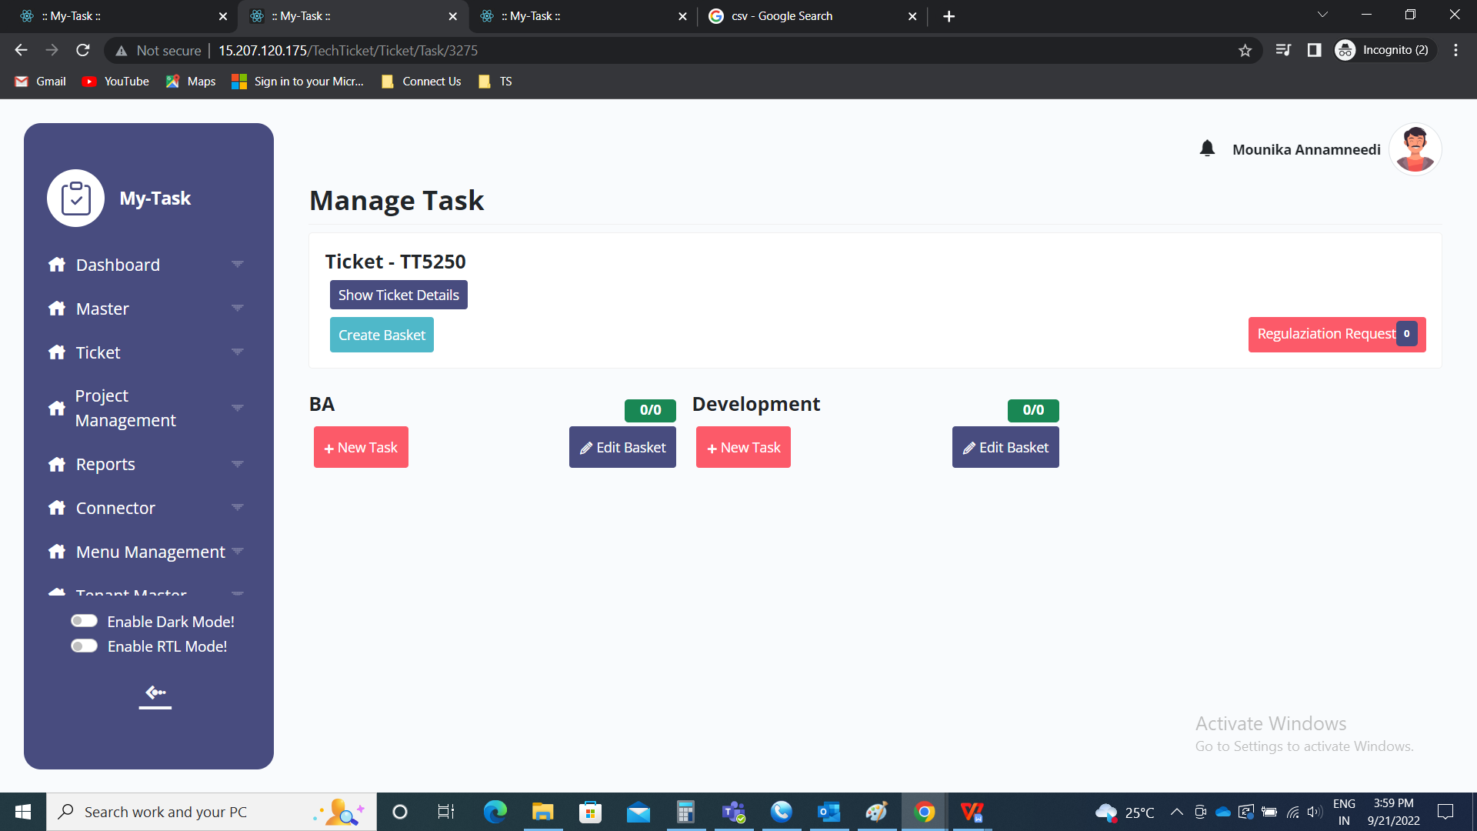

Add basket:

The add basket button is used to add the new basket in the ticket. The following are the fields in add basket.

* Basket name
* Select user
* Start date
* End date
* Submit
* Close

|  |  |  |  |
| --- | --- | --- | --- |
| **FIELDS** | **INPUT TYPE** | **MANDATORY/ OPTIONAL** | **DESCRIPTION** |
| Basket name | Text | Mandatory | The basket name is mentioned |
| Select user | Drop down | Mandatory | The basket owner is selected from the drop down list. The drop down options are obtained from user master. |
| Start date | Calender | Mandatory | The start date of that basket. The start date should not be before the start date of the ticket. |
| End date | Calender | Mandatory | The end date of the basket. The end date should not be after the end date of the ticket. |
| Submit | Button | Optional | To submit the data and create the basket. |
| Close | Button | Optional | To close the tab. |

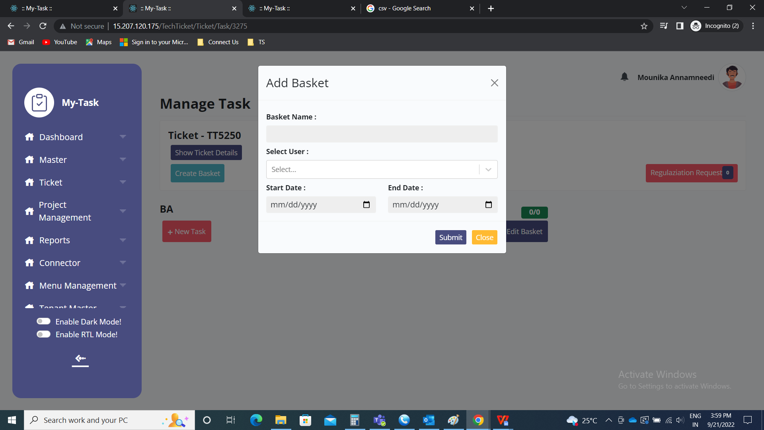

Basket edit:

The basket is edited by using the edit button. The following are the fields in edit basket.

* Basket name
* Select user
* Start date
* End date
* Submit
* Close

|  |  |  |  |
| --- | --- | --- | --- |
| **FIELDS** | **INPUT TYPE** | **MANDATORY/ OPTIONAL** | **DESCRIPTION** |
| Basket name | Text | Mandatory | The basket name is mentioned |
| Select user | Drop down | Mandatory | The basket owner is selected from the drop down list. The drop down options are obtained from user master. |
| Start date | Calender | Mandatory | The start date of that basket. The start date should not be before the start date of the ticket. |
| End date | Calender | Mandatory | The end date of the basket. The end date should not be after the end date of the ticket. |
| Submit | Button | Optional | To submit the data and create the basket. |
| Close | Button | Optional | To close the tab. |

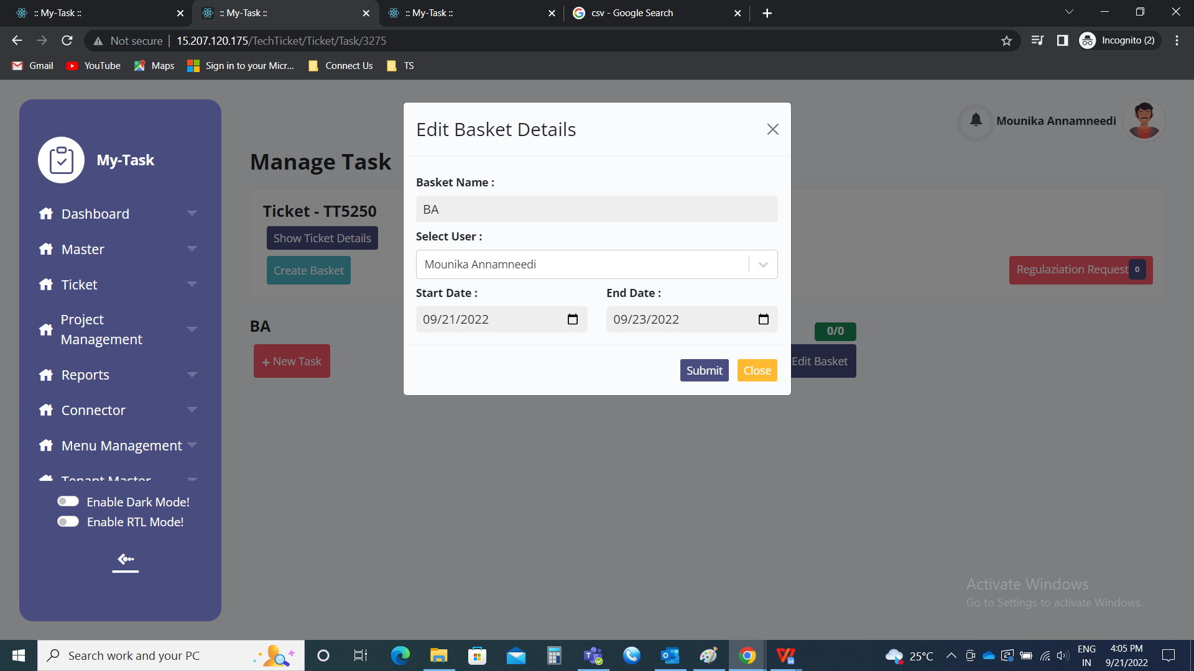

Ticket details:

The “show details” button, when clicked, then ticket description and any files attached are shown.

The files can be viewed and downloaded if required.

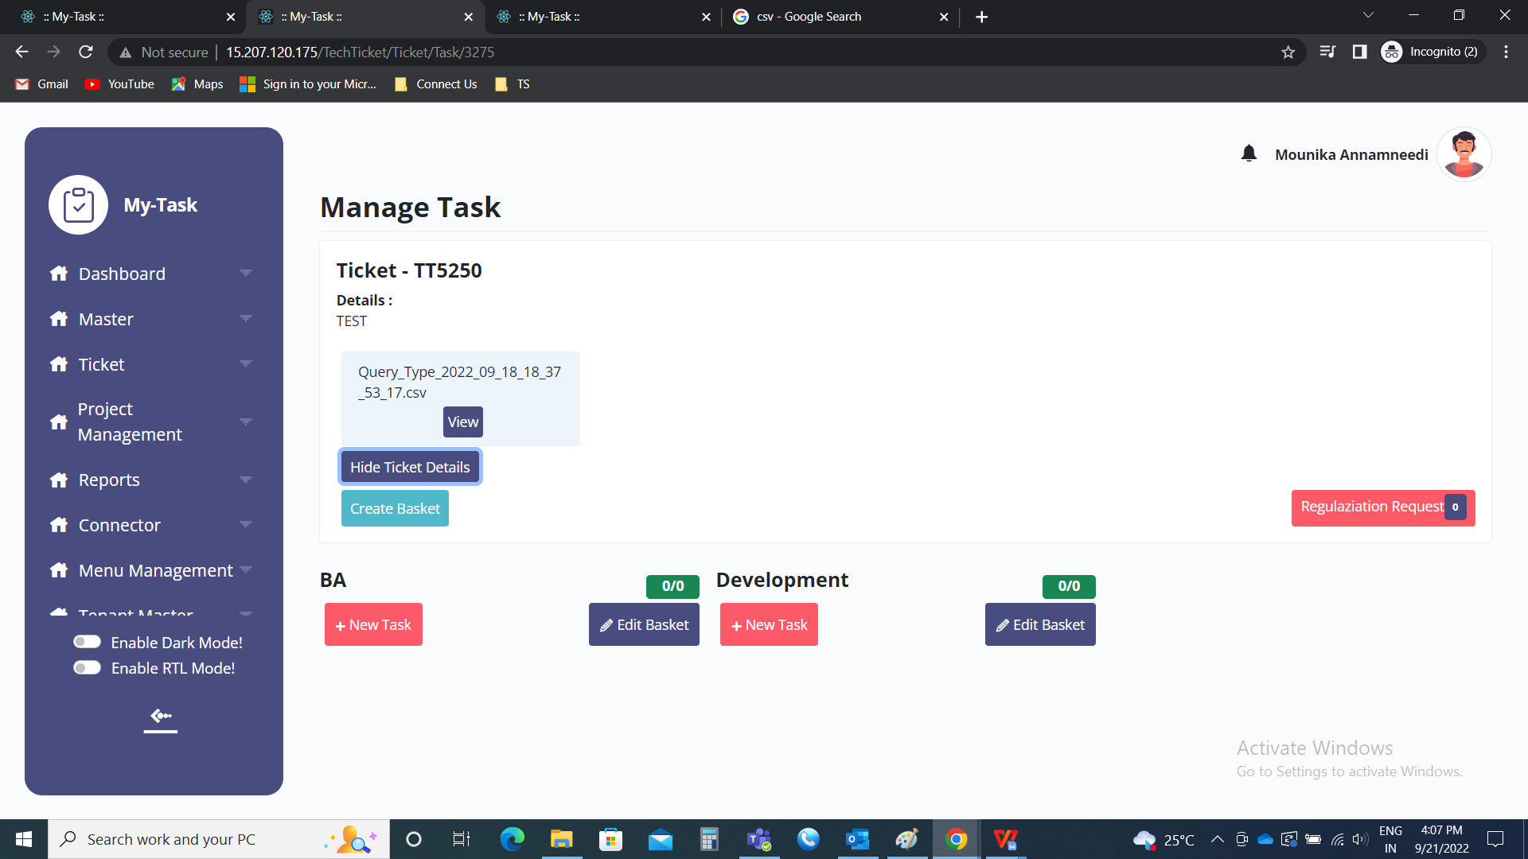

CREATION OF TASK

The tasks are added in the baskets. Tasks are nothing but the work done by the users in the detailed form.

Navigation to tasks from ticket page:

When the basket is created, it shows tasks button in the action fields which navigate to task page.

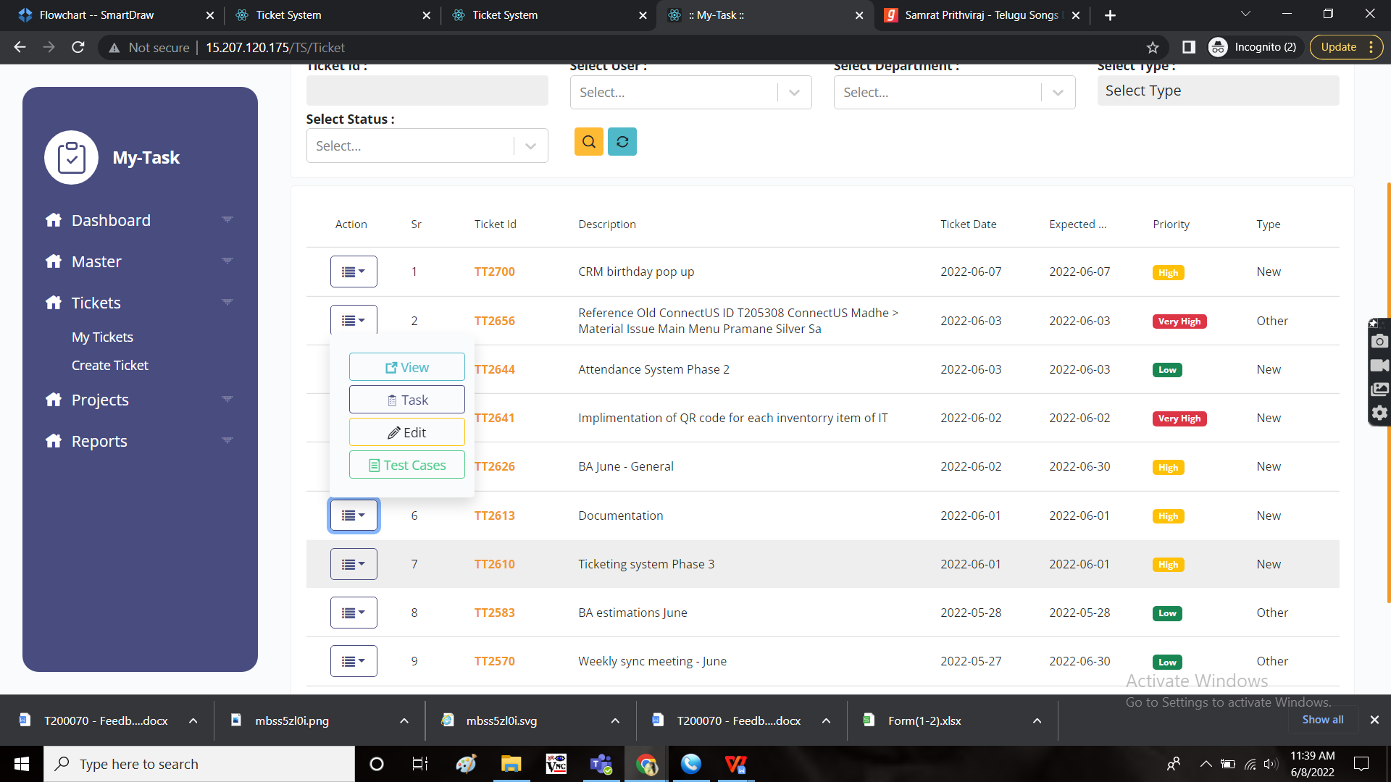

Creation of task:

The task is created by clicking the “Add task” button in the task’s page. A task is created under the basket. The following are the required fields for creation of tasks.

* Select task type
* Task name
* Start date
* End date
* Task hours
* Select priority
* Select status
* Description
* Assign to user
* Dependent task
* Attachment
* Submit
* Close

|  |  |  |  |
| --- | --- | --- | --- |
| **FIELDS** | **INPUT TYPE** | **MANDATORY/ OPTIONAL** | **DESCRIPTION** |
| Select task type | Radio button | Mandatory | The select type consists of 2 options.   * Task * Group activity   Task refers to the timing where the specific user have to play the task while working on it.  Group activity refers to the timing where the basket owner or the ticket owner can play the task and stop the task for the multiple users at a time. |
| Task name | Text | Mandatory | The task name is mentioned |
| Start date | Calender | Mandatory | The start date of the date is selected. The start date of the task should not be before the start date of the basket. |
| End date | Calender | Mandatory | The end date of the date is selected. The end date of the task should not be after the end date of the basket. |
| Task hours | Time | Optional | The task hours are the expected time for completion of the task. The format is in HH:MM. |
| Select priority | Drop down | Mandatory | The priority of the task is selected from the drop down. The following are the drop down options.   * High * Medium * Low |
| Select status | Drop down | - | Initially, the status is automatically “To do”. |
| Description | Text | Optional | The description of the task is mentioned |
| Assign to user | Drop down | Mandatory | The task owner is selected from the drop down list. Multiple users can be selected. The drop down is fetched from user master. |
| Dependent task | Drop down | Optional | The dependent task refers to the task on which the task is dependent. The dependent task is selected from the drop down list. The dependent tasks drop down consists of the other tasks in the same ticket. |
| Attachment | File upload | Optional | The file is uploaded in .csv format if necessary. |
| Submit | Button | Optional | The submit button to submit the details and to create the task. |
| Close | Button | Optional | To close the tab |

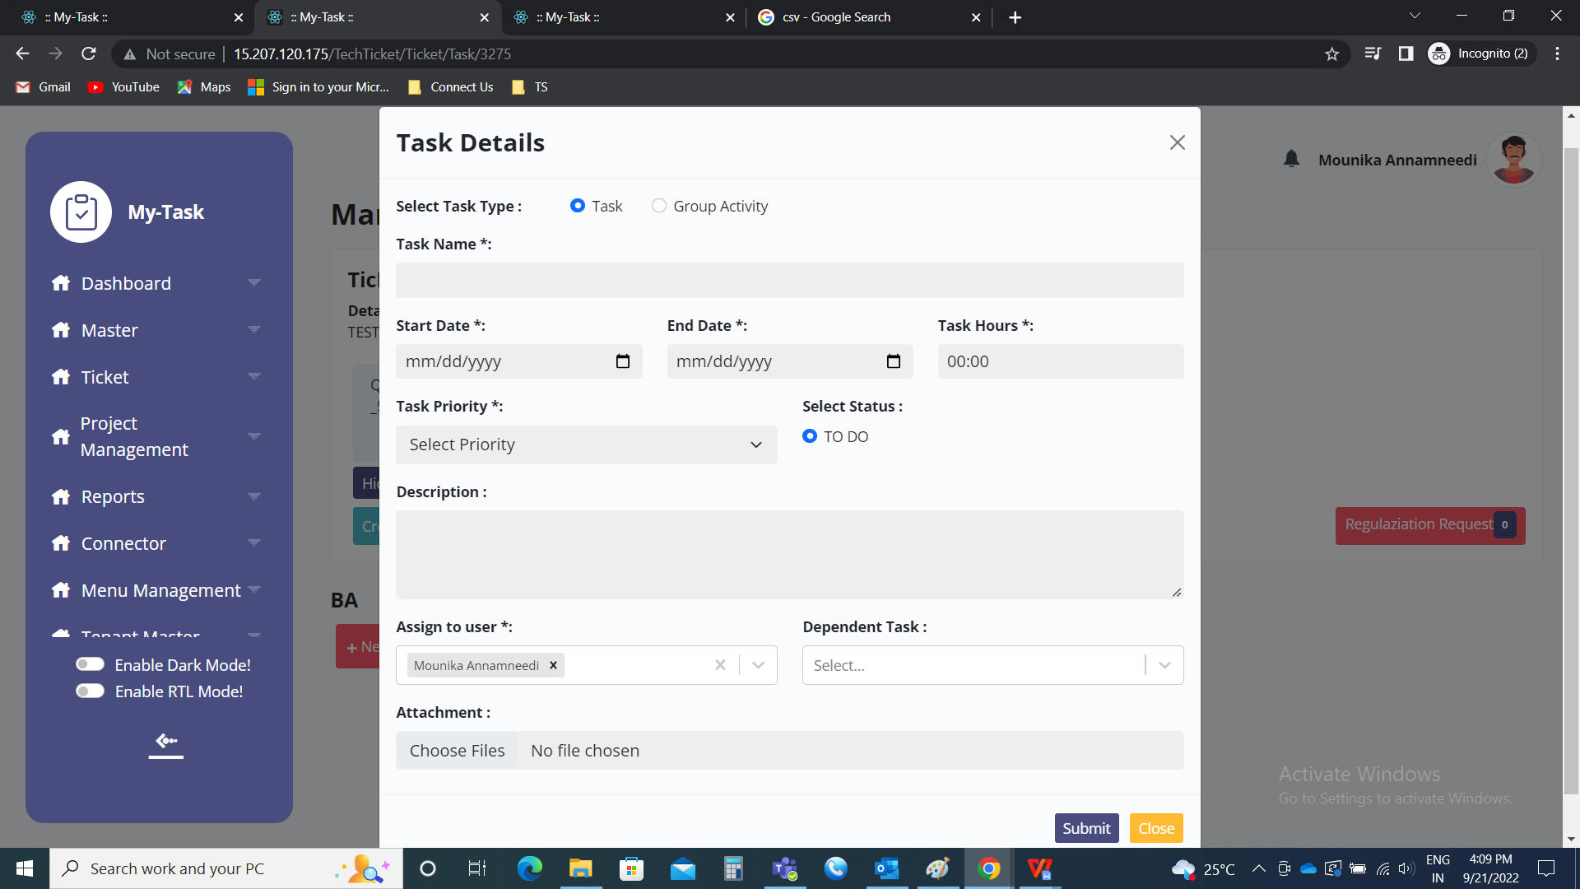

When the time cannot be estimated, the estimated time for that task is not mentioned. The task timing is calculated based on the total time worked by playing that task.

TASK VIEW

The tasks of the particular basket comes under that particular basket. The task view consists of the following fields.

* Priority
* Status
* Edit
* Delete
* Task name
* Assigned user
* Play/ pause
* Total worked - time
* Hamburger

|  |  |
| --- | --- |
| Field | Description |
| Priority | The priority of the task is mentioned |
| Status | The status of the task is mentioned |
| Edit | The edit button to edit the task |
| Delete | The delete button to delete the task |
| Task name | The task name is mentioned |
| Assigned user | The assigned user/ users assigned to that particular task |
| Play/ pause | The play or pause button to start and stop the task. |
| Total worked - time | The total time worked on the task. Initially, until we start, it will be “not started” |
| Hamburger | The hamburger menu consists of following.   * Planner * Test cases * Sub task * Request |

Task view when single user is selected.

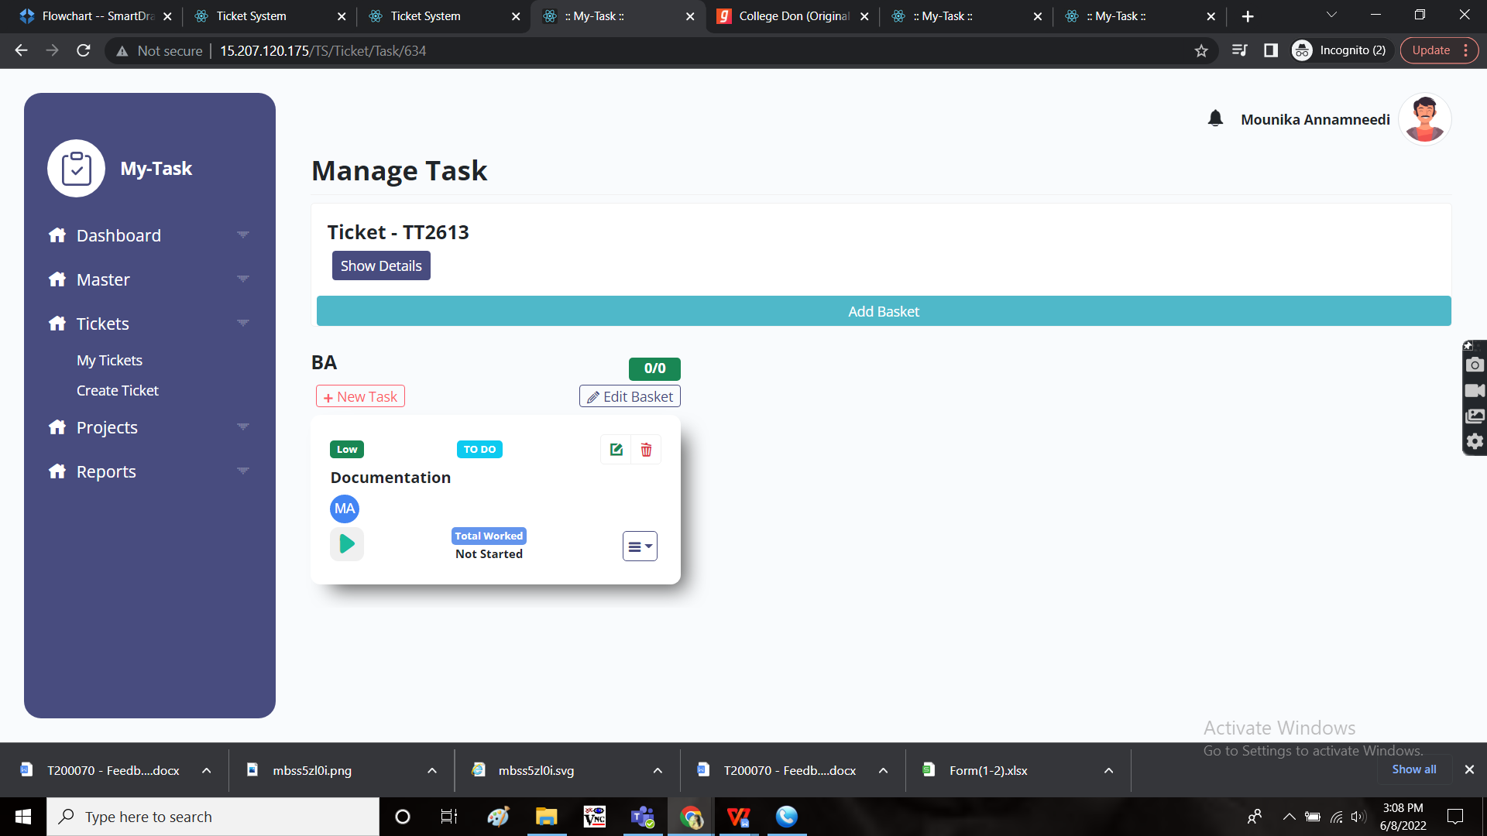

Task view when multiple users are selected.

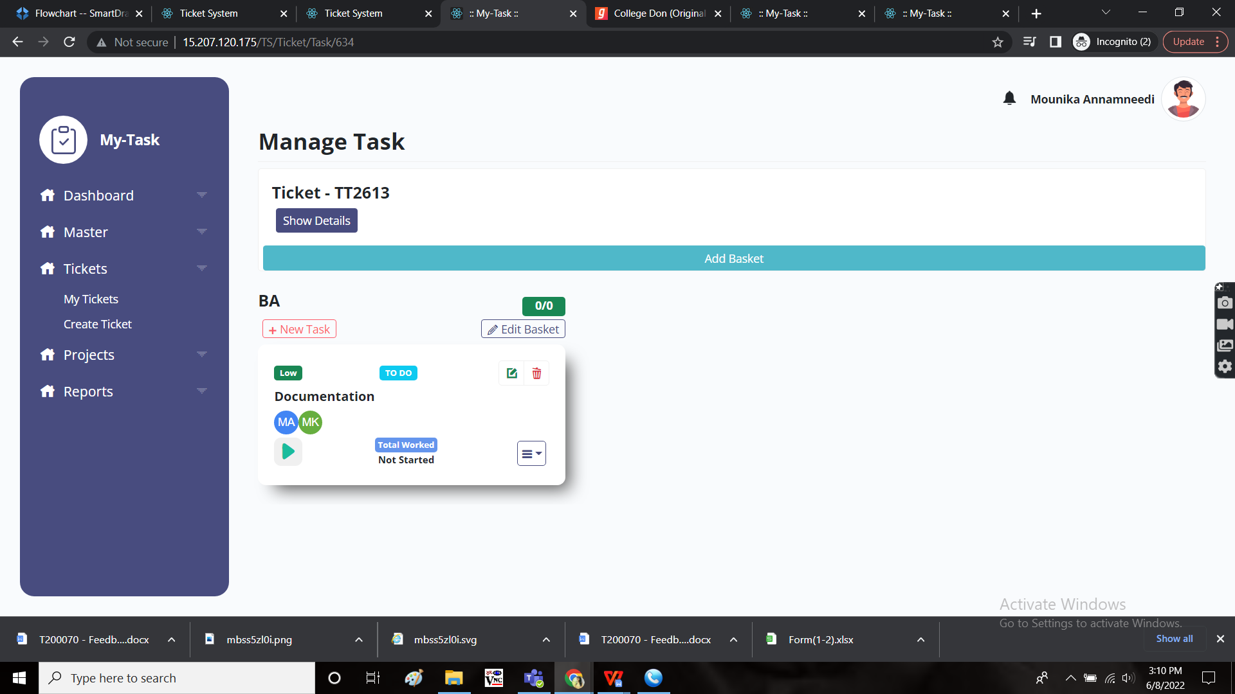

Task view when group activity is selected.

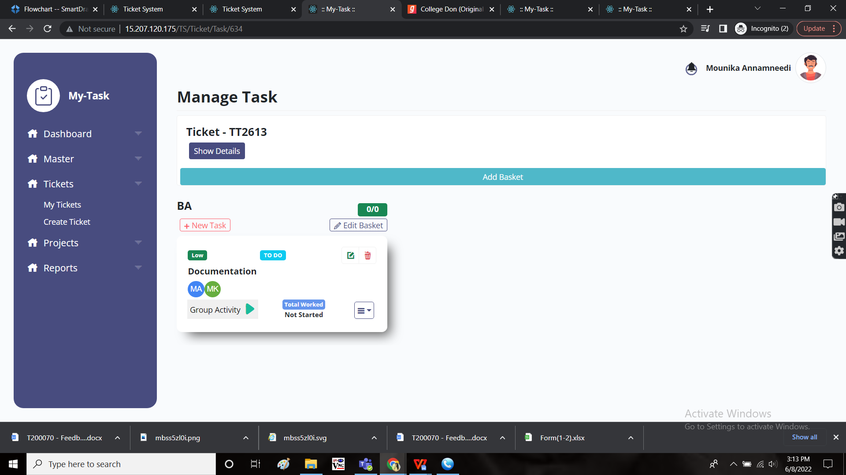

Edit task:

The edit button is used to edit the task. All the fields can be edited if required. The following are the fields in edit page.

* Select task type
* Task name
* Start date
* End date
* Task hours
* Select priority
* Select status
* Description
* Assign to user
* Dependent task
* Attachment
* Submit
* Close

|  |  |  |  |
| --- | --- | --- | --- |
| **FIELDS** | **INPUT TYPE** | **MANDATORY/ OPTIONAL** | **DESCRIPTION** |
| Select task type | Radio button | Mandatory | The select type consists of 2 options.   * Task * Group activity   Task refers to the timing where the specific user have to play the task while working on it.  Group activity refers to the timing where the basket owner or the ticket owner can play the task and stop the task for the multiple users at a time. |
| Task name | Text | Mandatory | The task name is mentioned |
| Start date | Calender | Mandatory | The start date of the date is selected. The start date of the task should not be before the start date of the basket. |
| End date | Calender | Mandatory | The end date of the date is selected. The end date of the task should not be after the end date of the basket. |
| Task hours | Time | Optional | The task hours are the expected time for completion of the task. The format is in HH:MM. |
| Select priority | Drop down | Mandatory | The priority of the task is selected from the drop down. The following are the drop down options.   * High * Medium * Low |
| Select status | Radio button | Mandatory | The radio button consists of following options.   * To do * In progress * Completed   Initially, the status will be “to do”, according to the status, the status is selected.  Once the task is completed. Completed is selected and completed task cannot be edited. |
| Description | Text | Optional | The description of the task is mentioned |
| Assign to user | Drop down | Mandatory | The task owner is selected from the drop down list. Multiple users can be selected. The drop down is fetched from user master. |
| Dependent task | Drop down | Optional | The dependent task refers to the task on which the task is dependent. The dependent task is selected from the drop down list. The dependent tasks drop down consists of the other tasks in the same ticket. |
| Attachment | File upload | Optional | The file is uploaded in .csv format if necessary. |
| Submit | Button | Optional | The submit button to submit the details and to edit the task. |
| Close | Button | Optional | To close the tab |

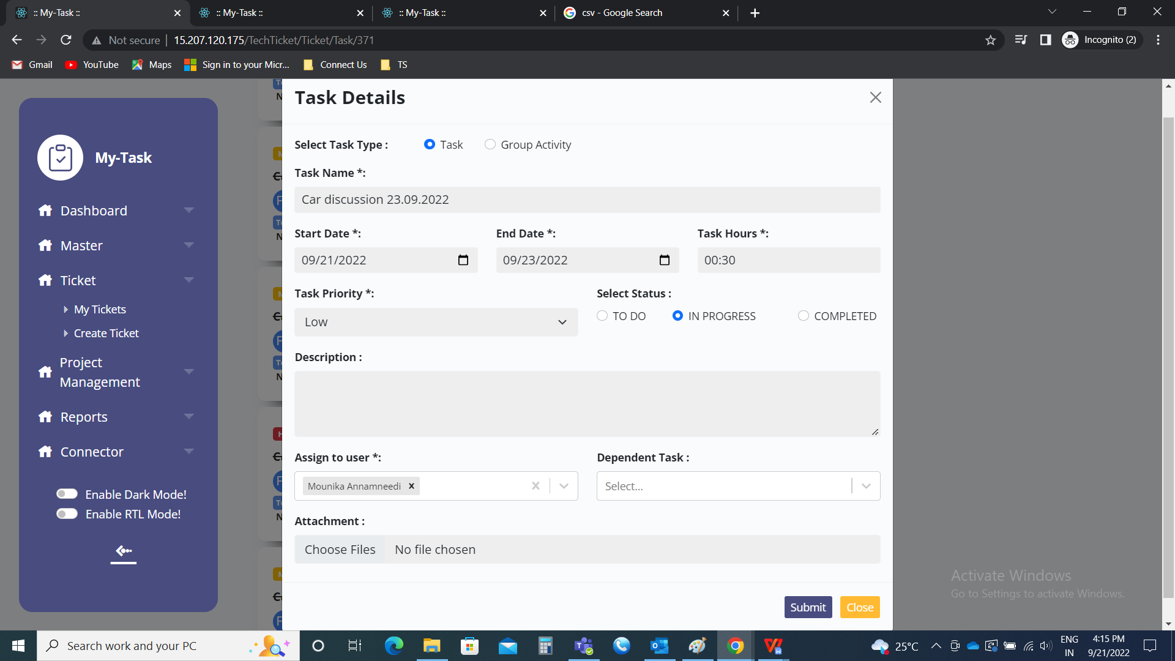

Status of the ticket task view:

When the task is created or the status is changed to “To do”, then





When the task is played or the status changed to “In progress”, then

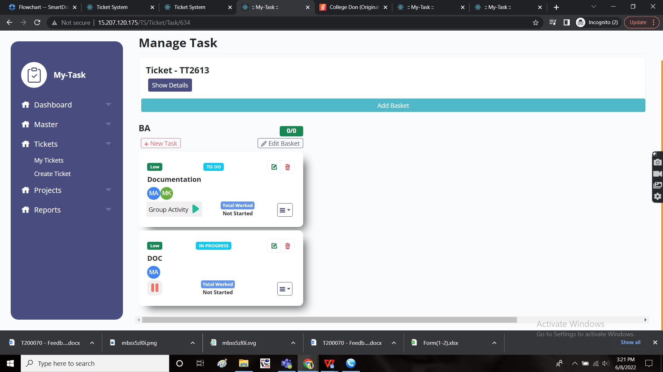



When the task played for some time and paused, the total time played will be shown, if played multiple times, total of time will be shown.

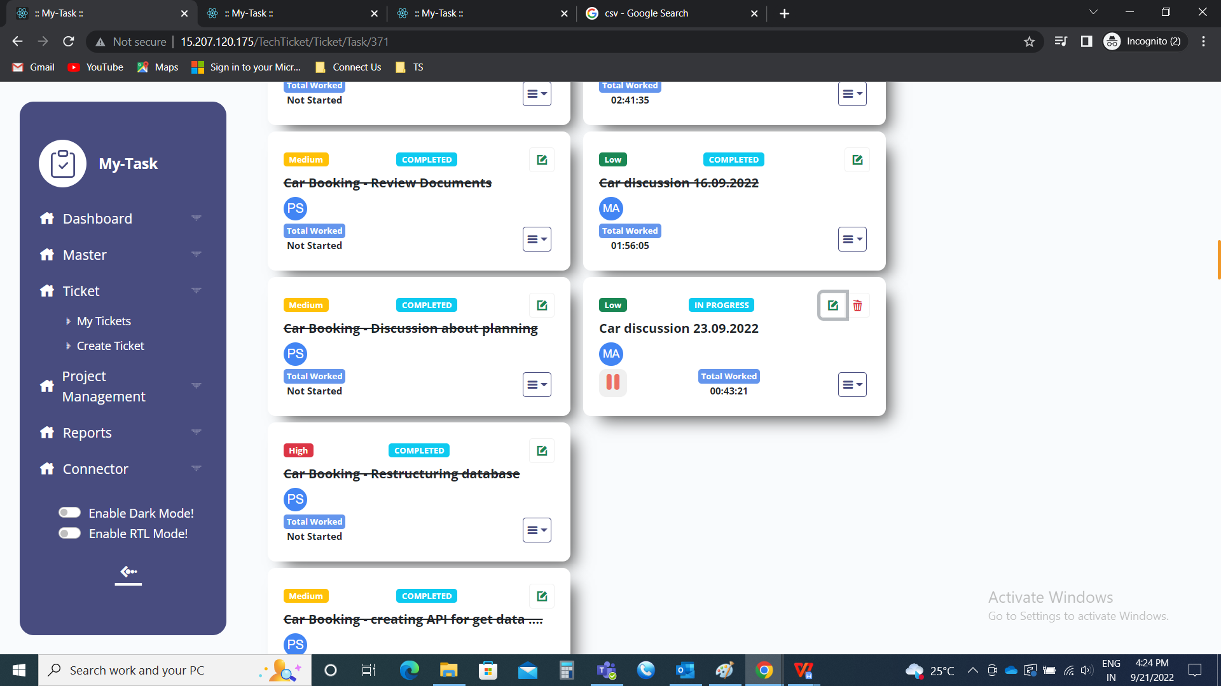

When the status is changed to completed, then

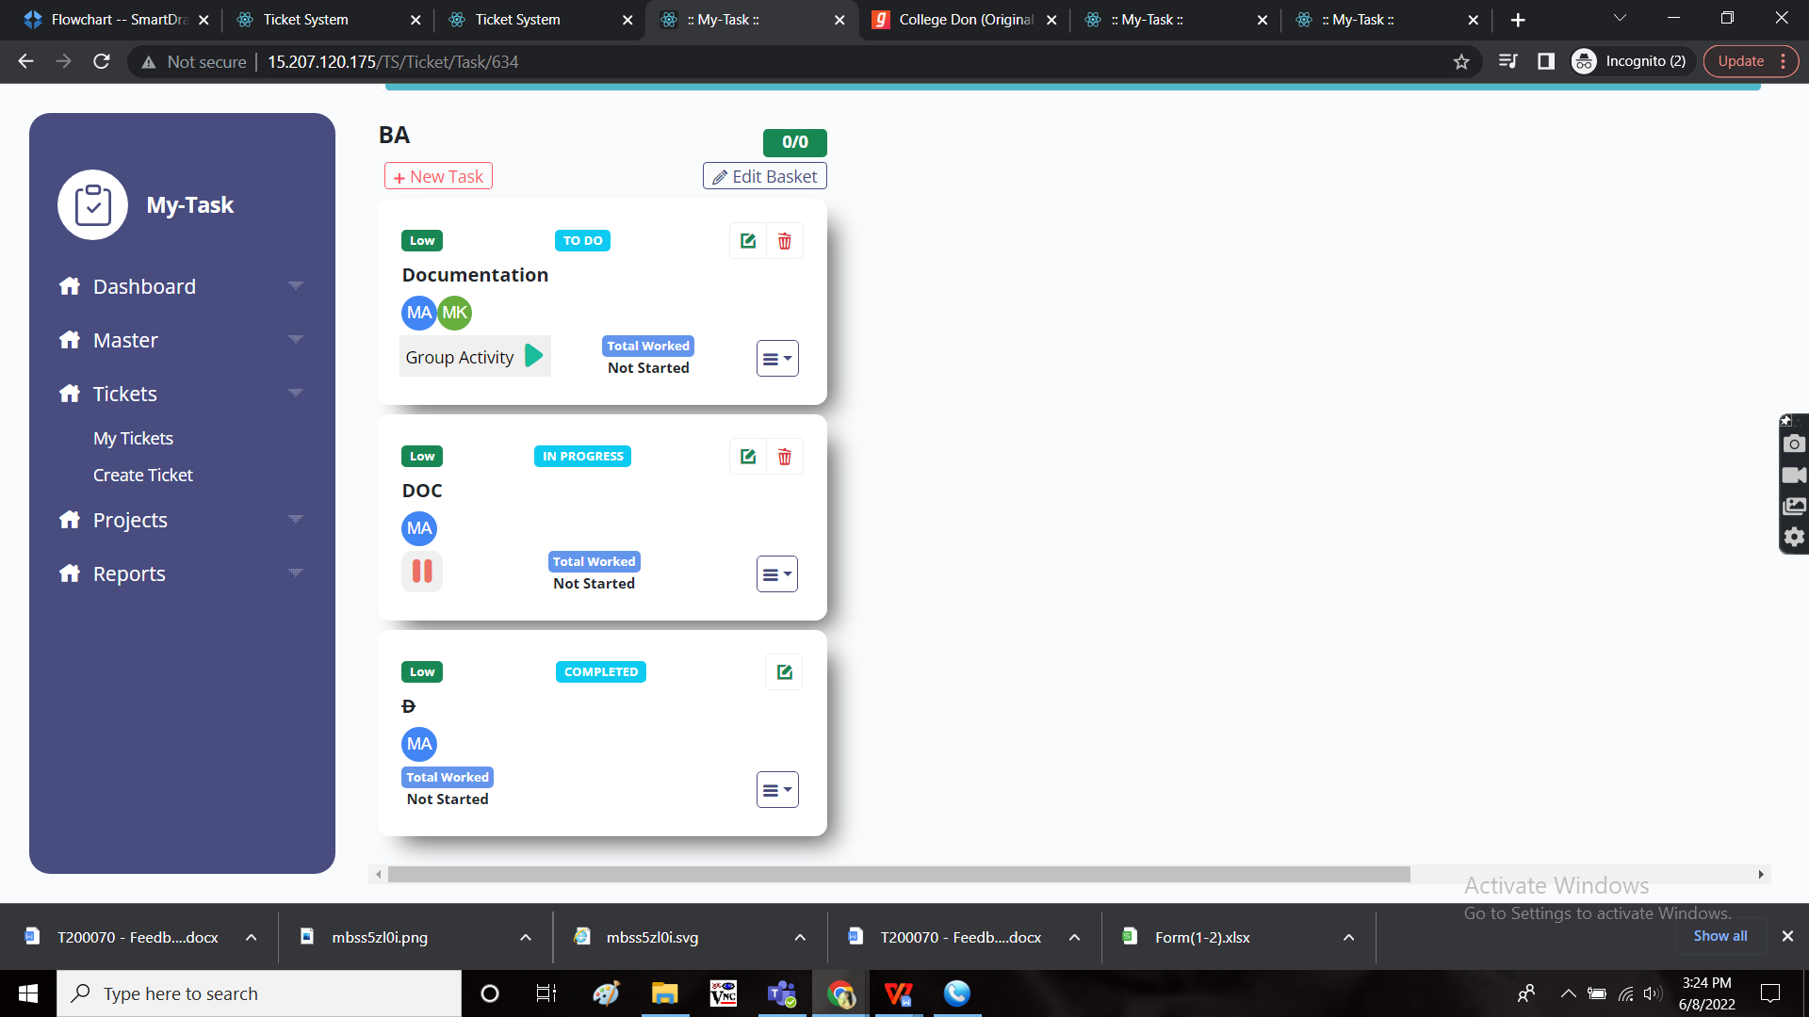

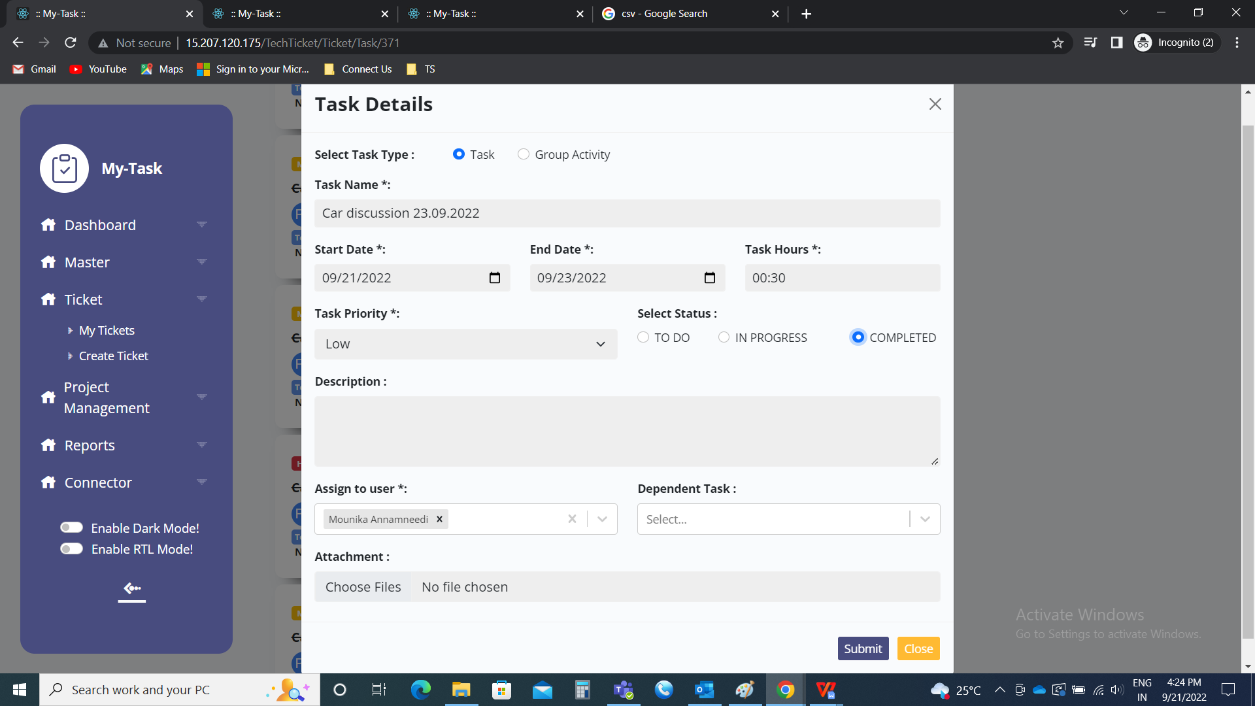

The completed task cannot be edited nor played and the task name will be striven.

Delete task:

The delete button is used to remove the task permanently from that particular basket.

Play/ pause button

At a time, a single task can only be played. When we play one task, automatically the other task will get paused.

When single task is selected.

The user plays on the ticket when the user is working on it. If not, pause button is clicked.

Play button



Pause button



When group activity is selected

Play button

The basket owner have the option to play the task of the group with selected members at a time. The following are the fields in the group activity task.

* Check box with members list
* Start task

|  |  |  |  |
| --- | --- | --- | --- |
| **FIELDS** | **INPUT TYPE** | **MANDATORY/ OPTIONAL** | **DESCRIPTION** |
| Members list | Check box | Mandatory | The members assigned to that task are displayed. So that the attended members are selected (who are working on the same point). |
| Start task | Button | Optional | To start the task |

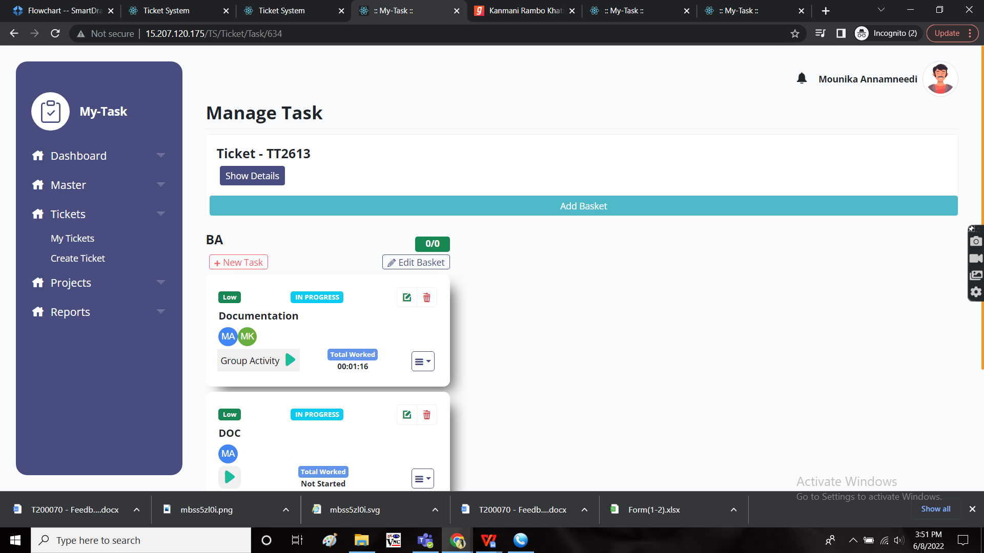

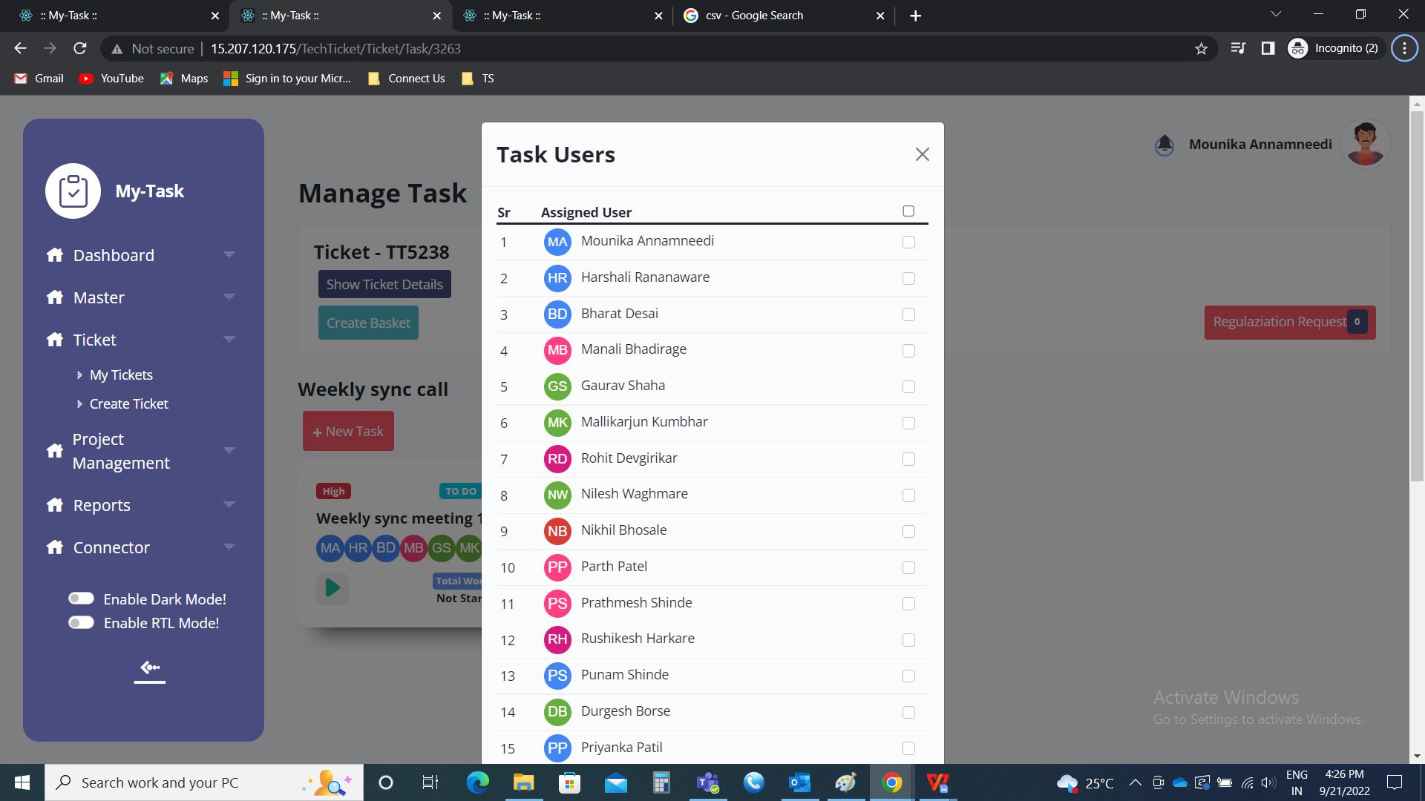

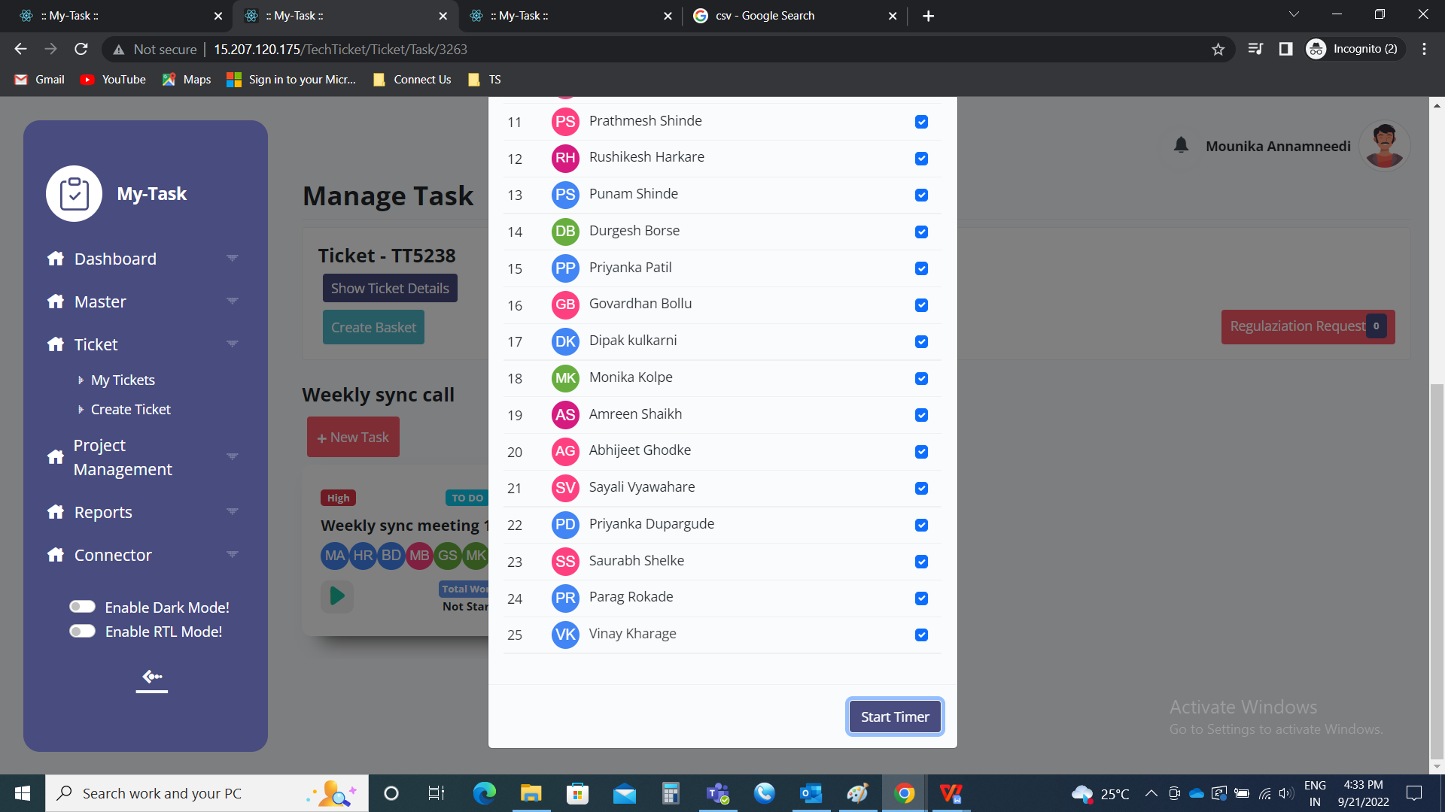

Pause button

The basket owner have the option to stop/ pause the task of the group with selected members at a time. The following are the fields in the group activity task.

* Check box with members list
* Stop task

|  |  |  |  |
| --- | --- | --- | --- |
| **FIELDS** | **INPUT TYPE** | **MANDATORY/ OPTIONAL** | **DESCRIPTION** |
| Members list | Check box | Mandatory | The members assigned to that task and working on that point are displayed. So, the participants who are exiting from that task are selected. |
| Stop task | Button | Optional | To stop the task |

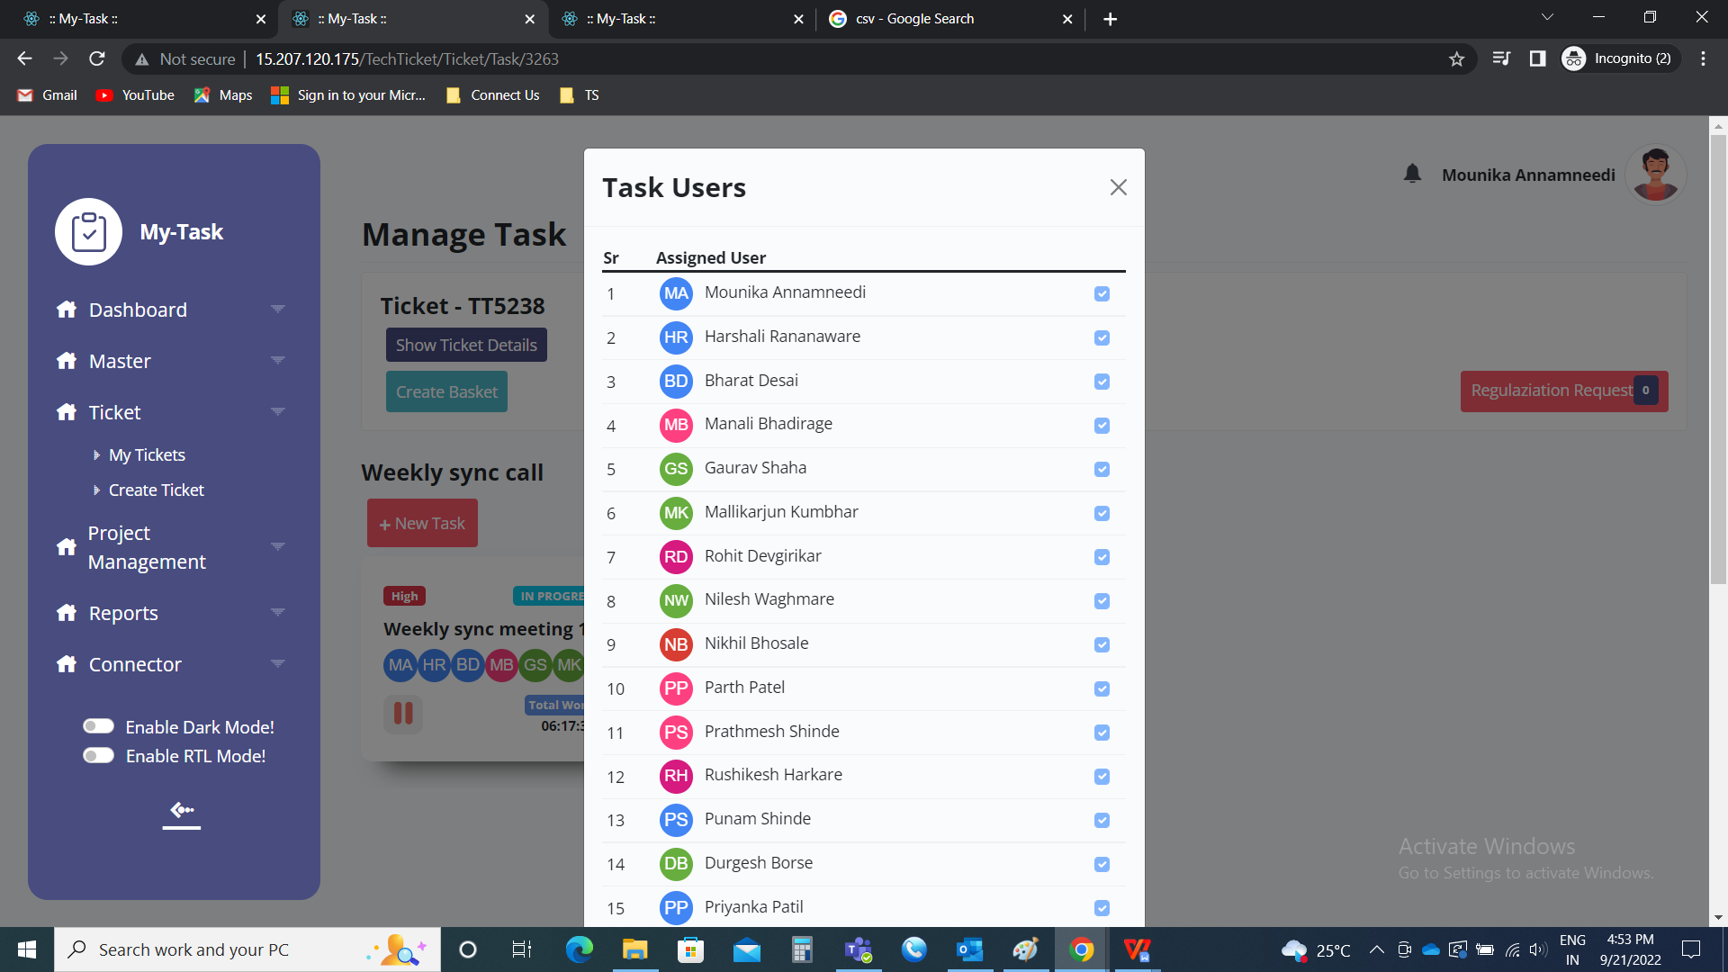

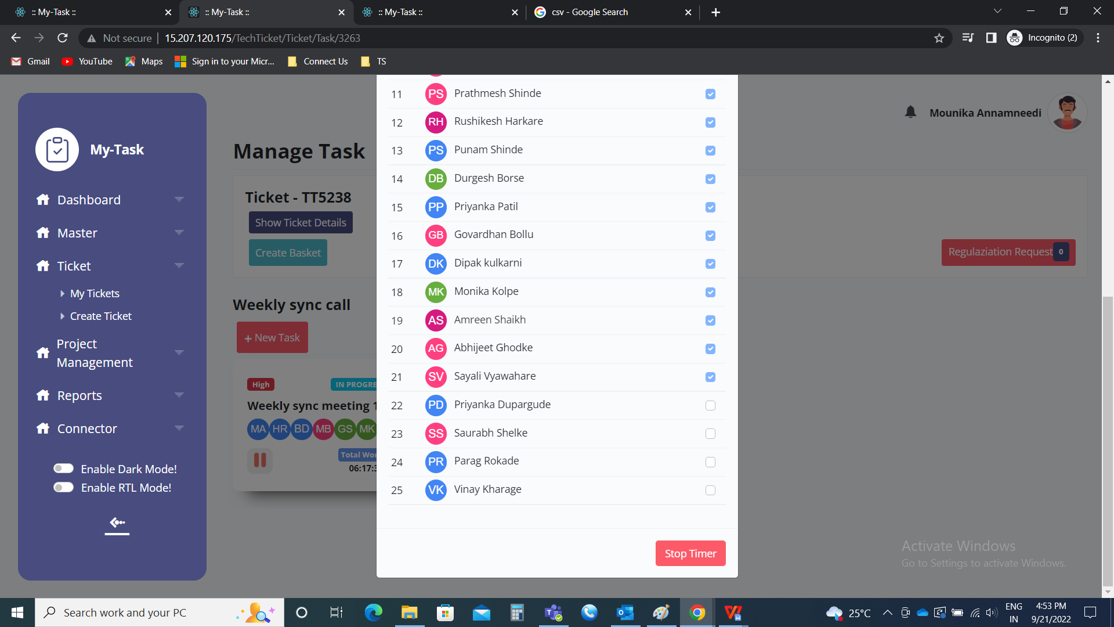

Total worked time

Initially, when the task is created, the total worked time will be as “not started”.



When the user plays the task, the time is displayed after it is paused. If the user plays multiple times, even then the time is calculated I.e., it is added and then shows the total time worked on that task.

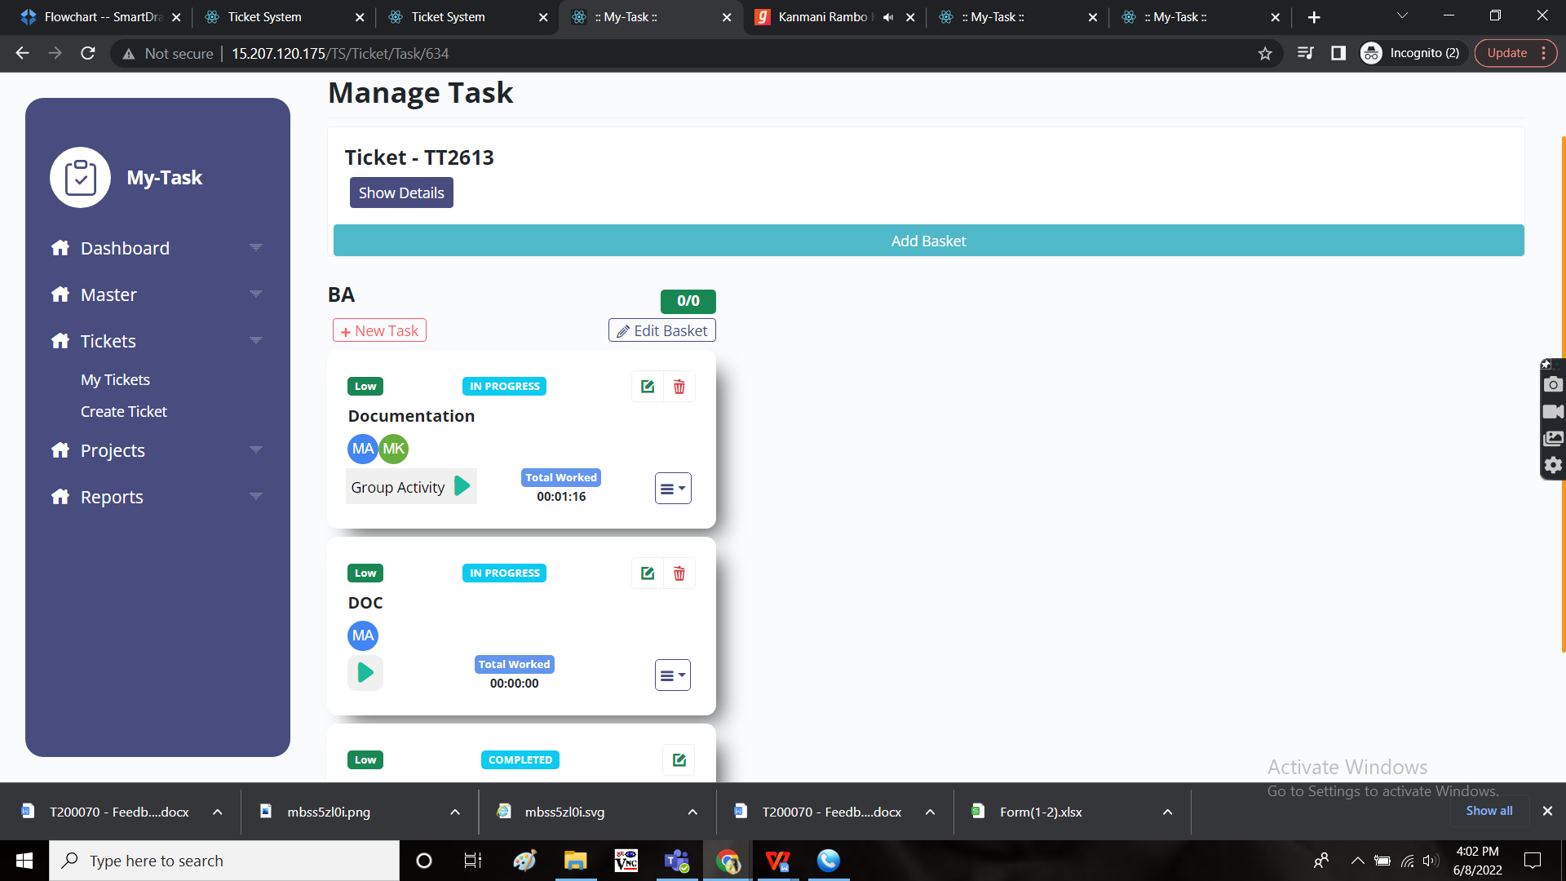

When the task is completed. Based on the time, whether it is started or not, it is closed. The display of the completed task is as follows.

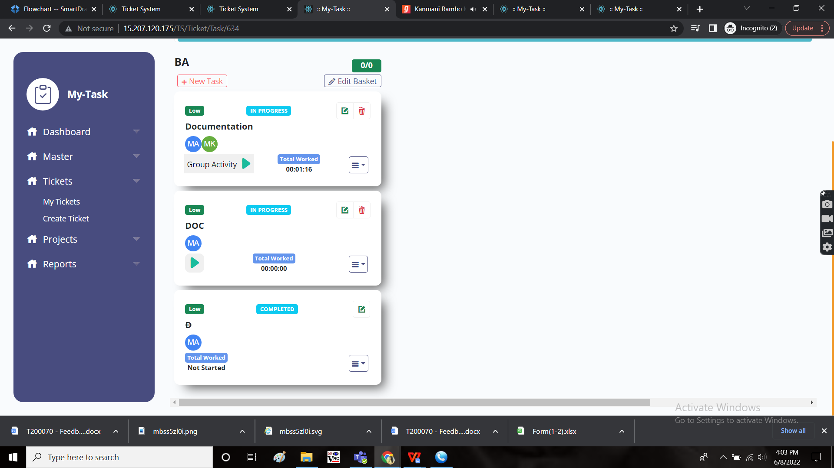

HAMBURGER MENU

The hamburger menu consists of the following.

* Planner
* Test cases
* Subtask
* Request

Planner

The planner relates the planning of the tasks in the regular life. It is based on how many hours a user is working on the particular day.

Initially the planner is divided with the number of the days and equal number of hours in the particular day. As of now, the Saturday and Sunday were excluded in the planner list.

If there were multiple users, the hours is divided equally among all the users based on the days equally.

The following are the fields in the planner.

* Sr no
* Username
* Date
* Hours
* Total hours
* Update close

|  |  |
| --- | --- |
| Field | Description |
| Sr no | The serial number |
| Username | The user name is mentioned |
| Date | The dates on which the task to be played I.e., worked |
| Hours | The no. Of hours on that particular day to be worked |
| Total hours | The total number of hours, totally scheduled |
| Update | To update the planner |
| Close | To close the tab |

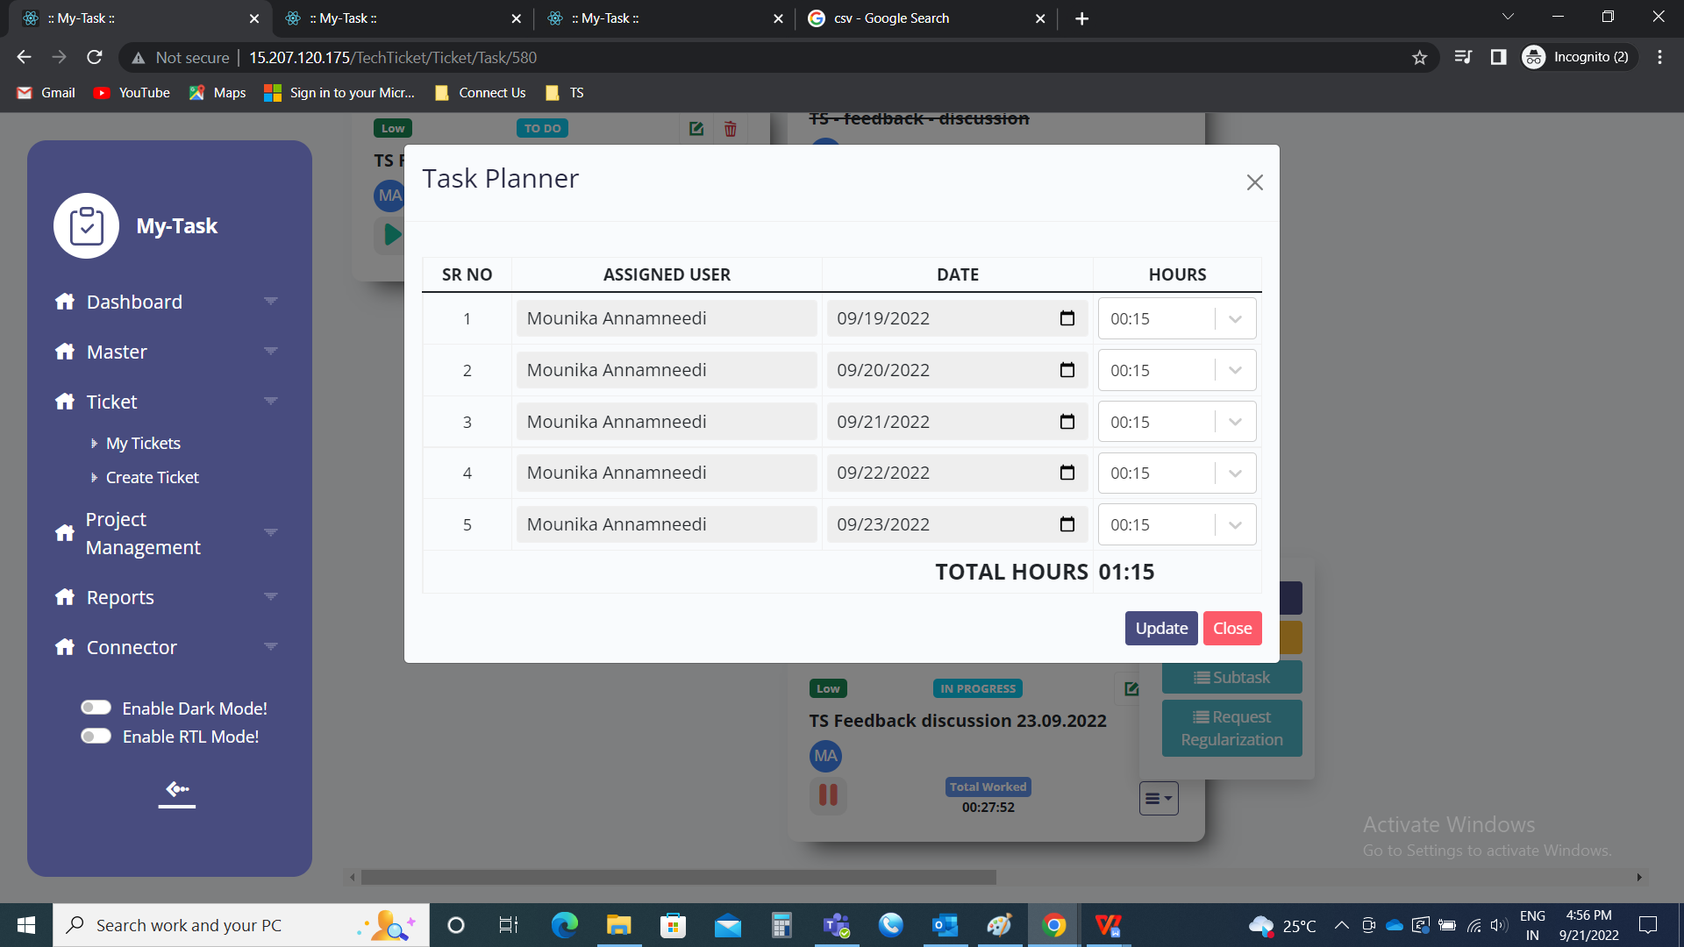

Planner edit

The planner can be edited according to the user. The username, date and hours can be edited.

|  |  |  |  |
| --- | --- | --- | --- |
| **FIELDS** | **INPUT TYPE** | **MANDATORY/ OPTIONAL** | **DESCRIPTION** |
| Sr no | - | - | The serial number |
| Username | Drop down | Optional | The user name is mentioned from the drop down list. The drop down consists of the users who are assigned to that particular task. |
| Date | Calender | Optional | The dates on which the task to be played I.e., worked is selected. The date should be in between the task start and end date. |
| Hours | Time | Optional | The no. Of hours on that particular day to be worked is selected. The hour format is HH:MM |
| Total hours | - | - | The total number of hours, totally scheduled. The total hours should not be more than the estimated time scheduled in the task. |
| Update | Button | Optional | To update the planner |
| Close | Button | Optional | To close the tab |



SUB TASK

The sub task are the part of the tasks. The sub-tasks are mentioned as check lists which helps in easing the process. The following are the fields of sub-task.

* Sub-task
* Action
* Text field
* “+” button

|  |  |
| --- | --- |
| Field | Description |
| Sub-task | The sub task is mentioned |
| Action | The action button consists of delete button to delete the sub task and done button for completion of the sub-task. |
| Text field | The text field is used to mention the sub-task name. |
| “+” button | The “+” button is used to add sub-task. |

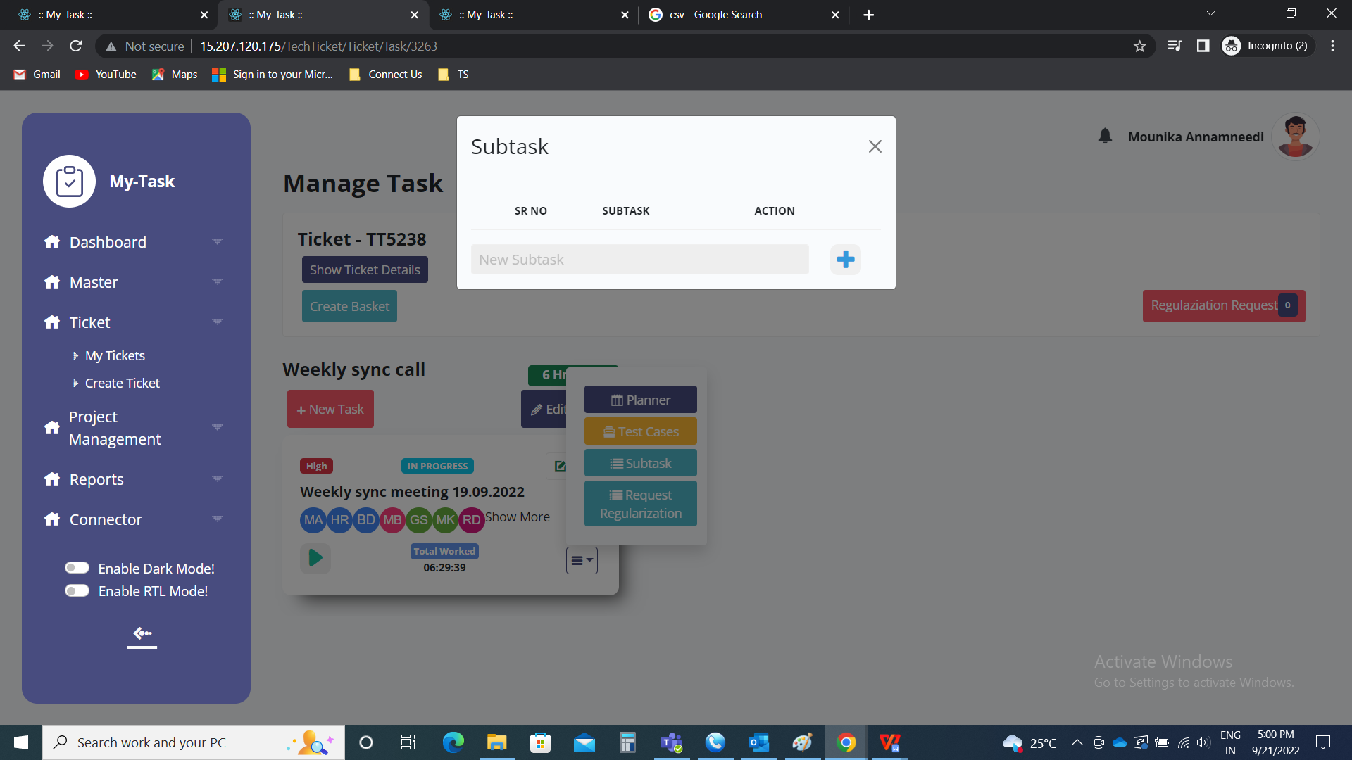

Action in sub-task.

The action consists of the delete and done button.

|  |  |
| --- | --- |
| Field | Description |
| Delete | To delete the sub-task |
| Done | To complete the sub-task |

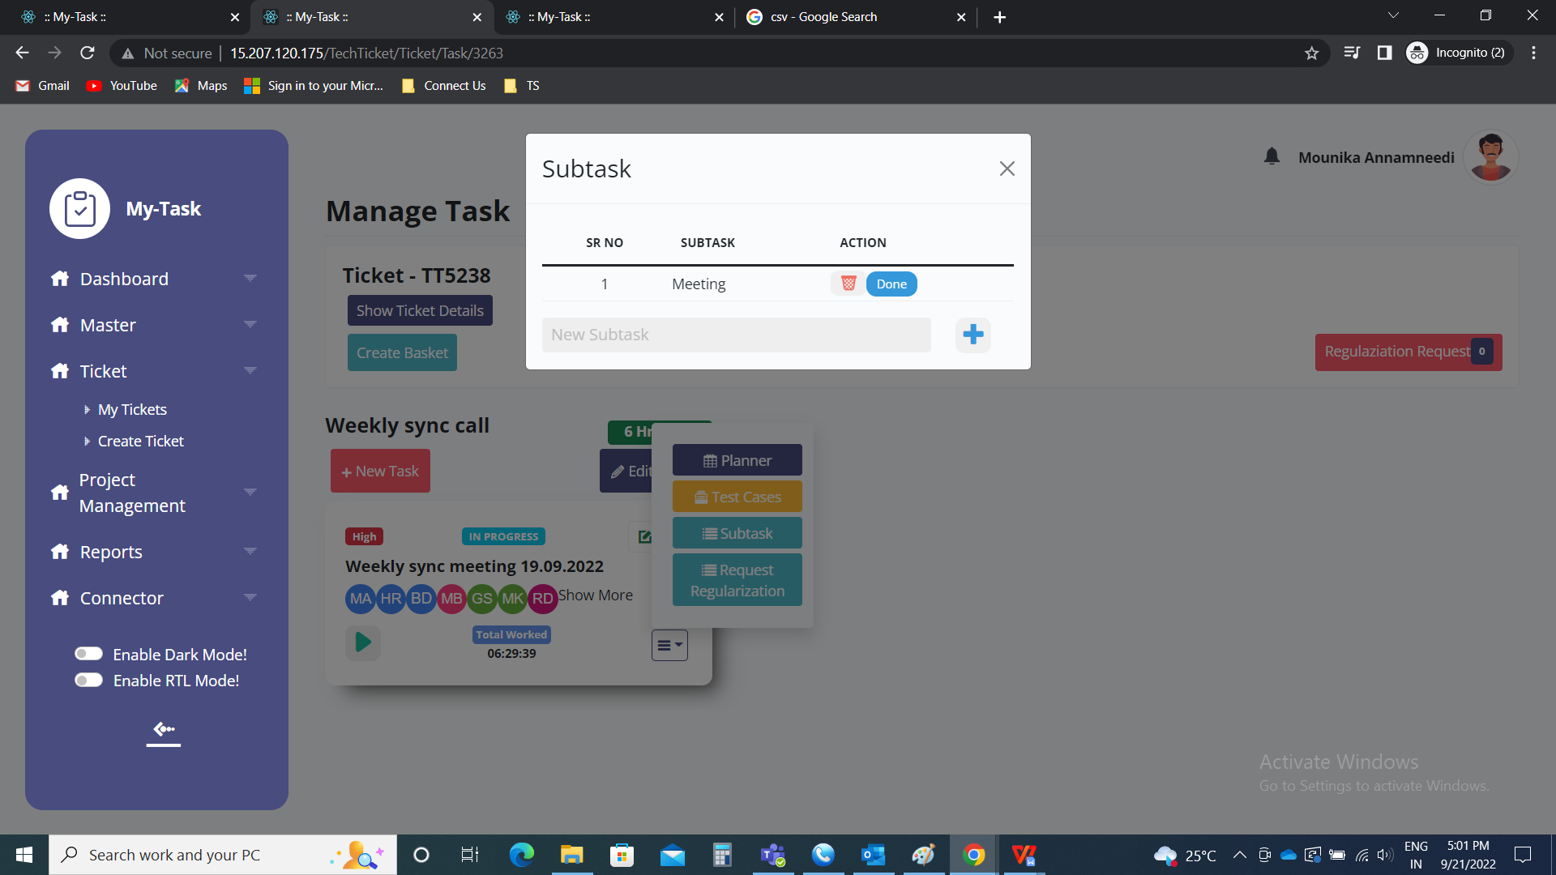

Sub-task when sub-task is completed. The sub-task will be strike through

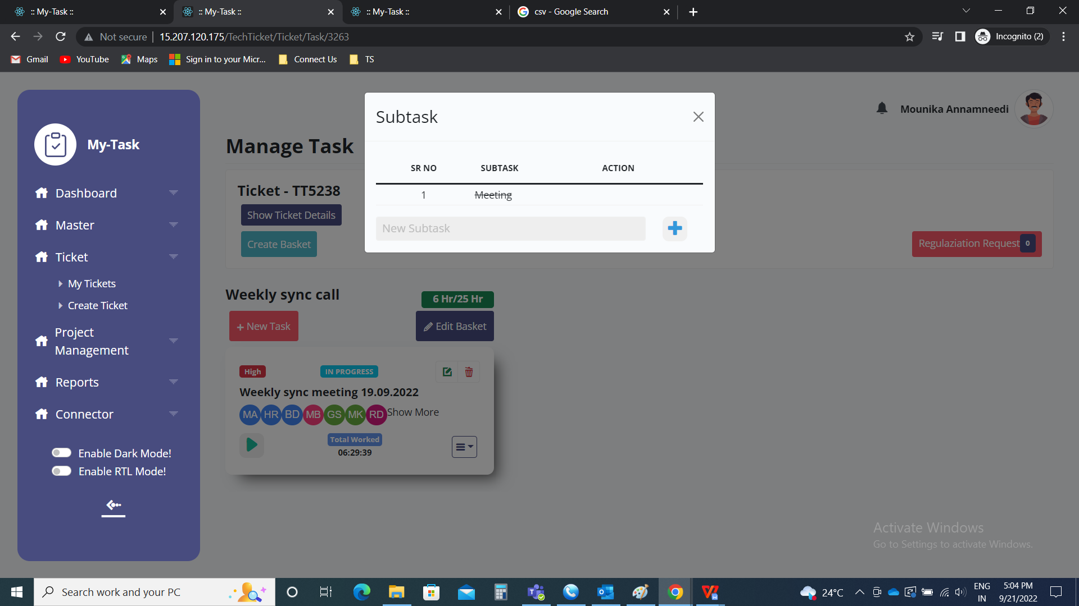

REQUEST

The request option is used when the user worked on a specific time and forgot to start the time. It is nothing but the regularization of time.

The ticket owner or the project owner can approve the requests of the users (task owners, basket owners).

But if the ticket owner is raising any request on specific task, only the project owner can approve.

The following are the fields in the regularization of time.

* Date
* From
* To
* “+” button
* Submit
* Close

|  |  |  |  |
| --- | --- | --- | --- |
| **FIELDS** | **INPUT TYPE** | **MANDATORY/ OPTIONAL** | **DESCRIPTION** |
| Date | Calender | Mandatory | The date on which the regularization is required is selected. The date is limited to the start task date and task end date. |
| From | Time | Mandatory | The time from which the user worked on that specific point is mentioned. The time format is HH:MM. |
| To | Time | Mandatory | The time to which the user worked on that specific point is mentioned. The time format is HH:MM. |
| “+” button | Button | Optional | The “+” button to add one more request |
| Submit | Button | Optional | The submit button to submit the details |
| Close | Button | Optional | The “x” button to close the tab |

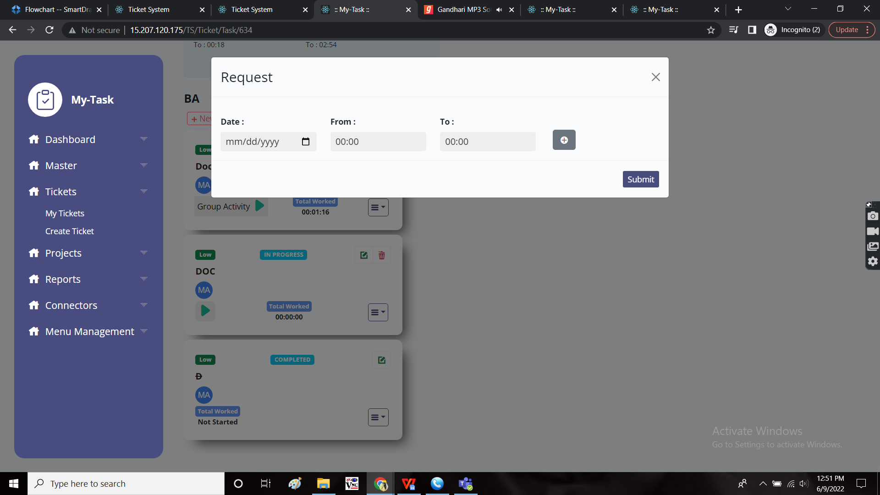

Request when extra field is selected

By clicking on “+” button, an extra row is added. Then the following additional fields are added. The following are the extra fields in the request.

* Delete
* “+”

|  |  |  |  |
| --- | --- | --- | --- |
| **FIELDS** | **INPUT TYPE** | **MANDATORY/ OPTIONAL** | **DESCRIPTION** |
| Delete | Button | Optional | To remove the row |
| “+” | Button | Optional | To add a new row for the regularization |

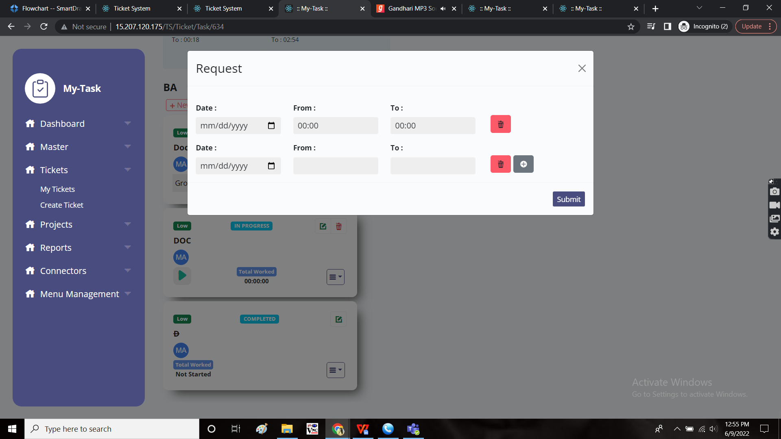

The requests are shown on the ticket to ticket owner and the project on the top of the baskets in “task” menu of the tickets.

REGULARIZATION

The regularization of the ticket is used when the user misses to play the task and the user can later regularize using the regularize option.

The time when the user sending the request should not be used in playing the other ticket. The regularization request won’t be send in that case.

In case of request raised by any other ticket owner, the request is sent to ticket owner and the project owner (if no project owner, then only ticket owner).

In case of request raised by ticket owner, the request is sent to project owner (if no project owner, then only ticket owner).

As soon as the user sends the request, it is shown in regularization request.

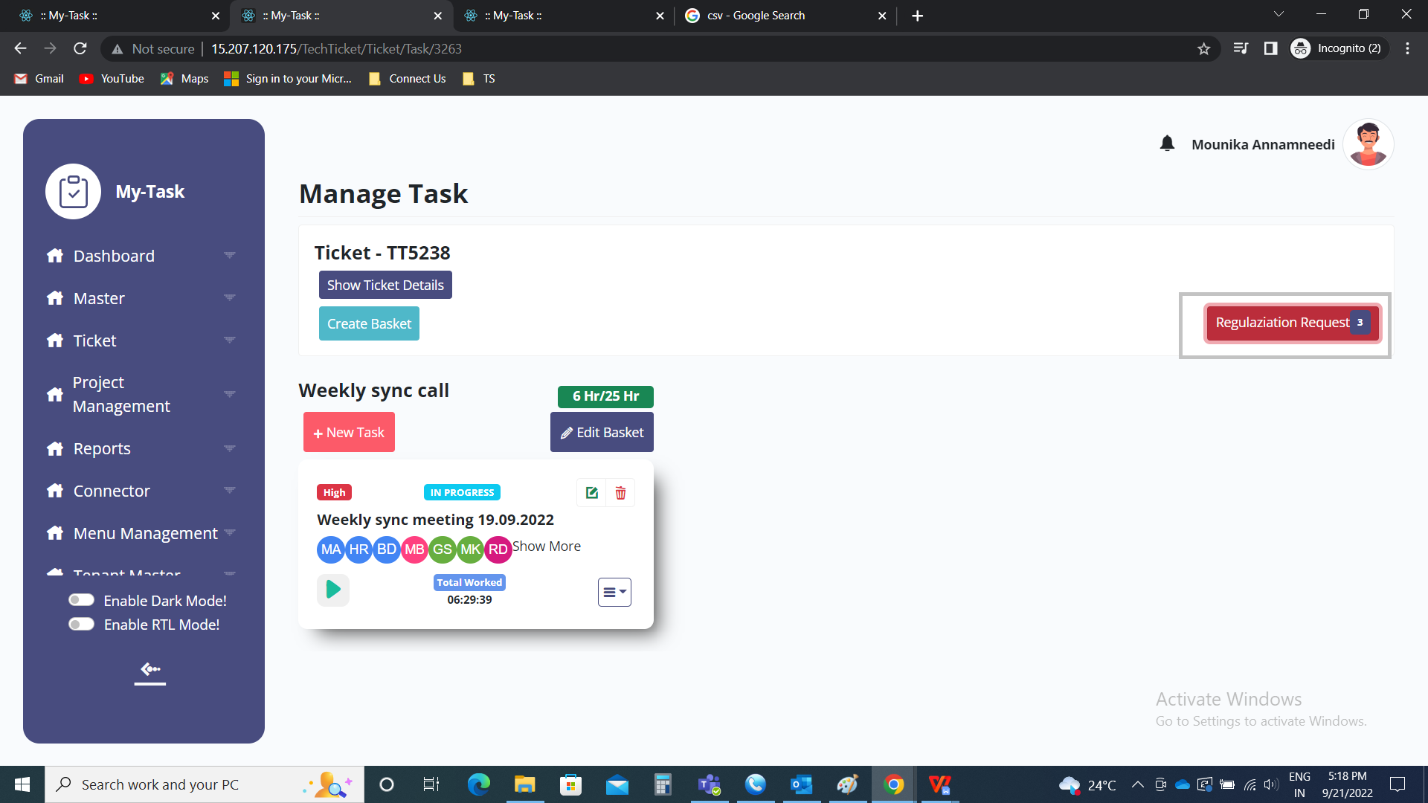

Regularization request

The regularization request consists of the following fields.

* Select
* Requested by
* Date
* From time
* To time
* Action
* Approve
* Reject

|  |  |
| --- | --- |
| Field | Description |
| Select | The select consists of the check boxes where multiple selection is done |
| Requested by | The request by consists of the user name who sends the request for the regularization |
| Date | The date consists of the date on which the regularization sent (the date of regularization) |
| From time | The from time the user worked sent for regularization |
| To time | The to time the user worked sent for regularization |
| Action | The action consists of the status such the regularization is pending, approved or rejected. Initially, when the request sent, the status is pending. When the request accepted, the status changes to approved. If the request rejected, the status changes to pending. |
| Approve | The approve button to approve the request sent for the regularization. As soon as the request is accepted, the status changes to approved and the time worked will be added to the user in that particular task. |
| Reject | The reject button to reject the request sent for the regularization. As soon as the request is rejected, the status changes to rejected. |

