|  |  |
| --- | --- |
| **Ticket ID** | TT6498 |
| **Ticket description** | Hi Team,  We required individual notification in MY CS App  point already discussed with Gaurav Sir. |
| **Created by** | Manali |
| **Created on** | 08/12/2022 |
| **Priority** | Medium |
| **Version** | 1.0 |

**Version**

|  |  |  |  |  |
| --- | --- | --- | --- | --- |
| **Sr. No** | **Version no** | **Version Date** | **User name** | **User department** |
| **01** | **1.0** | **08/12/2022** | **Sagar Dahane** |  |
|  |  |  |  |  |
|  |  |  |  |  |

**Approvals**

|  |  |  |
| --- | --- | --- |
| **Field** | **Name of the User** | **Approved date by the user** |
| **Actual User Name** | Sagar Dahane |  |
| **Actual User Department** |  |  |
| **Organization Name** | CSJewellers |  |
| **Assigned BA** | Manali Bhadirage |  |
| **Assigned Developer** |  |  |
| **Assigned Tester** | Abhijeet Ghodke |  |

**Estimation**

|  |  |  |  |  |
| --- | --- | --- | --- | --- |
| **Department name** | **Estimated Time (In hr)** | **Scheduled Date (Starting date )** | **Estimated date** | **Actual delivery date** |
| **BA** |  |  |  |  |
| **Development** |  |  |  |  |
| **Testing** |  |  |  |  |
|  |  |  |  |  |

**Introduction**

MY CS application is used by employees of CSJ through which they can mark attendance, generate promo code and submit surveys assigned to them.

**Business requirement**

User needs ‘Action’ tab in MY CS app and Notification module in the back-end through which they intend to send the notification / alerts / reminders to each individual / bulk of employees.

**Existing system**

Existing MY CS application doesn’t have Action menu and CU doesn’t have notification module.

**Proposed system**

In Connect Us-> create Notification module. It will have two sub-modules in it:-

* Create Notification
* Notification Report

Step 1. In CU -> Notification module -> Create Notification, it will have following fields in it:

* Notification Name
* Existing Notification Name
* Branch Name
* Create (button)
* Preview of Notification Name
* Download template (button)
* Upload file (button)

Also, once user has attached the file then it’s preview should be displayed with submit button below it.

|  |  |
| --- | --- |
| **FIELDS** | **DESCRIPTION** |
| Notification Name | It will be mandatory field.  User will enter the subject of the notification in this field.  It should accept characters, special characters, space and numbers with maximum 50 inputs. |
| Existing Notification Name | It will be drop-down displaying list of all active notification names. |
| Create | Once user clicks on create button, it will display notification preview below. |
| Preview of Notification Name | If user has entered any data in ‘Notification Name’ field then the same will be displayed here.  Else, user selects any existing notification name then it will be displayed in this field.  It will be read only field. |
| Download template | Once user clicks on this button, it will download the notification template in .csv format.  It will have following columns in it:  Sr. No.  Branch Name  Employee ID  Employee Name  Notification Name  Description  .csv file should have branch name, employee ID, notification name and employee name columns pre-filled in it.  It should include all active employees from employee master (all branches, all roles, all designations, all department)  User will download the template and enter the description in it.  It should have maximum length of 250 inputs. It should accept characters, special characters, space and numbers. |
| Upload File | User will save the downloaded file in which user has written the description. User will attach that file through ‘upload file’ button.  Once user had attached the file, it will display the preview of the file below. |
| Submit | Once user clicks on submit button, it will display a confirmation dialog box stating “Are you sure you want to send?”  Once user clicks on yes, notifications should be sent to all the desired employees in MY CS app -> action. |

Step 2. In MY CS app -> Action menu needs to be created.

* It will have list of notifications which are sent to employee.
* The count of notifications sent to the employee should be displayed on the ‘Action’ menu.
* Notifications which are not read yet, it should be highlighted with colour. Once employee clicks on particular notification, notification will be viewed on next page with all content in it and that notification will be considered as read.
* Read notifications shouldn’t have colour / shouldn’t be highlighted.
* Once particular notification is read, then the count of notifications should be decreased.
* Below is the format of the list of the notifications: Date & Time - Notification Name (in bold)
* Date & Time on which the notification was sent to the employee should be displayed.
* Once user clicks on notification name, notification will be displayed in below format:
* Date & Time
* Notification Name
* Content (description which is written in .csv file for this particular employee)

Step 3. In CU -> Notification -> Notification Report needs to be created.

It will have following fields:

* Search by notification name - Drop-down which will include all created notification names.
* Submit (button)

Once user clicks on submit, it will display the following details in grid:

* Edit Action - Through edit action, employee will be able to enable / disable notification
* Sr. No.
* Date - Date on which notification was created.
* Notification Name
* Active / Inactive - User can enable / disable particular notification name by just by toggle.
* View Report

For each notification name, user should have view report button. Once user selects particular notification and clicks on view report button, it should display report below in following format:

* Sr. No.
* Employee ID
* Employee Name
* Status - Read or Unread
* Date - Date on which employee read the notification.

Once user clicks on view report, report will either be displayed on same page or on next page. Also, it will have export button at the top corner through which user can can export the viewed report through export button.

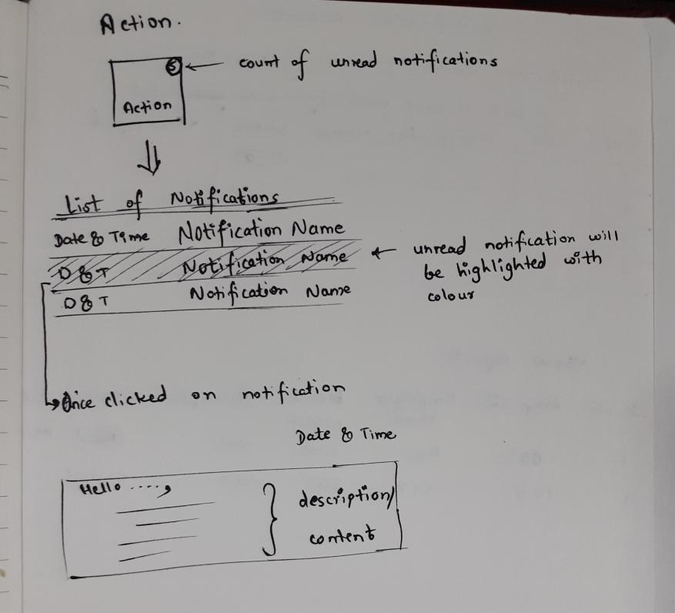

Fig: MY CS -> Action -> list of notifications

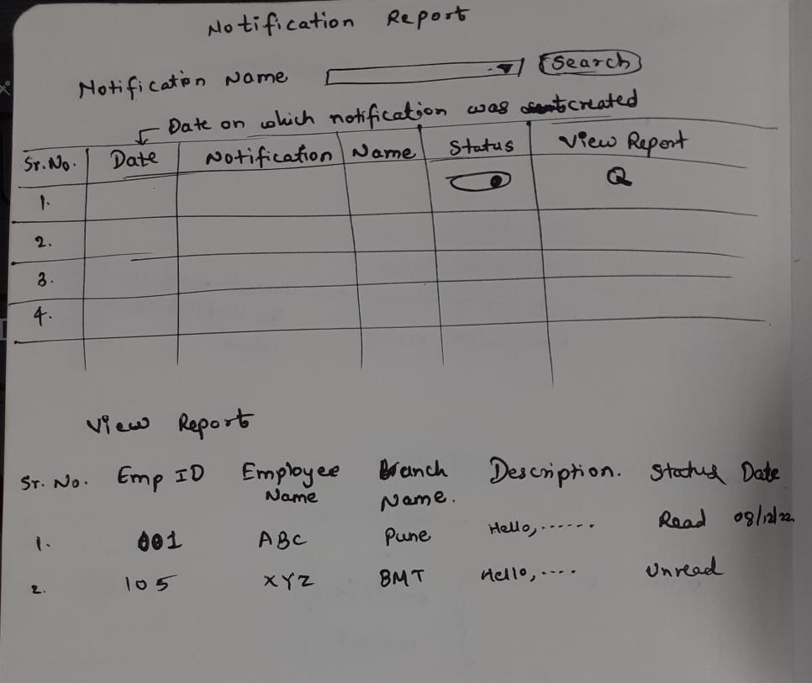

Fig: CU -> Notification -> Notification Report

**References of the users**

|  |  |  |  |
| --- | --- | --- | --- |
| **User** | **Name** | **Mail** | **Contact number** |
| **Actual user** | Sagar Dahane | da@csjewellers.com | 2938 |
| **Ticket created by (if any)** | Sagar Dahane | da@csjewellers.com | 2938 |
| **Assigned business analyst** | Manali Bhadirage | Manali.bhadirage@techneai.com | 2965 |
| **Assigned developer** |  |  |  |
| **Assigned tester** | Abhijeet Ghodke | Abhijeet.ghodke@techenai.com | 2965 |