|  |  |
| --- | --- |
| **Ticket ID** | T200244 |
| **Ticket description** | Please create Special Authorities as below -  Order edit - Menu Flow -  Customer Order -> Order Detail -> edit any Order  While we click on edit button, Currently it shows blank page. |
| **Created by** | Divya Narayan Danpelli |
| **Created on** | 18/02/2022 |
| **Priority** | Medium |
| **Version** | 0 |

**Version**

|  |  |  |  |  |
| --- | --- | --- | --- | --- |
| **Sr. No** | **Version no** | **Version Date** | **User name** | **User department** |
| 0 | 1 | 23.02.2022 | Divya Narayan Danpelli | IT application support |

**Approvals**

|  |  |  |
| --- | --- | --- |
| **Field** | **Name of the User** | **Approved date by the user** |
| **Actual User Name** | Divya Narayan Danpelli | 18.02.2022 |
| **Actual User Department** | IT application support |  |
| **Organization Name** | Techneai |  |
| **Sign-off** |  |  |
| **Assigned BA** | Mounika KrishnaVeni Annamneedi | 23.02.2022 |
| **Assigned Developer** |  |  |
| **Assigned Tester** |  |  |

**Estimation**

|  |  |  |  |  |
| --- | --- | --- | --- | --- |
| **Department name** | **Estimated Time (In hr)** | **Scheduled Date (Starting date )** | **Estimated date** | **Actual delivery date** |
| **BA** | 3 | 23.02.2022 | 23.02.2022 |  |
| **Development** |  |  |  |  |
| **Testing** |  |  |  |  |

**Introduction**

Special authority is the authority or the special permissions given to change or edit the particular module.

**Business requirement**

Creating the special authority for

* Order edit.

So that, the user can give the authorities to the other employees in the organization.

**Existing system**

There are no special authorities created for module.

**Proposed system**

* Creation of special authorities
  + Order edit

Step-1

In connect US -> Bill checking -> Bill checking master -> Special authority master

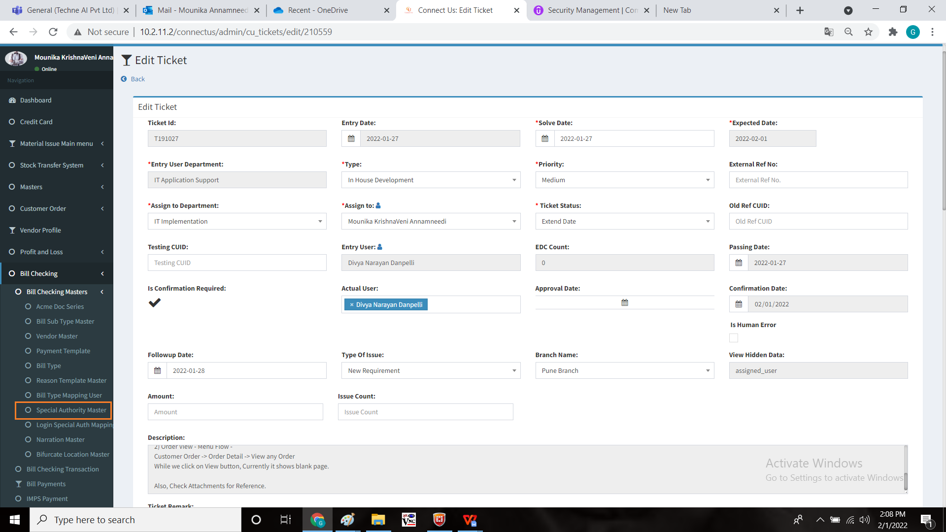

In special authority master, add new module

* + Order edit

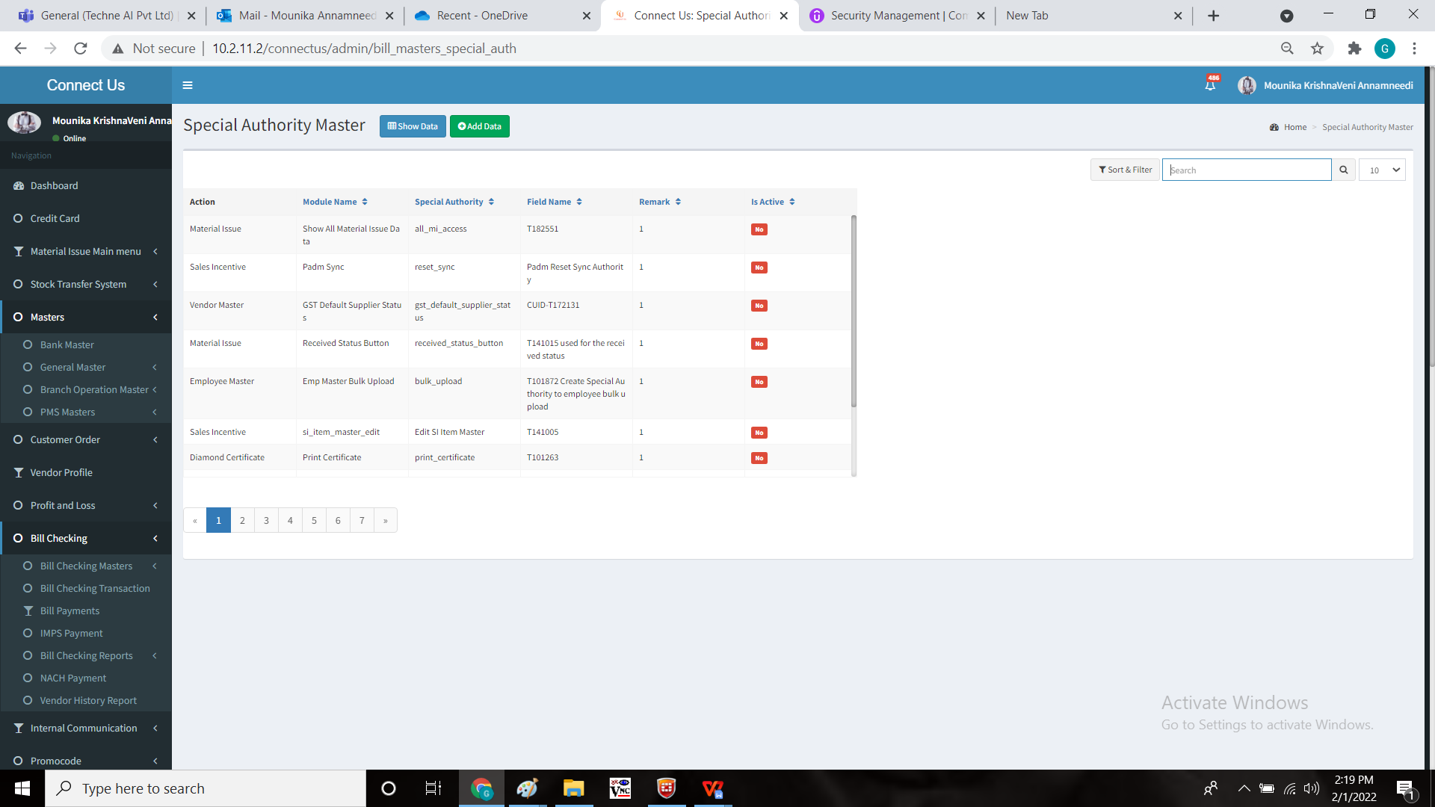

Order edit:

In Connect US -> Customer order -> Order detail -> edit order

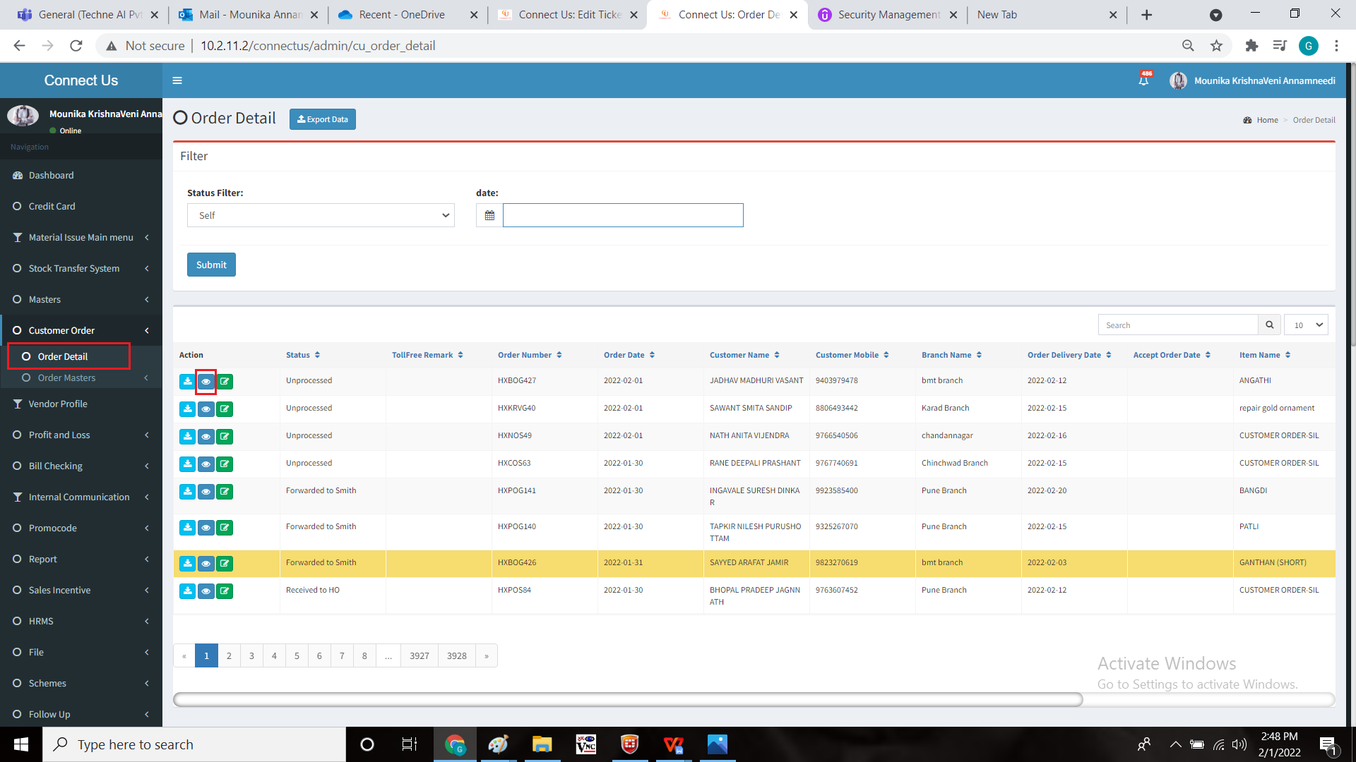

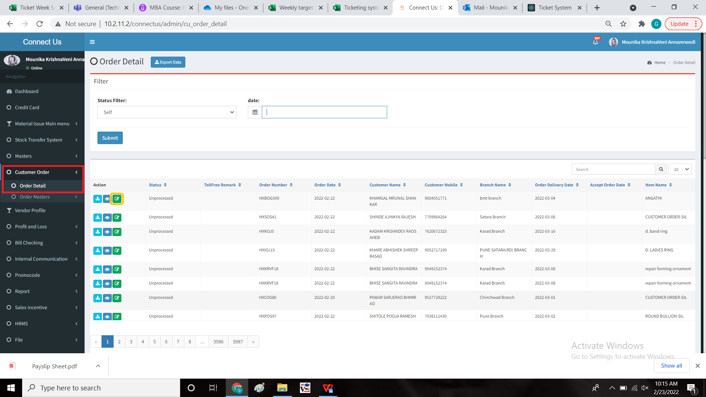



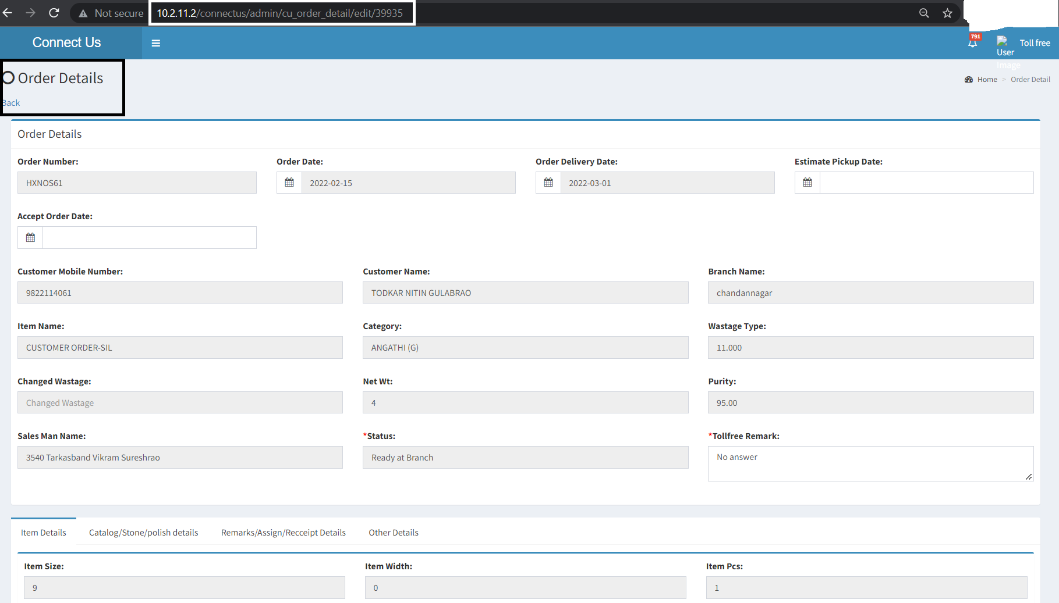

**References of the users**

|  |  |  |  |
| --- | --- | --- | --- |
| **User** | **Name** | **Mail** | **Contact number** |
| **Actual user** | Divya Narayan Danpelli |  |  |
| **Assigned business analyst** | Mounika KrishnaVeni Annamneedi | Mounika.annamneedi@techneai.com | 8669917920 |
| **Assigned developer** |  |  |  |
| **Assigned tester** |  |  |  |