|  |  |
| --- | --- |
| **Ticket ID** | T201213 |
| **Ticket description** | Connectus Madhe Report Name :- 1) User Wise Weight Checking Report 2) Bar-Code Wise Weight Checking Report Ya Don Reprt Wrong Yet Aahe Tya Madhe Changes Karun Dene |
| **Created by** | Tushar Shivaji Nikam |
| **Created on** | 28/02/2022 |
| **Priority** | High |
| **Version** | 0 |

**Version**

|  |  |  |  |  |
| --- | --- | --- | --- | --- |
| **Sr. No** | **Version no** | **Version Date** | **User name** | **User department** |
| 1 | 0 | 16.03.2022 | Tushar Shivaji Nikam | Inventory Silver HO |

**Approvals**

|  |  |  |
| --- | --- | --- |
| **Field** | **Name of the User** | **Approved date by the user** |
| **Actual User Name** | Tushar Shivaji Nikam | 28.02.2022 |
| **Actual User Department** | Inventory Silver HO |  |
| **Organization Name** | C S Jewellers |  |
| **Sign-off** |  |  |
| **Assigned BA** | Mounika KrishnaVeni Annamneedi | 16.03.2022 |
| **Assigned Developer** |  |  |
| **Assigned Tester** |  |  |

**Estimation**

|  |  |  |  |  |
| --- | --- | --- | --- | --- |
| **Department name** | **Estimated Time (In hr)** | **Scheduled Date (Starting date )** | **Estimated date** | **Actual delivery date** |
| **BA** | 3 | 16.03.2022 | 17.03.2022 |  |
| **Development** |  |  |  |  |
| **Testing** |  |  |  |  |

**Existing system**

The exported data in weight checking module menu - user wise weight checking report and bar code wise weight checking report showing the wrong data.

**Proposed system**

Rectification of the errors.

**Step-1**

In Connect US -> Weight checking Module -> User wise weight checking report

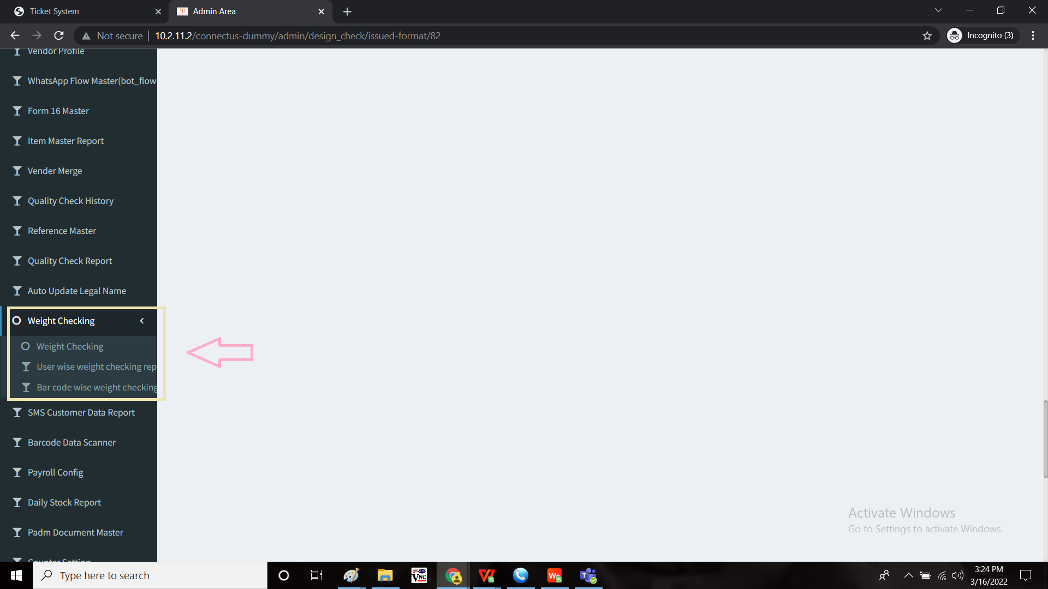

The data or the report displayed and the exported data are different. The exported data to be matched.

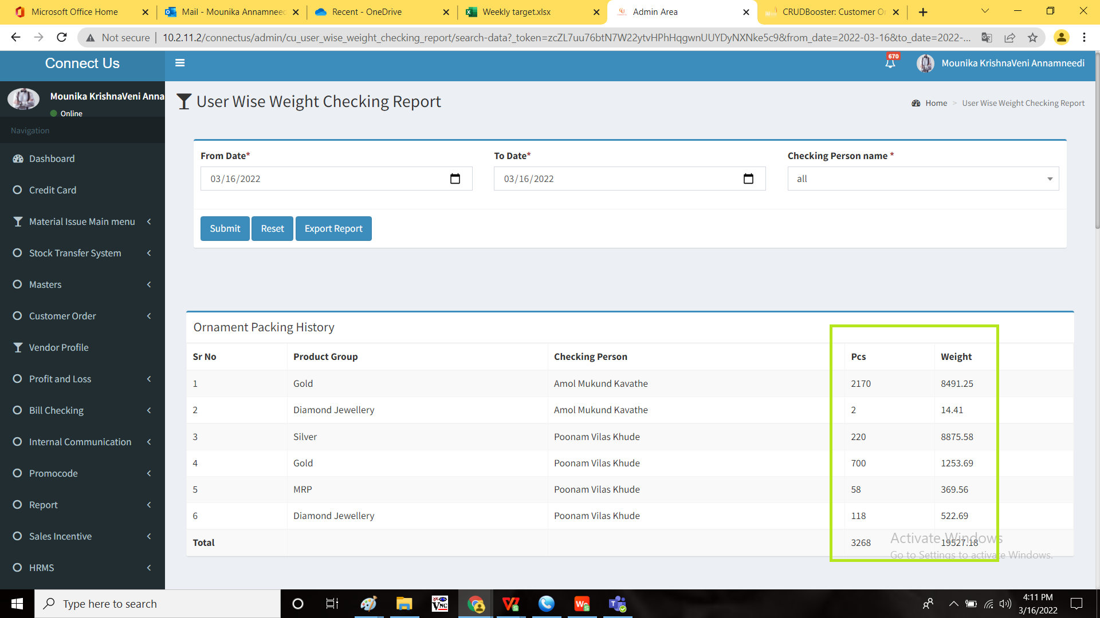

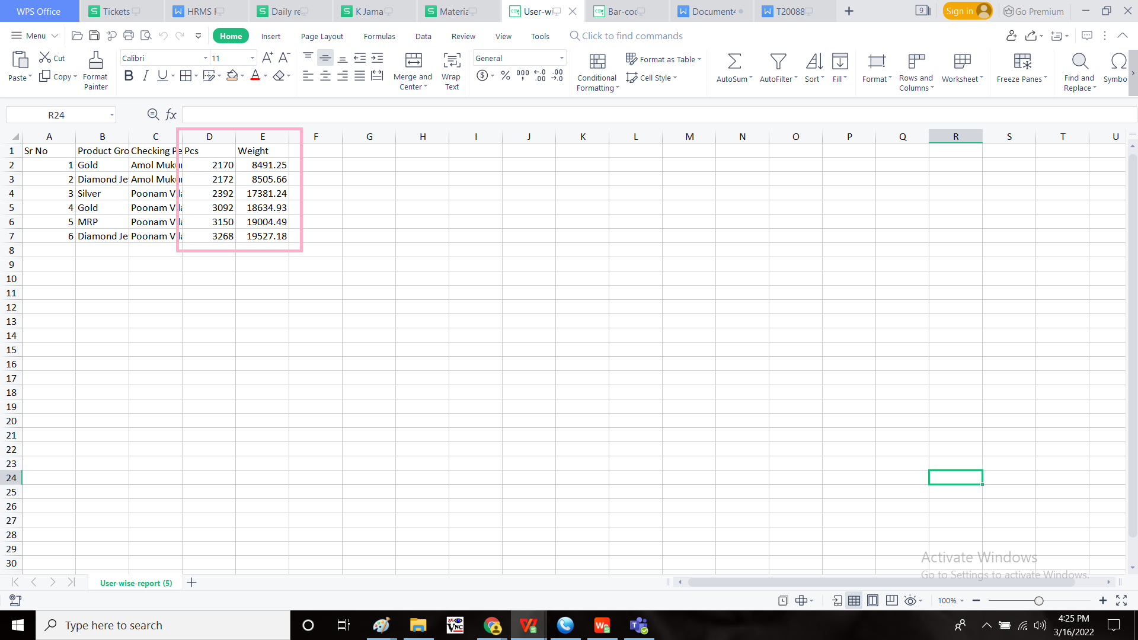

**Step-2**

In Connect US -> Weight checking Module -> Bar code wise weight checking report



The data or the report displayed and the exported data are different. The exported data to be matched.

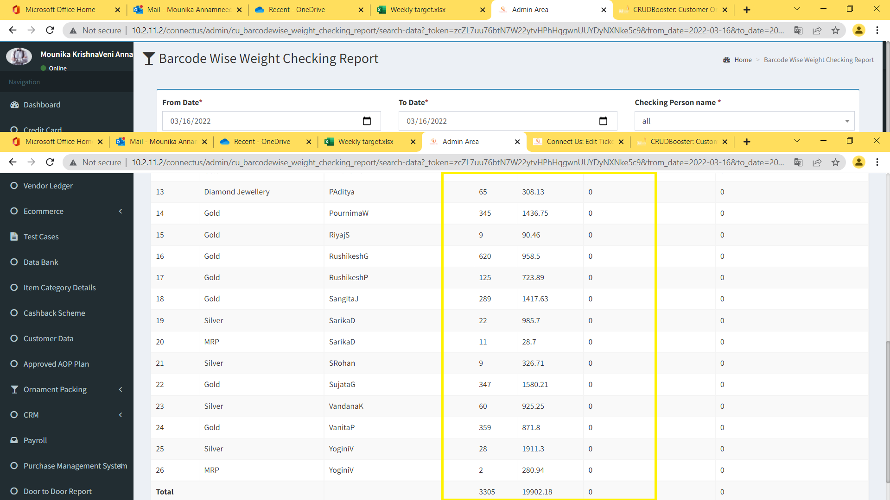

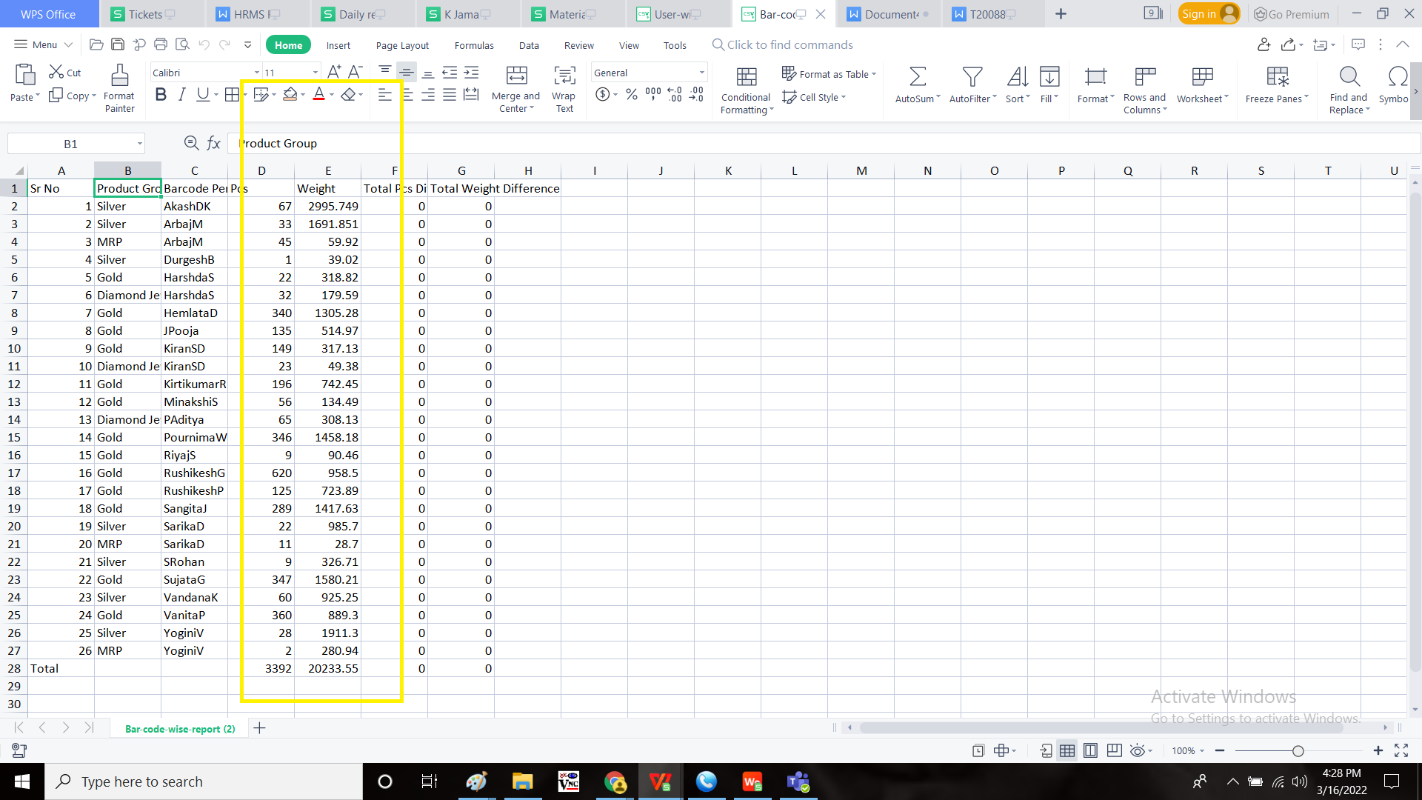

**References of the users**

|  |  |  |  |
| --- | --- | --- | --- |
| **User** | **Name** | **Mail** | **Contact number** |
| **Actual user** | Tushar Shivaji Nikam | designgd@csjewellers.com |  |
| **Assigned business analyst** | Mounika KrishnaVeni Annamneedi | Mounika.annamneedi@techneai.com | 8669917920 |
| **Assigned developer** |  |  |  |
| **Assigned tester** | Monika Kolpe | Monika.kolpe@techneai.com |  |