|  |  |
| --- | --- |
| **Ticket ID** | *T195353* |
| **Ticket description** | *IN-OUT DEPT BMT-HO*  *१ )६ नंबर बॉक्समध्ये जे document no टाकणार आहे ते स्कॅन करून ते document auto पडले पाहिजे .*  *२ ) ८ नंबर बॉक्समध्ये auto box count झाले पाहिजे ( पडले पाहिजे ).*  *३ ) जे document स्कॅन झाले आहे किंवा पडले आहे ते खाली गेले पाहिजे ( ९ नं बॉक्स वर पडला पाहिजे व ७ नं बॉक्स खाली गेला पाहिजे ).*  *४ ) ज्यावेळी Select Type यामध्ये manually select करतो त्यावेळी ADD option असला पाहिजे .*  *५ ) Document ची प्रिंट काढतो त्या प्रिंटवर No Of Box आले पाहिजे .* |
| **Created by** | *Jayant dilip magdum* |
| **Created on** | *07-02-2022* |
| **Priority** | *Very high* |
| **Version** | *0* |

**Version**

|  |  |  |  |  |
| --- | --- | --- | --- | --- |
| **Sr. No** | **Version no** | **Version Date** | **User name** | **User department** |
| 1 | 0 | 07-02-2022 | Jayant dilip magdum | Inventory Silver HO |

**Approvals**

|  |  |  |
| --- | --- | --- |
| **Field** | **Name of the User** | **Approved date by the user** |
| **Actual User Name** | Jayant dilip magdum |  |
| **Actual User Department** | Inventory Silver HO |  |
| **Organization Name** | CSPL |  |
| **Assigned BA** | Akash Rewade |  |
| **Assigned Developer** | Nikhil bhosale |  |
| **Assigned Tester** | Maruti Hakke |  |

**Estimation**

|  |  |  |  |  |
| --- | --- | --- | --- | --- |
| **Department name** | **Estimated Time (In hr)** | **Scheduled Date (Starting date )** | **Estimated date** | **Actual delivery date** |
| **BA** |  |  |  |  |
| **Development** |  |  |  |  |
| **Testing** |  |  |  |  |
|  |  |  |  |  |

**Introduction**

*New Requirement*

**Business requirement**

In connect us-> Stock transfer system user require change in system are

* In stock transfer system when user search with document no in ( From series no ) in Proposed system user want scan document without Add on click button .
* Also
* No box count automatic.
* Series document no in serial wise.

When click on “print document “user want No Box count .

**Abbreviations & terms**

Connect us > CU

Acme > PADM

**Existing system**

* In CU > stock transfer system when user click on select type “AUTO” In present system User must click on “Add” Refer ( Image 1 ) so that Document entry is Generated In stock transfer detail As shown (Refer Image 2 ).

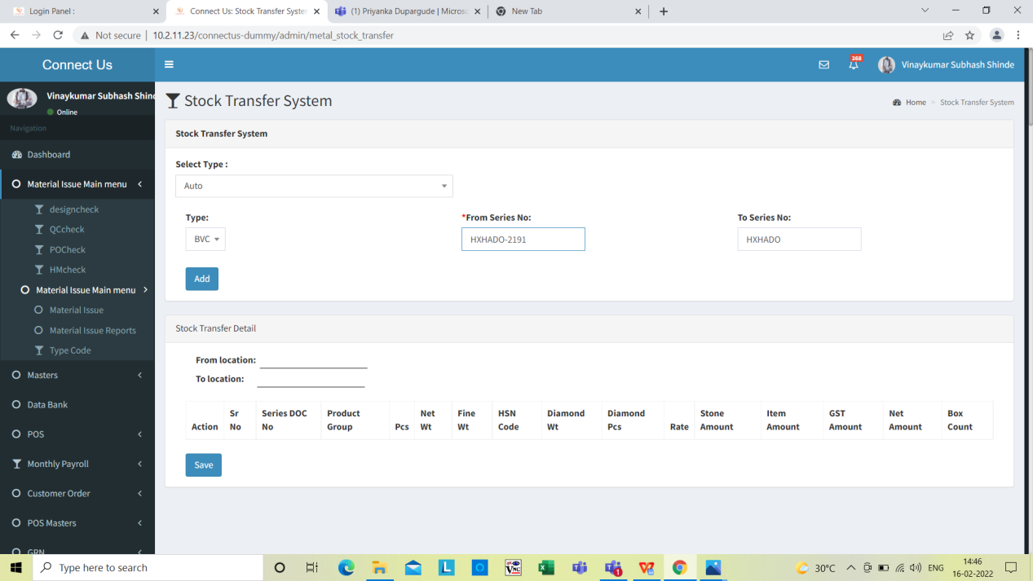

Click on Add

**Image 1**

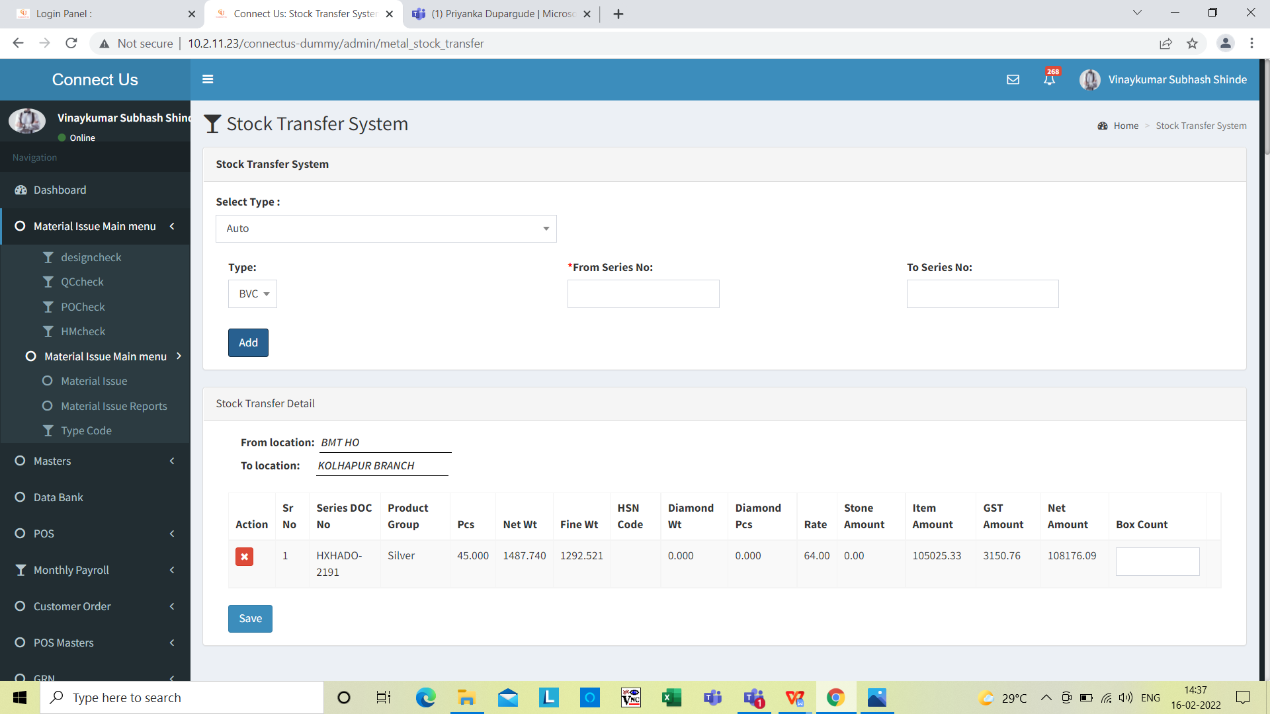

When user click on “ADD” Button eg - barcode- HXHADO -2191 stock transfer Detail entry is generated .

**Image 2**

* In CU > Stock transfer system when user click on select type “AUTO” In present system stock transfer detail “Box count” User do it manually Refer (Image 3)



Box count user fill manual

**Image 3**

* In CU > Stock transfer system when user click on select type “AUTO” In present system stock transfer detail “series doc no” is not Sr no wise (Image 4)

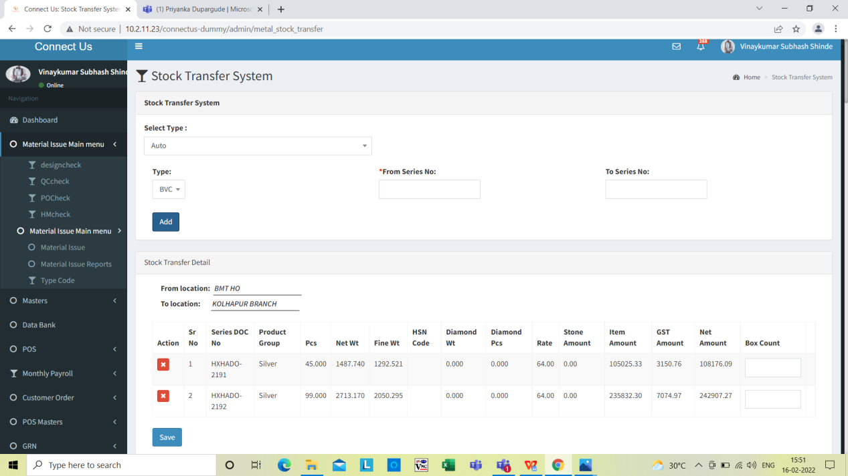

Series Doc no is not serial is not as per serial wise

**Image 4**

* In PADM > Document master >Select Branch HO to Branch transfer Gold > click on “print document In existing system user Don’t have No box count on Print document Refer ( Image5 )

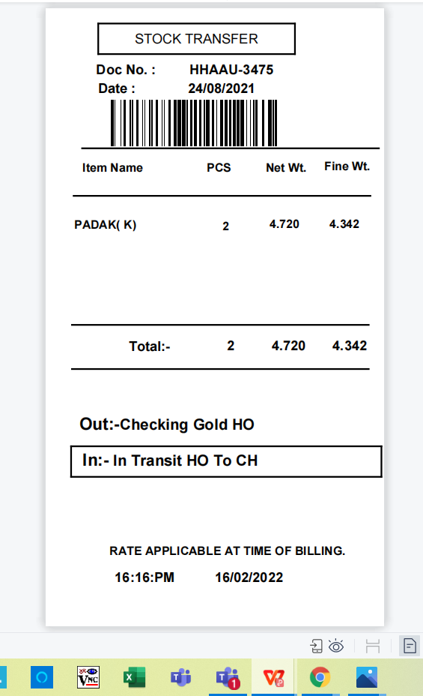

When user click on print Box count is not showing in Existing stock transfer on Print

**Image 5**

**Proposed system**

*Enter the process overview step-by-step in detail.*

**Input table**

|  |  |  |  |  |
| --- | --- | --- | --- | --- |
| **FIELDS** | **INPUT TYPE** | **MANDATORY/ OPTIONAL** | **DESCRIPTION** | **CONDITIONS IF ANY** |
|  |  |  |  |  |
|  |  |  |  |  |
|  |  |  |  |  |

**References of the users**

|  |  |  |  |
| --- | --- | --- | --- |
| **User** | **Name** | **Mail** | **Contact number** |
| **Actual user** |  |  |  |
| **Ticket created by (if any)** |  |  |  |
| **Assigned business analyst** |  |  |  |
| **Assigned developer** |  |  |  |
| **Assigned tester** |  |  |  |