|  |  |
| --- | --- |
| **Ticket ID** | *T184215* |
| **Ticket description** | *User need to add new columns in B2B --> Order Management --> Order Place Report* |
| **Created by** | *Sandeep Avchitte* |
| **Created on** | *13/01/2022* |
| **Priority** | *Very High* |
| **Version** | *0* |

**Version**

|  |  |  |  |  |
| --- | --- | --- | --- | --- |
| **Sr. No** | **Version no** | **Version Date** | **User name** | **User department** |
| *1* | *0* | *13/01/2022* | *Tushar Nikam* | *Inventory Silver HO* |

**Approvals**

|  |  |  |
| --- | --- | --- |
| **Field** | **Name of the User** | **Approved date by the user** |
| **Actual User Name** | *Tushar Nikam* |  |
| **Actual User Department** | *Inventory Silver HO* |  |
| **Organization Name** | *CSPL* |  |
| **Assigned BA** | *Sandeep Avchitte* |  |
| **Assigned Developer** | *Baliram Rajwad* |  |
| **Assigned Tester** | *Maruti Hakke* |  |

**Estimation**

|  |  |  |  |  |
| --- | --- | --- | --- | --- |
| **Department name** | **Estimated Time (In hr)** | **Scheduled Date (Starting date )** | **Estimated date** | **Actual delivery date** |
| **BA** |  |  |  |  |
| **Development** |  |  |  |  |
| **Testing** |  |  |  |  |

**Introduction**

*User needs to add new columns in B2B --> Order Management --> Order Place Report.*

**Business requirement**

*User needs to add new columns in B2B --> Order Management --> Order Place Report.*

**Abbreviations & terms**

*B2B - Branch to Branch.*

**Existing system**

*Currently there are no such columns present in the B2B --> Order Management --> Order Place Report.*

**Proposed system**

*User needs to add new columns named Item Name, Gross Weight, Net Weight, and Diamond Carat Weight in B2B --> Order Management --> Order Place Report as shown in the below image.*

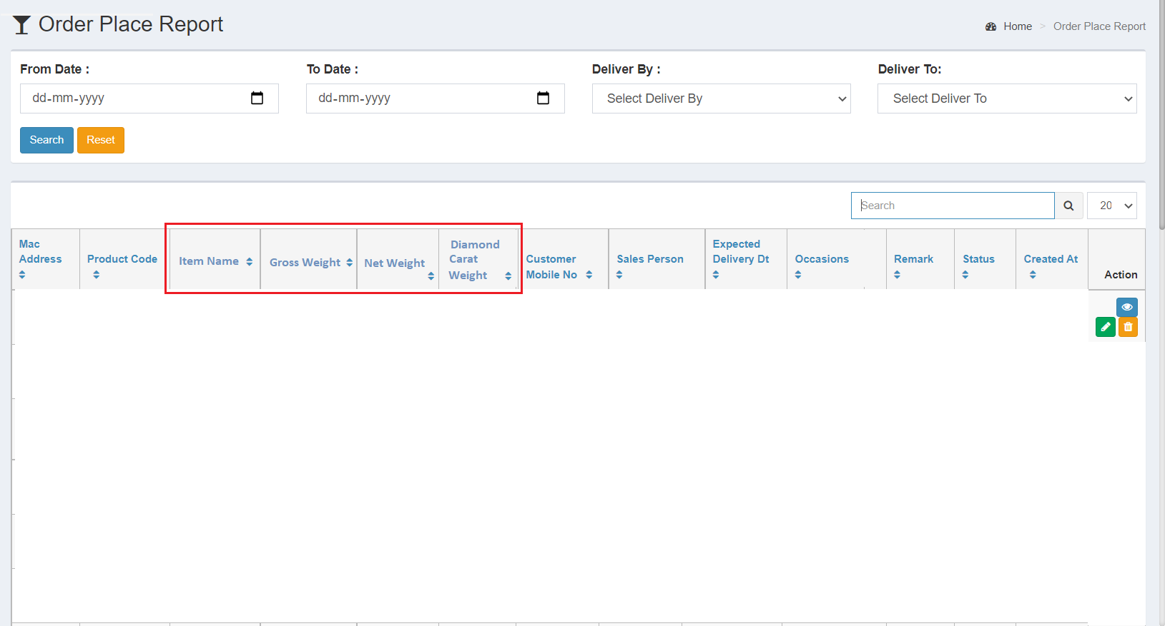

*Image 1: New Column Addition*

*Here,* *Item Name, Gross Weight, Net Weight, and Diamond Carat Weight’s data should be fetch from Padm ERP Software Application according to barcode/product code.*

* ***Action***

***View*** *- In this, User should be able to view the details for these new added field.*

***Edit*** *- In this, These newly added column details should be disable that means user should not be able to edit these these details and remaining functionality should be same.*

***Delete*** *- In this, Record should be deleted when click on delete button.*

**References of the users**

|  |  |  |  |
| --- | --- | --- | --- |
| **User** | **Name** | **Mail** | **Contact number** |
| **Actual user** | *Tushar Nikam* | *[designgd@csjewellers.com](mailto:designgd@csjewellers.com)* | *2544* |
| **Assigned business analyst** | *Sandeep Avchitte* | *Sandeep.avchitte@techneai.com* | *2965* |
| **Assigned developer** | *Baliram Rajwad* | *[Baliram.rajwad@techneai.com](mailto:Baliram.rajwad@techneai.com)* | *2965* |
| **Assigned tester** | *Maruti Hakke* | *[Maruti.hakke@techneai.com](mailto:Maruti.hakke@techneai.com)* | *2965* |