|  |  |
| --- | --- |
| **Ticket ID** | T201590 |
| **Ticket description** | 7350250000 hya number var whatsapp sathi new tab banavane.  * Them/Offer - Attached Offer whatsapp Creative  * Monthly Scheme - Scheme T&C, enrollment, Payment  * Store Location - Go to Store locaters website page  * Toll free - If any other Details to call 18002670999 |
| **Created by** | Vishal Shantinath Patil |
| **Created on** | 28/02/2022 |
| **Priority** | High |
| **Version** | 1 |

**Version**

|  |  |  |  |  |
| --- | --- | --- | --- | --- |
| **Sr. No** | **Version no** | **Version Date** | **User name** | **User department** |
| 1 | 0 | 23.03.2022 | Vishal Shantinath Patil | Branch Operation Control |
| 2 | 1 | 26.05.2022 | Vishal Shantinath Patil | Branch Operation Control |

**Approvals**

|  |  |  |
| --- | --- | --- |
| **Field** | **Name of the User** | **Approved date by the user** |
| **Actual User Name** | Vishal Shantinath Patil | 28.02.2022 |
| **Actual User Department** | Vishal Shantinath Patil |  |
| **Organization Name** | CS Jewellers |  |
| **Sign-off** |  |  |
| **Assigned BA** | Mounika KrishnaVeni Annamneedi | 23.03.2022 |
| **Assigned Developer** |  |  |
| **Assigned Tester** |  |  |

**Estimation**

|  |  |  |  |  |
| --- | --- | --- | --- | --- |
| **Department name** | **Estimated Time (In hr)** | **Scheduled Date (Starting date )** | **Estimated date** | **Actual delivery date** |
| **BA** | 3 | 23.03.2022 | 24.03.2022 |  |
| **Development** |  |  |  |  |
| **Testing** |  |  |  |  |

**Introduction**

Whatsapp application is used for CSPL promotions and information for easy access for the users.

**Business requirement**

The user want to add few more options in the whatsapp application.

**Existing system**

The existed system is having only 5 options as of now.

1. Last transaction
2. Current rate
3. Latest e-catalogue
4. Download mobile app
5. Change language

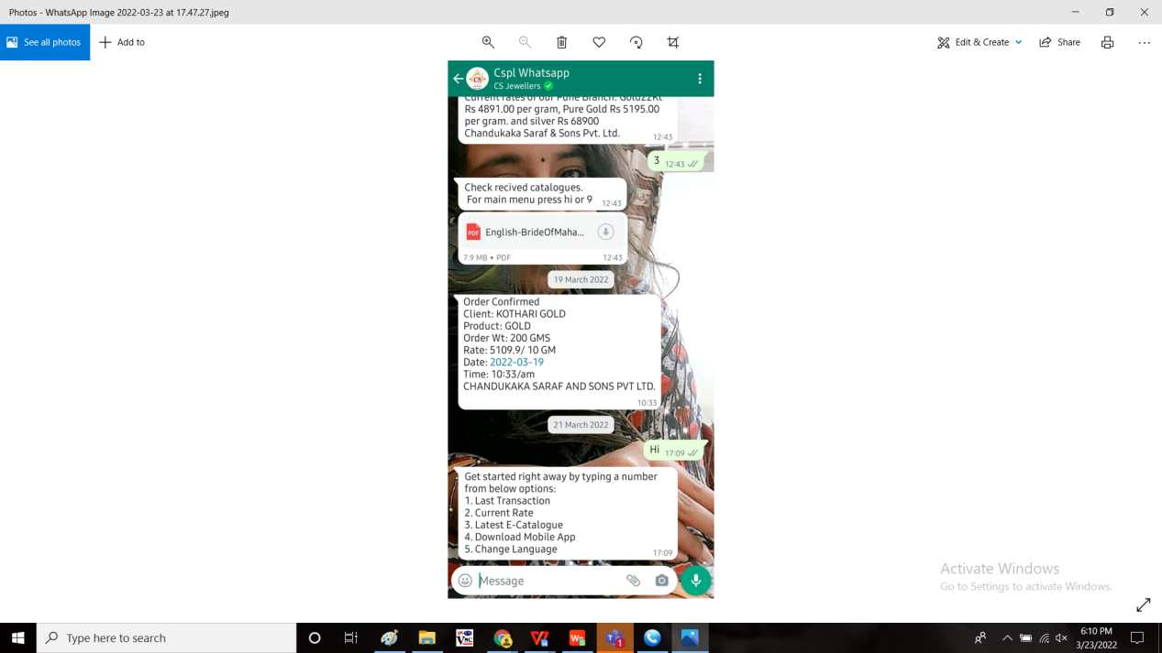

**Proposed system**

* Introduction of few more options in the Whatsapp application

1. Theme/offer
2. Monthly scheme
3. Store location
4. Toll free

OUTPUT:

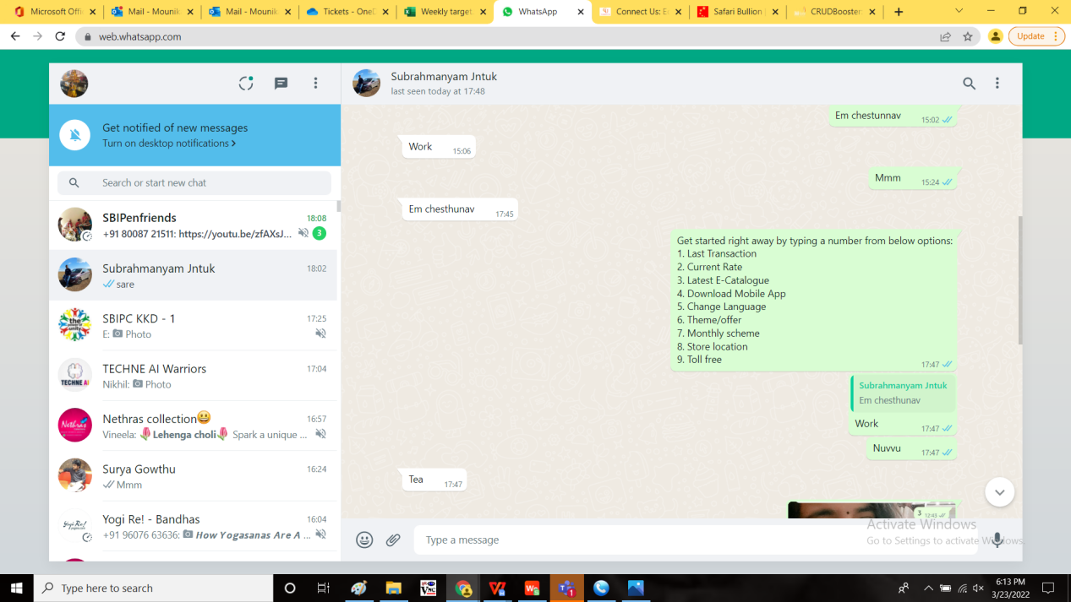

|  |  |
| --- | --- |
| **OPTION** | **DESCRIPTION** |
| Theme/ offer | Attached offer whatsapp creative |
| Monthly scheme | Scheme T&C, Enrollment and Payment |
| Store location | Go to store locators website |
| Toll free | If any other details, call to 18002670999 |

Step 1:

Theme/ offer:

A link is displayed to the customer when they enter “6”. So that the customer can know the current offer.

Provision to the user to update the link according to the offer.

Step 2:

Monthly scheme:

When the customer enters the number “7”, the following message displays. The monthly scheme consists of 3 links.

Scheme terms & conditions and enrollment link and payment link.

Links are below:

|  |
| --- |
| Scheme T&C:  Kalpataru scheme:  <https://www.csjewellers.com/static/cspljewels/images/Kalpataru-scheme-T&C.pdf>  GTS:  <https://www.csjewellers.com/static/cspljewels/images/Gold-Tree-Plus-Scheme-T&C.pdf>  Enrollment & Payment:  <https://www.csjewellers.com/schemes> |

When the customer clicks on the link, it should automatically redirects to that page.

Step 3:

Store location:

The link that navigates to store locations page is displayed when the customer enters the number “8”. The following message is shown.

|  |
| --- |
| Store locations  https://www.csjewellers.com/storelocate |

When the customer clicks on the link, it should automatically redirects to that page.

Step 4:

Toll free :

The toll free number is displayed when the customer enters the number “9”. The following message is shown.

|  |
| --- |
| Toll free  18002670999 |

When the customer clicks on the toll free number. It should automatically reload to their calling application with the number.

**References of the users**

|  |  |  |  |
| --- | --- | --- | --- |
| **User** | **Name** | **Mail** | **Contact number** |
| **Actual user** | Vishal Shantinath Patil |  |  |
| **Assigned business analyst** | Mounika KrishnaVeni Annamneedi | Mounika.annamneedi@techneai.com | 9885900039 |
| **Assigned developer** |  |  |  |
| **Assigned tester** | Monika Kolpe | Monika.kolpe@techneai.com |  |