|  |  |
| --- | --- |
| **Ticket ID** | TT2567 |
| **Ticket description** | In CU - > bill checking want to add electricity bills. |
| **Created by** | Harshali Rananaware |
| **Created on** | 30 May 2022 |
| **Priority** | Very high |
| **Version** | 1 |

**Version**

|  |  |  |  |  |
| --- | --- | --- | --- | --- |
| **Sr. No** | **Version no** | **Version Date** | **User name** | **User department** |
| 1 | 1 | 30 May 2022 | Pritam Metha |  |

**Approvals**

|  |  |  |
| --- | --- | --- |
| **Field** | **Name of the User** | **Approved date by the user** |
| **Actual User Name** | Pritam Metha |  |
| **Actual User Department** |  |  |
| **Organization Name** | CSPL |  |
| **Assigned BA** | Harshali Rananaware |  |
| **Assigned Developer** |  |  |
| **Assigned Tester** |  |  |

**Estimation**

|  |  |  |  |  |
| --- | --- | --- | --- | --- |
| **Department name** | **Estimated Time (In hr)** | **Scheduled Date (Starting date )** | **Estimated date** | **Actual delivery date** |
| **BA** |  |  |  |  |
| **Development** |  |  |  |  |
| **Testing** |  |  |  |  |

**Business requirement**

In CU - > bill checking want to add electricity bills.

**Abbreviations & terms :**

Connect us - CU

**Proposed System :**

In CU -> BC -> Bill payments -> download payment. In bill payment add two option download payment and auto update payment.

**1) download payment** - Click on download payment then enter till date then bill type lights bills and telephone bills show ( Refer Img 2 ) . Click on download payment list then file download in text format ( Refer Img 3 ) same as IMPS payment file. Acme balance and payment amount is difference then show in different color. After download file then point status auto change “ confirmation pending ”.

**2) Auto update payment** - Receive bank file then the user can upload this file by using “ auto update payment ” ( Refer Img 4 ) . The user can add text file and after click on update button then and upload successfully. Point status auto update paid. If any issue from bank side then status is bank reject. Give cancel option. Click on cancel then the show mail window ( Refer Img 1 ). “ Auto update payment ” Auto update in padm bank payment HO.

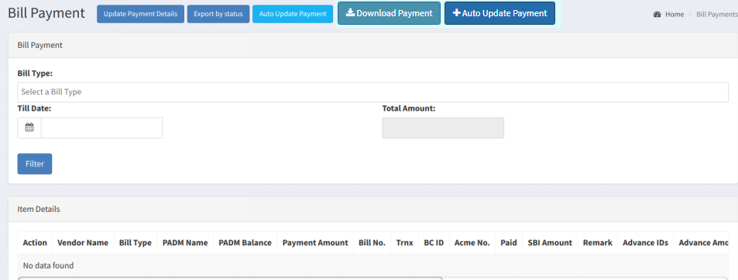

Img 1

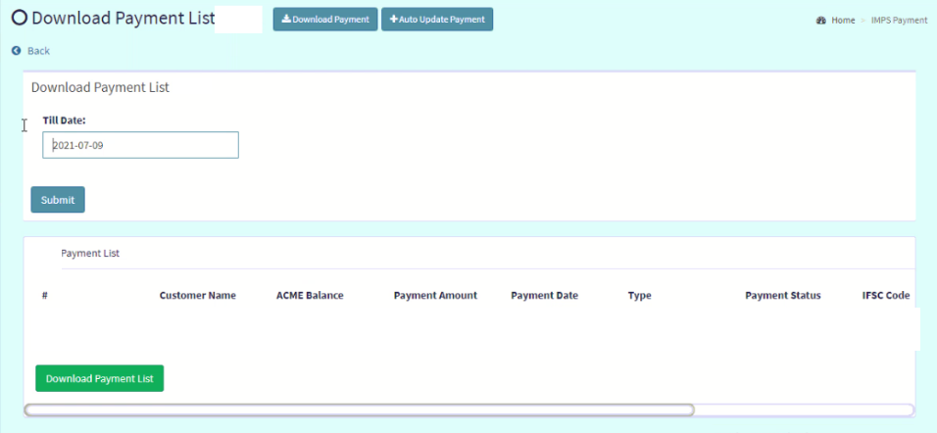

Img 2

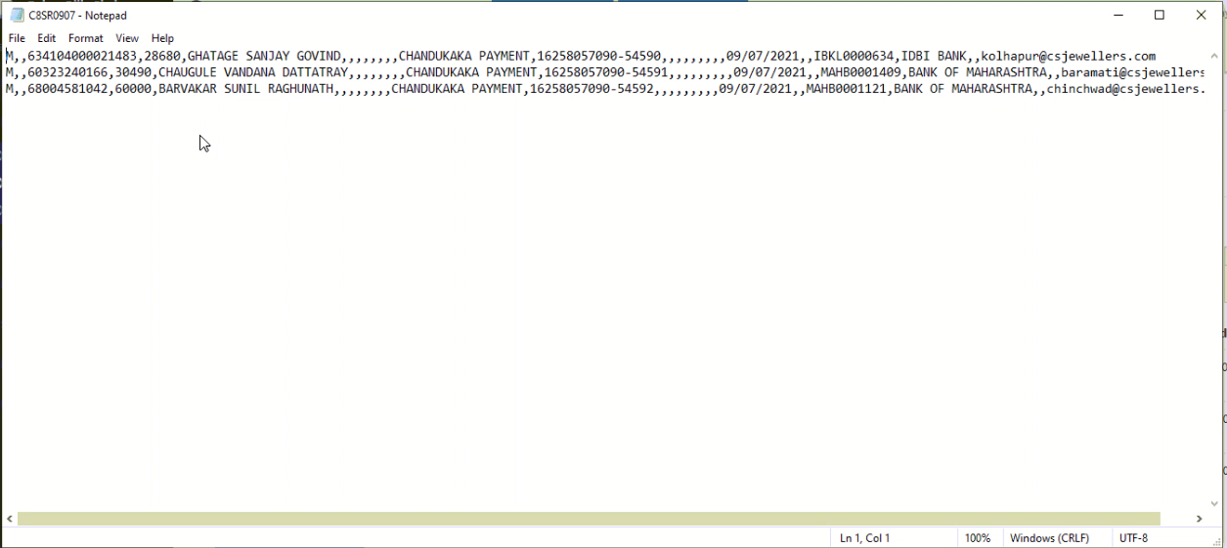

Img 3

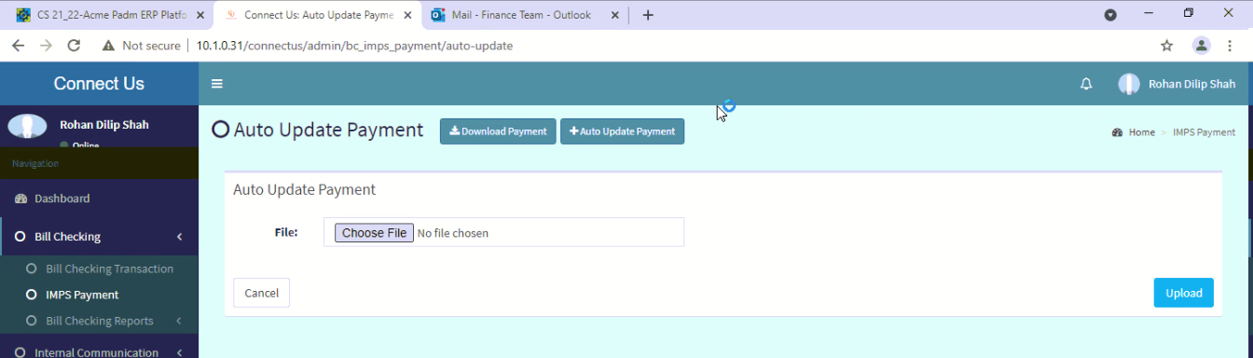

Img 4

In CU -> bill checking -> bill checking master -> vendor master Beneficiary name , account no , bank name and IFSC code is mandatory. These four fields fetch from vendor master.

All transaction transaction type is NEFT.

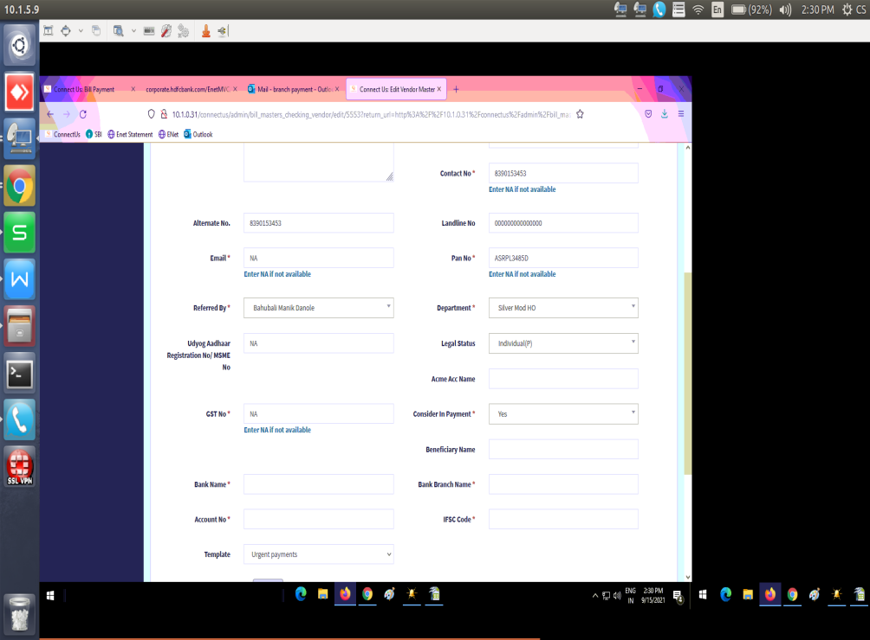

Img 5

we select light bill then “branch” column show.

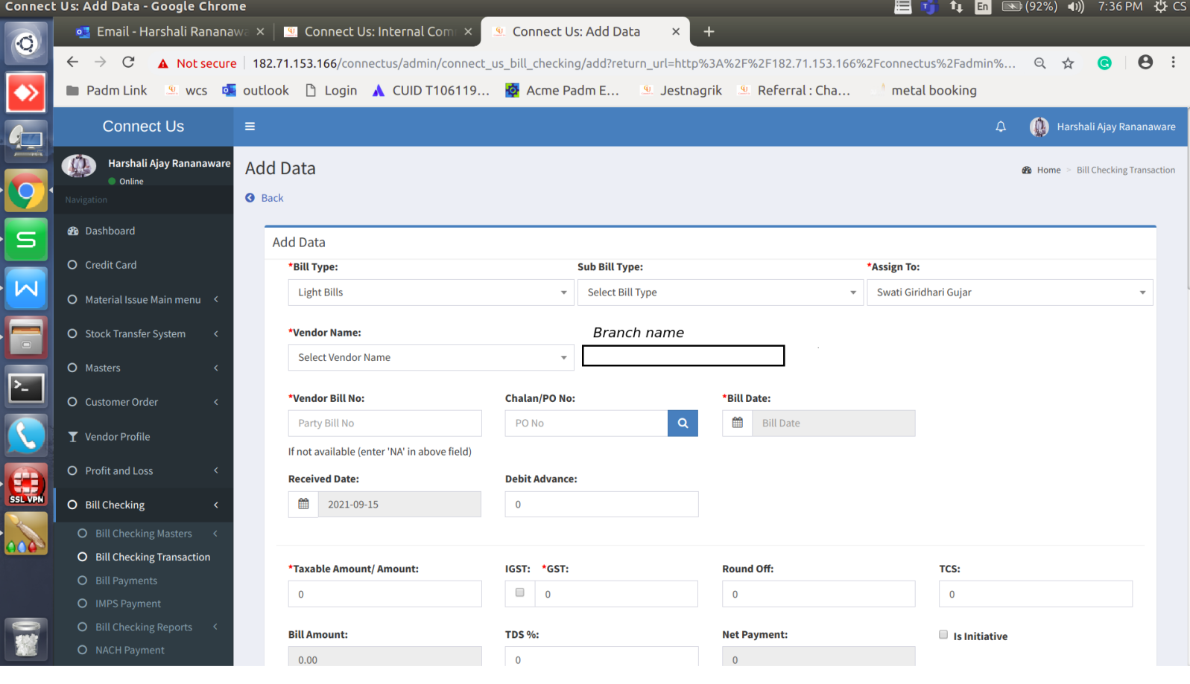

Img 6

**Flowchart :**

Stop

Change bill checking status

Update payment in bank

Generate text file

Download payment

CU -> BC -> bill checking transaction

Log

in

F

T

Start

Enter correct user name and password

T

F