|  |  |
| --- | --- |
| **Ticket ID** | T216236/TT2433 |
| **Ticket description** | In CU Employee Target will update or change by Authority base person, between 1st to 5th of every month only. Then after it will be can't change by any branch person, & if any case, require to change any Emp target then, only change by Backend authority after sending point by branch. |
| **Created by** | Harshali Rananaware |
| **Created on** | 26 May 2022 |
| **Priority** | Very high |
| **Version** | 1 |

**Version**

|  |  |  |  |  |
| --- | --- | --- | --- | --- |
| **Sr. No** | **Version no** | **Version Date** | **User name** | **User department** |
| 1 | 1 | 26 May 2022 | Dinesh Bhagyawan Sonawane | Accounting Department |

**Approvals**

|  |  |  |
| --- | --- | --- |
| **Field** | **Name of the User** | **Approved date by the user** |
| **Actual User Name** | Dinesh Bhagyawan Sonawane |  |
| **Actual User Department** | Accounting Department |  |
| **Organization Name** | CSPL |  |
| **Assigned BA** | Harshali Rananaware |  |
| **Assigned Developer** |  |  |
| **Assigned Tester** |  |  |

**Estimation**

|  |  |  |  |  |
| --- | --- | --- | --- | --- |
| **Department name** | **Estimated Time (In hr)** | **Scheduled Date (Starting date )** | **Estimated date** | **Actual delivery date** |
| **BA** |  |  |  |  |
| **Development** |  |  |  |  |
| **Testing** |  |  |  |  |

**Business requirement**

In CU Employee Target will update or change by Authority base person, between 1st to 5th of every month only. Then after it will be can't change by any branch person, & if any case, require to change any Emp target then, only change by Backend authority after sending point by branch.

**Abbreviations & terms :**

Connect us - CU

**Proposed System :**

In CU -> Sales transaction -> period target (Refer Image 1) select the particulate period and generate the report.

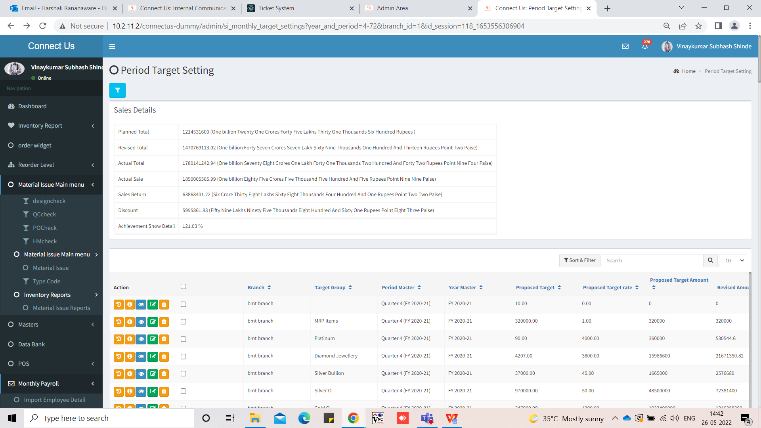

Image 1

In CU -> Sales transaction -> period target after generating report select “counterwise target”.

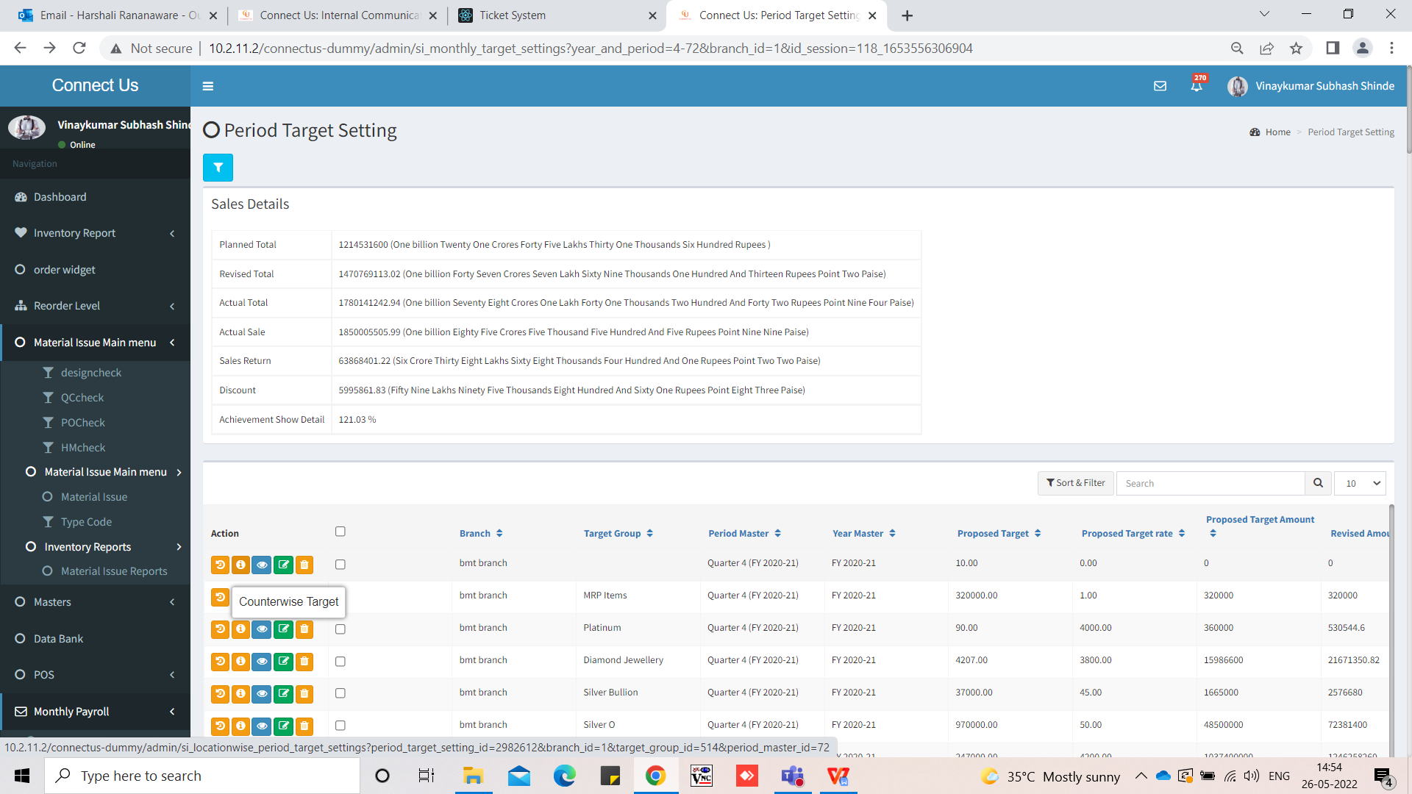

Image 2

In CU -> Sales transaction -> period target after generating report select “counterwise target” then here we want new functionality to add target 1st to 5th for each month authority base .

Back office user want to add target any time.

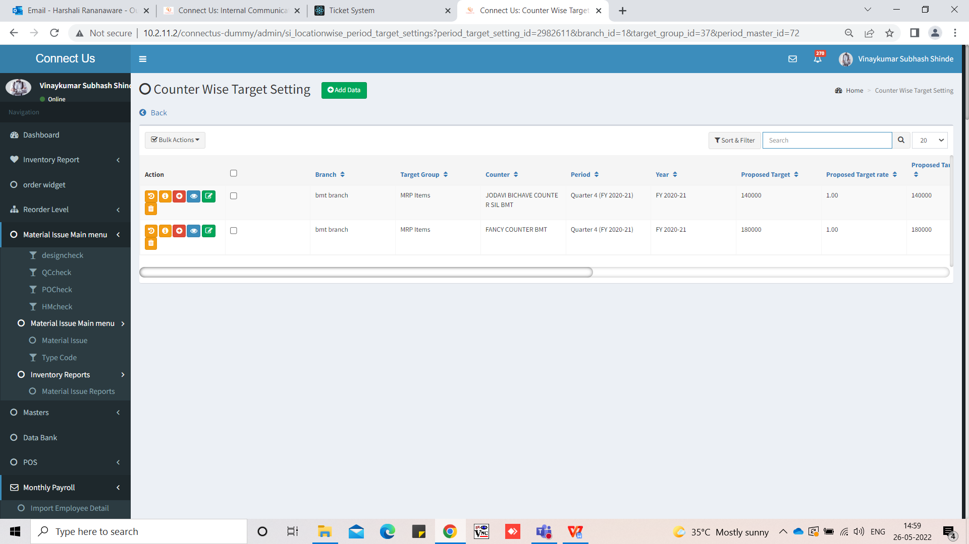

Image 3

“Regenerate Emp Target” want to authority base for users.

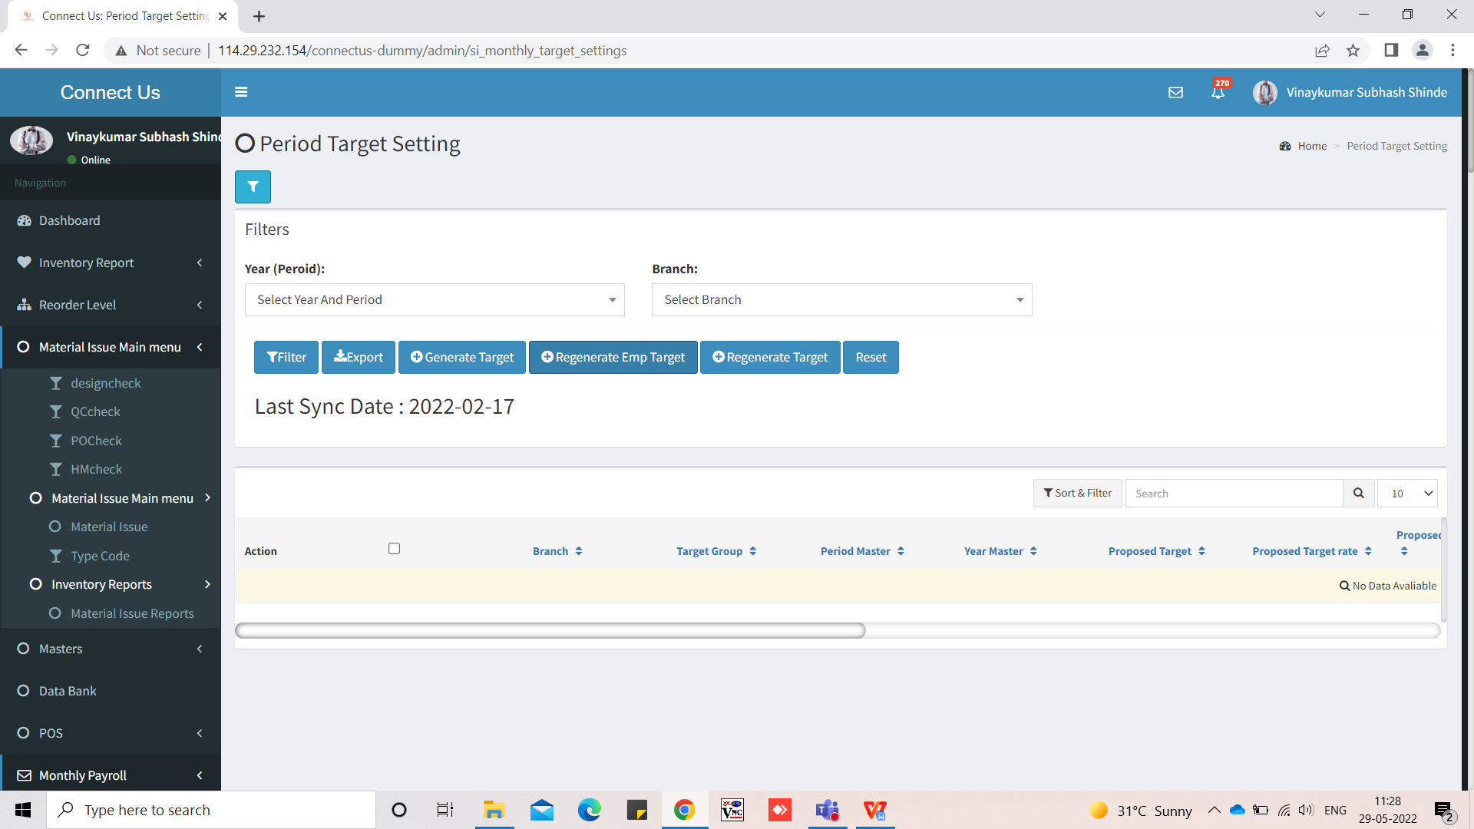

Image 4

**References of the users**

|  |  |  |  |
| --- | --- | --- | --- |
| **User** | **Name** | **Mail** | **Contact number** |
| **Actual user** | Dinesh Sonawane | hoaccountcc@csjewellers.com | 2931 |
| **Assigned business analyst** | Harshali Rananaware | [harshali.rananaware@techneai.com](mailto:harshali.rananaware@techneai.com) | 8669917920 |
| **Assigned developer** | Parth Patel | [parth.patel@techneai.com](mailto:parth.patel@techneai.com) |  |