|  |  |
| --- | --- |
| **Ticket ID** | T615 |
| **Ticket description** | *Description: In AOP require new AOP plan (budgeting) month wise, location and department wise, fulfill online through department and its hit to AOP as per period master and distribute to branch as per sales ratio*  *In Plan two type requirement Revenue expenses (Opex)and Capital expenses (Capex). In Opex and Capex two different type are their 1- Regular and 2. Innitative planning I attach sheet for reference Budget start for FY 19-20 from Jan-19* |
| **Created by** | *Harshali Rananaware* |
| **Created on** | 20 Dec 2021 |
| **Priority** | *Very high* |
| **Version** | *0* |

**Version**

|  |  |  |  |  |
| --- | --- | --- | --- | --- |
| **Sr. No** | **Version no** | **Version Date** | **User name** | **User department** |
| 1 | 0 | 20 Dec 2021 | Dinesh Bhagyawan Sonawane | Accounting Department |

**Approvals**

|  |  |  |
| --- | --- | --- |
| **Field** | **Name of the User** | **Approved date by the user** |
| **Actual User Name** | Dinesh Bhagyawan Sonawane |  |
| **Actual User Department** | Accounting Department |  |
| **Organization Name** | CSPL |  |
| **Assigned BA** | *Harshali Rananaware* |  |
| **Assigned Developer** |  |  |
| **Assigned Tester** |  |  |

**Estimation**

|  |  |  |  |  |
| --- | --- | --- | --- | --- |
| **Department name** | **Estimated Time (In hr)** | **Scheduled Date (Starting date )** | **Estimated date** | **Actual delivery date** |
| **BA** |  |  |  |  |
| **Development** |  |  |  |  |
| **Testing** |  |  |  |  |

**Business requirement**

*Description: In AOP require new AOP plan (budgeting) month wise, location and department wise, fulfill online through department and its hit to AOP as per period master and distribute to branch as per sales ratio*

*In Plan two type requirement Revenue expenses (Opex)and Capital expenses (Capex). In Opex and Capex two different type are their 1- Regular and 2. Innitative planning I attach sheet for reference Budget start for FY 19-20 from Jan-19*

**Abbreviations & terms**

Connect us - CU

**Existing system**

1) Profit and Loss-> Profit and Loss -> Edit (Image 2) head then “department” and “approving user”. In department we select perticuler department then only this head should be allocate to this perticuler user for adding plane (Image 3).

**For example** we edit “SALES JEWELLERY” and add “department - accounting” then we open this user login then this user show SALES JEWELLERY.

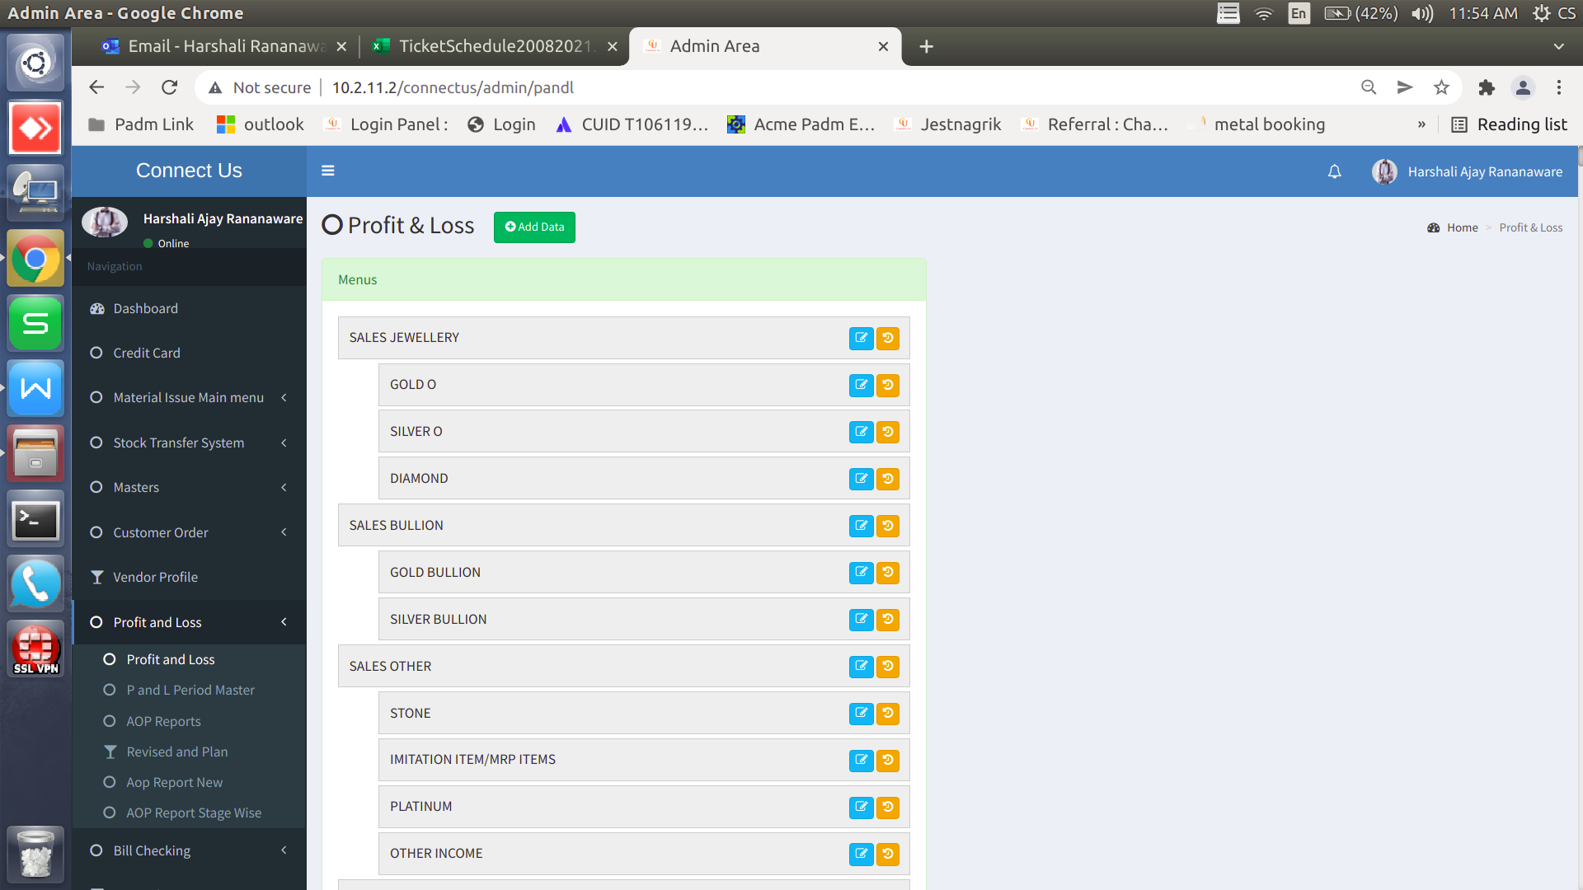

Click here to show image 2

Image 1

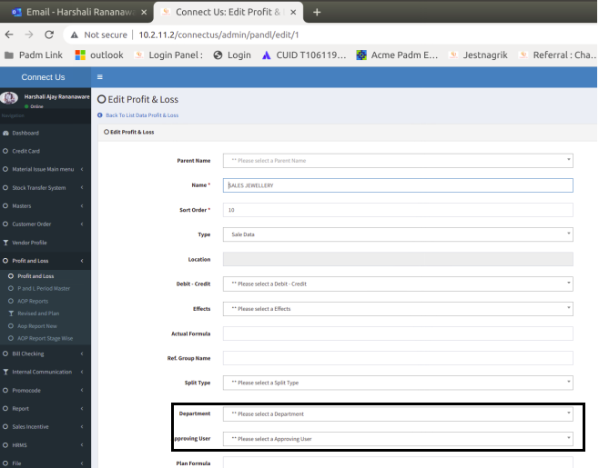

Image 2

1. Now we add plan for peritculer period then need to generate the AOP.

3) Profit and Loss -> Revised and Plan -> select period and submit then add amount branchwise for head. Management reject the plan then now this plan should not be editable to the user.

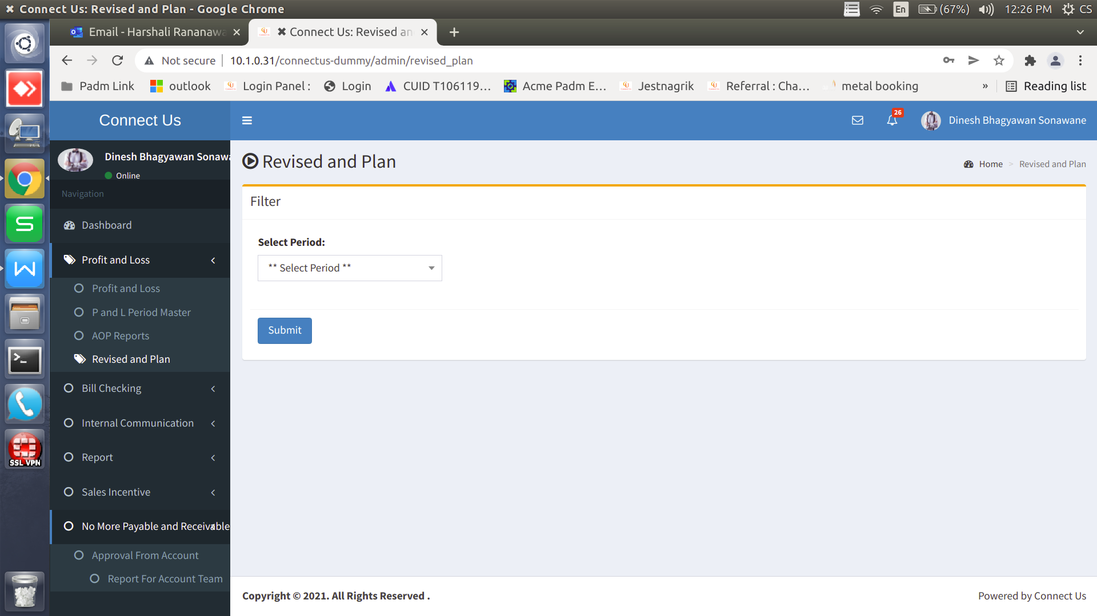

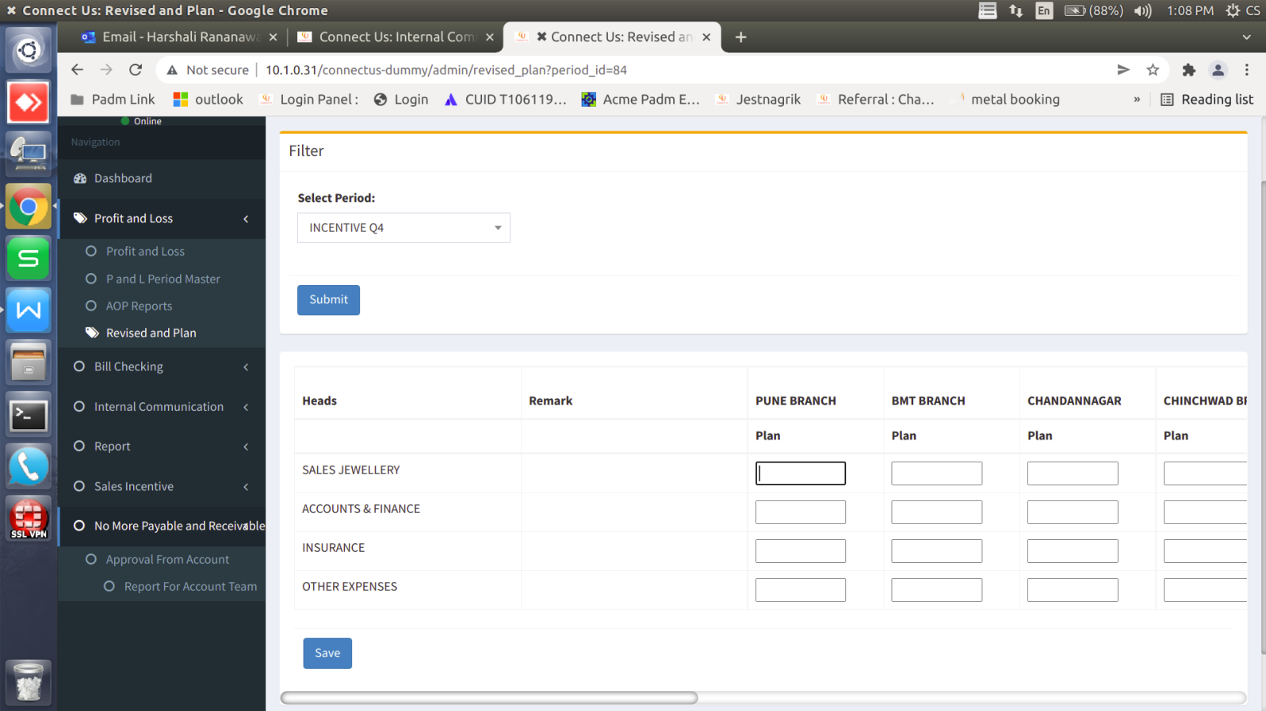

1. Profit and Loss -> Approve AOP Plan -> in this menu want when we approve head then sub head should be approve and also want add remark. “Remark” field is mandtory.
2. Profit and Loss -> Profit and Loss when we edit head then department is “**account department**” then enable corporate office and disable all branch. User can add plane for corporate and this plne is distrubute auto all branch wise. In sales incentive -> sales transaction -> period master -> generate report their is add the sales ratio. As per sales ration distribute as per branch.

**Proposed System :**

1) Profit and Loss-> Profit and Loss -> Edit (Image 2) head then “department” and “approving user”. In department we select perticuler department then all sub-head should be allocate to this perticuler user for adding plane (Image 3).



Click here to show image 2

Image 1



Image 2

Profit and Loss -> Revised and Plan -> select period and submit.(Image 3)

**For example** we edit “SALES JEWELLERY” and add “department - accounting” then we open this user login then this user show SALES JEWELLERY GOLD O , SILVER O and DIAMOND. User add plane for GOLD O , SILVER O and DIAMOND.

This all group total show in “SALES JEWELLERY”, here this filed is diasble user not add the amount in head sestion if sub head is present. In head sub head is not added then we can able to enter the amount in head.



Image 3

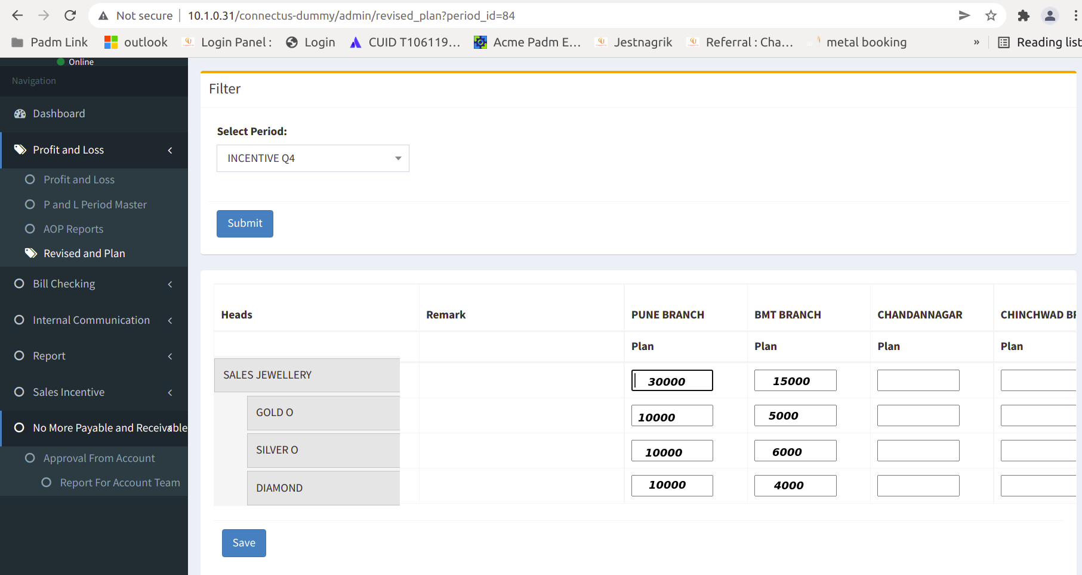

Image 4

1. Now we add plan for peritculer period then user no need to generate the AOP.
2. Profit and Loss -> Revised and Plan -> select period and submit. Add amount branchwise for sub-head. Management reject the plan then this plan should be editable to the user. If plan is approve then the plan is not editable. If user want to revise the amount then user add amount in revise column.



Image 5



Image 6

1. In connect us “Approved AOP Plan” in this menu select period and generate report.

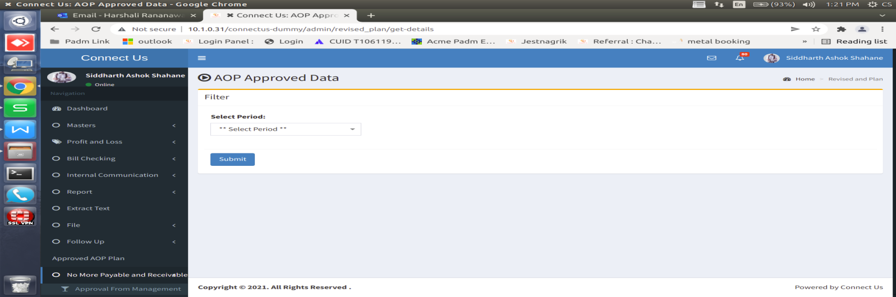

Image 7

User select the head then sub head and click on approve or reject button and auto approve or reject head and also want add remark. “Remark” field is mandtory.

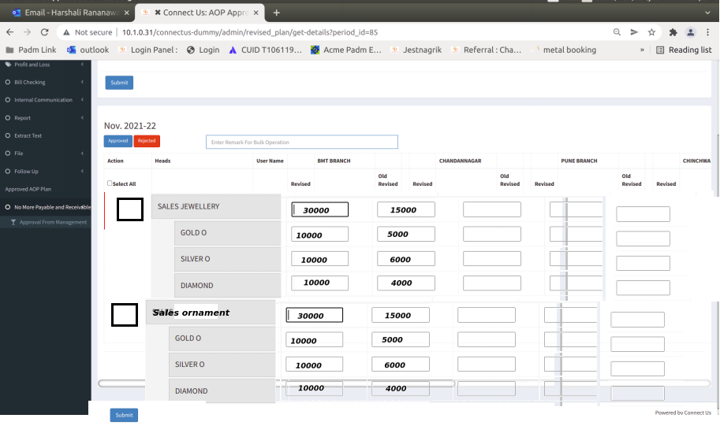

Image 8

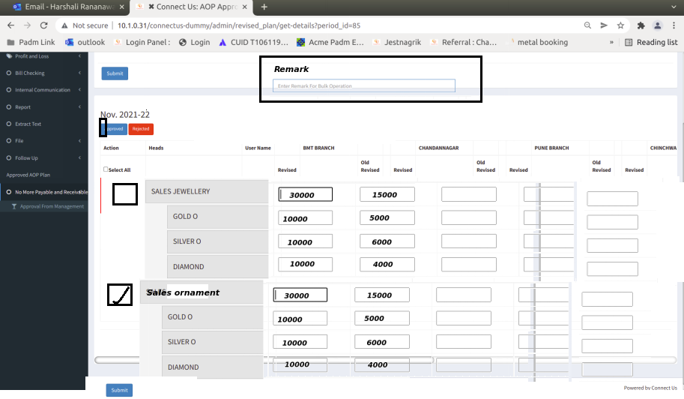

Image 9

1. Profit and Loss -> Profit and Loss when we edit head then department is “**account department**” then enable corporate office and disable all branch. User can add plane for corporate and this plne is distrubute auto all branch wise. In sales incentive -> sales transaction -> period master -> generate report their is add the sales ratio. As per sales ration distribute as per branch.

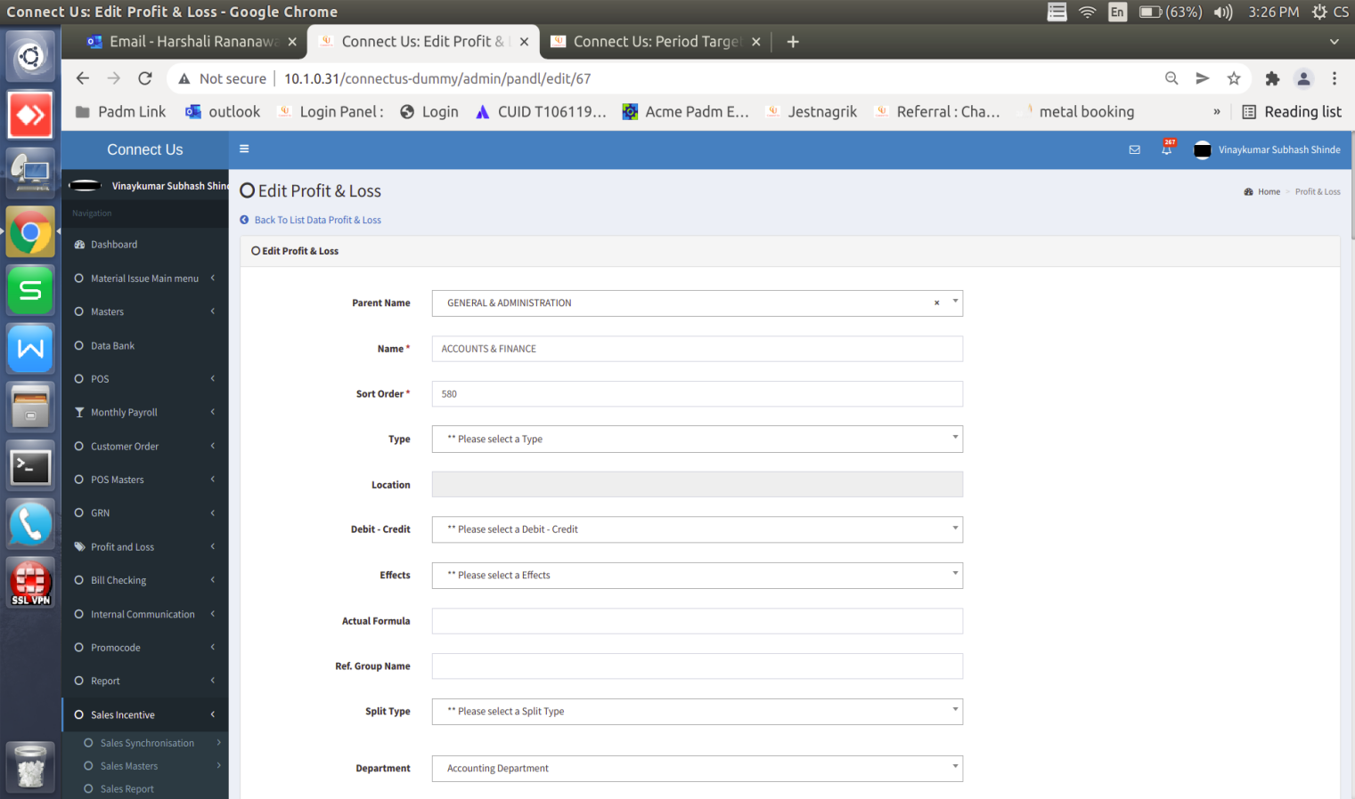

Image 10

propose target amount is cosider as a plan.

Revise amount is consider as a revise.

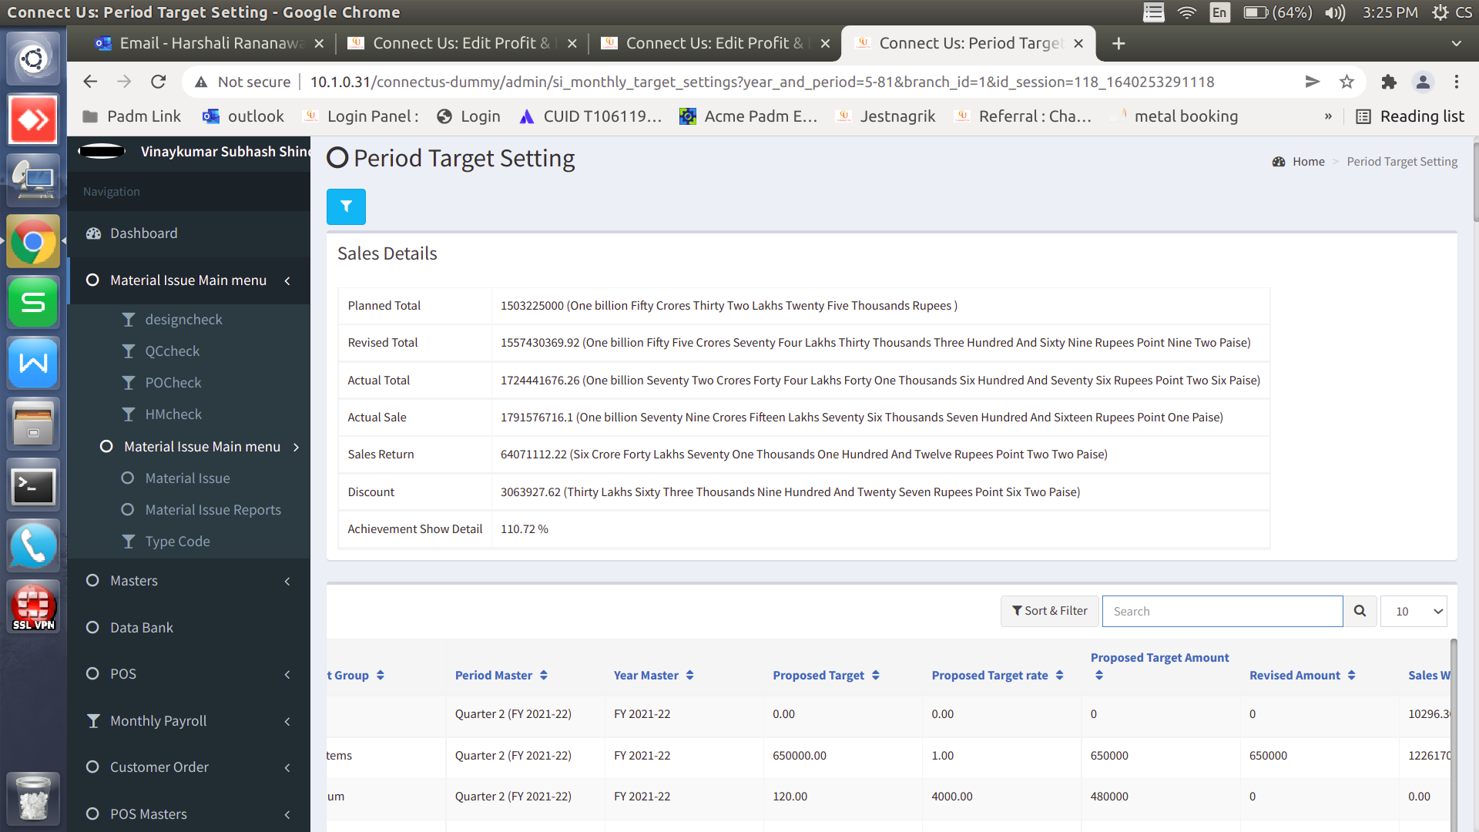

Image 11

**References of the users**

|  |  |  |  |
| --- | --- | --- | --- |
| **User** | **Name** | **Mail** | **Contact number** |
| **Actual user** | Dinesh Sonawane | hoaccountcc@csjewellers.com | 2931 |
| **Ticket created by (if any)** |  |  |  |
| **Assigned business analyst** | *Harshali Rananaware* | [harshali.rananaware@techneai.com](mailto:harshali.rananaware@techneai.com) | 8669917920 |
| **Assigned developer** | Parth Patel | [parth.patel@techneai.com](mailto:parth.patel@techneai.com) |  |