|  |  |
| --- | --- |
| **Ticket ID** | TT2719 |
| **Ticket description** | waddtech Software मध्ये टीडीएस Summary Report ला कस्टमर चे पुर्ण नाव येत नाही आणि Mobile No fild add करून देणे. |
| **Created by** | Harshali Rananaware |
| **Created on** | 17 Jun 2022 |
| **Priority** | Very high |
| **Version** | 1 |

**Version**

|  |  |  |  |  |
| --- | --- | --- | --- | --- |
| **Sr. No** | **Version no** | **Version Date** | **User name** | **User department** |
| 1 | 1 | 17 Jun 2022 | Dadaso Kumbhar |  |

**Approvals**

|  |  |  |
| --- | --- | --- |
| **Field** | **Name of the User** | **Approved date by the user** |
| **Actual User Name** | Dadaso Kumbhar |  |
| **Actual User Department** |  |  |
| **Organization Name** | BDD |  |
| **Assigned BA** | Harshali Rananaware |  |
| **Assigned Developer** |  |  |
| **Assigned Tester** |  |  |

**Estimation**

|  |  |  |  |  |
| --- | --- | --- | --- | --- |
| **Department name** | **Estimated Time (In hr)** | **Scheduled Date (Starting date )** | **Estimated date** | **Actual delivery date** |
| **BA** | 3 | 17 Jun 2022 | 17 Jun 2022 | 17 Jun 2022 |
| **Development** |  |  |  |  |
| **Testing** |  |  |  |  |

**Business requirement**

waddtech Software मध्ये टीडीएस Summary Report ला कस्टमर चे पुर्ण नाव येत नाही आणि Mobile No fild add करून देणे.

**Proposed System :**

In BDD first we can login ( Refer Image 1 )

User name - Ram

Password - a12345678

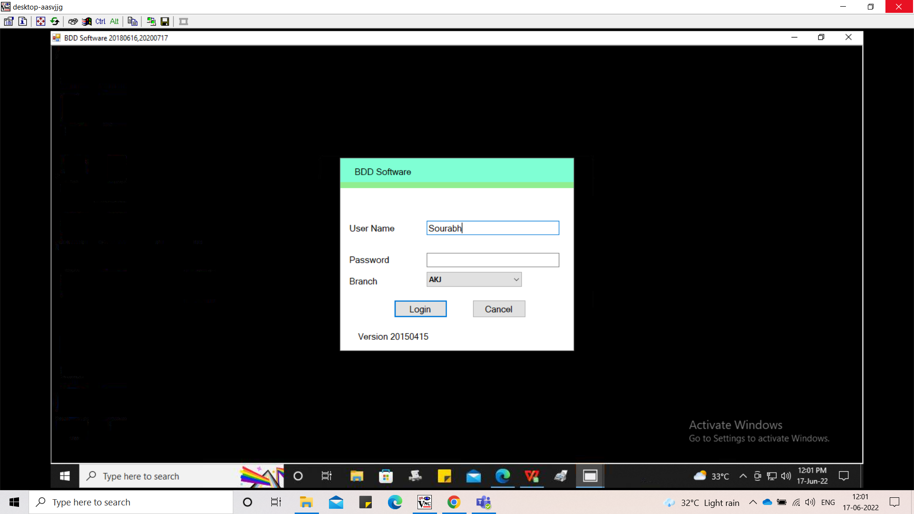

Image 1

In BDD-> TDS Summery Report -> Excel Based (Refer Image 2) in this report want to add customer full name and mobile number column.

Currently first name and last name showing in the customer name column.

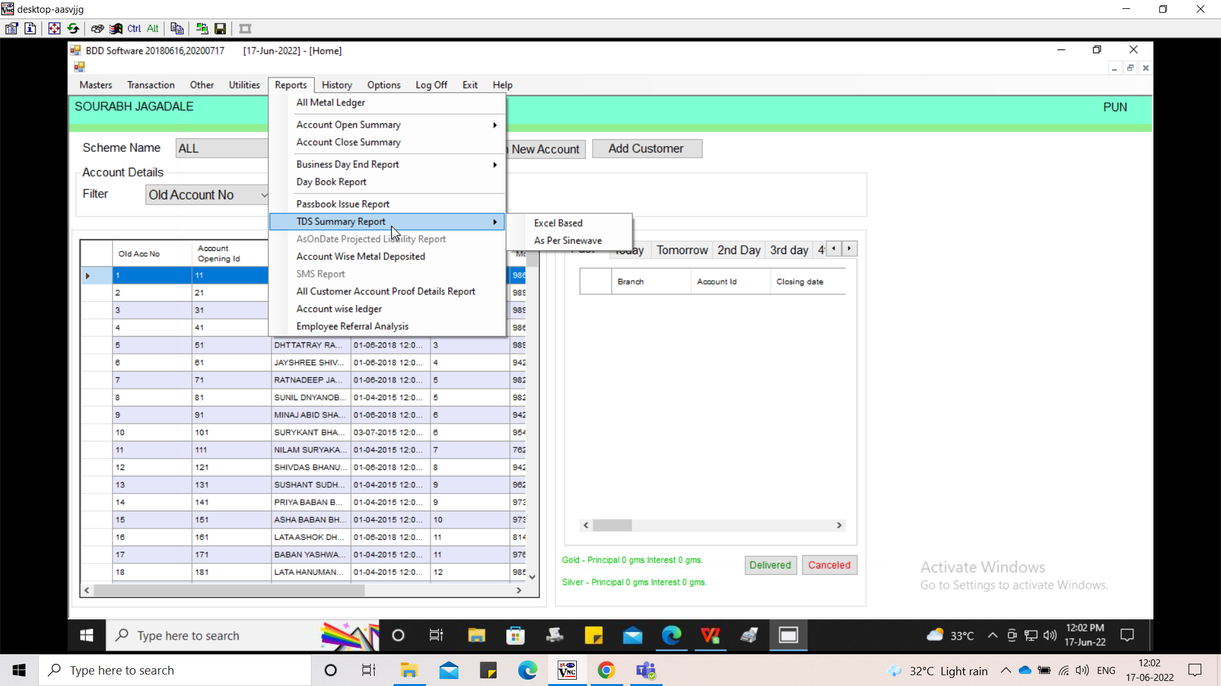

Image 2

In Report we can select From date , to date and branch click on search (Refer Image 3) then report should be generated.

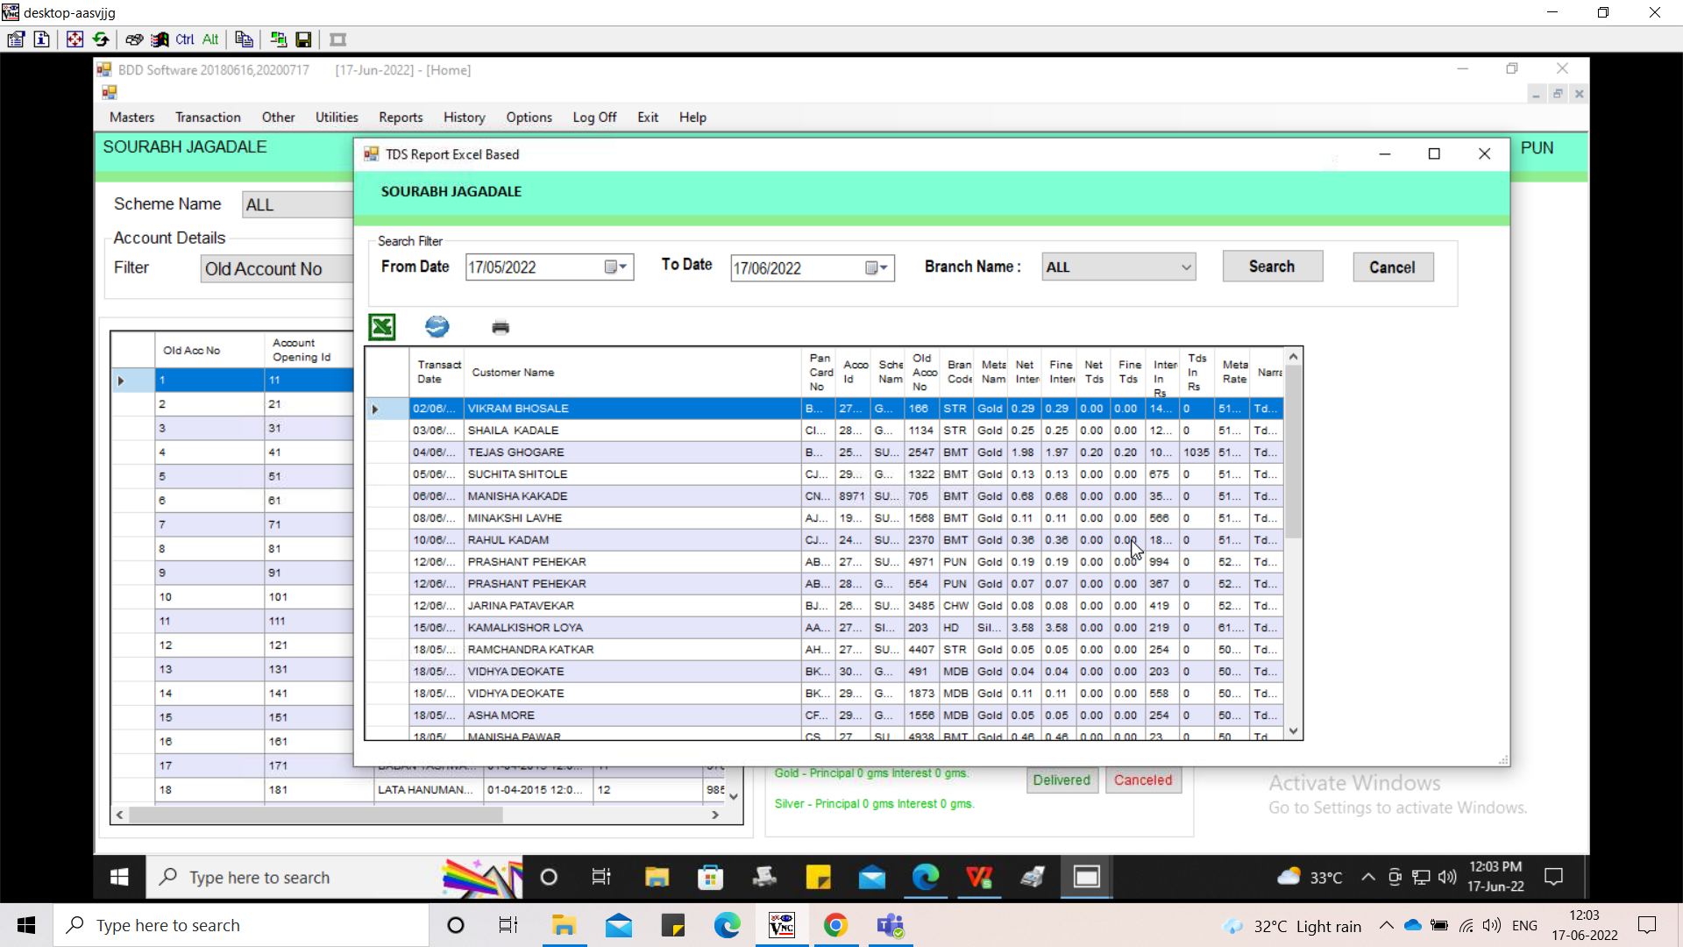

Image 3

In BDD -> Master -> customer master(Refer Image 4) in this master customer full name and mobile number present.

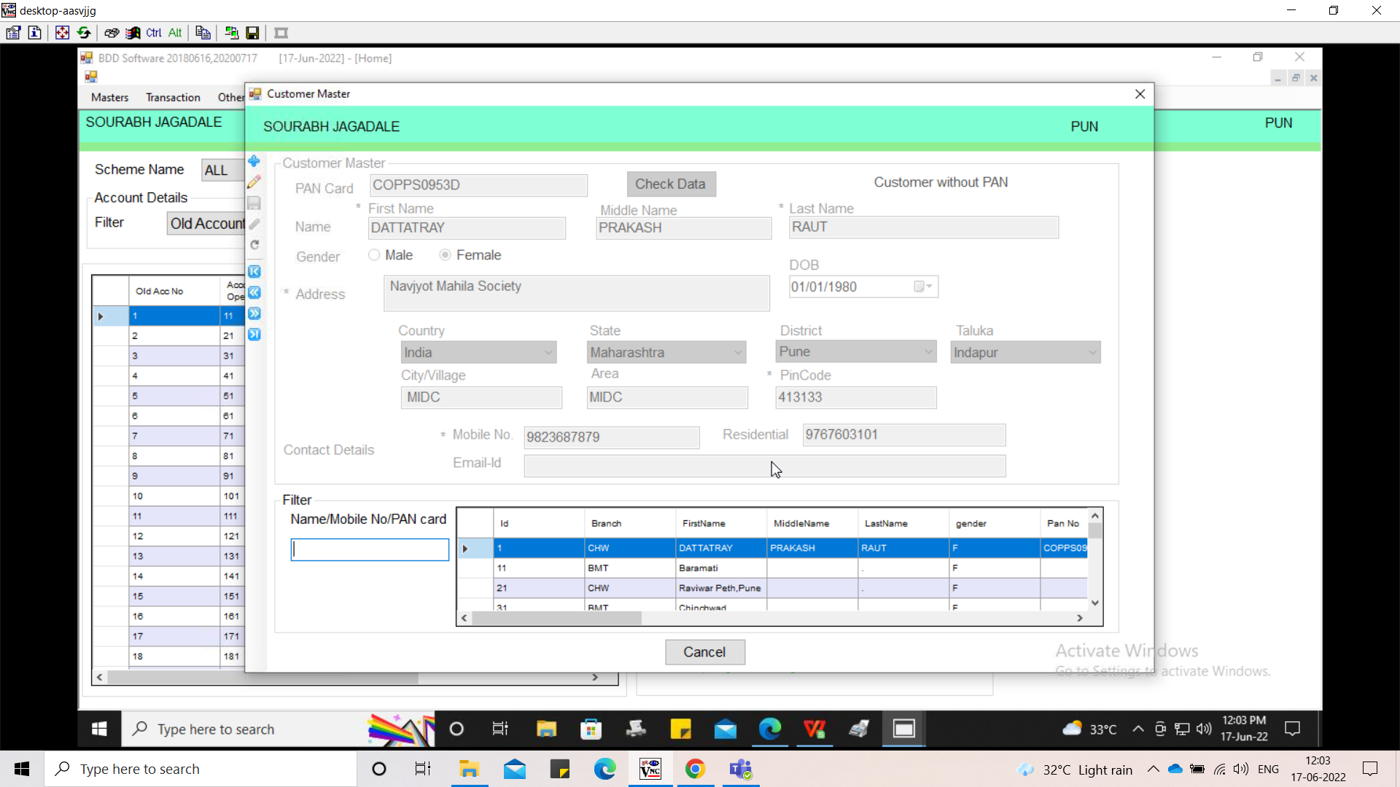

Image 4

**References of the users**

|  |  |  |  |
| --- | --- | --- | --- |
| **User** | **Name** | **Mail** | **Contact number** |
| **Actual user** | Dadaso Kumbhar | hobdd@csjewellers.com | 2599 |
| **Assigned business analyst** | Harshali Rananaware | [harshali.rananaware@techneai.com](mailto:harshali.rananaware@techneai.com) | 8669917920 |
| **Assigned developer** |  |  |  |