|  |  |
| --- | --- |
| **Ticket ID** | *T200247* |
| **Ticket description** | *Quality Check History Menue Madhe Doc Edit View Madhe Changes Karne* |
| **Created by** | *Tushar shivaji nikam* |
| **Created on** | *23-02-2022* |
| **Priority** | *High* |
| **Version** | *0* |

**Version**

|  |  |  |  |  |
| --- | --- | --- | --- | --- |
| **Sr. No** | **Version no** | **Version Date** | **User name** | **User department** |
| 1 | 0 | 25-02-2022 | *Tushar shivaji nikam* | Inventory Silver HO |

**Approvals**

|  |  |  |
| --- | --- | --- |
| **Field** | **Name of the User** | **Approved date by the user** |
| **Actual User Name** | *Tushar shivaji nikam* |  |
| **Actual User Department** | Inventory Silver HO |  |
| **Organization Name** | Cspl |  |
| **Assigned BA** | Sandeep Avchitte |  |
| **Assigned Developer** | Nikhil bhosale |  |
| **Assigned Tester** | Maruti hakke |  |

**Estimation**

|  |  |  |  |  |
| --- | --- | --- | --- | --- |
| **Department name** | **Estimated Time (In hr)** | **Scheduled Date (Starting date )** | **Estimated date** | **Actual delivery date** |
| **BA** |  |  |  |  |
| **Development** |  |  |  |  |
| **Testing** |  |  |  |  |

**Introduction**

New requirement

**Business requirement**

*In connect > quality check history >Action> Edit user want edit Field except “Date and Document no” so that user can able to edit record In present system edit field is not properly user want edit filed “Item and category” .*

**Abbreviations & terms**

In connect > CU

**Existing system**

*In connect > quality check history >Action> click on Edit In present system user not able to edit “Item & category field” which is not editable so that user not able edit record also in present system.*

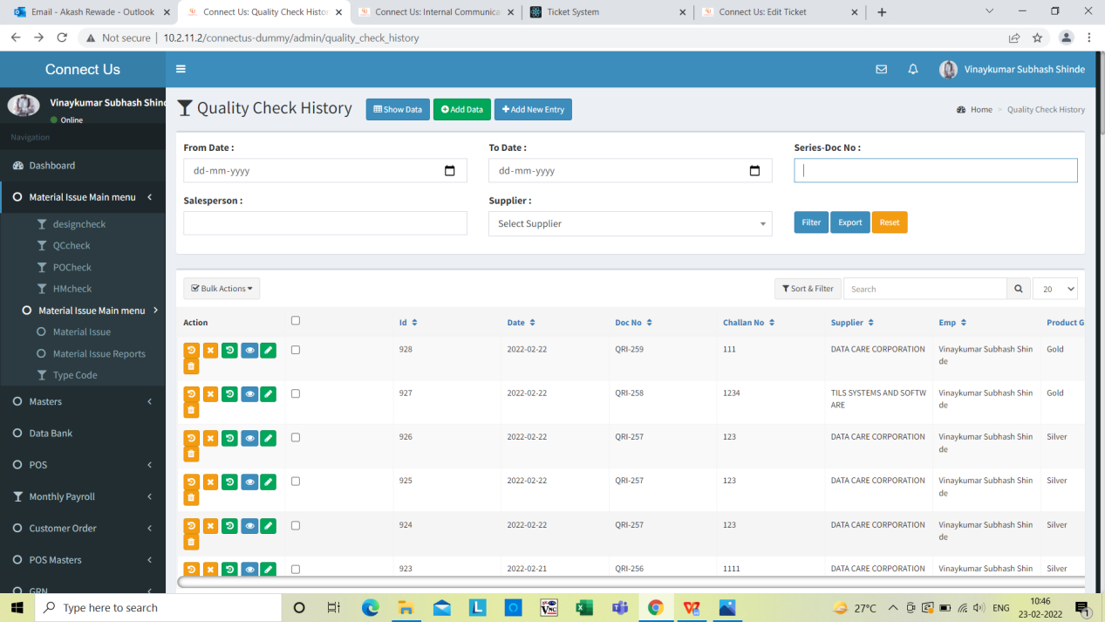

Click on edit record

*Image 1*

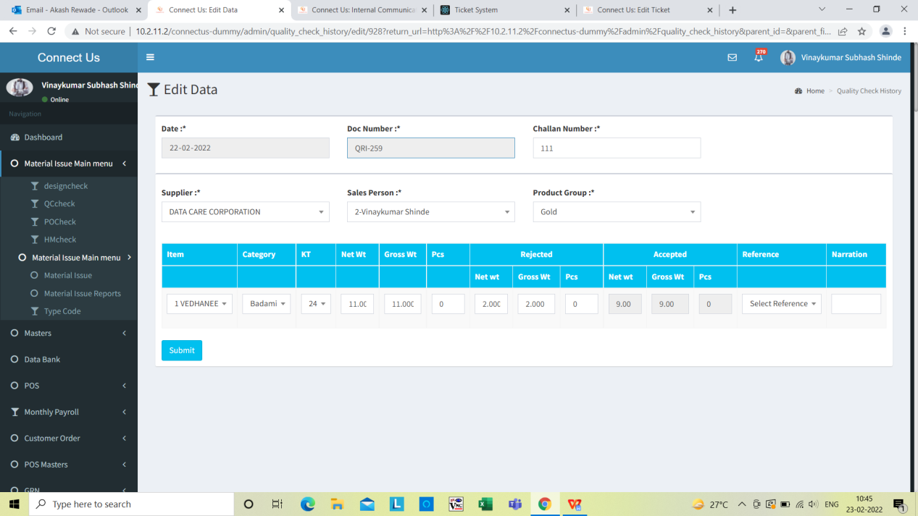

“Item and category” field not editable

*Image 2*

**Proposed system**

*In connect > quality check history >Action> click on Edit In Proposed system user want Edit “Item & category” field*

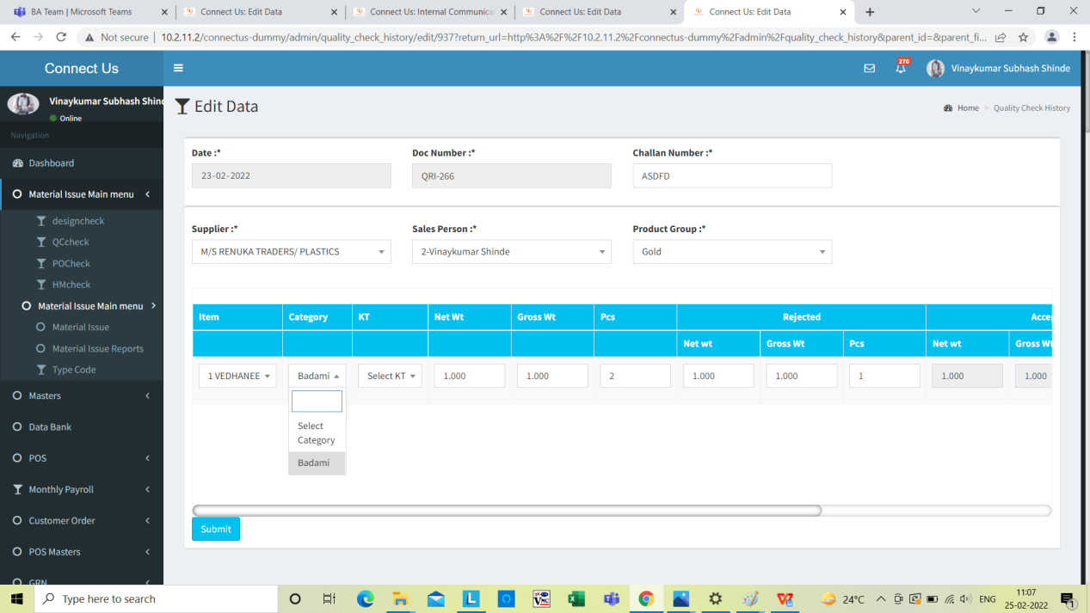

User want edit “category field”

Image 3

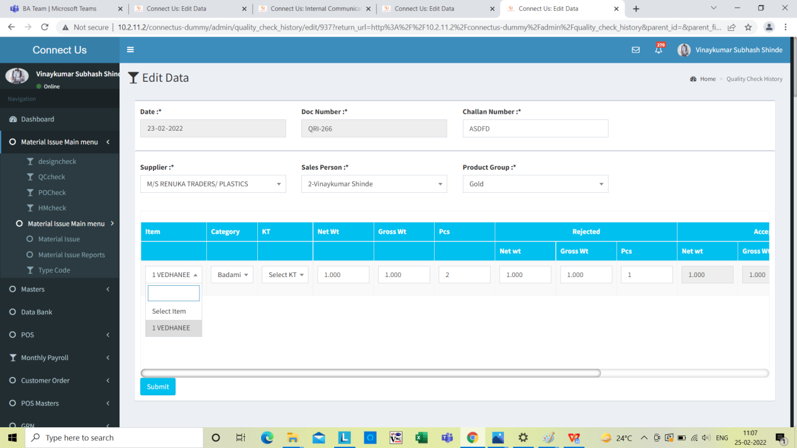

User want “Item field” editable

*Image 4*

**References of the users**

|  |  |  |  |
| --- | --- | --- | --- |
| **User** | **Name** | **Mail** | **Contact number** |
| **Actual user** | Tushar Nikam | [designgd@csjewellers.com](mailto:designgd@csjewellers.com) | 2533 |
| **Assigned business analyst** | Sandeep Avchitte | Sandeep.avchitte@techneai.com | 2965 |
| **Assigned developer** | Baliram Rajwad | Baliram.rajwad@techneai.com | 2971 |
| **Assigned tester** | Rohan Magar | [Rohan.magar@techneai.com](mailto:Rohan.magar@techneai.com) | 2965 |