|  |  |
| --- | --- |
| **Ticket ID** |  |
| **Ticket description** | *DAYODAY GOSHALA DONATE* |
| **Created by** | *Harshali Rananaware* |
| **Created on** | 26 Apr 2022 |
| **Priority** | *Very high* |
| **Version** | *1* |

**Version**

|  |  |  |  |  |
| --- | --- | --- | --- | --- |
| **Sr. No** | **Version no** | **Version Date** | **User name** | **User department** |
| 1 | 1 | 26 Apr 2022 |  |  |

**Approvals**

|  |  |  |
| --- | --- | --- |
| **Field** | **Name of the User** | **Approved date by the user** |
| **Actual User Name** |  |  |
| **Actual User Department** |  |  |
| **Organization Name** | CSPL |  |
| **Assigned BA** | *Harshali Rananaware* |  |
| **Assigned Developer** |  |  |
| **Assigned Tester** |  |  |

**Estimation**

|  |  |  |  |  |
| --- | --- | --- | --- | --- |
| **Department name** | **Estimated Time (In hr)** | **Scheduled Date (Starting date )** | **Estimated date** | **Actual delivery date** |
| **BA** |  |  |  |  |
| **Development** |  |  |  |  |
| **Testing** |  |  |  |  |

**Business requirement :** User want to know the how many customer donate the donation for goshala in a month/year. After one year complete then send the reminder to the customer.Any new changes done in goshala then this information send on wahtsapp to customer.

**Proposed System :**

**DAYODAY GOSHALA DONATE** - For this create a new web link “[www.dayodaygoshala.com](http://WWW.dayodaygoshala.com)

“. In that link show the images and videos.

We slide the arrow then we can select the amount which we want to donate also we can add amount manually .

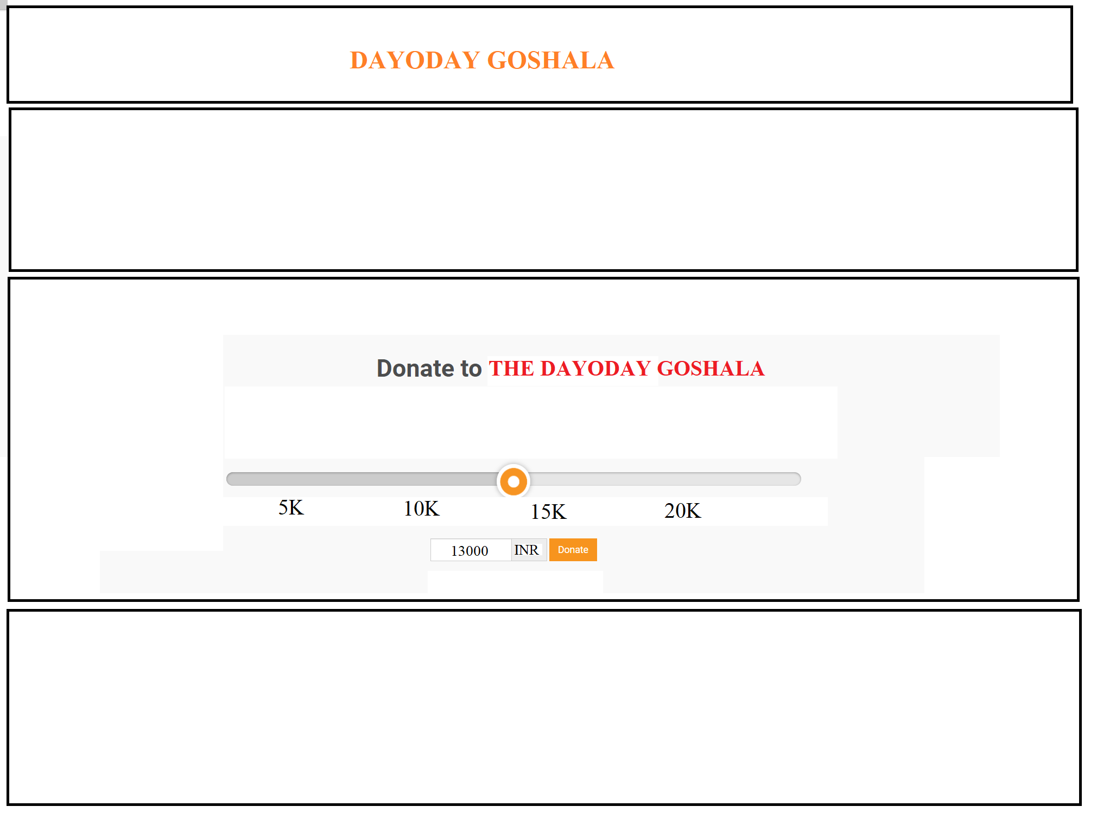

Click on “**Donate**” button then open a new form. Following are the fields.

1. Receipt No
2. Received name
3. PAN no
4. Aadhar no
5. Contact no
6. Address
7. Pin
8. Amount in RS
9. Amount in word RS
10. Bank name

After click on submit button then open the payment gateway.

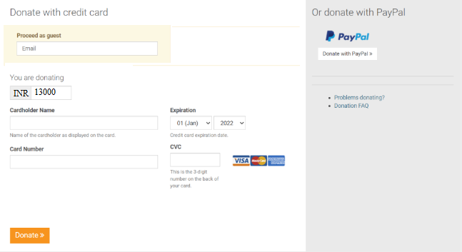

After payment done successful then send the invoice on whats app. Check the below format:

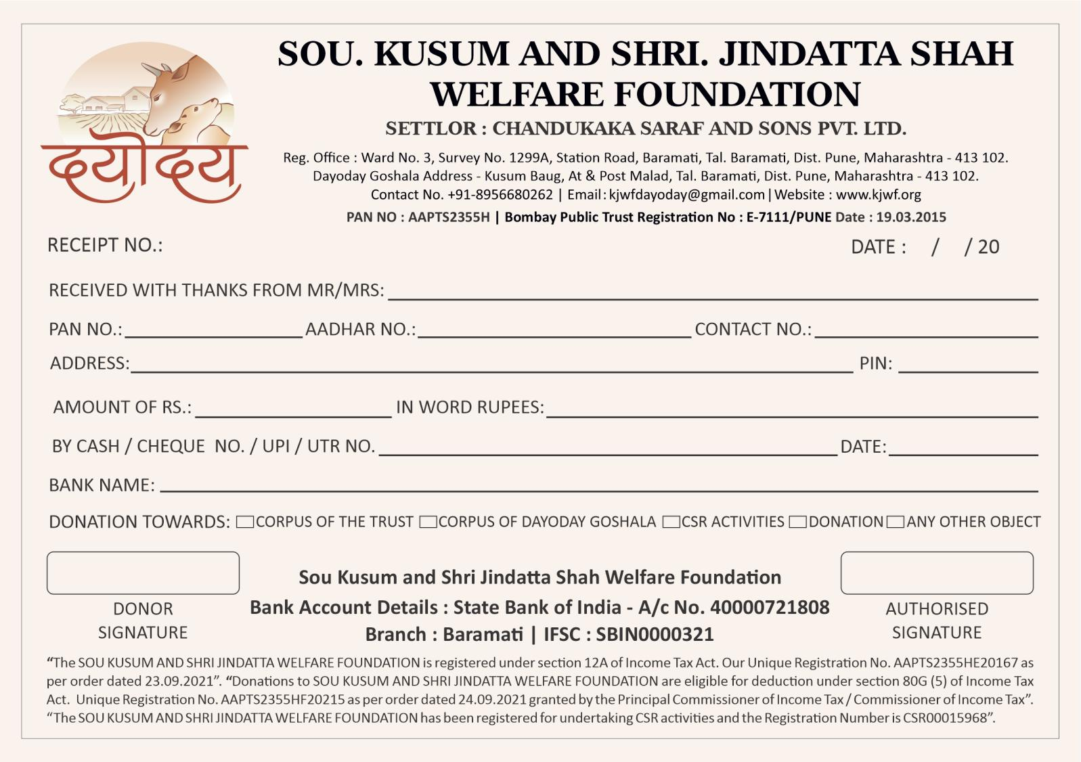

**For admin side** - admin can login through web. Admin login through username and password. In this login show report “Donate Report” in this report following column should be shown. Report Export in csv , excel and pdf.

Select from date and to date then so the following fields.

1. Sr no
2. Date
3. Receipt No
4. Received name
5. PAN no
6. Aadhar no
7. Contact no
8. Address
9. Pin
10. Amount in RS
11. Amount in word RS
12. Bank name
13. Payment gateway - by cash/ by cheque/UPI
14. Payment date
15. UTR no

**References of the users**

|  |  |  |  |
| --- | --- | --- | --- |
| **User** | **Name** | **Mail** | **Contact number** |
| **Actual user** |  |  |  |
| **Assigned business analyst** | *Harshali Rananaware* | [harshali.rananaware@techneai.com](mailto:harshali.rananaware@techneai.com) | 8669917920 |
| **Assigned developer** |  |  |  |