|  |  |
| --- | --- |
| **Ticket ID** |  |
| **Ticket description** |  |
| **Created by** | Smita Bahubali Danole |
| **Created on** |  |
| **Priority** |  |
| **Version** | 0 |

**Version**

|  |  |  |  |  |
| --- | --- | --- | --- | --- |
| **Sr. No** | **Version no** | **Version Date** | **User name** | **User department** |
| 1 | 0 |  | Smita Bahubali Danole | Franchise support |

**Approvals**

|  |  |  |
| --- | --- | --- |
| **Field** | **Name of the User** | **Approved date by the user** |
| **Actual User Name** | Smita Bahubali Danole |  |
| **Actual User Department** | Franchise support |  |
| **Organization Name** | C S Jewellers |  |
| **Sign-off** |  |  |
| **Assigned BA** | Mounika KrishnaVeni Annamneedi |  |
| **Assigned Developer** |  |  |
| **Assigned Tester** |  |  |

**Estimation**

|  |  |  |  |  |
| --- | --- | --- | --- | --- |
| **Department name** | **Estimated Time  (In hr)** | **Scheduled Date (Starting date )** | **Estimated date** | **Actual delivery date** |
| **BA** | 3 | 12.04.2022 | 13.04.2022 |  |
| **Development** |  |  |  |  |
| **Testing** |  |  |  |  |

**Introduction**

Metal booking is a software which is used to buy metal like gold and silver at a particular price on spot or we can trigger the amount, so that when the price hits the same, automatically, the metal is booked at that triggered price.

**Business requirement**

Template change of notifications on whatsapp, SMS and email when the metal is booked on spot and when the metal is booked at that triggered price both to the user and the contacts in the notification master.

Initially, there is 10 grams of gold and 1kg of silver in the template. Now, change to 1 gram of gold and 1 gram of silver.

**Existing system**

In the existing system, there is provision for the notifications.

**Proposed system**

* Change of template for the contacts to be notified in the whatsapp, SMS and email which is presented in SMS template master.
* Initially, there is 10 grams of gold and 1kg of silver in the template. Now, change to 1 gram of gold and 1 gram of silver.

Step-1

In Metal booking, “Notification master”.



Step-2

* Notification master consists of the contacts to whom the notifications have to be sent in whatsapp, SMS and e-mail.

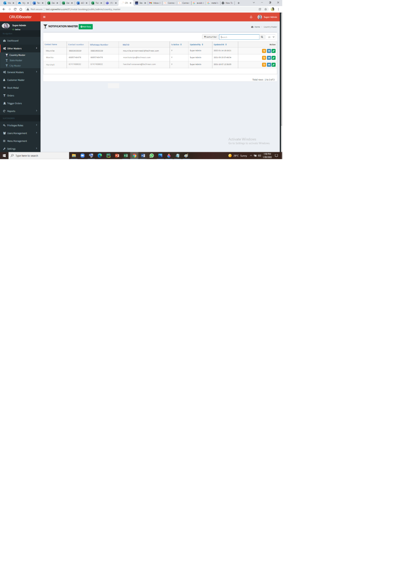

Step-3

SMS Template Master

* Change of the SMS template in SMS template master.

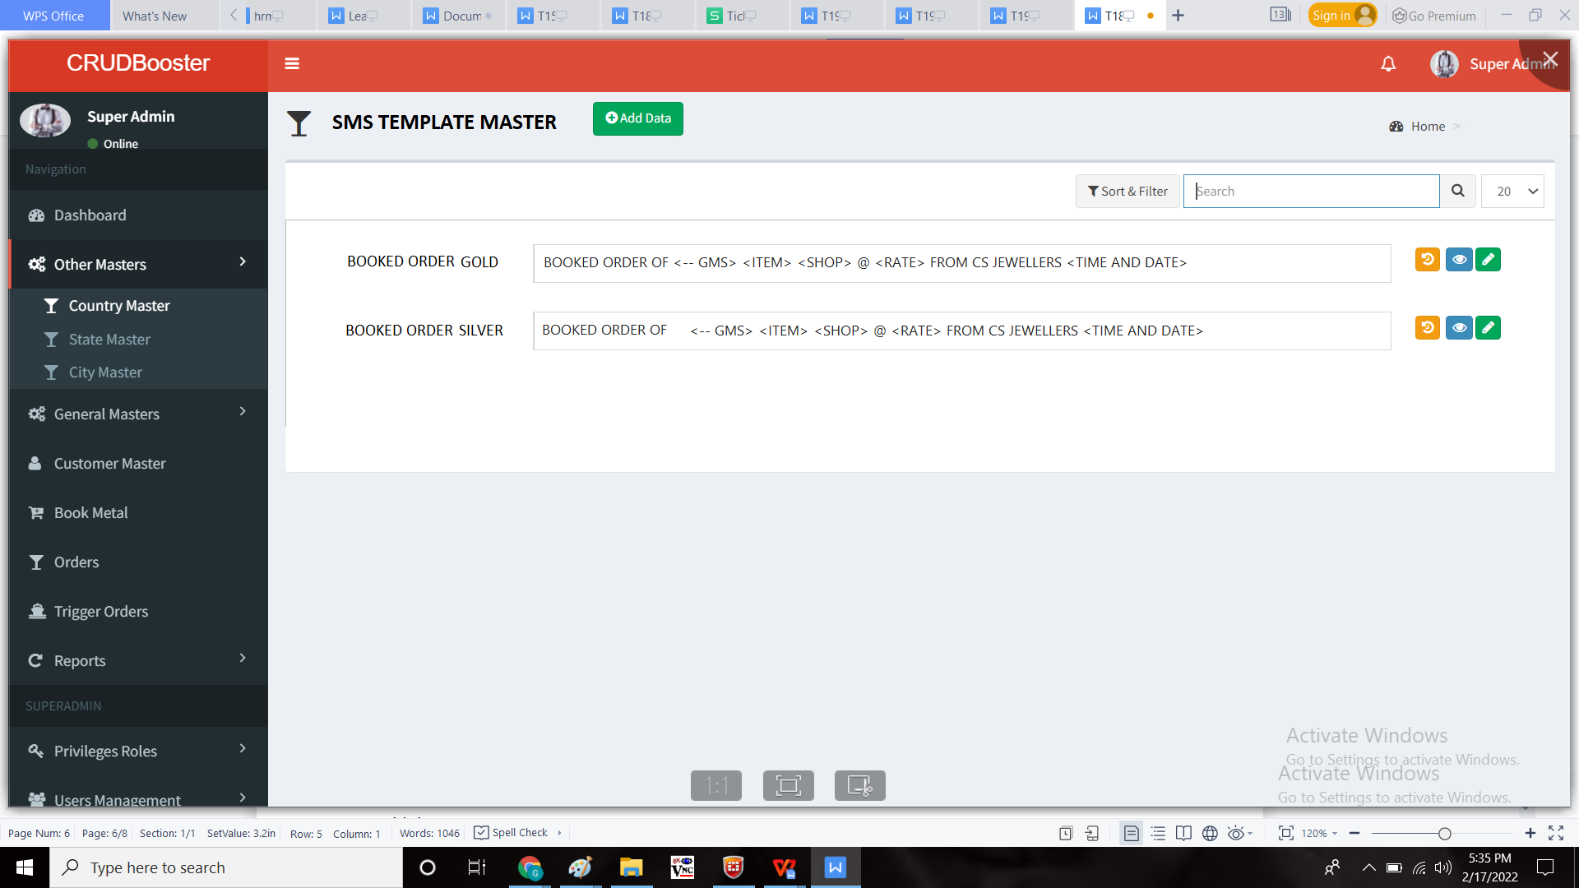

Add data

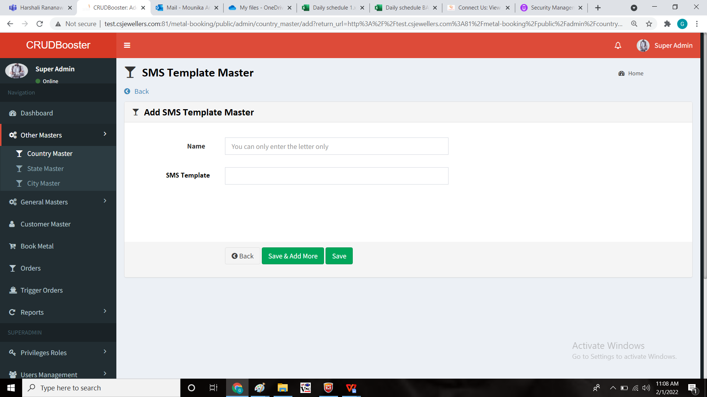

Step-4

The contacts in the notification master and the booked user (the booked user data is fetched from the customer master) has to be notified in whatsapp, SMS and mail when the order is placed and when the triggered order is placed.

Notification:

Order Confirmed  
Client: {#var#}  
Product: SILVER  
Order Wt: {#var#} GMS  
Rate: {#var#}/ 1 Gram  
Date: {#var#}  
Time: {#var#} {#var#}/{#var#}  
CHANDUKAKA SARAF AND SONS PVT LTD.

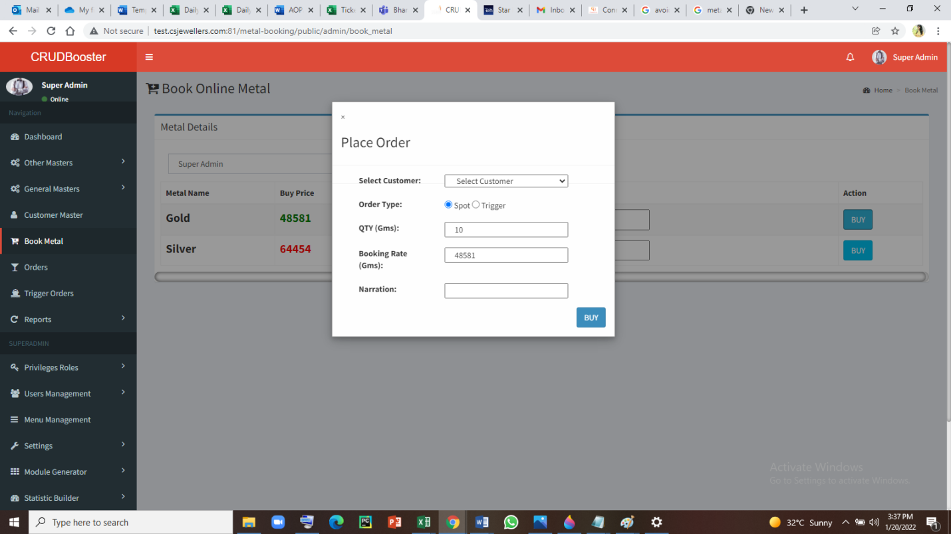

Step-5:

**Approved message templates: (old)**

|  |  |  |  |  |  |  |  |  |  |
| --- | --- | --- | --- | --- | --- | --- | --- | --- | --- |
| **TEMPLATE ID** | **TEMPLATE NAME** | **TYPE** | **HEADER** | **REGISTERED DLT** | **REQUESTED ON** | **STATUS DATE** | **APPROVAL STATUS** | **STATUS** | **TEMPLATE MESSAGE** |
| '1507164498841342758' | Metal Booking 3 | Service-Implicit | {CSPLHO} | MTNL | 16/02/2022 10:43 | 16/02/2022 10:44 | Approved | Active | Order Confirmed Client: {#var#} Product: SILVER Order Wt: {#var#} GMS Rate: {#var#}/ 1 KG Date: {#var#} Time: {#var#} {#var#}/{#var#} CHANDUKAKA SARAF AND SONS PVT LTD. |
| '1507164498832472386' | Metal Booking 2 | Service-Implicit | {CSPLHO} | MTNL | 16/02/2022 10:42 | 16/02/2022 10:45 | Approved | Active | Order Confirmed Client: {#var#} Product: GOLD Order Wt: {#var#} GMS Rate: {#var#}/ 10 GM Date: {#var#} Time: {#var#} {#var#}/{#var#} CHANDUKAKA SARAF AND SONS PVT LTD. |

**Approved message templates: (New)**

|  |  |  |  |  |  |  |  |  |  |
| --- | --- | --- | --- | --- | --- | --- | --- | --- | --- |
| **TEMPLATE ID** | **TEMPLATE NAME** | **TYPE** | **HEADER** | **REGISTERED DLT** | **REQUESTED ON** | **STATUS DATE** | **APPROVAL STATUS** | **STATUS** | **TEMPLATE MESSAGE** |
| '1507164949782558658' | Order Confirmed .. | Service-Implicit | {CSPLHO} | MTNL | 4/9/2022 15:20 | 4/9/2022 20:16 | Approved | Active | Order Confirmed Client: {#var#}  Product: SILVER Order Wt: {#var#} GMS Rate: {#var#}/ GM Date: {#var#} Time: {#var#} AM/ PM CHANDUKAKA SARAF AND SONS PVT LTD. |
| '1507164949775960867' | Order Confirmed . | Service-Implicit | {CSPLHO} | MTNL | 4/9/2022 15:19 | 4/9/2022 20:16 | Approved | Active | Order Confirmed Client: {#var#}  Product: GOLD  Order Wt: {#var#} GMS Rate: {#var#}/ GM Date: {#var#} Time: {#var#} AM/ PM CHANDUKAKA SARAF AND SONS PVT LTD. |

**References of the users**

|  |  |  |  |
| --- | --- | --- | --- |
| **User** | **Name** | **Mail** | **Contact number** |
| **Actual user** | Smita Bahubali Danole |  |  |
| **Assigned business analyst** | Mounika KrishnaVeni Annamneedi | Mounika.annamneedi@techneai.com | 8669917920 |
| **Assigned developer** |  |  |  |
| **Assigned tester** |  |  |  |