|  |  |
| --- | --- |
| **Ticket ID** | T197457 |

**Existing system**

In the existing system, In bill checking -> in bill checking masters -> in vendor master, there is option to select the GST defaulter status for the privileged users for GST defaulter status.

**Proposed system**

The user wants NA for the GST defaulter status for the unprivileged users in bill checking -> in bill checking masters -> vendor master

In connect us -> bill checking -> in bill checking masters -> vendor master

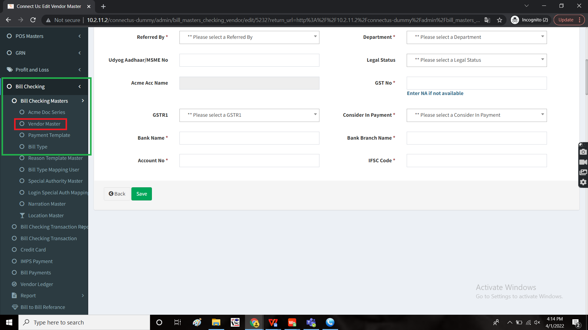

For approved vendors, except for the privileged users, the user wants the GST defaulter status to be shown as NA by default.

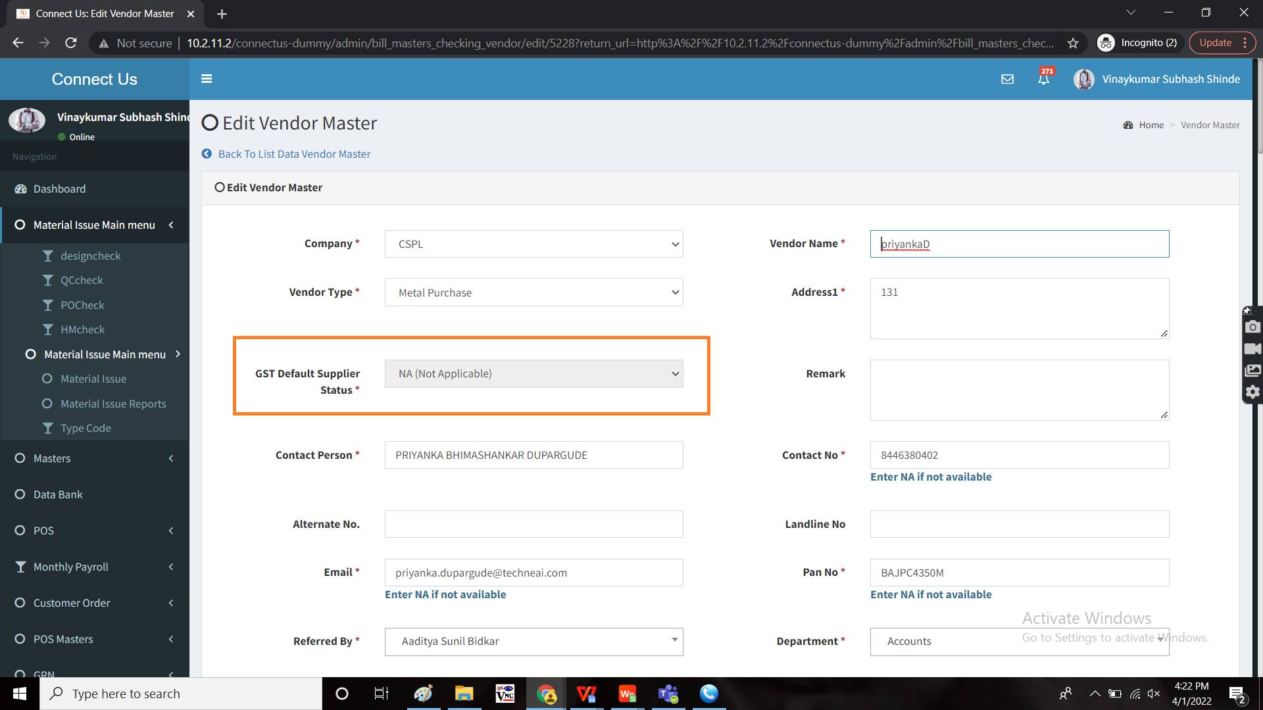

**OUTPUT:**

As expected.