|  |  |
| --- | --- |
| **Ticket ID** | TT2061 |

**Business requirement**

1. In AOP now PLAN & REVISED SALES & COGS values are updated but its total is not calculated also below formula is blank. need to work all formulas correct asper Actual AOP.
2. require correct sequence such as PLAN, REVISED then ACTUL ( branch wise & total)
3. need to add new column in start of PLAN TOTAL & REVISED TOTAL like ACTUAL TOTAL

**Abbreviations & terms**

Connect us - CU

**Existing system :**

1) In CU ->Profit and Loss -> AOP Report new -> column show plan actual revised.

2) In CU ->Profit and Loss -> AOP Report currently only show plan total.

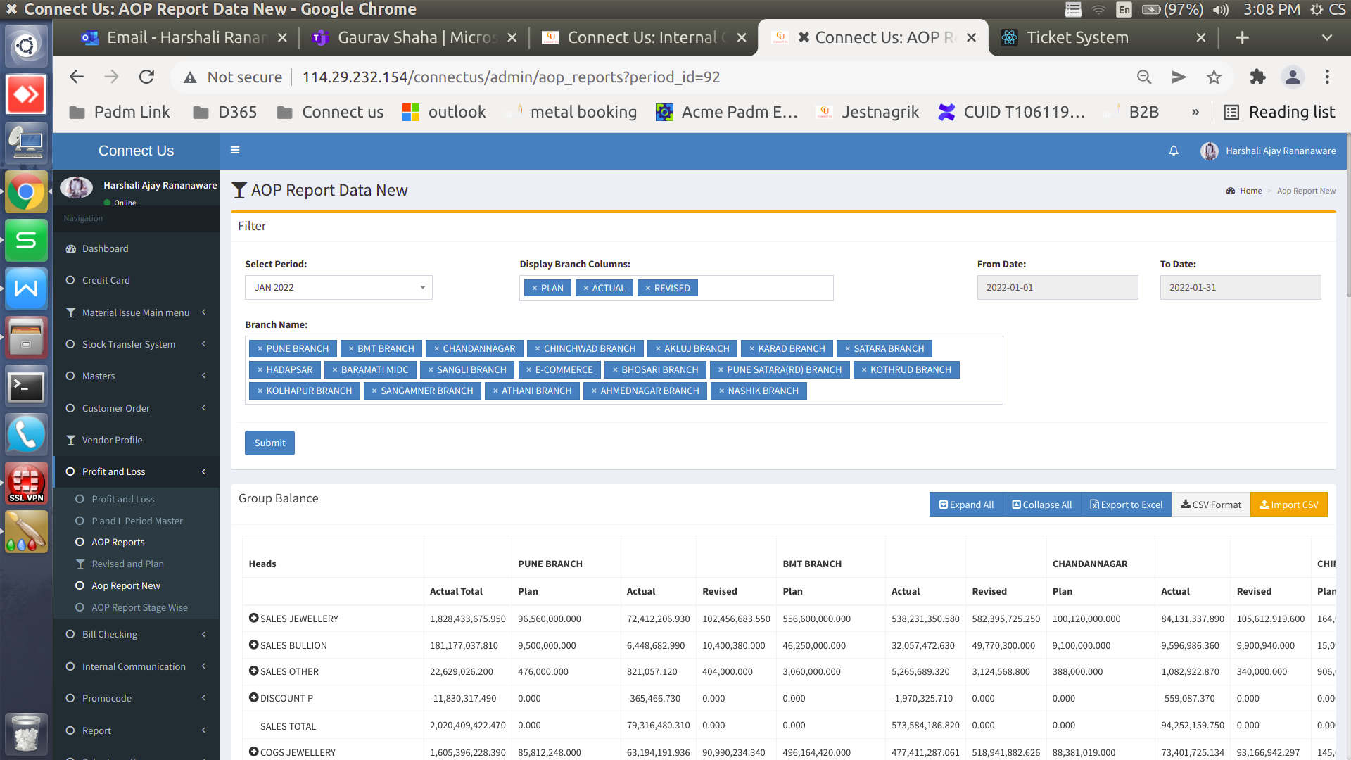

Image 1

**Proposed System :**

1. In CU ->Profit and Loss -> AOP Report new want to show the column sequence plan revised actual for all branches. (Refer Image 2) Also, this column sequence wants in the excel file.
2. In CU ->Profit and Loss -> AOP Report new want to add two new column plan total and revised total. column sequence plan total revised total actual total. (Refer Image 2) Also, this column sequence wants in the excel file.

**Plan total** - want to show all branch plan total amount.

**Revised total** - want to show all branch revised total amount.

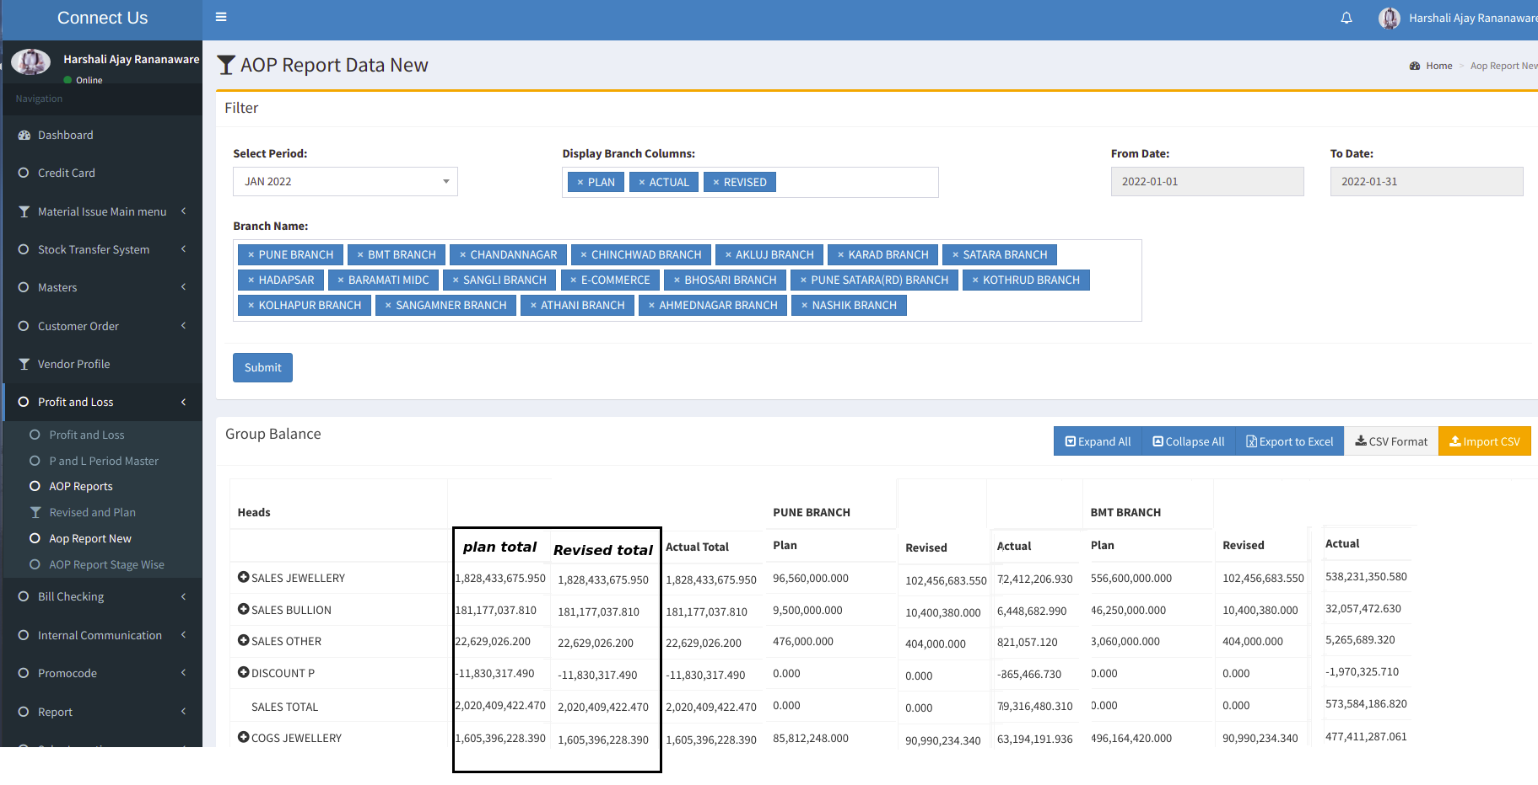

Image 2

1. In CU ->Profit and Loss -> AOP Report new want to update formula for plan and revised same as actual.

**For example** :

**Plan Sales total** = DISCOUNT P + SALES OTHER + SALES BULLION + SALES JEWELLERY

**Revised Sales total** = DISCOUNT P + SALES OTHER + SALES BULLION + SALES JEWELLERY

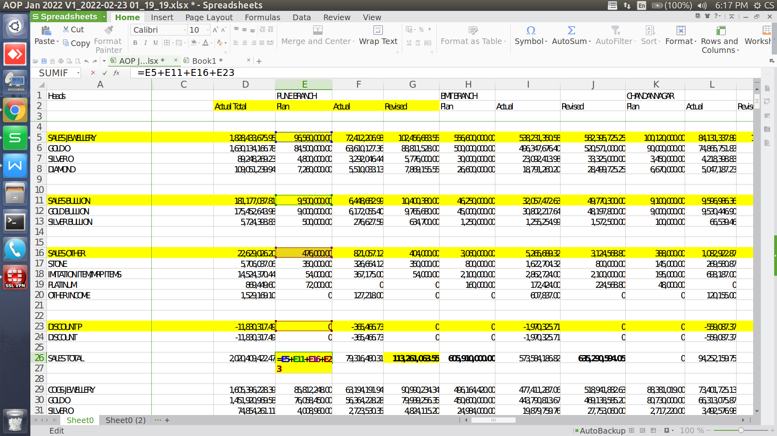

OUTPUT:

As expected.

