|  |  |
| --- | --- |
| **Ticket ID** | T207095 |

**Business Requirement**

The user want to know whether the customer requires EMI option or not for the schemes when the user calls to the customer.

**Existing system**

In connect us, in reports, in feedback, when the user calls the user, there is no option for the EMI.

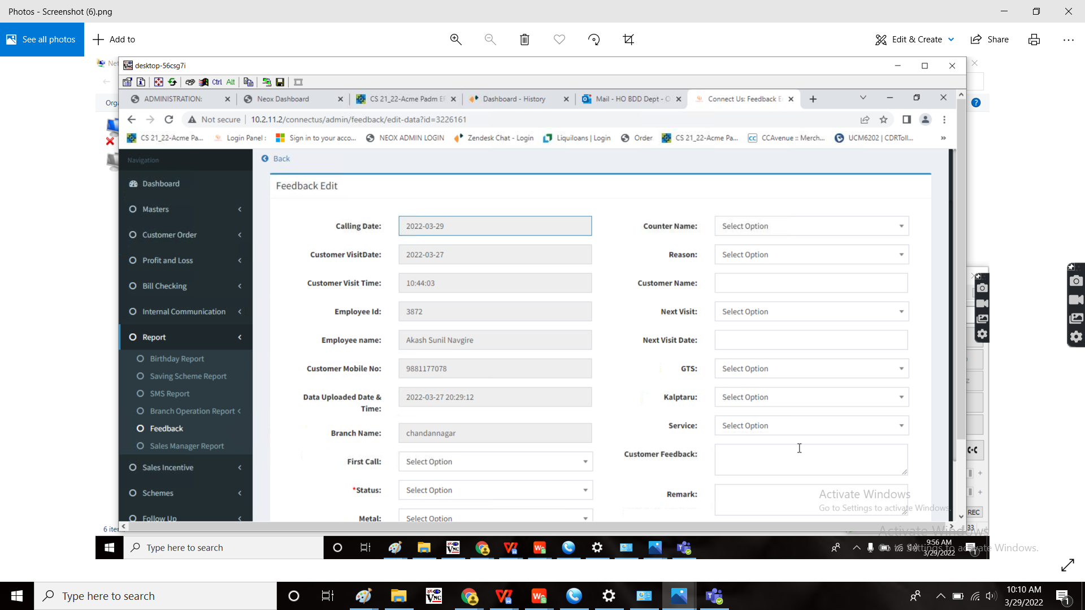

**Proposed system**

In connect us, in reports, in feedback, when the user submits, the user need an additional field “EMI” under kalptaru scheme.

**Step-1**

In Connect US -> Reports -> Feedback

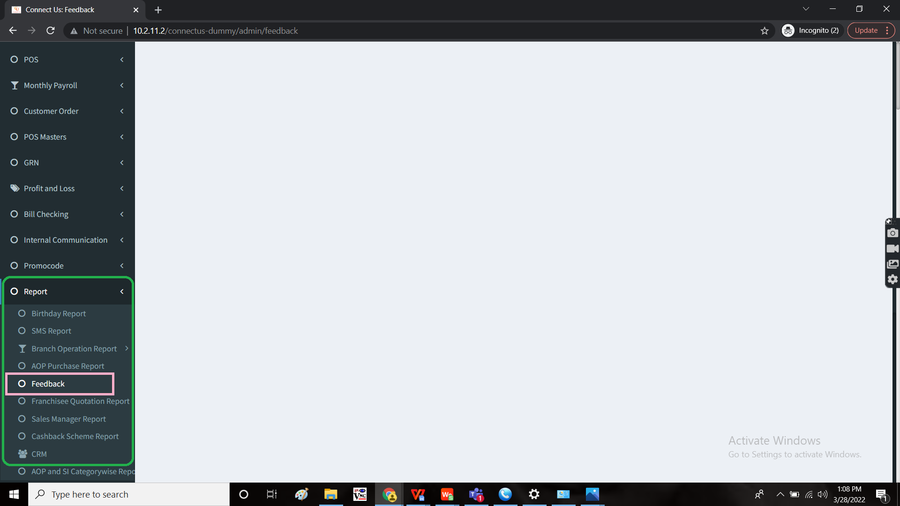

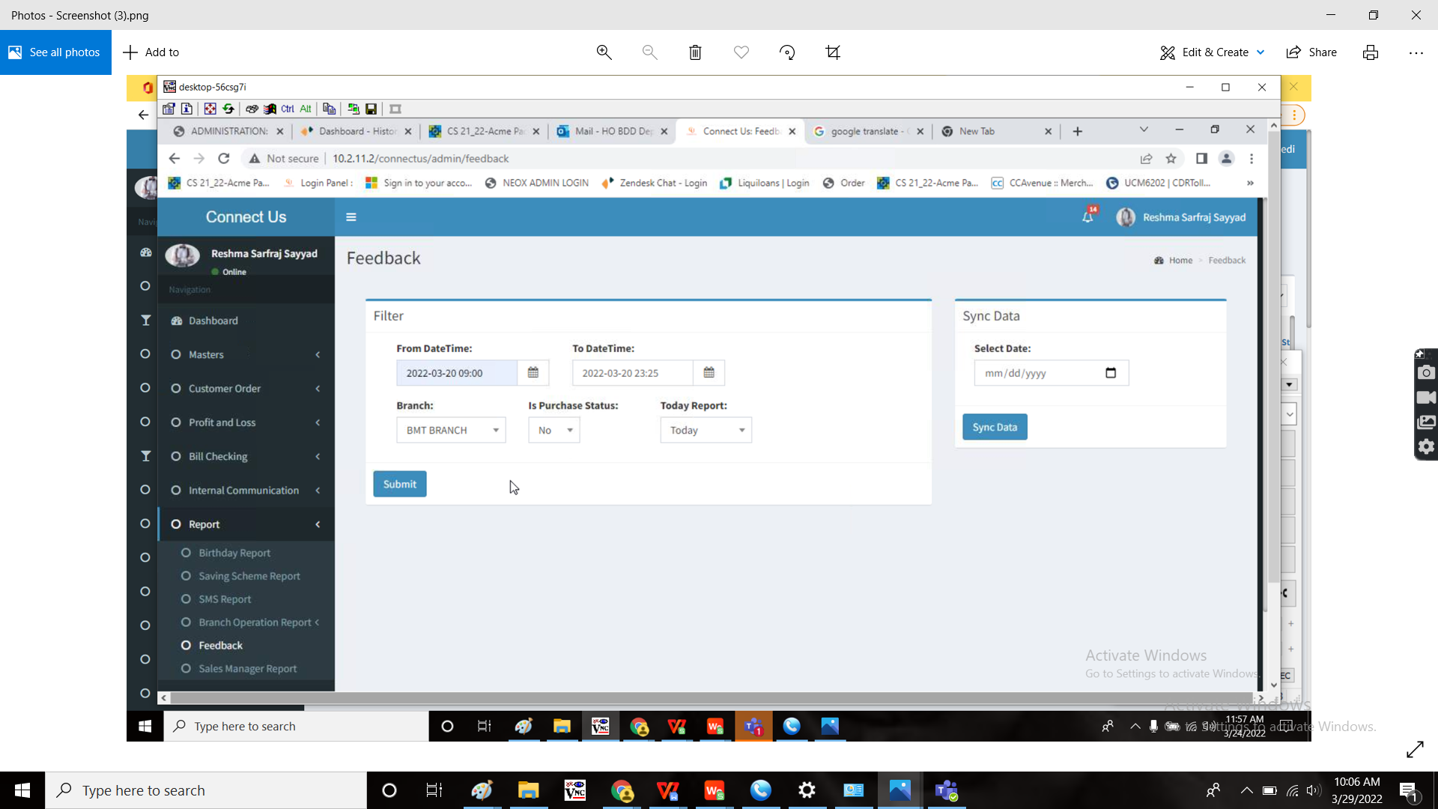

When the user fills all the fields and submit, then the following report displays.

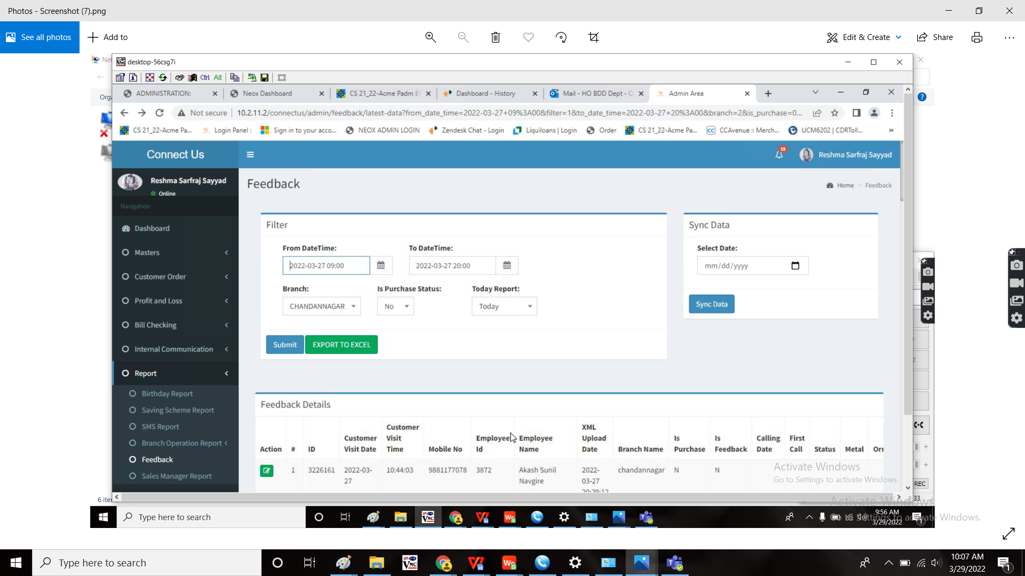

When the user clicks on the edit, the user wants to add a new field “EMI” under “Kalptaru” field with the drop down menu “yes” or “no”.

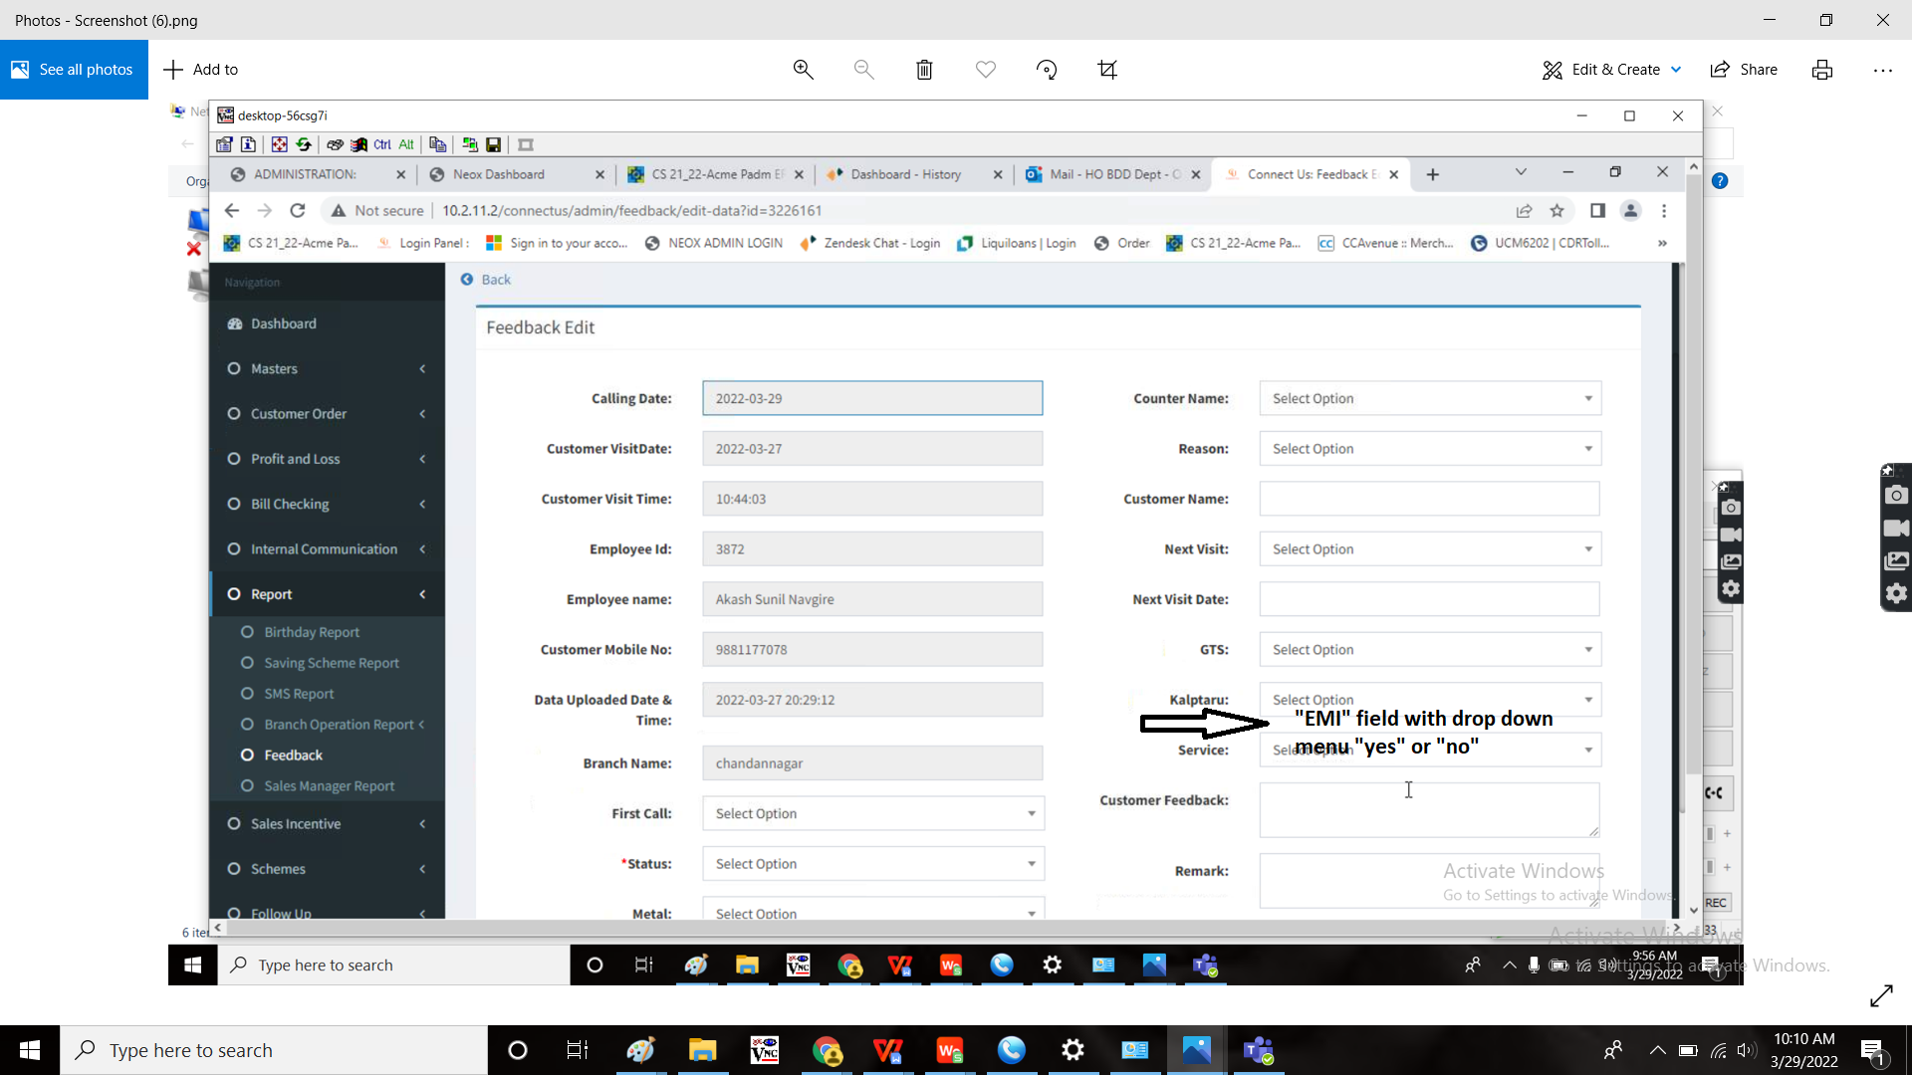

And should also represent in the report page

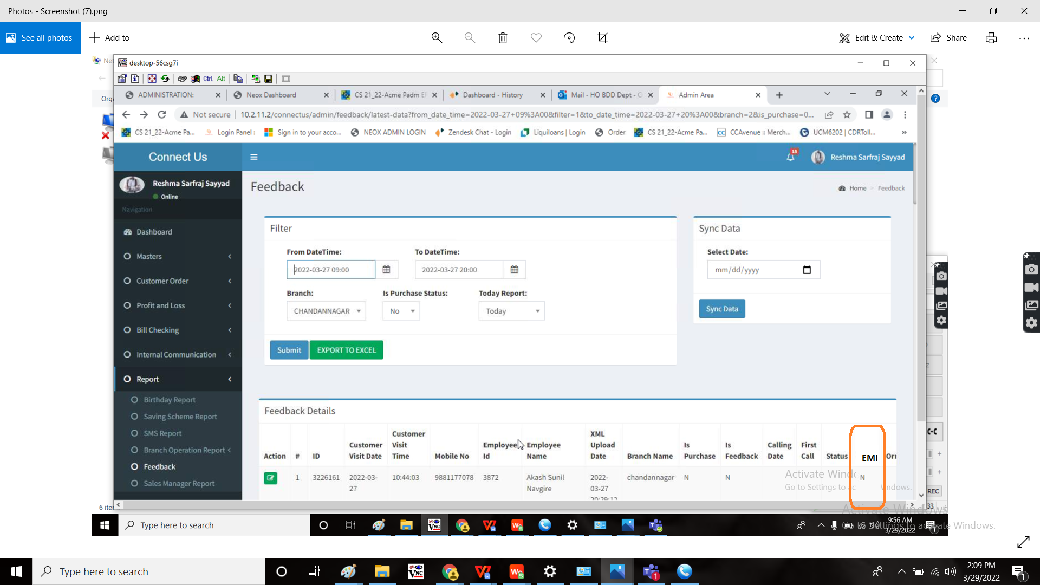

**OUTPUT:**

As expected.

