|  |  |
| --- | --- |
| **Ticket ID** | T203800 |
| **Ticket ID** | T218842 |

**Business requirement**

In material issue main menu, material issue reports, the user requires a new report K Jama and RD report.

This report helps the user in knowing the rejected vendors and this report is helpful in reporting the higher management.

**Existing system**

In the existing system, there is no K Jama and RD report.

**Proposed system**

* Creation of new menu “Inventory reports”. And assigning the “Material issue reports” menu under the inventory reports.
* Creation of filter tab for suppliers
* Creation of the new report K Jama and RD report.
* Export of whole suppliers and single supplier chart both in .csv and pdf format.

**Step-1**

In Connect US -> Material Issue Main Menu -> Add “Inventory reports” and under it, add “Material issue reports”

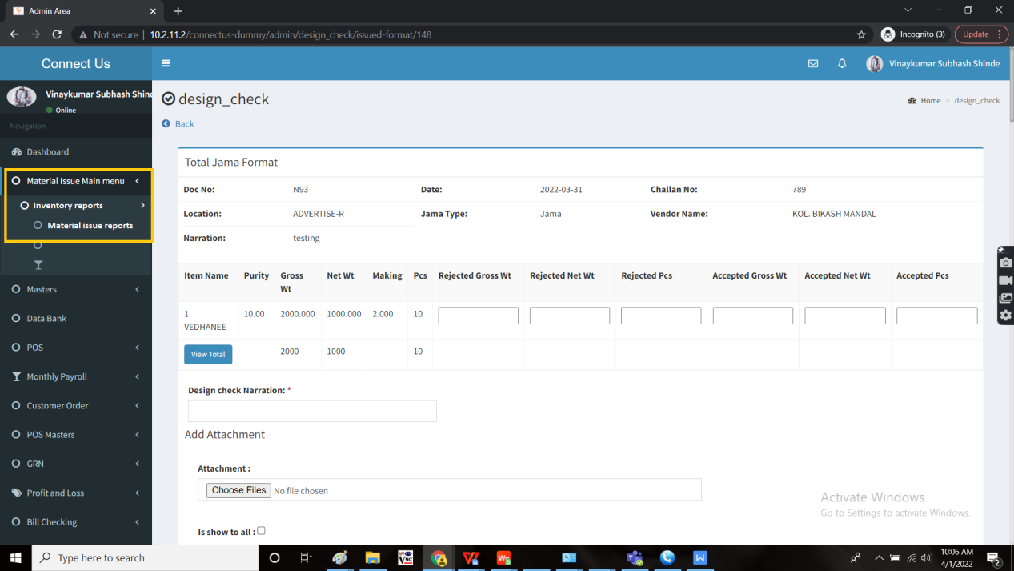

Add new report “K Jama” and “RD Reports” and a filter for suppliers.

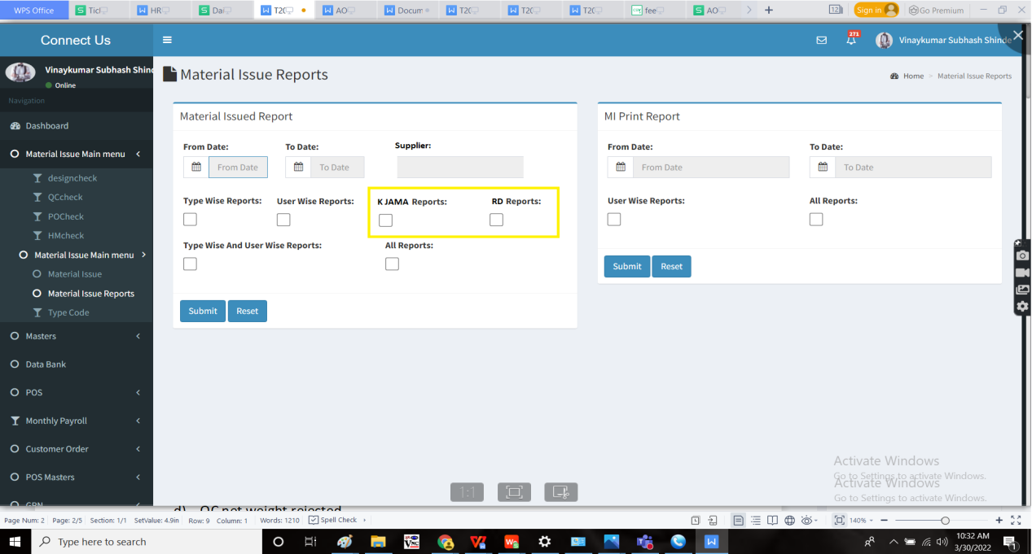

The report consists of the following fields

1. K Jama Report
   1. Karagir name
   2. Jama net weight
   3. Design net weight rejected
   4. QC net weight rejected
   5. PO net weight rejected
   6. HM net weight rejected
   7. Net weight accepted
   8. Design net weight rejected % = [(Design net weight rejected/ Jama net weight) *100]
   9. QC net weight rejected % = [(QC net weight rejected/ Jama net weight) *100]
   10. PO net weight rejected % = [(PO net weight rejected/ Jama net weight) *100]
   11. HM net weight rejected % = [(HM net weight rejected/ Jama net weight) *100]
   12. Net weight accepted % = [(Net weight accepted/ Jama net weight) *100]
   13. Total net weight rejected % = [(Total net weight rejected/ Jama net weight) *100]
   14. Chart
2. RD
   1. Karagir name
   2. Jama net weight
   3. Design net weight rejected
   4. QC net weight rejected
   5. PO net weight rejected
   6. HM net weight rejected
   7. Net weight accepted
   8. Design net weight rejected % = [(Design net weight rejected/ Jama net weight) *100]
   9. QC net weight rejected % = [(QC net weight rejected/ Jama net weight) *100]
   10. PO net weight rejected % = [(PO net weight rejected/ Jama net weight) *100]
   11. HM net weight rejected % = [(HM net weight rejected/ Jama net weight) *100]
   12. Net weight accepted % = [(Net weight accepted/ Jama net weight) *100]
   13. Total net weight rejected % = [(Total net weight rejected/ Jama net weight) *100]
   14. Chart

The data is fetched from the material issue main menu - design check, QC check, PO check and HM check.

The filter of suppliers should have the option of selecting all the suppliers and single or multiple suppliers. The data of the suppliers is fetched from vendor master from bill checking module.

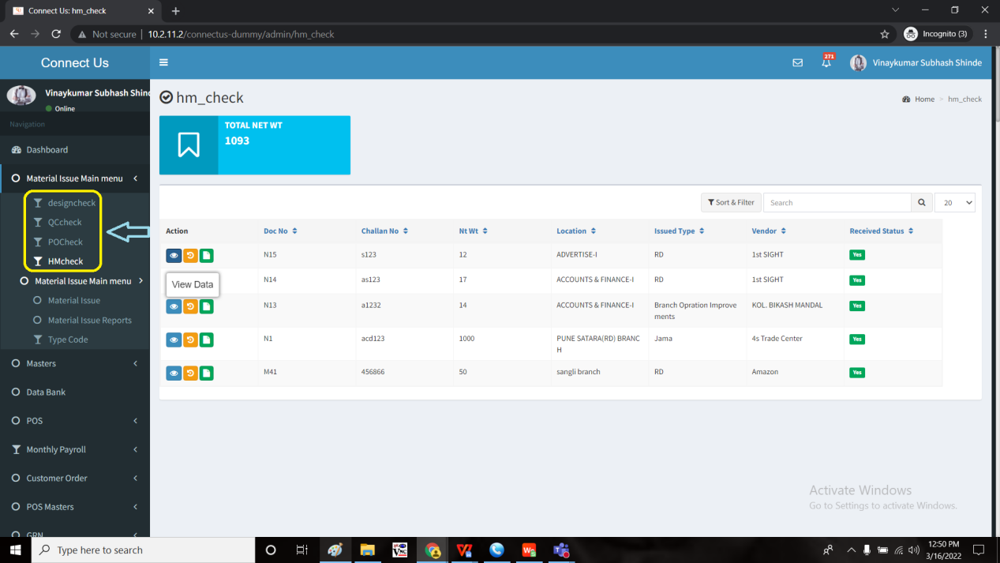

When the user fills the data and clicks on submit, the following data is displayed. The report consists of the export button where it can be exported both in .csv and pdf format.

Calculation sample:

For both K Jama and RD

Ashok (Karagir) having 4 documents named N1, N2, N3, N4.

Therefore, the report consists of the addition of 4 documents.

|  |  |  |  |  |  |  |
| --- | --- | --- | --- | --- | --- | --- |
| Karagir name - AShok | Jama net weight | Design net wt rejected | QC net wt rejected | PO net wt rejected | HM net wt rejected | Net wt accepted |
| N1 | 10 | 1 | 0 | 0 | 0 | 9 |
| N2 | 20 | 0 | 0 | 0 | 0 | 20 |
| N3 | 40 | 4 | 0 | 0 | 0 | 36 |
| N4 | 30 | 5 | 0 | 0 | 0 | 25 |

There Karagir - Ashok = Jama net weight = N1+N2+N3+N4 = 10+20+40+30 = 100

|  |  |  |  |  |  |  |  |  |  |  |  |  |
| --- | --- | --- | --- | --- | --- | --- | --- | --- | --- | --- | --- | --- |
| Karagir name | Jama net weight | Design net wt rejected | QC net wt rejected | PO net wt rejected | HM net wt rejected | Net wt accepted | Design net wt rejected % | QC net wt rejected % | PO net wt rejected % | HM net wt rejected % | Net wt accepted % | Total weight rejected % |
| Ashok | 100 | 10 | 0 | 0 | 0 | 90 | 10% | 0% | 0% | 0% | 90% | 10% |
| Argentinum | 200 | 20 | 20 | 0 | 0 | 160 | 10% | 10% | 0% | 0% | 80% | 20% |

OUTPUT: When the K Jama is exported in .csv format

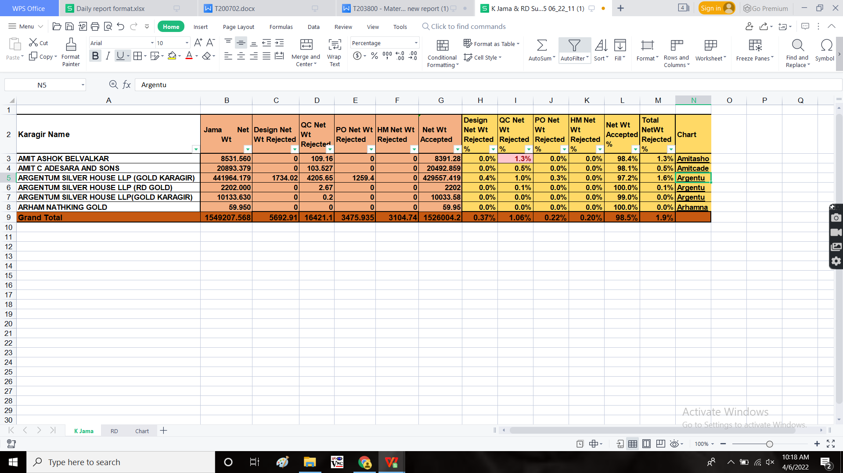

OUTPUT: When the RD is exported in .csv format

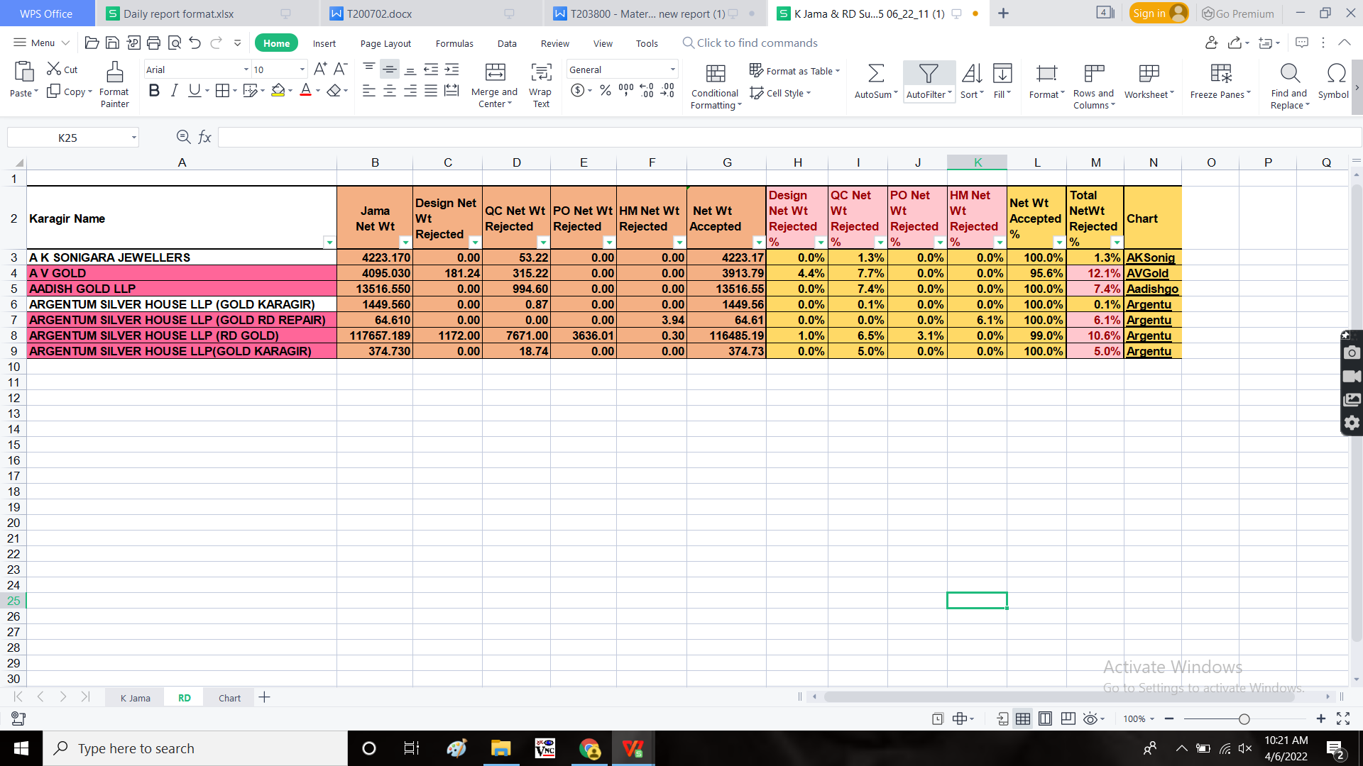

When the user clicks on the link in the chart, it re-directs to the report of a single supplier, the user selected. The report consists of the single Karagir name and the report in the pie-chart format.

There should be an export button when user selects the specific karagir (the details of the karagir and the chart to be exported). The data to be exported both in .csv and pdf format.

OUTPUT :

When single supplier is exported in .csv

|  |  |  |  |  |  |  |  |  |  |  |  |  |
| --- | --- | --- | --- | --- | --- | --- | --- | --- | --- | --- | --- | --- |
| **Karagir Name** | **Jama Net Wt** | **Design Net Wt Rejected** | **QC Net Wt Rejected** | **PO Net Wt Rejected** | **HM Net Wt Rejected** | **Net Wt Accepted** | **Design Net Wt Rejected %** | **QC Net Wt Rejected %** | **PO Net Wt Rejected %** | **HM Net Wt Rejected %** | **Net Wt Accepted %** | **Total NetWt Rejected %** |
| **ARGENTUM SILVER HOUSE LLP (RD GOLD)** | **117657.189** | **1172.00** | **7671.00** | **3636.01** | **0.30** | **116485.19** | **1.0%** | **6.5%** | **3.1%** | **0.0%** | **90.0%** | **10.6%** |

Note:

The report consists of karagir values of the particular karagir. This report is the merging data of the specific karagir.

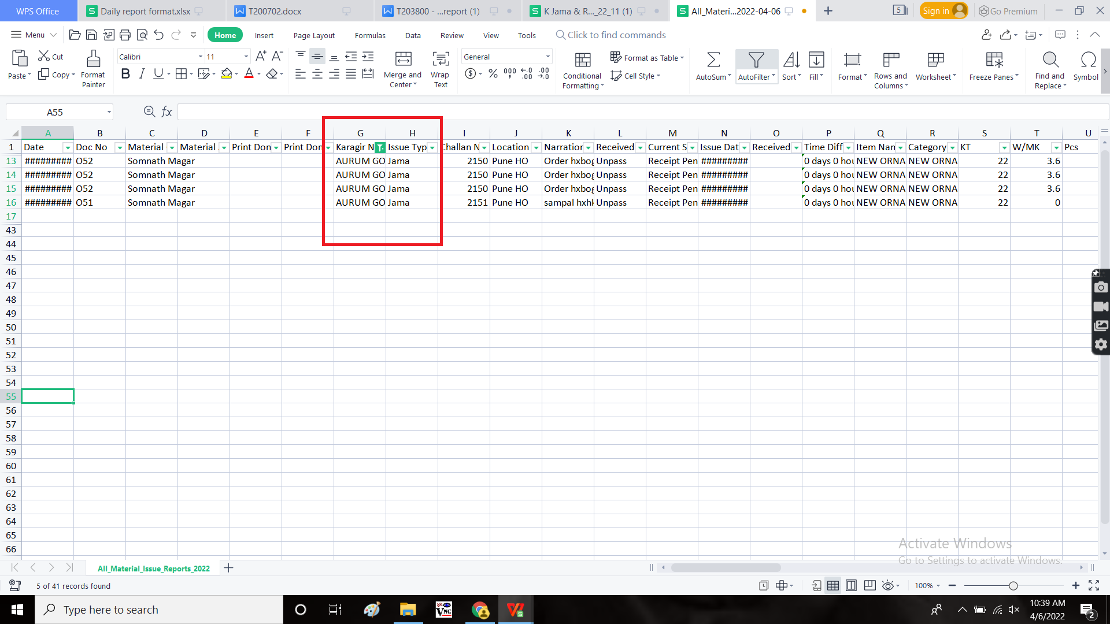

**Change request:**

**Business requirement**

Change of menu name and insertion of new menu.

**Existing system**

In the existing system, as per the old requirement, made the changes I.e., creation of new menu “Inventory reports” and K Jama and RD reports are added in that.

**Proposed system**

* Creation of new menu “Inventory reports” and under that K Jama and RD reports were included.
* Existing menu - material issue reports to be changed like earlier reports.

Step 1

In Connect Us -> Material issue main menu -> material issue reports.

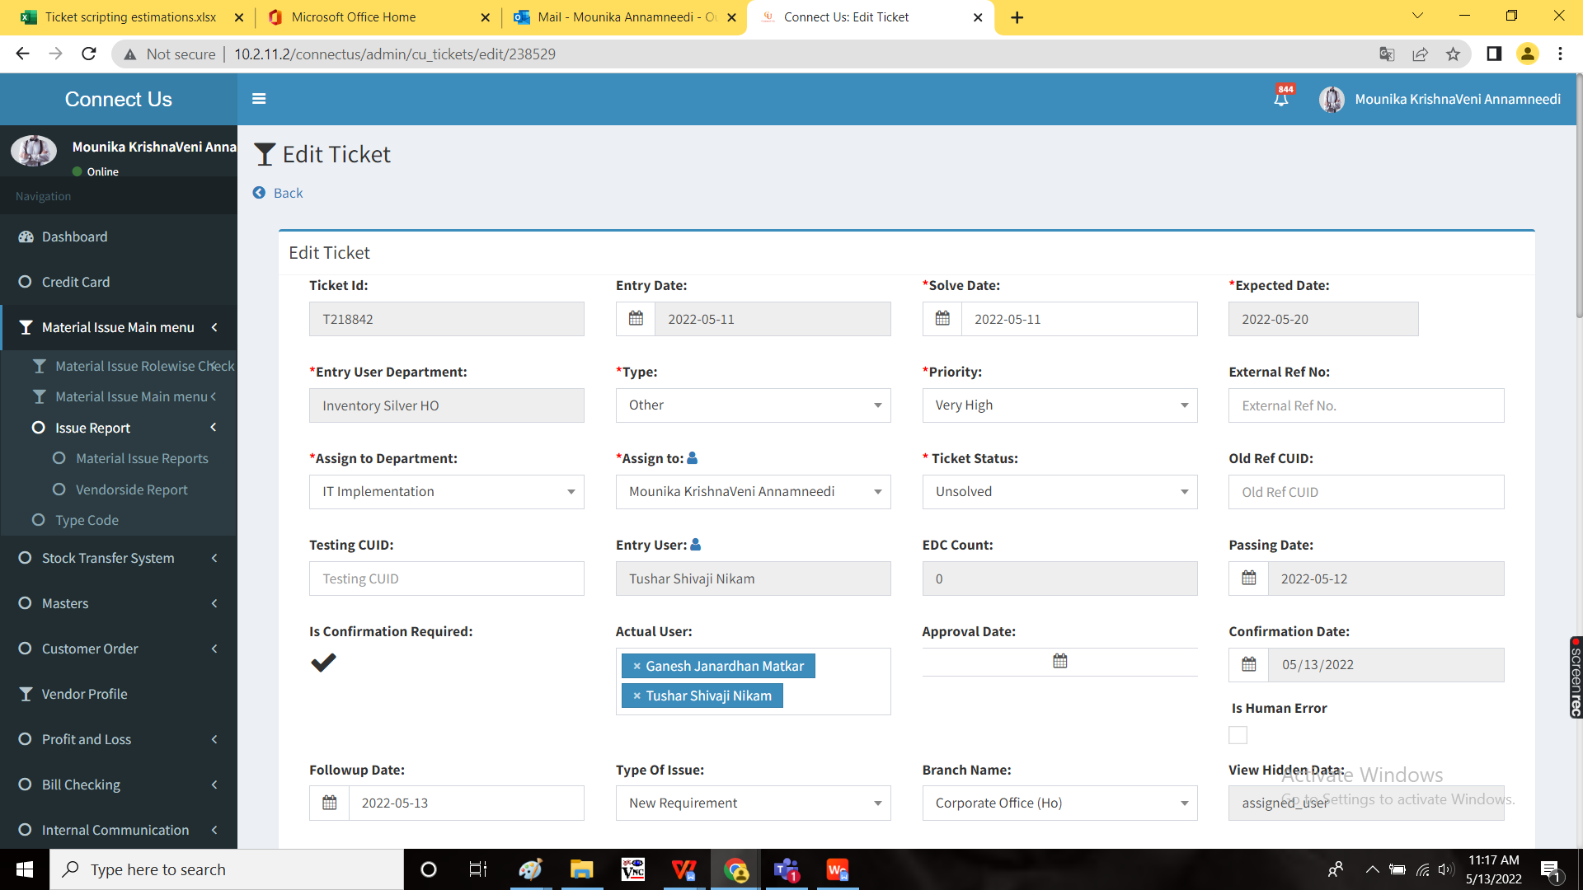

Material issue reports consists of existing old reports such as user wise reports, type wise reports and all reports. And in MI print reports, user wise reports and all reports.

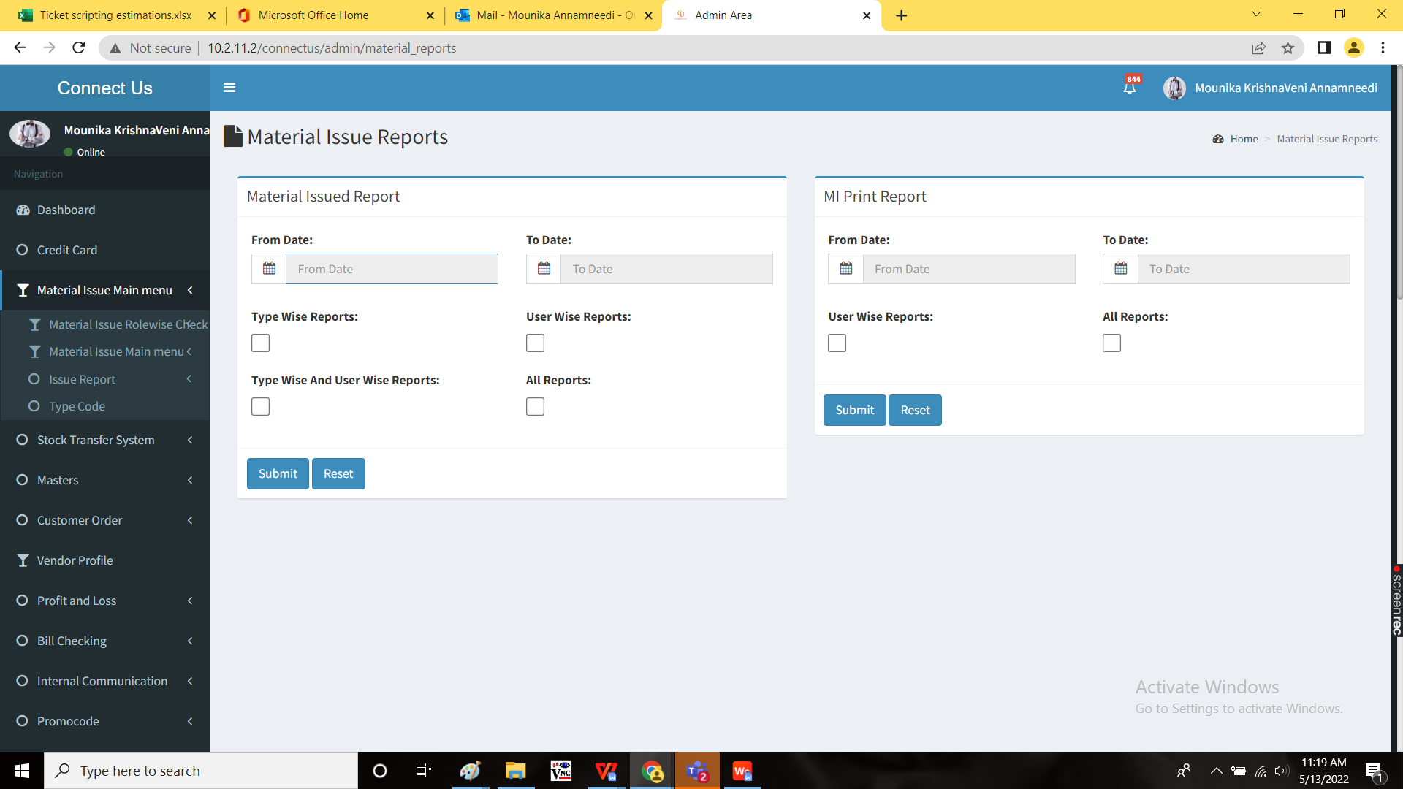

Step 2:

Creation new menu “Inventory reports” in connect us

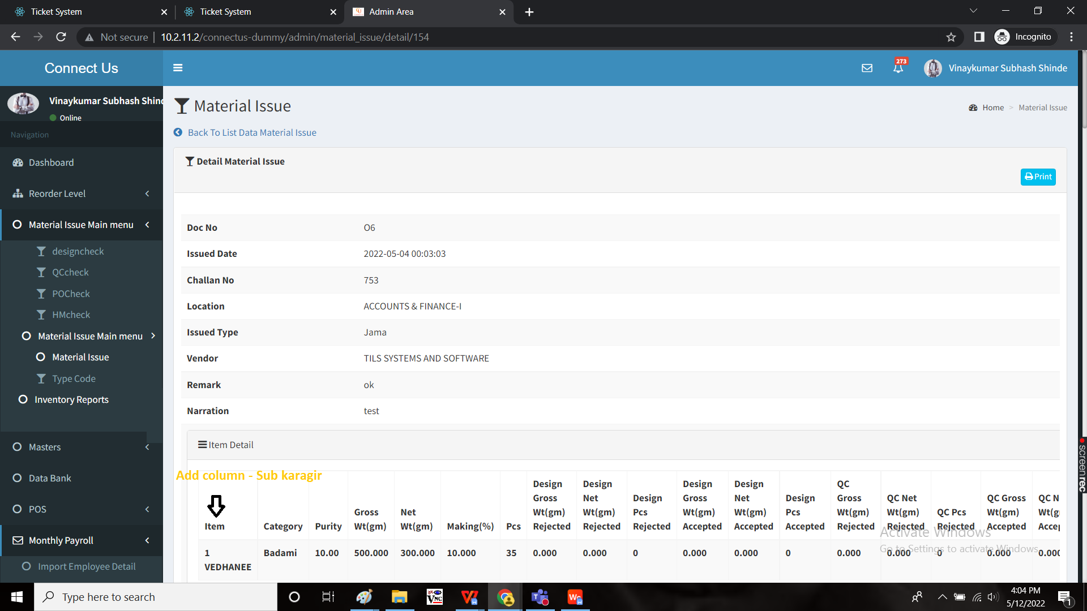

Inventory reports conists of both existing and new reports K Jama and RD reports.

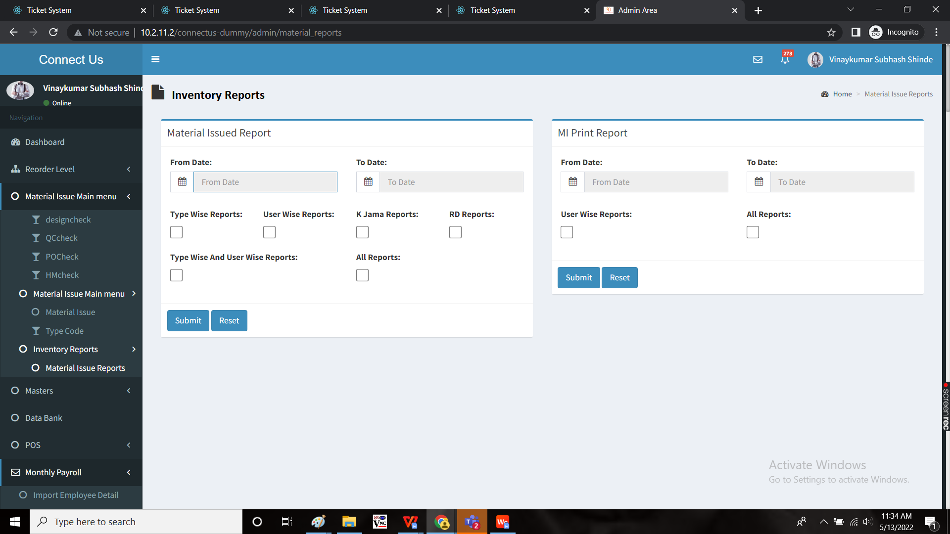

**OUTPUT:**

New menu inventory reports in Connect Us.

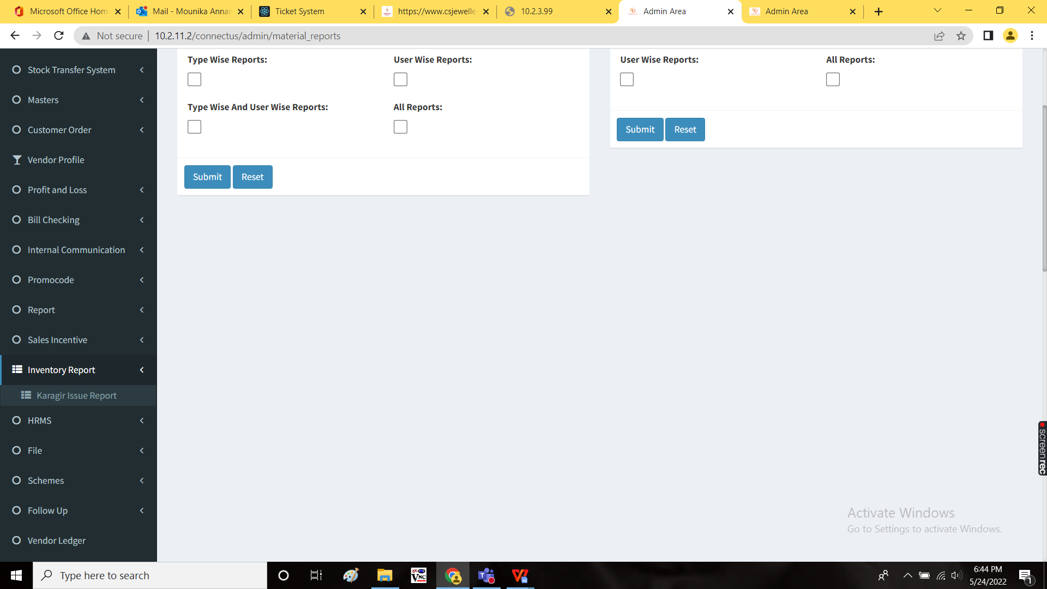

Karagir issue report:

The karagir issue report consist of material issue reports (Material issue main menu -> issue report -> material issue reports) and addition of 2 new fields “K Jama” and “RD” and a filter option for suppliers (This filter is shown when any one of the K Jama or RD report is selected).

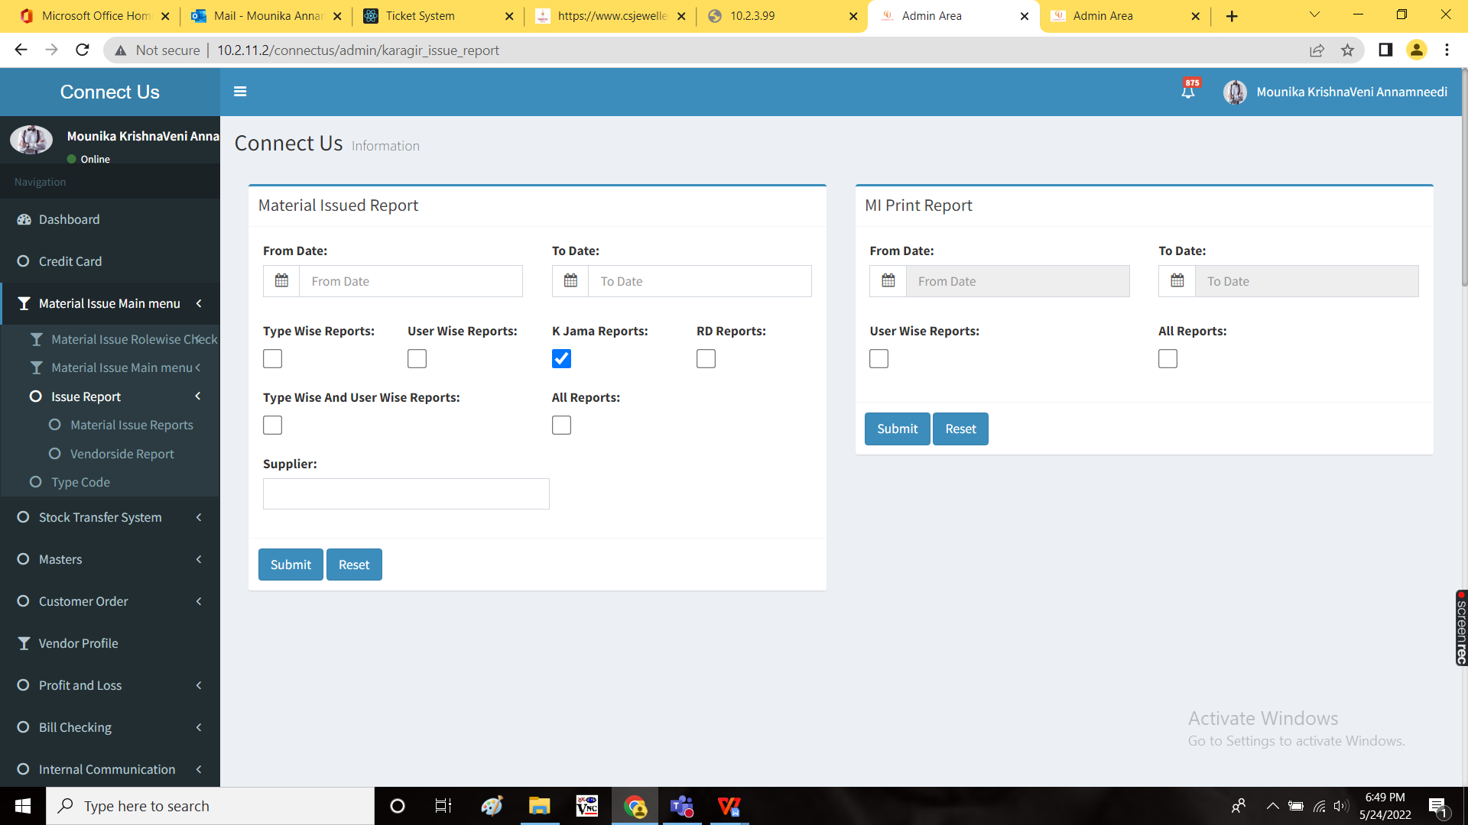

Report is displayed as follows:

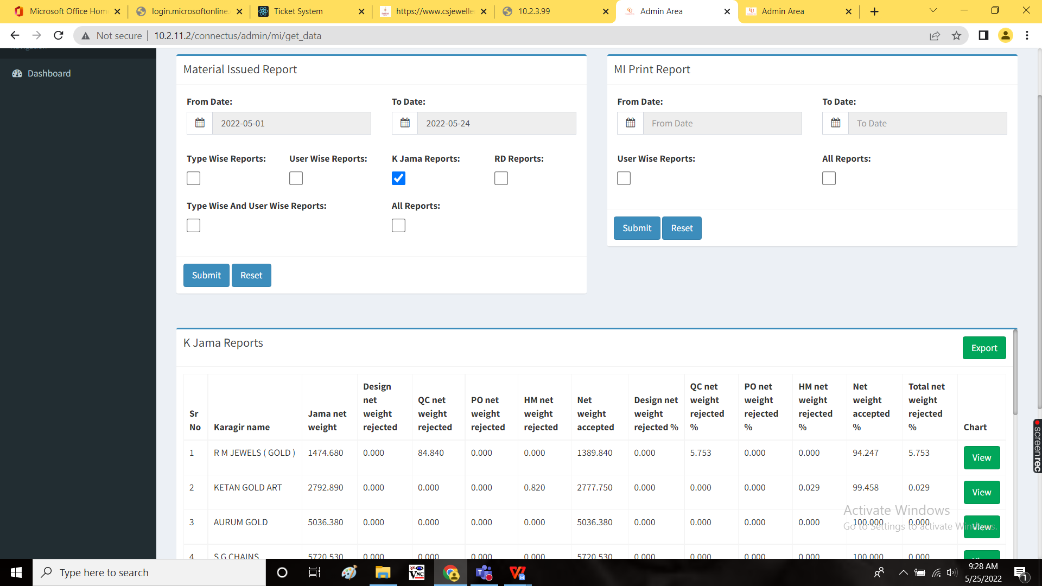

Exported file view:

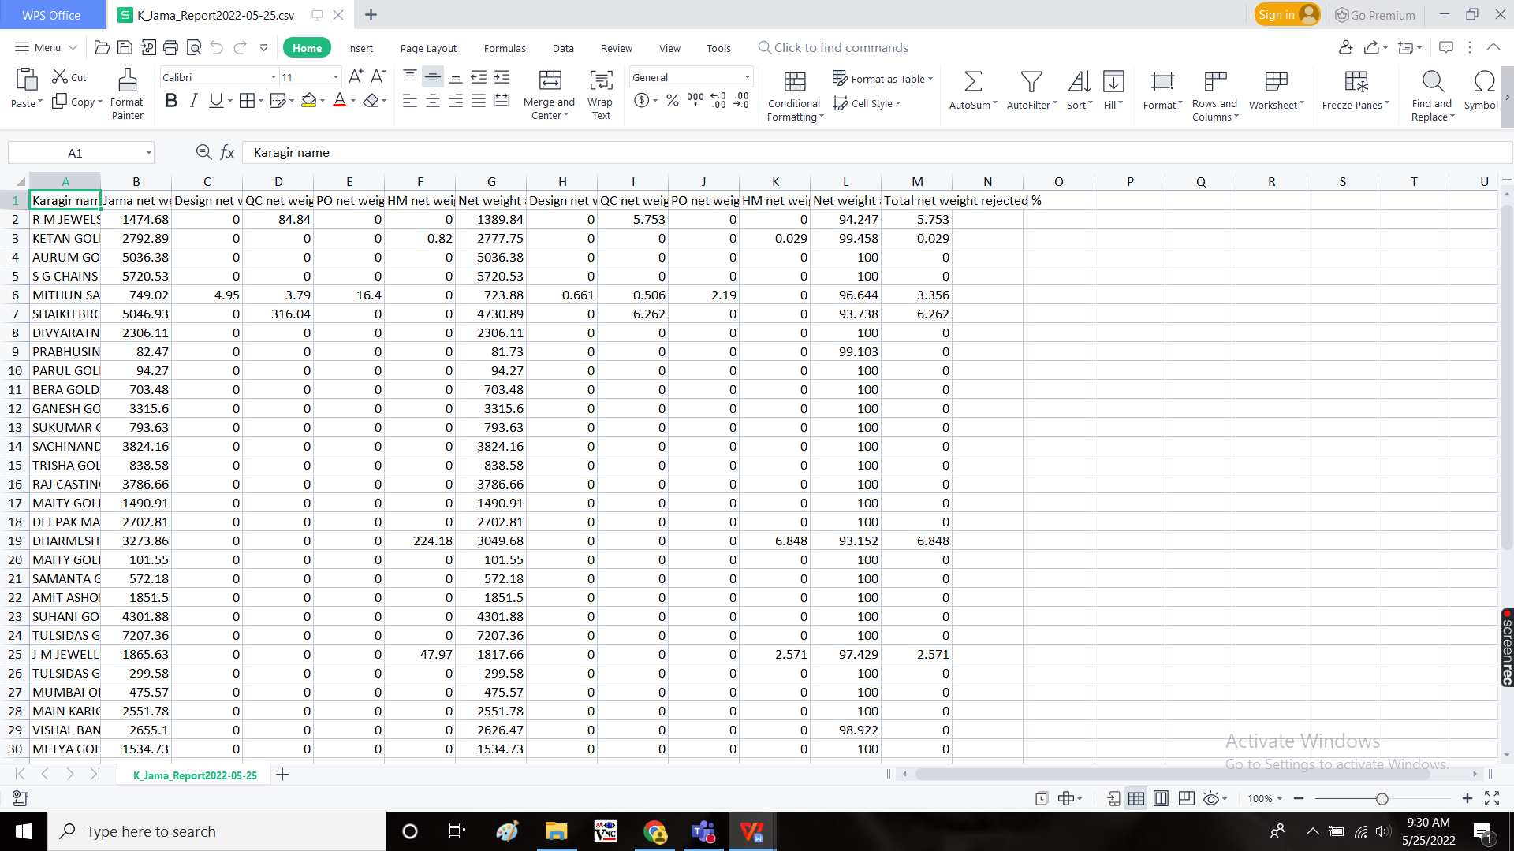

View form of chart:

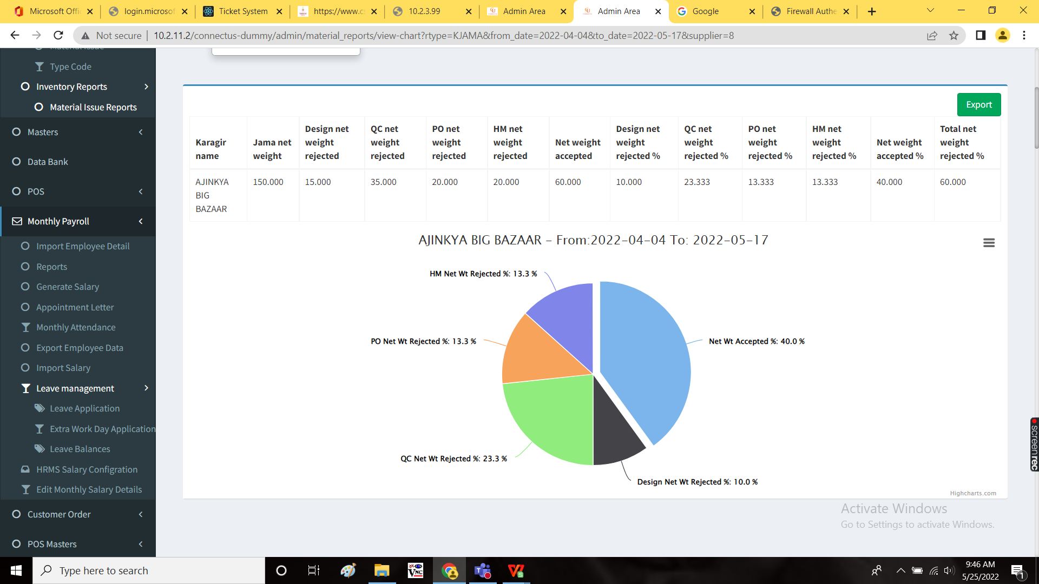

Exported view of chart:

