|  |  |
| --- | --- |
| **Ticket ID** | TT2960 |
| **Ticket description** | 7350250000 Add this tab Marathi and Kannada language number in tab 6 to 9 |
| **Created by** | Vishal Shantinath Patil |
| **Created on** | 22.06.2022 |
| **Priority** | High |
| **Version** | 1 |

**Version**

|  |  |  |  |  |
| --- | --- | --- | --- | --- |
| **Sr. No** | **Version no** | **Version Date** | **User name** | **User department** |
| 1 | 1 | 23.06.2022 | Vishal Shantinath Patil | Branch Operation Control |

**Approvals**

|  |  |  |
| --- | --- | --- |
| **Field** | **Name of the User** | **Approved date by the user** |
| **Actual User Name** | Vishal Shantinath Patil | 23.06.2022 |
| **Actual User Department** | Vishal Shantinath Patil |  |
| **Organization Name** | CS Jewellers |  |
| **Sign-off** |  |  |
| **Assigned BA** | Mounika KrishnaVeni Annamneedi |  |
| **Assigned Developer** |  |  |
| **Assigned Tester** |  |  |

**Estimation**

|  |  |  |  |  |
| --- | --- | --- | --- | --- |
| **Department name** | **Estimated Time (In hr)** | **Scheduled Date (Starting date )** | **Estimated date** | **Actual delivery date** |
| **BA** | 2 | 23.06.2022 | 23.06.2022 |  |

**Introduction**

Whatsapp application is used for CSPL promotions and information for easy access for the users.

**Business requirement**

The user want to add 6 to 9 options in Marathi and Kannada languages in the whatsapp application.

**Existing system**

The existed system is having only 5 options as of now in 3 languages.

1. Last transaction
2. Current rate
3. Latest e-catalogue
4. Download mobile app
5. Change language

As per the CUID - T201590, 6 to 9 options in only English Language

1. Theme/offer
2. Monthly scheme
3. Store location
4. Toll free

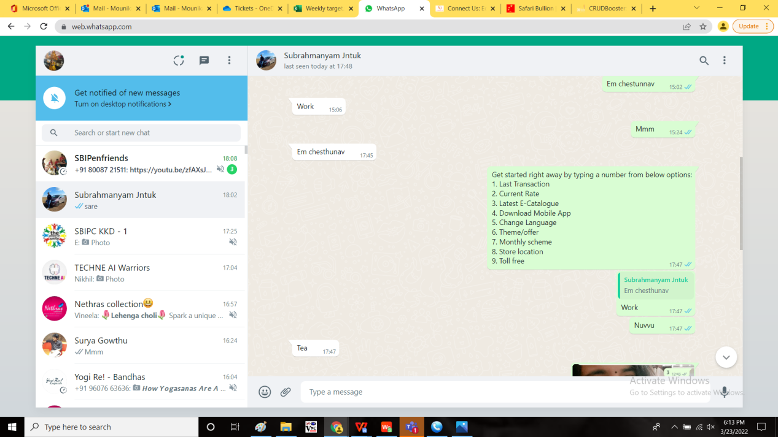

**Proposed System:**

The user wants 6 to 9 options in both Marathi and Kannada language.

The following are the details of both the languages.

Marathi language:

When the user sends “hi” or “10”

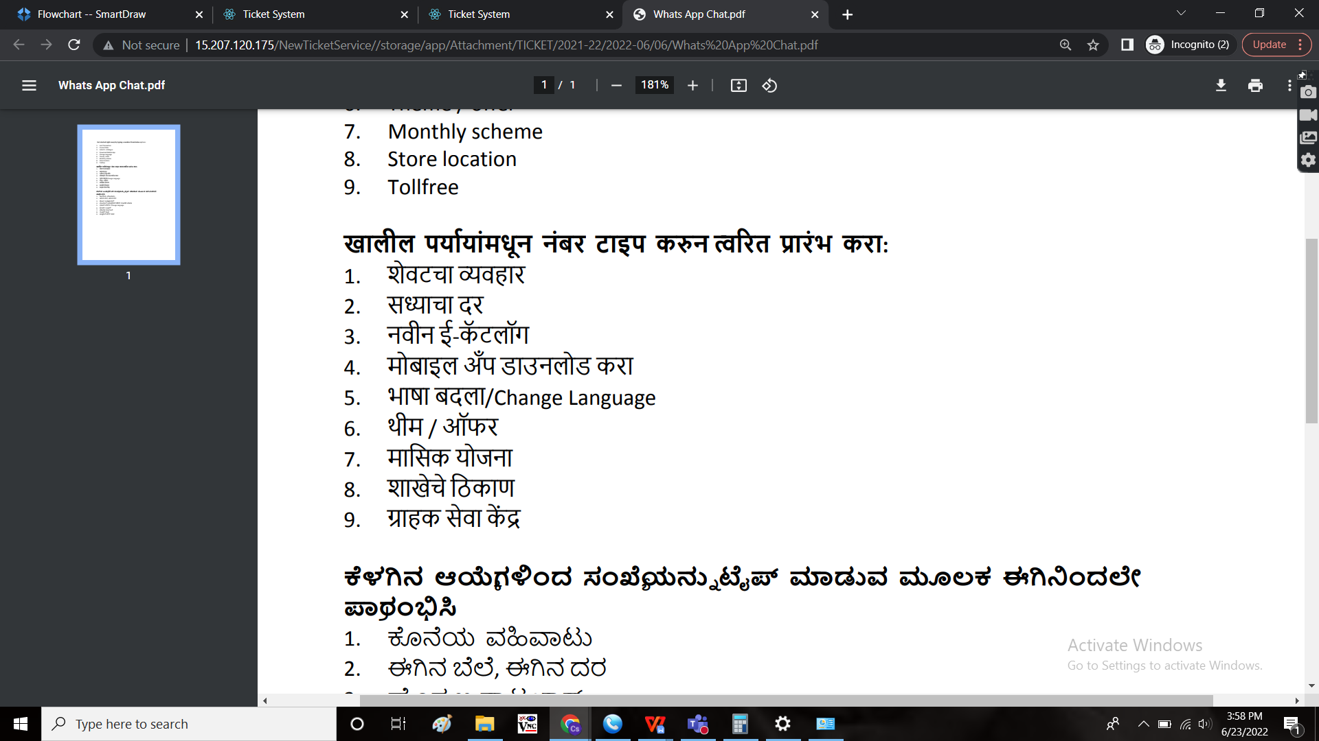

When the user selects 7, links are followed respectively as earlier (as in English)

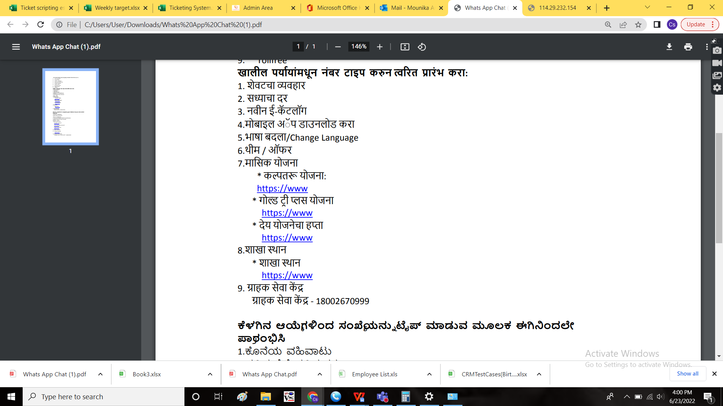

When the user selects 8, links are followed respectively as earlier (as in English)



When the user selects 9, links are followed respectively as earlier (as in English)

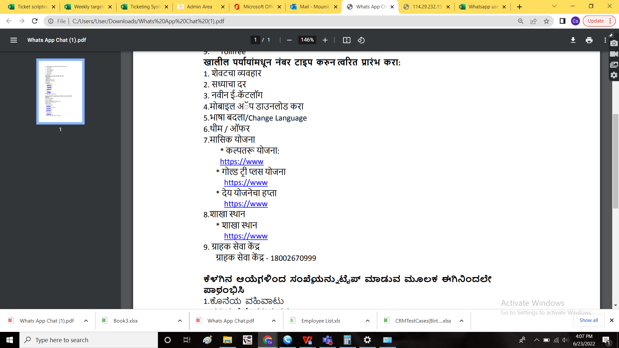

Kannada language:

When the user sends “hi” or “10”

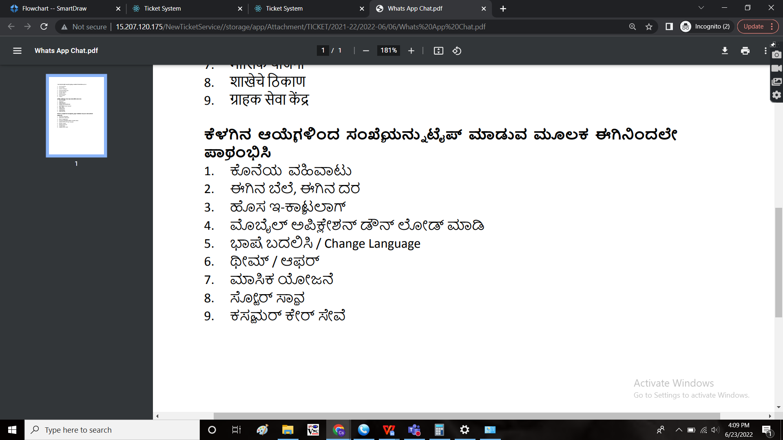

When the user selects 7, links are followed respectively as earlier (as in English)

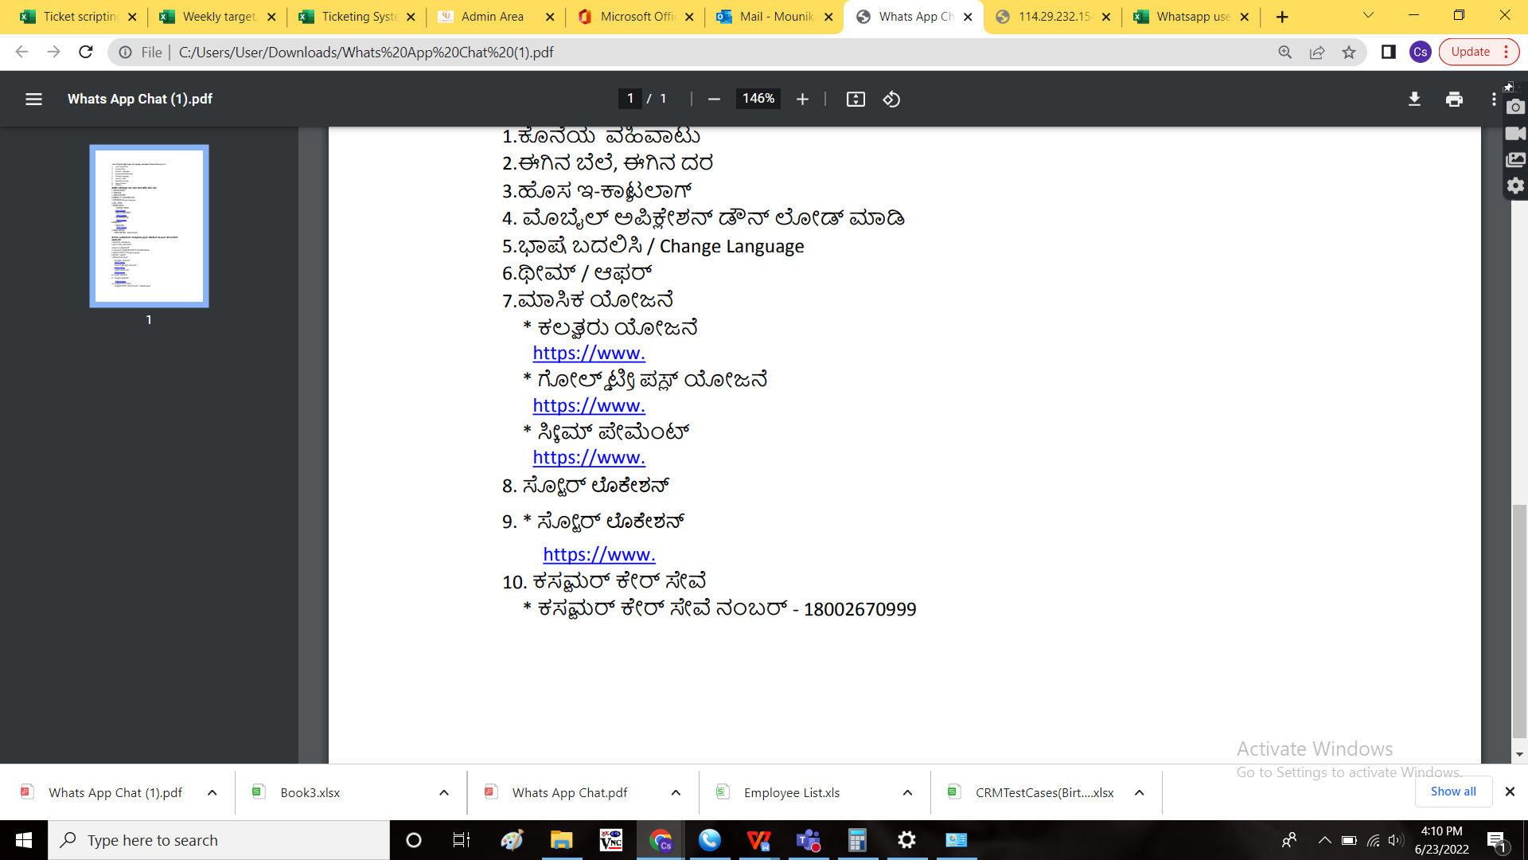

When the user selects 8, links are followed respectively as earlier (as in English)



When the user selects 9, links are followed respectively as earlier (as in English)



**References of the users**

|  |  |  |  |
| --- | --- | --- | --- |
| **User** | **Name** | **Mail** | **Contact number** |
| **Actual user** | Vishal Shantinath Patil |  |  |
| **Assigned business analyst** | Mounika KrishnaVeni Annamneedi | Mounika.annamneedi@techneai.com | 9885900039 |
| **Assigned developer** |  |  |  |
| **Assigned tester** | Monika Kolpe | Monika.kolpe@techneai.com |  |