|  |  |
| --- | --- |
| **Ticket ID** | *T187969* |
| **Ticket description** | *Need to create feedback module in My CS App. So that user can be able to send his/her feedback to concern department.* |
| **Created by** | *Sandeep Vishnu Avchitte* |
| **Created on** | *17 Jan 2022* |
| **Priority** | *High* |
| **Version** | *1.0* |

**Version**

|  |  |  |  |  |
| --- | --- | --- | --- | --- |
| **Sr. No** | **Version no** | **Version Date** | **User name** | **User department** |
| *1* | *1.0* | *17 Jan 2022* | *Aditya Atul Shah* | *E-Commerce* |

**Approvals**

|  |  |  |
| --- | --- | --- |
| **Field** | **Name of the User** | **Approved date by the user** |
| **Actual User Name** | *Aditya Atul Shah* |  |
| **Actual User Department** | *E-Commerce* |  |
| **Organization Name** | *CSPL* |  |
| **Assigned BA** | *Sandeep Vishnu Avchitte* |  |
| **Assigned Developer** | *Goverdhan Bollu/Parth Patel* |  |
| **Assigned Tester** | *Rohan Magar* |  |

**Estimation**

|  |  |  |  |  |
| --- | --- | --- | --- | --- |
| **Department name** | **Estimated Time (In hr)** | **Scheduled Date (Starting date )** | **Estimated date** | **Actual delivery date** |
| **BA** |  |  |  |  |
| **Development** |  |  |  |  |
| **Testing** |  |  |  |  |

**Introduction**

*User need a feedback module in MY CS App.*

**Business requirement**

*User need a feedback module in MY CS App. So that he/she can be able to send his/her feedback to concern person.*

**Existing system**

*Currently no provision is available to send user feedback in MY CS App.*

**Proposed system**

* ***Front-end***

*At very first, User should be able to get Feedback menu option when he/she will tap on hamburger button as shown in below image.*

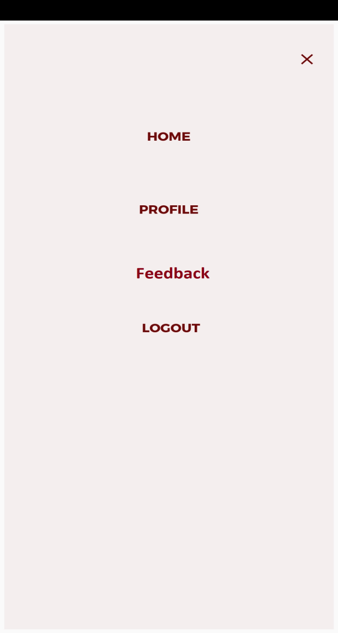

*Image 1: Feedback menu button*

*Now when user will tap on feedback option button then he/she should be able get below form to fill his/her feedback (refer image 2).*

***Feedback To*** *-*

*In this form, When user will tap feedback To filed then he/she should be able to get concern department names (HR, Management) in the drop down and user should be able to select the name as per his choice.*

*\*\*Please note that this field is mandatory to fill and person names should fetch from Management Master.*

***Description*** *-*

*Now, After this user should be able to type his/her feedback in description box.*

*\*\*Please note that description box should accept small-capital alphabets, numbers, special characters, Devnagari (Marathi/Hindi) font and words limit should be 1000. Also, this field is mandatory to fill.*

***Audio Record*** *: User should be able to record his voice when he/she will tap on speaker button and after completion of the recording the same recording user should be able to submit and send.*

*The voice recording should be happened only when user will tap and hold the speaker button.*

*\*\*Please not that the maximum size of the recording should be 500MB.*

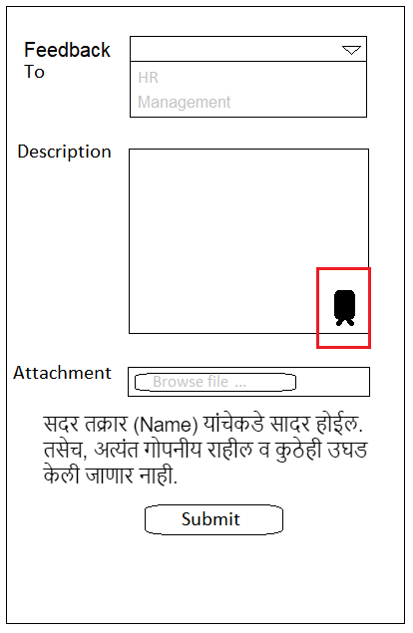

*Image 2: Feedback form*

***Attachment*** *- User should be able to attach various types/formats of documents/files in the attachment as shown in the below table.*

|  |  |
| --- | --- |
| ***File Type*** | ***File Format with max size*** |
| *Image* | *.png, .jpeg, .jpg* |
| *File* | *.csv, .xls, .xlsx, .doc, .pdf, .ppt* |
| *Audio* | *.wav, .aiff, .au* |
| *Video* | *.mp4* |

*\*\*Please note that when user will select any name from the drop down option then* ***“सदर तक्रार (Concern Person Name) यांचेकडे सादर होईल. तसेच, अत्यंत गोपनीय राहील व कुठेही उघड केली जाणार नाही.”*** *pop-up message should be appear below the attachment as shown in the above image (refer image 2).*

***Submit*** *- After all this details filling done user should be able to submit the same and when user will tap on submit button pop-up message should be appear on screen that* ***“Are you sure want to submit ?”*** *followed by* ***“Yes or No”*** *buttons****.***

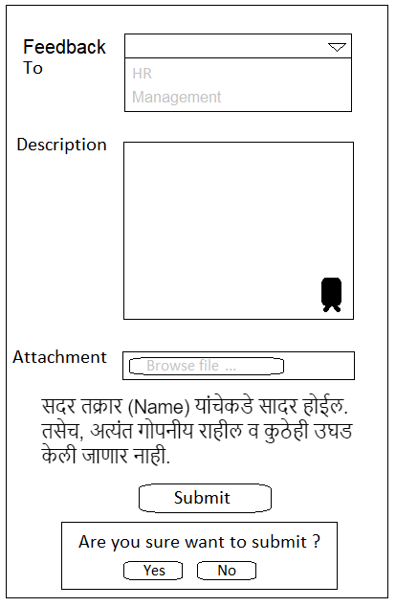

*Image 3: Submit pop-up message*

*When user will tap on “****Yes”*** *button then details should be send in the form of mail on the selected person’s email id (pre-define in the backend I.e. Connect Us). And* ***“Your feedback has been submitted successfully !”*** *pop-up message should be populate on the screen (refer image 4).*

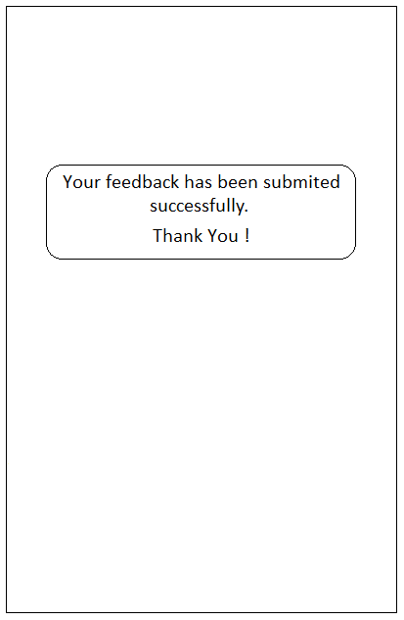

*Image 4: Feedback submission pop-up*

* ***Mail Format/Draft*** *-*

*Mail Subject -* ***#Feedback***

*Attachment: If any\**

*Feedback By : Name of the sender.*

*Dear Sir,*

*(Description - Form description)*

***Thanks & Regards,***

***Employee name,***

*\*\*Please note that mail should be sent by [no-reply@csjewellers.com](mailto:no-reply@csjewellers.com) mail id.*

* ***Back-end***

***HRMS Department master*** *- Connect us -> master -> general master -> HRMS Department master add new field* ***“Show on App - Yes/No”****. If yes then show employee list, which employee against email id is present in the Connect us -> master -> general master -> employee master.*

***Action -***

1. ***View*** *- User should be able to view the all the grid view details for that particular record only.*
2. ***Edit*** *- User should be able to edit all the grid view details except department (disable) for that particular record only.*
3. ***History*** *- User should be able to check the all the grid view details for that particular record only. I.e. All the activity log to that particular record only.*

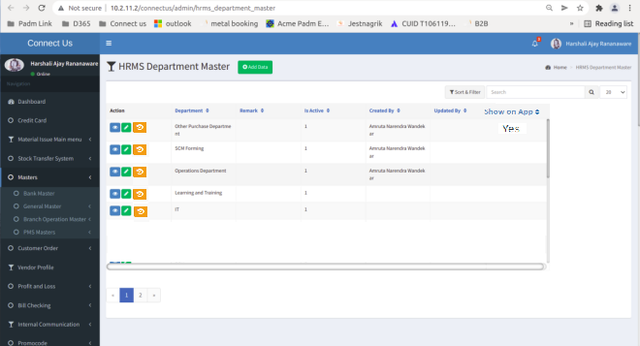

*Image 5: HRMS Department Master*

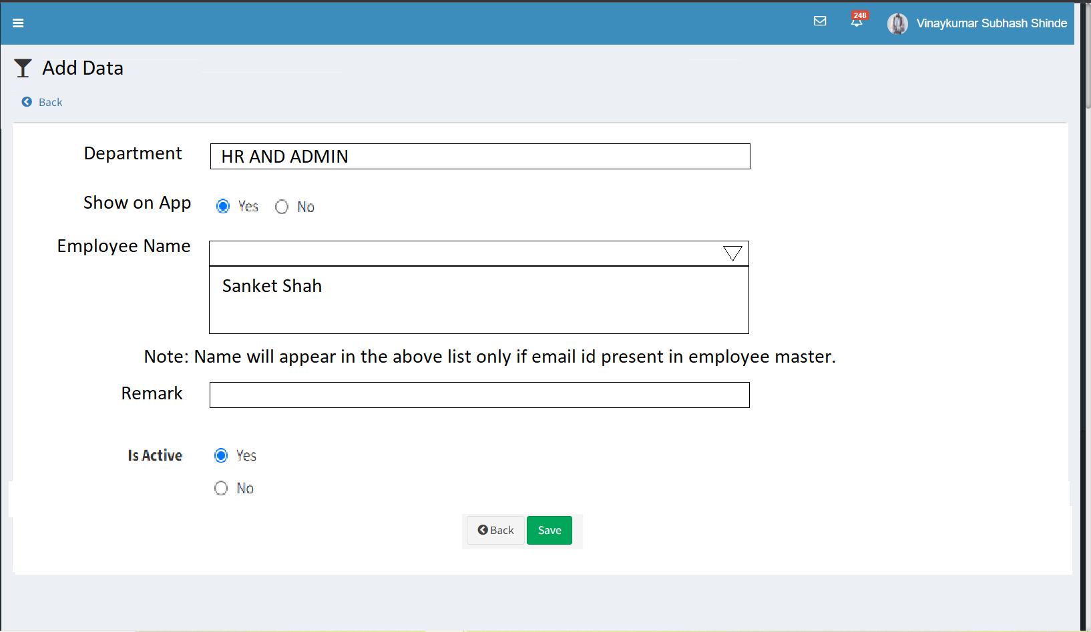

*Image 6: Add Data to HRMS Department Master*

*\*\*Please note that here as shown in the above image the employee name should fetch in the list only if email id is present in the employee master (Please refer below image). Also,* ***“Department”*** *field is mandatory if user selects* ***“Yes”*** *radio button for* ***“Show on App”*** *option.*

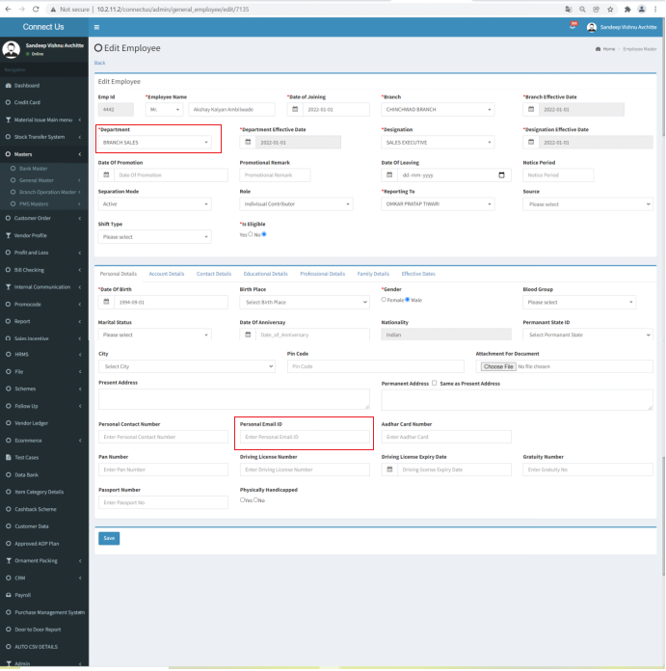

*Image 7: Note reference*

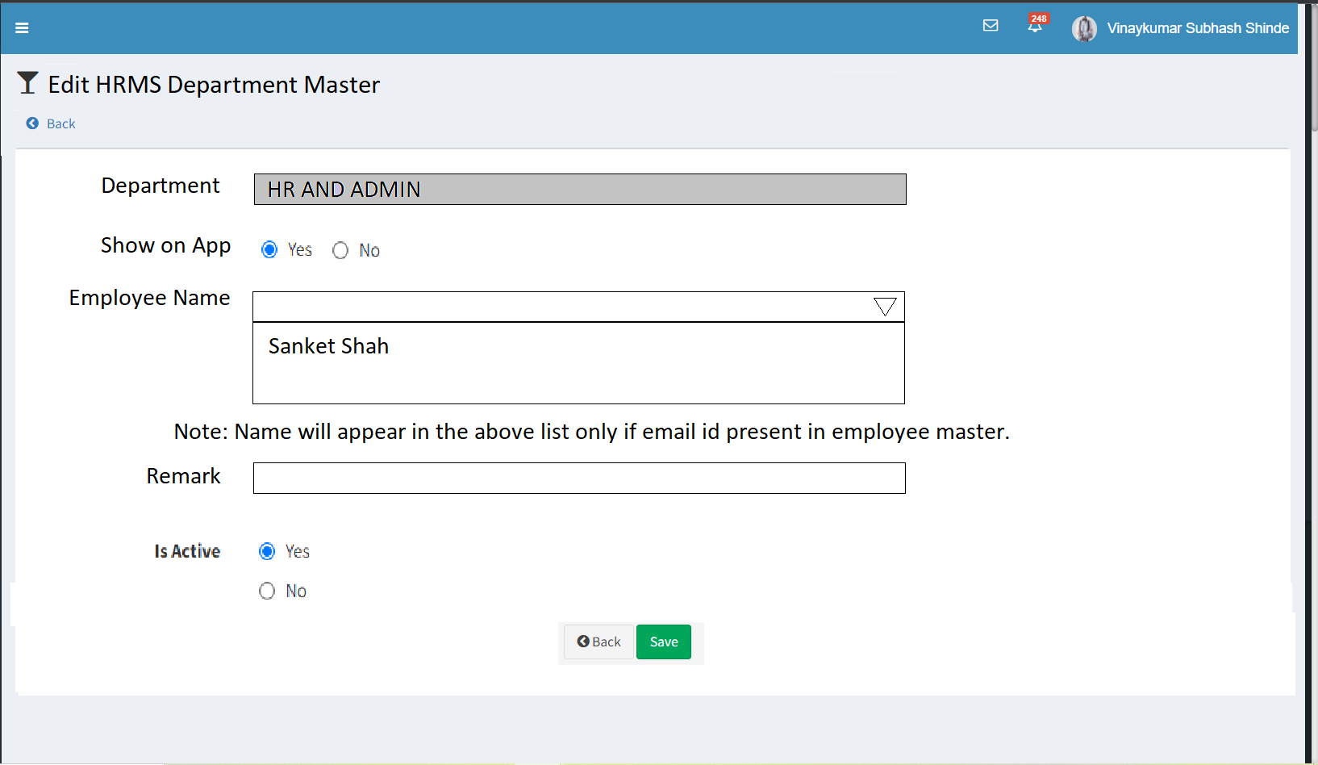

*Image 8: Edit HRMS Department Master*

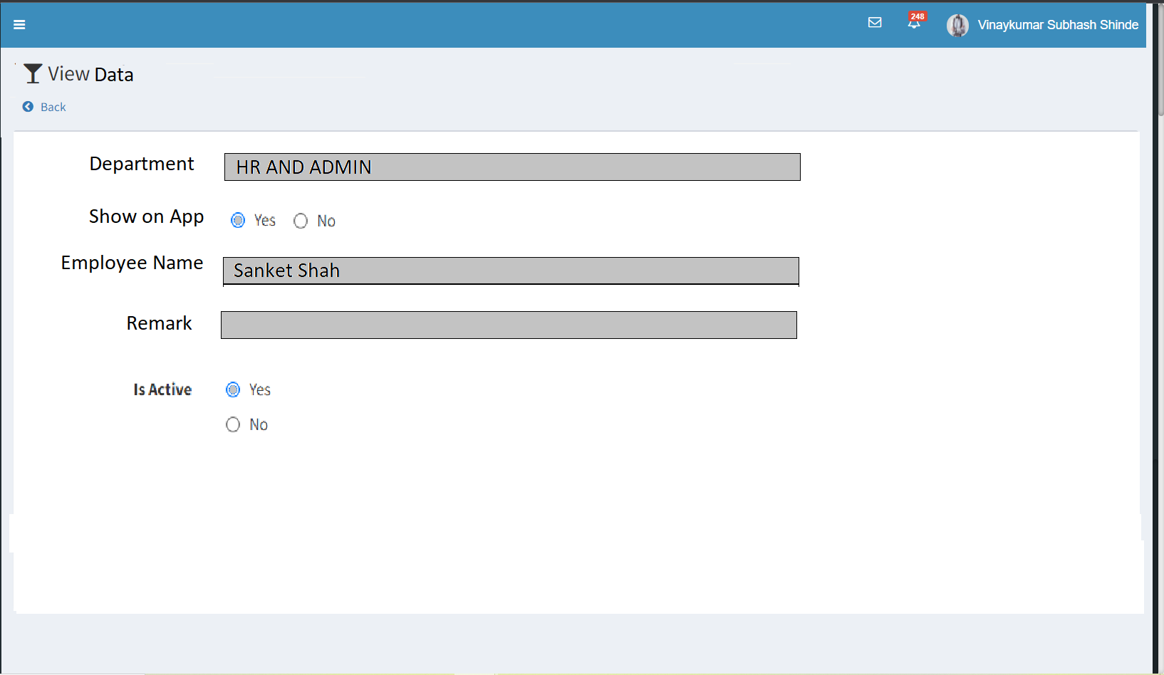

*Image 9: View HRMS Department Master data*

***Database***

*Here, In the database description should be stored in encrypted format only. No one should be able to read the description data.*

***For example*** *- #!%^@*%&!^*Y&^((*_*

**References of the users**

|  |  |  |  |
| --- | --- | --- | --- |
| **User** | **Name** | **Mail** | **Contact number** |
| **Actual user** | *Aditya Atul Shah* | *[aditya@techneai.com](mailto:aditya@techneai.com)* | *2983* |
| **Assigned business analyst** | *Sandeep Avchitte* | *[Sandeep.avchitte@techneai.com](mailto:Sandeep.avchitte@techneai.com)* | *2965* |
| **Assigned developer** | *Parth Patel and Goverdhan Bollu* | *[Parth.patel@techneai.com](mailto:Parth.patel@techneai.com) and goverdhan.bollu@techneai.com* | *2965* |
| **Assigned tester** | *Rohan Magar* | *Rohan.magar@techneai.com* | *2965* |