|  |  |
| --- | --- |
| **Ticket ID** | T198700 |
| **Ticket description** | Connectus Madhe Weight Checking Module Madhe Pcs Wrong Show Hot Aahet Te Clear Karun Dene (Bangle, Mani, Etc) |
| **Created by** | Tushar Shivaji Nikam |
| **Created on** | 12/02/2022 |
| **Priority** | Medium |
| **Version** | 0 |

**Version**

|  |  |  |  |  |
| --- | --- | --- | --- | --- |
| **Sr. No** | **Version no** | **Version Date** | **User name** | **User department** |
| 1 | 0 | 17.02.2022 | Tushar Shivaji Nikam | Inventory Silver HO |

**Approvals**

|  |  |  |
| --- | --- | --- |
| **Field** | **Name of the User** | **Approved date by the user** |
| **Actual User Name** | Tushar Shivaji Nikam | 12.02.2022 |
| **Actual User Department** | Inventory Silver HO |  |
| **Organization Name** | C S Jewellers |  |
| **Sign-off** |  |  |
| **Assigned BA** | Mounika KrishnaVeni Annamneedi | 12.02.2022 |
| **Assigned Developer** |  |  |
| **Assigned Tester** |  |  |

**Estimation**

|  |  |  |  |  |
| --- | --- | --- | --- | --- |
| **Department name** | **Estimated Time (In hr)** | **Scheduled Date (Starting date )** | **Estimated date** | **Actual delivery date** |
| **BA** | 3 | 17.02.2022 | 17.02.2022 |  |
| **Development** |  |  |  |  |
| **Testing** |  |  |  |  |

**Abbreviations & terms**

Pcs - pieces

**Business requirement**

In weight checking module, the pieces should be replaced with the items.

**Existing system**

In the present system, the pieces are presented in the weight checking.

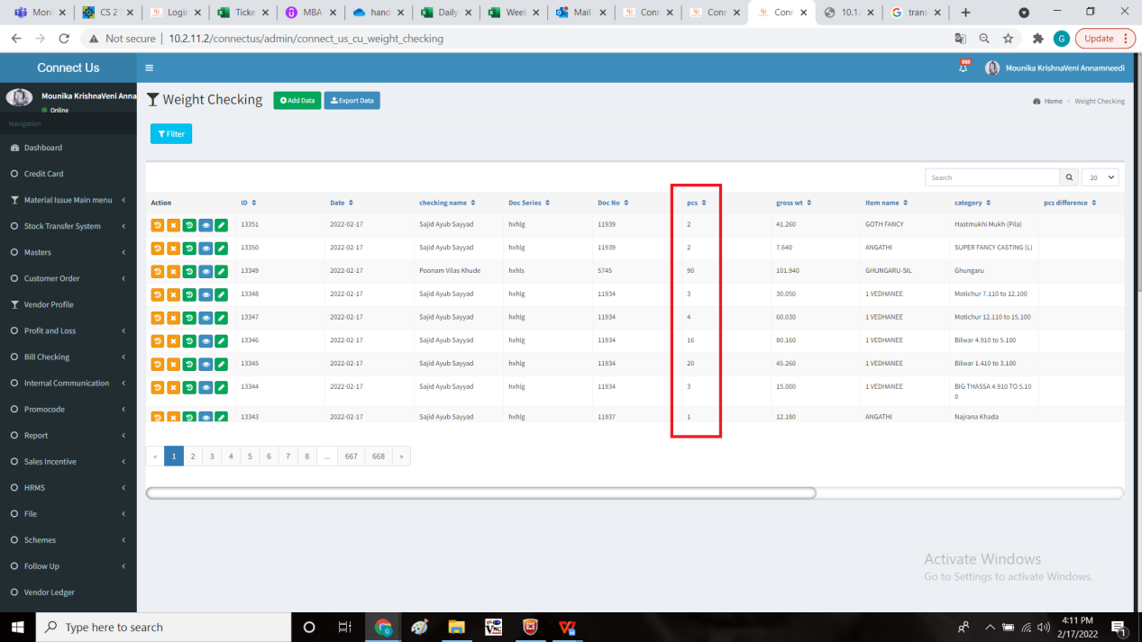

**Proposed system**

* Change the pieces to items in weight checking against barcode.

Step-1

In connect us -> weight checking module -> weight checking.

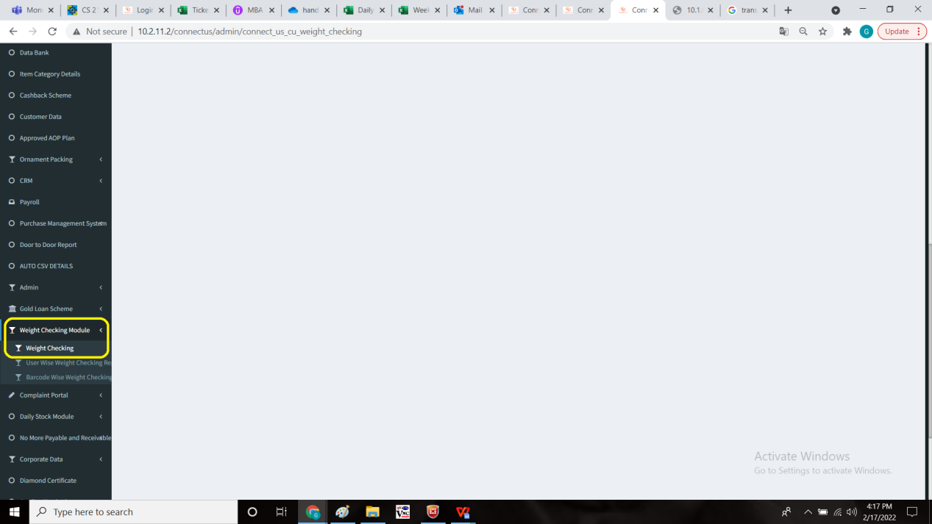

Change the pieces to items against the barcode.

The items are fetched from padm -> documents -> labelling voucher

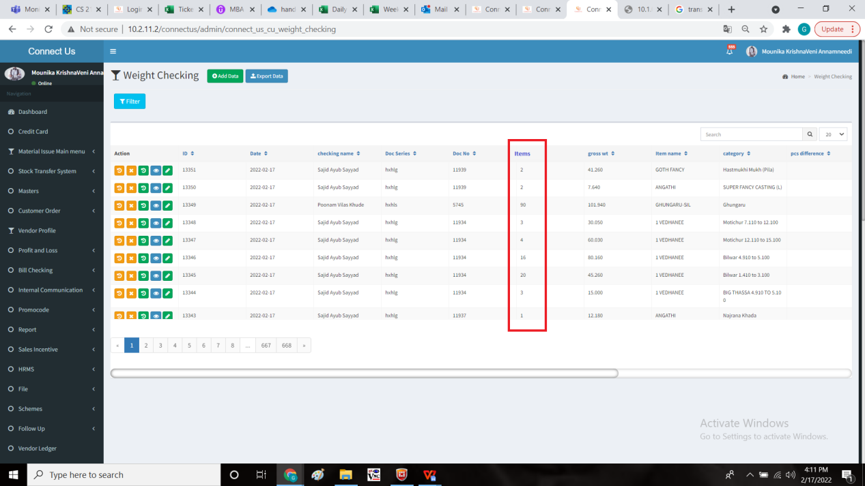

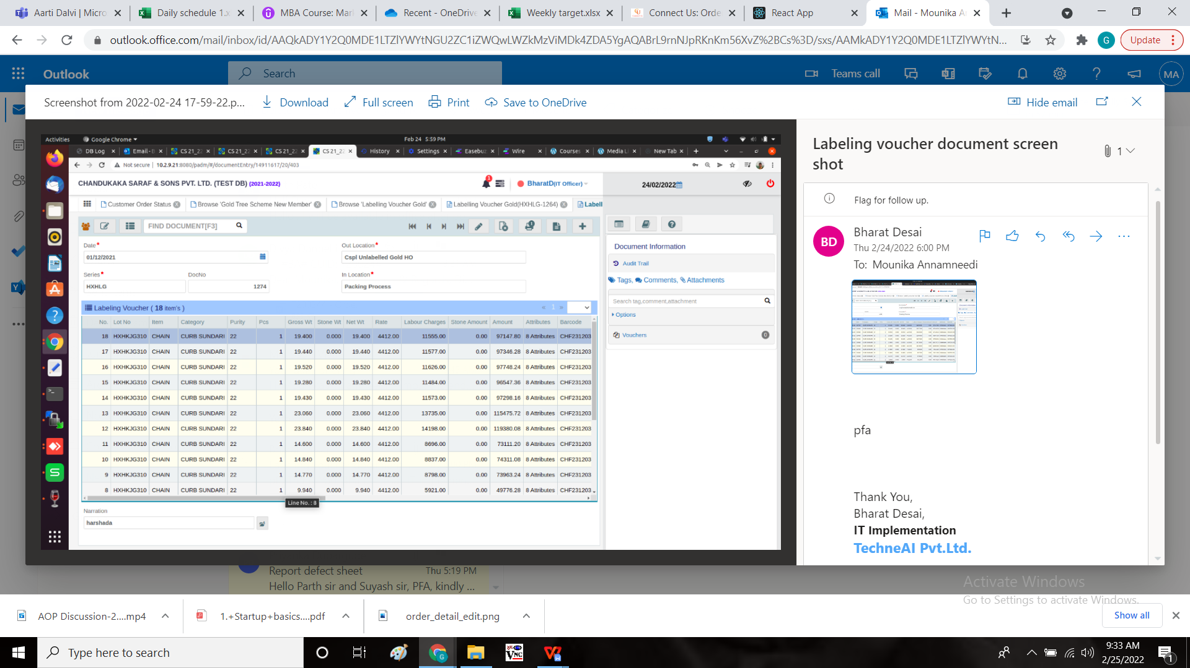

**References of the users**

|  |  |  |  |
| --- | --- | --- | --- |
| **User** | **Name** | **Mail** | **Contact number** |
| **Actual user** | Tushar Shivaji Nikam | designgd@csjewellers.com |  |
| **Assigned business analyst** | Mounika KrishnaVeni Annamneedi | Mounika.annamneedi@techneai.com | 8669917920 |
| **Assigned developer** |  |  |  |
| **Assigned tester** |  |  |  |