|  |  |
| --- | --- |
| **Ticket ID** | *T195288* |
| **Ticket description** | *Bulk Upload & Confirmation Menu Madhe Existing Column Madhe Bill Number Cha New Column Add Karun Milava* |
| **Created by** | *Shahrukh rashid pathan* |
| **Created on** | *15-02-2022* |
| **Priority** | *medium* |
| **Version** | *0* |

**Version**

|  |  |  |  |  |
| --- | --- | --- | --- | --- |
| **Sr. No** | **Version no** | **Version Date** | **User name** | **User department** |
| **1** | **0** | **15-02-2022** | **Shahrukh Rashid Pathan** | **I & O audit** |

**Approvals**

|  |  |  |
| --- | --- | --- |
| **Field** | **Name of the User** | **Approved date by the user** |
| **Actual User Name** | Shahrukh Rashid Pathan |  |
| **Actual User Department** | I & O audit |  |
| **Organization Name** | Cspl |  |
| **Assigned BA** | Akash rewade |  |
| **Assigned Developer** | Nikhil bhosale |  |
| **Assigned Tester** | Maruti hakke |  |

**Estimation**

|  |  |  |  |  |
| --- | --- | --- | --- | --- |
| **Department name** | **Estimated Time (In hr)** | **Scheduled Date (Starting date )** | **Estimated date** | **Actual delivery date** |
| **BA** |  |  |  |  |
| **Development** | 6 hr |  |  |  |
| **Testing** |  |  |  |  |
|  |  |  |  |  |

**Introduction**

*New requirement*

**Business requirement**

User want add new bill number & customer name column in bulk upload and confirmation widget so that It will help reduce time .

1 ) In CU > Internal communication > Admin > User need Bill number and customer name column ( optional field ) in below field

1- Add data

2 -Edit data

3 -View Data

4- Download

5 - Bulk upload format

6 - upload attachment format

1. upload attachment
2. History

2) In CU> Internal communication > Confirmation > User need Bill Number & customer name column .

1- Add data

2 -Edit data

3 -View Data

4- Download

5 - Bulk upload format.

6 - Upload attachment format.

7- Upload attachment

**Abbreviations & terms**

*Connect us > CU*

**Existing system**

In Existing system Bill number & Customer name Column is not in system

**Proposed system**

1 ) In CU > Internal communication > Admin > User need Bill number column & customer name column below field

1- Add data

2 -Edit data

3 -View Data

4- Download

5 - Bulk upload format

6 - Upload attachment format

1. History

* **Add data**

In Cu > Internal communication > admin > click on add data > User want Bill number field (Optional ) & customer name Shown in Image 1 & Image 2.

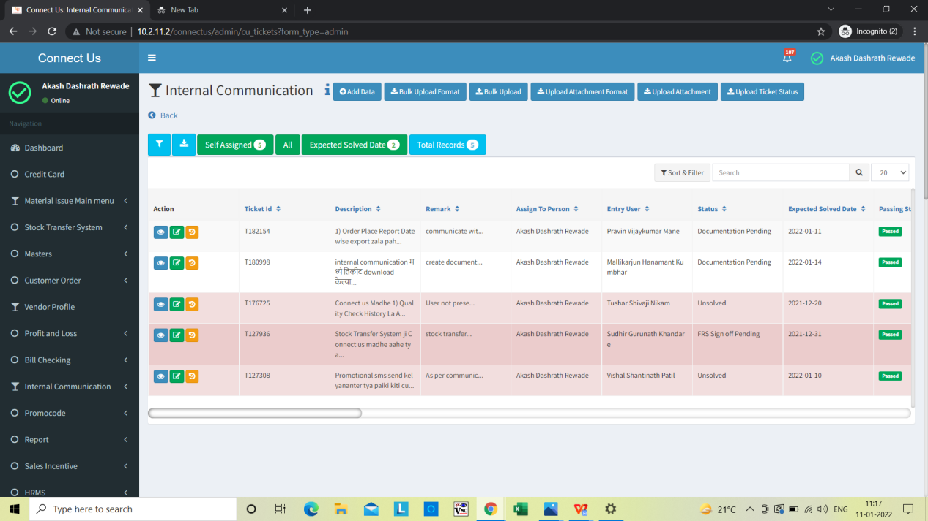

Click on add data

Image 1

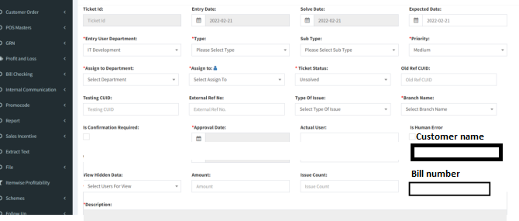

Image 2

* View data

In Cu > Internal communication > admin > Action > view data User want Bill number and customer name column (Optional ) Shown in Image 3

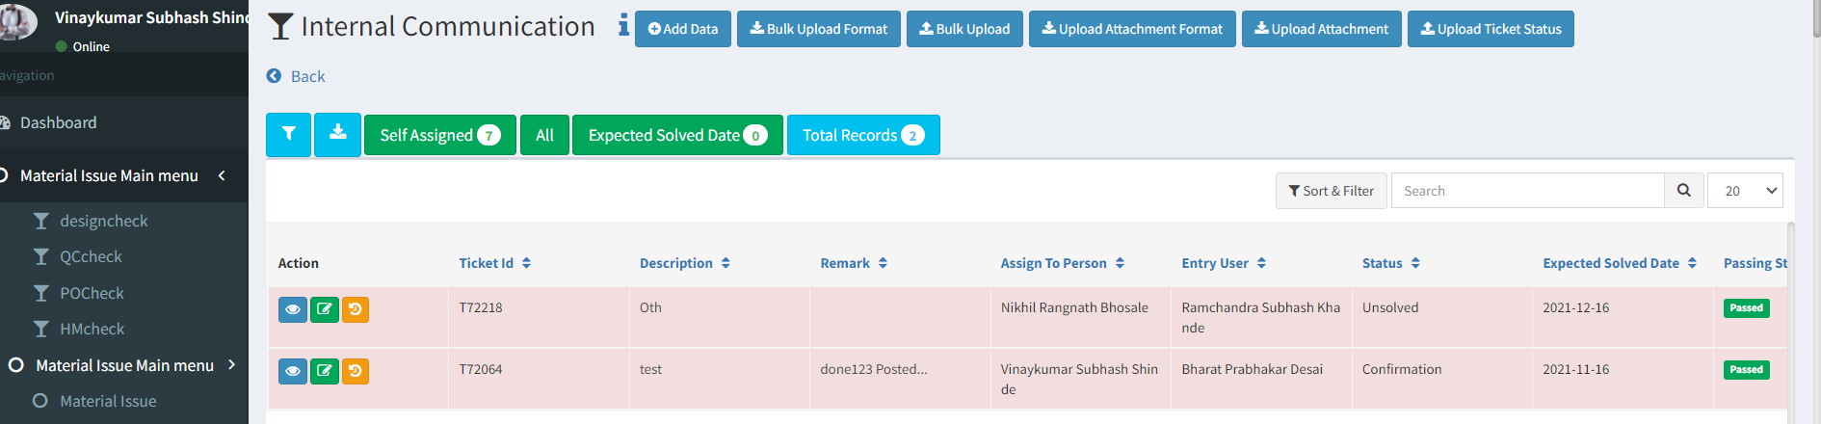

Click on view data

**+**

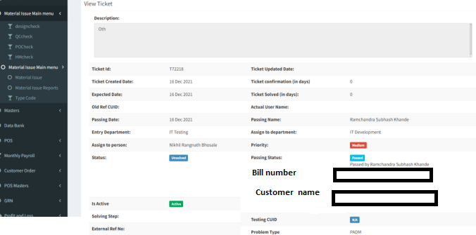

Bill number field & Customer name

Image 3

* **Edit -** In Cu > Internal communication > admin > Action > Edit User want Bill number & Customer name (Optional ) Shown in Image 4



Click on edit

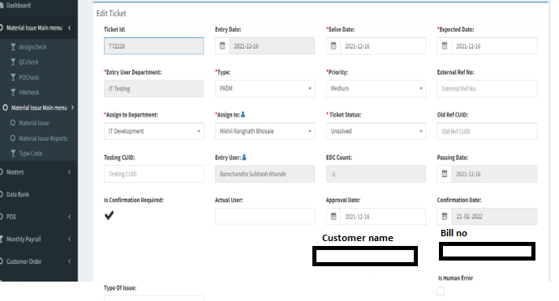

Image 4

Customer name and bill no field

* Bulk upload format-

In CU > Internal communication > admin > click on bulk upload format User want Bill number & customer name column (Optional ) as Shown in Image 5 . 

Click on bulk upload Formate

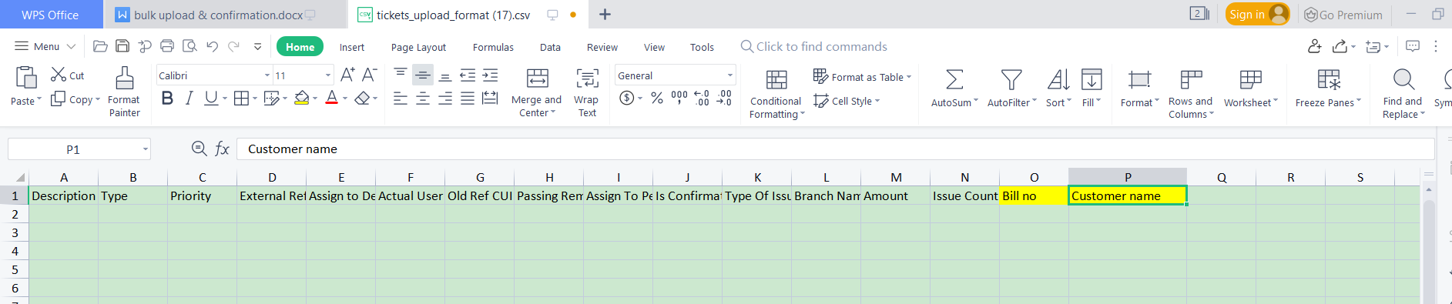

Bill number column and customer name cplumn

Image 5

* Download

In CU > Internal communication > admin > click on download User want Bill number and customer name column(Optional ) as Shown in Image 6.



Click on download

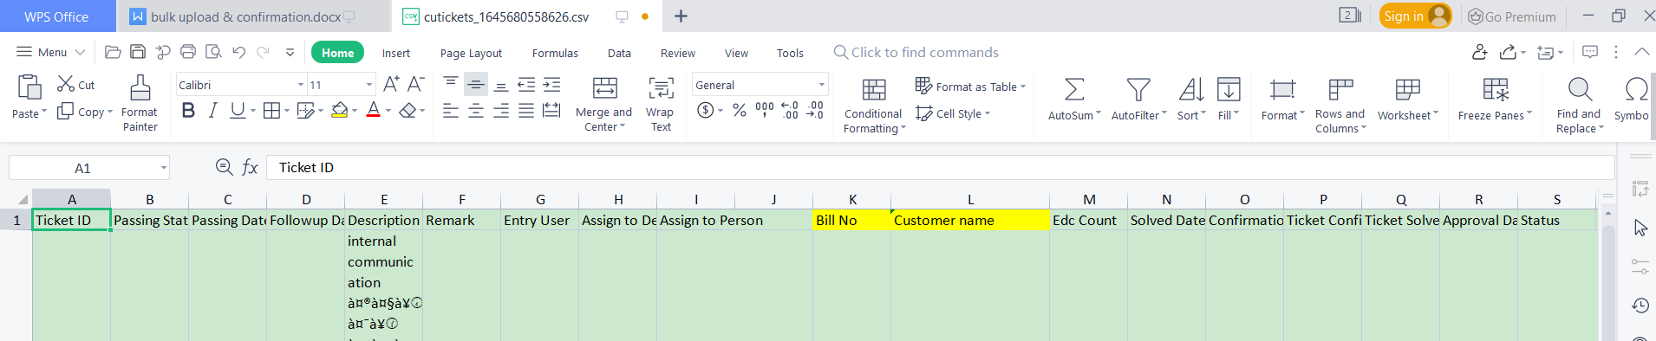

Bill number & customer name Column

Image 6

* Upload attachment format

In CU > Internal communication > admin > Upload attachment format User want Bill Number column and customer name column (Optional ) Shown in Image 7 .



Click on upload attach format

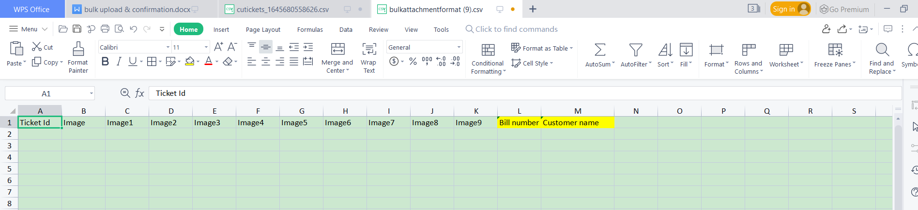

Bill number & customer name

Image 7

* History

In CU > Internal communication > admin > click on History Bill number and customer name column (Optional ) Shown in below Image.



Click on history

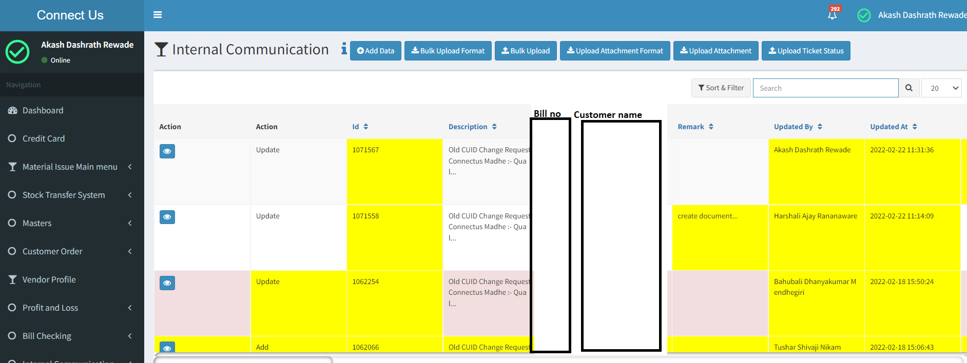

**Confirmation**

1 ) In CU > Internal communication > confirmation> User need Bill number and customer name column in below field

1- Add data

2 -Edit data

3 -View Data

4- Download

5 - Bulk upload format

6 - Upload attachment format

* Add Data

In CU > Internal communication > confirmation> Click on Add data User need Bill number column and customer name column as shown in Image 8.

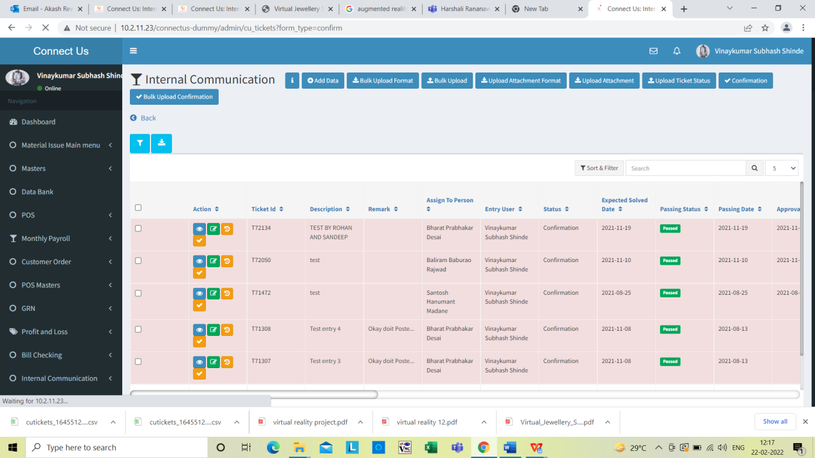

Click on Add data



Image 8

* Edit

In CU > Internal communication > confirmation> Click on Edit data User need Bill number and customer name column as shown in Image 9

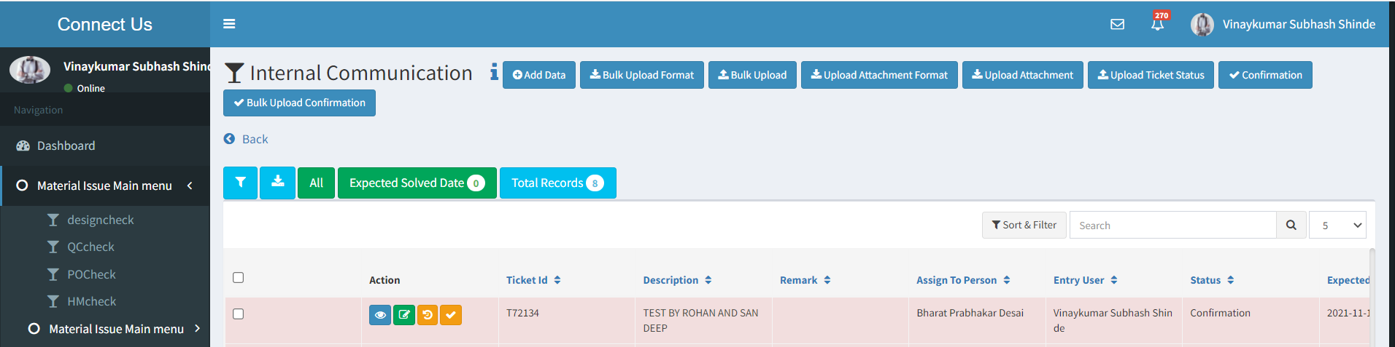

Click on edit



Image 9

* View data

In CU > Internal communication > confirmation> Click on view data User need Bill number and customer name column as shown in Image10



Click on view data



Image 10

* Download

In CU > Internal communication > confirmation> Click on download User need Bill number and customer name column as shown in Image 11



Click on download



Bill no & customer name column

Image 11

* Bulk upload format

In CU > Internal communication > confirmation> Click bulk upload format User need Bill number & customer name column as shown in Image 12 .





Bill no & customer name column

Image 12

* Upload attachment format

In CU > Internal communication > confirmation> Click upload attachment format User need Bill number & customer name column as shown in Image 13.





Bill no & customer name

Image 13

* History -

In CU > Internal communication > confirmation> Click History User need Bill number & customer name column as shown in Image 14



Click on History



Image 14

**References of the users**

|  |  |  |  |
| --- | --- | --- | --- |
| **User** | **Name** | **Mail** | **Contact number** |
| **Actual user** | *Shahrukh rashid pathan* |  |  |
| **Ticket created by (if any)** |  |  |  |
| **Assigned business analyst** | Akash Rewade | Akash.rewade@techneai.com |  |
| **Assigned developer** | Nikhil bhosale | Nikhil.bhosale@techneai.com |  |
| **Assigned tester** | Maruti hakke | Maruti.hakke@techneai.com |  |