1

|  |  |
| --- | --- |
| **Ticket ID** | *T176732* |
| **Ticket description** | *Need to add Collection Field in B2B App* |
| **Created by** | *Sandeep Avchitte* |
| **Created on** | *07/12/2021* |
| **Priority** | *Very High* |
| **Version** | *0* |

**Version**

|  |  |  |  |  |
| --- | --- | --- | --- | --- |
| **Sr. No** | **Version no** | **Version Date** | **User name** | **User department** |
| **1** | **0** | **07/12/2021** | **Pravin Mane** |  |

**Approvals**

|  |  |  |
| --- | --- | --- |
| **Field** | **Name of the User** | **Approved date by the user** |
| **Actual User Name** | Pravin Mane |  |
| **Actual User Department** | B2B |  |
| **Organization Name** | CSPL |  |
| **Assigned BA** | Sandeep Avchitte |  |
| **Assigned Developer** | Parth Patel, Govardhan Gollu |  |
| **Assigned Tester** | Maruti Hakke |  |

**Estimation**

|  |  |  |  |  |
| --- | --- | --- | --- | --- |
| **Department name** | **Estimated Time (In hr)** | **Scheduled Date (Starting date )** | **Estimated date** | **Actual delivery date** |
| **BA** |  |  |  |  |
| **Development** |  |  |  |  |
| **Testing** |  |  |  |  |

**Introduction**

*User need to add Collection Filter in B2B App.*

**Business requirement**

*User need to add Collection Filter in B2B App.*

**Existing system**

*Currently there is no provision for Collection Filter in B2B App, Refer below image.*

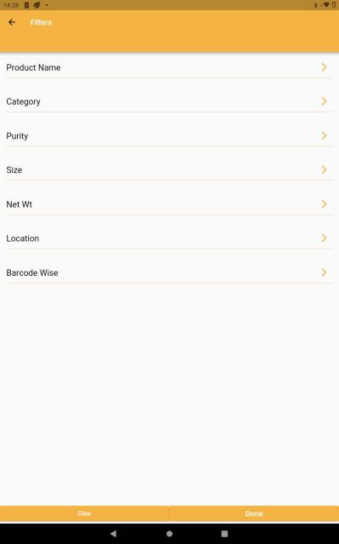

Image 1: Existing B2B App

**Proposed system**

***Back End :***

*Use below link to visit portal:*

*“<http://test.csjewellers.com:81/cspl/admin/product_detail>”*

*Need to create a new collection column in product management --> Product details module as shown in the below image.*

*From here the particular barcode should be fetch to B2B Application (Collection Filter) according to the collection aligned to the barcode.*

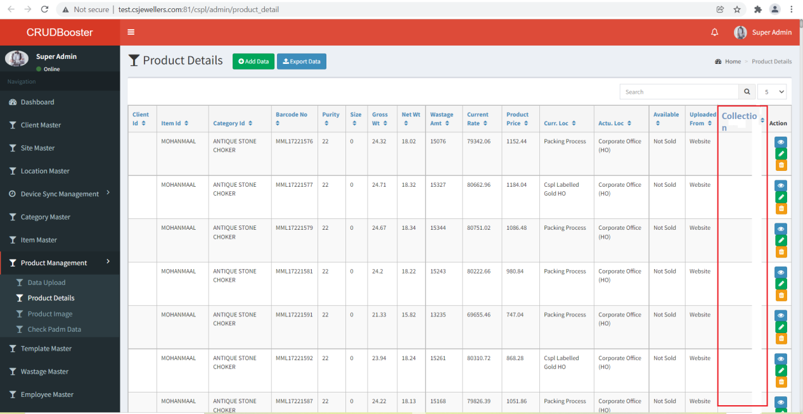

Image 2: Product Details

***Front End (B2B Application) :***

*When user tap on filter button then user should be able to see new added filter named Collection.*

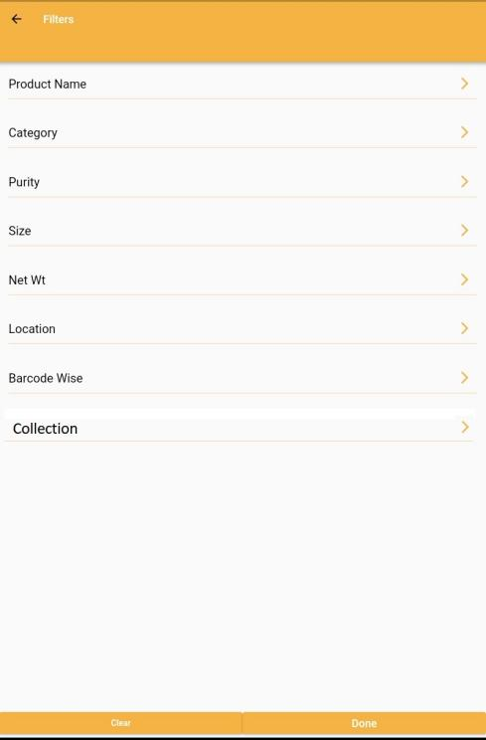

Image 3: Collection

*In which user should be able to see the collection names which should be fetched from product details (back-end).*

*For Instance,*

*Collection names - Wedding 2021, Amulya, Naira, etc.*

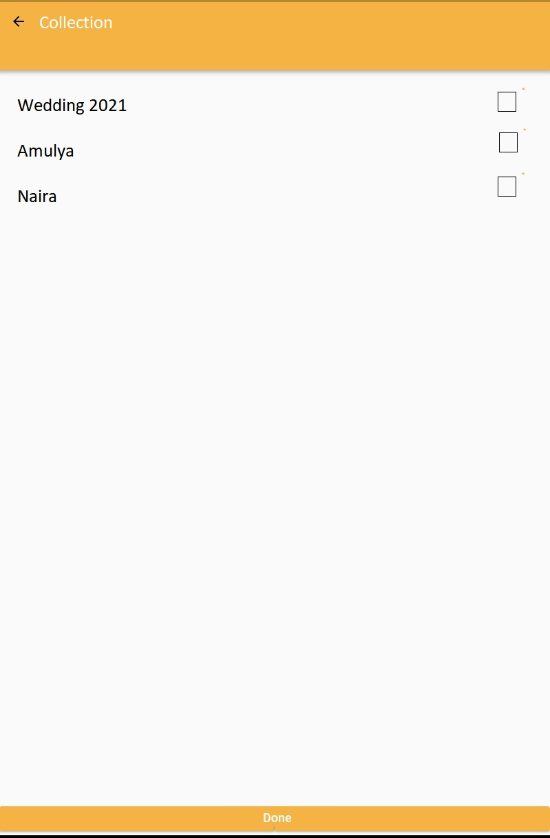

Image 4: After tap on collection field

*After tap on single or multiple check box user should be able to see the related images to the selected collections as shown in the below image. These images should be view on Home page as shown in the below image.*

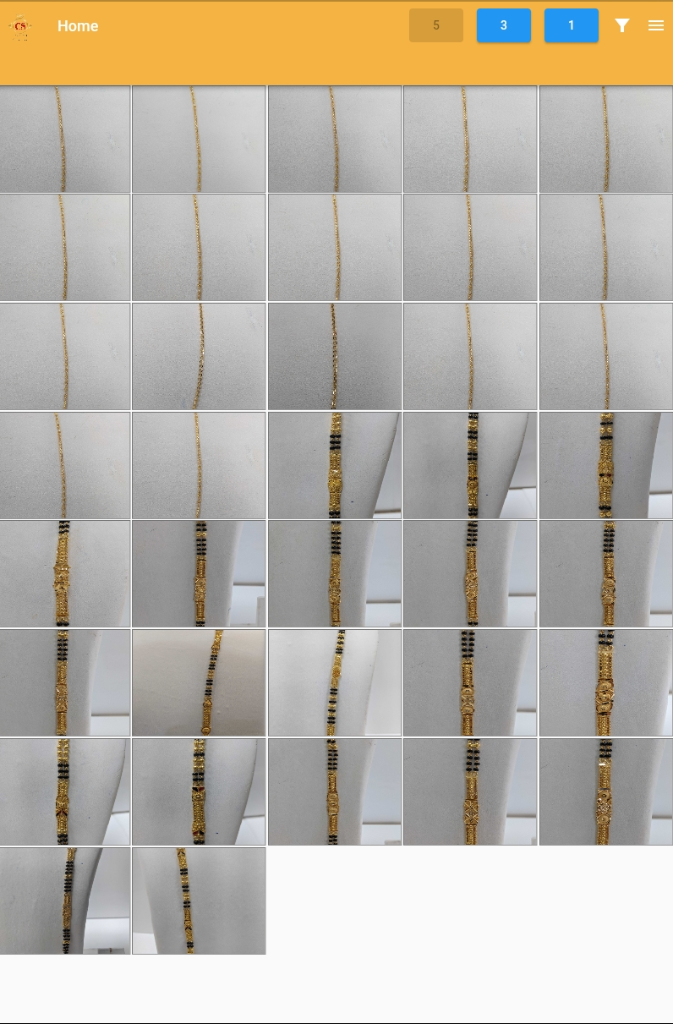

Image 5: Home Page

**References of the users**

|  |  |  |  |
| --- | --- | --- | --- |
| **User** | **Name** | **Mail** | **Contact number** |
| **Actual user** | Pravin Mane | b2b@csjewellers.com | 2533 |
| **Assigned business analyst** | Sandeep Avchitte | [Sandeep.avchitte@techneai.com](mailto:Sandeep.avchitte@techneai.com) | 2967 |
| **Assigned developer** | Parth Patel | [Parth.patel@techneai.com](mailto:Parth.patel@techneai.com) | 2965 |
| **Assigned tester** | Maruti Hakke | [Maruti.hakke@techneai.com](mailto:Maruti.hakke@techneai.com) | 2979 |