|  |  |
| --- | --- |
| **Ticket ID** | T215352 |
| **Ticket description** | Connect us madhil Unpass che Point Pass karat astana Download karun Excel Sheet la Export kelyanantar "Is Confirmation Required (Yes/No)" He option tya formar madhye disat nahi tari te Add karun dene. |
| **Created by** | Harshali Rananaware |
| **Created on** | 11 May 2022 |
| **Priority** | Very high |
| **Version** | 2 |

**Version**

|  |  |  |  |  |
| --- | --- | --- | --- | --- |
| **Sr. No** | **Version no** | **Version Date** | **User name** | **User department** |
| 1 | 1 | 28 July 2021 (T124604) | Akshay Bahubali Gandhi | I and O Audit |
| 2 | 2 | 11 May 2022 | Nikita Bramhnath Darure | I and O Audit |

**Approvals**

|  |  |  |
| --- | --- | --- |
| **Field** | **Name of the User** | **Approved date by the user** |
| **Actual User Name** | Nikita Bramhnath Darure |  |
| **Actual User Department** | I and O Audit |  |
| **Organization Name** | CSPL |  |
| **Assigned BA** | Harshali Rananaware |  |
| **Assigned Developer** | Nikhil Bhosale |  |
| **Assigned Tester** | Amreen Shaikh |  |

**Estimation**

|  |  |  |  |  |
| --- | --- | --- | --- | --- |
| **Department name** | **Estimated Time (In hr)** | **Scheduled Date (Starting date )** | **Estimated date** | **Actual delivery date** |
| **BA** | 2 hr | 10 May 22 | 12 May 22 | 11 May 22 |
| **Development** |  |  |  |  |
| **Testing** |  |  |  |  |

**Business requirement**

Connect us madhil Unpass che Point Pass karat astana Download karun Excel Sheet la Export kelyanantar "Is Confirmation Required (Yes/No)" He option tya formar madhye disat nahi tari te Add karun dene.

**Abbreviations & terms :** Connect us - CU , Internal communication -> IC

**Existing system :** The currently , there is provision to bulk pass or reject point.

1. Go to CU -> IC -> unpassed weight.
2. Export to all unpass point ( Export CSV ) then this CSV file change Passing Status set pass and Passing Remark add save these CSV .
3. After Save file upload thought “ Bulk upload Unpass ” and pass all point only.

**Proposed System :**

In CU -> IC -> unpassed widget.

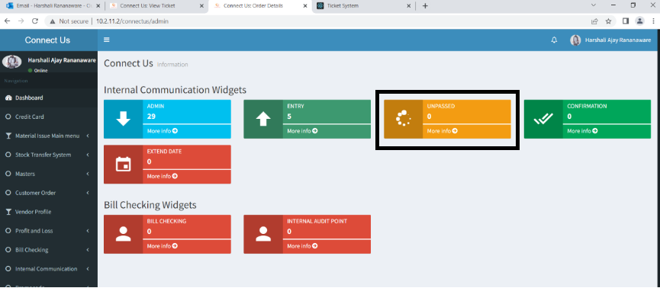

Image 1

Click on “ Bulk upload unpass ” (Refer Image 2) and open a pop up (Refer Image 3) we can upload the CSV file here.

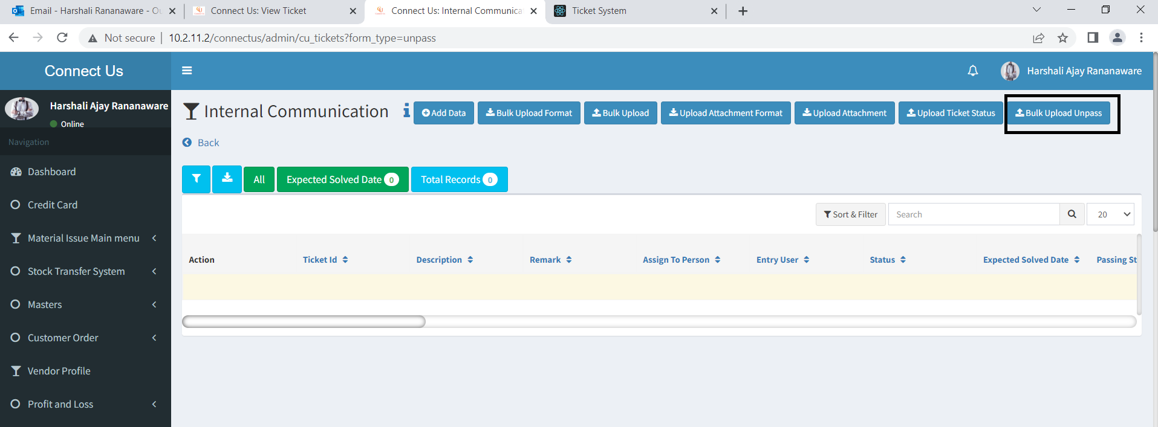

Image 2

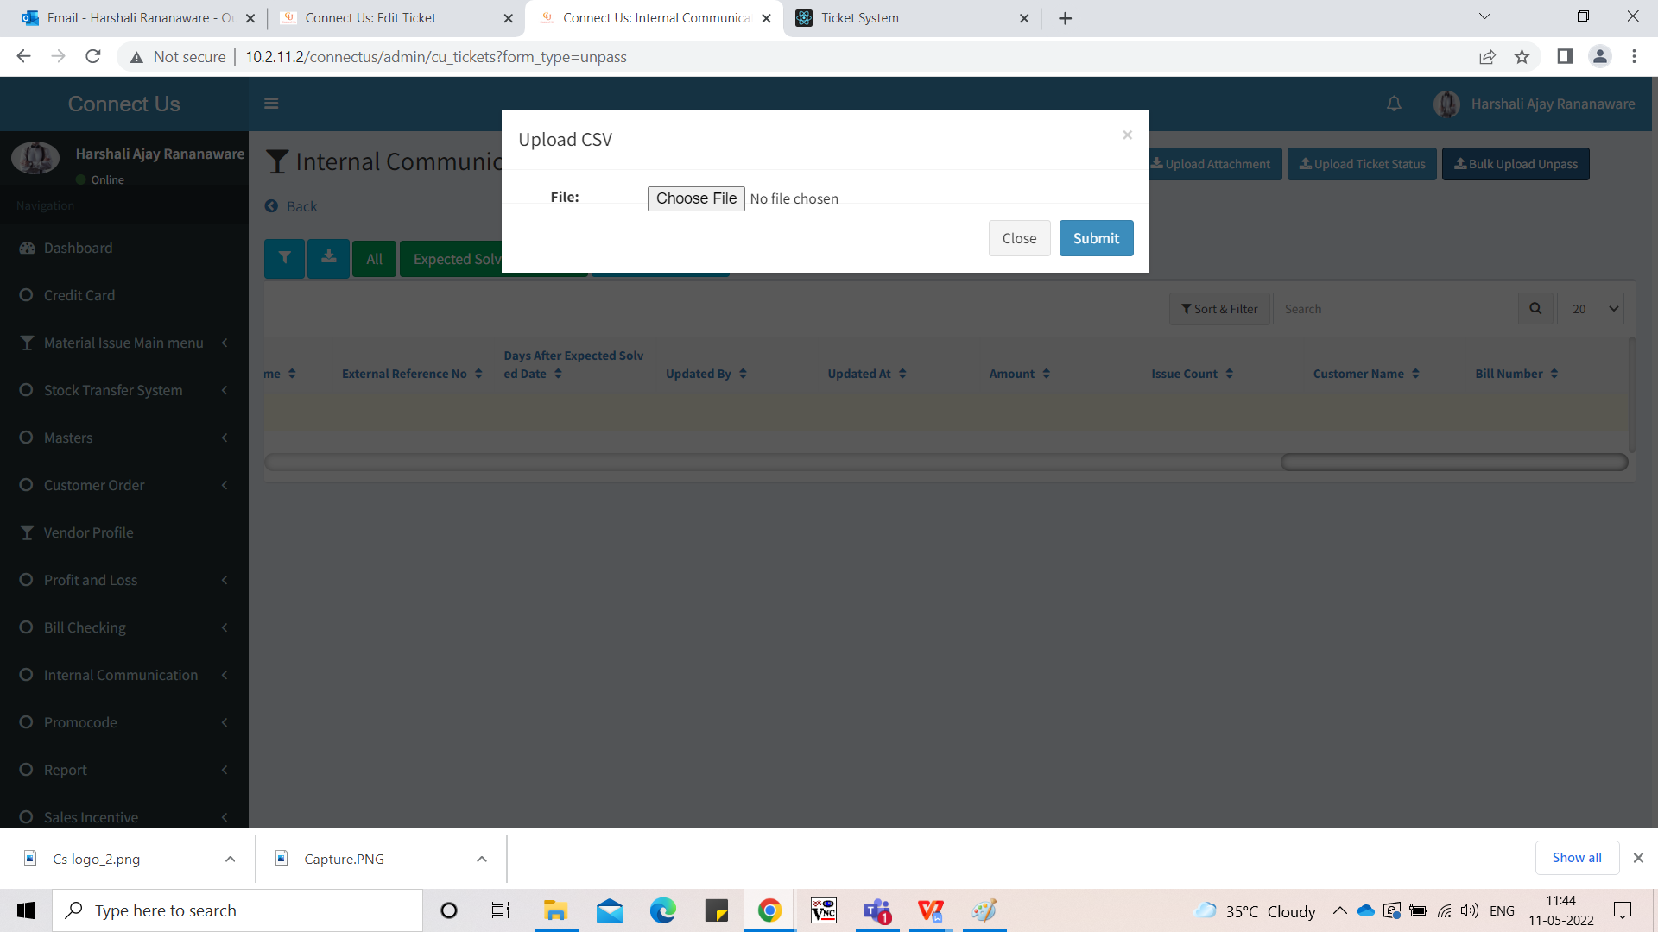

Image 3

In CSV file and grid view add new column “Is Confirmation Required”(Refer Image 4).

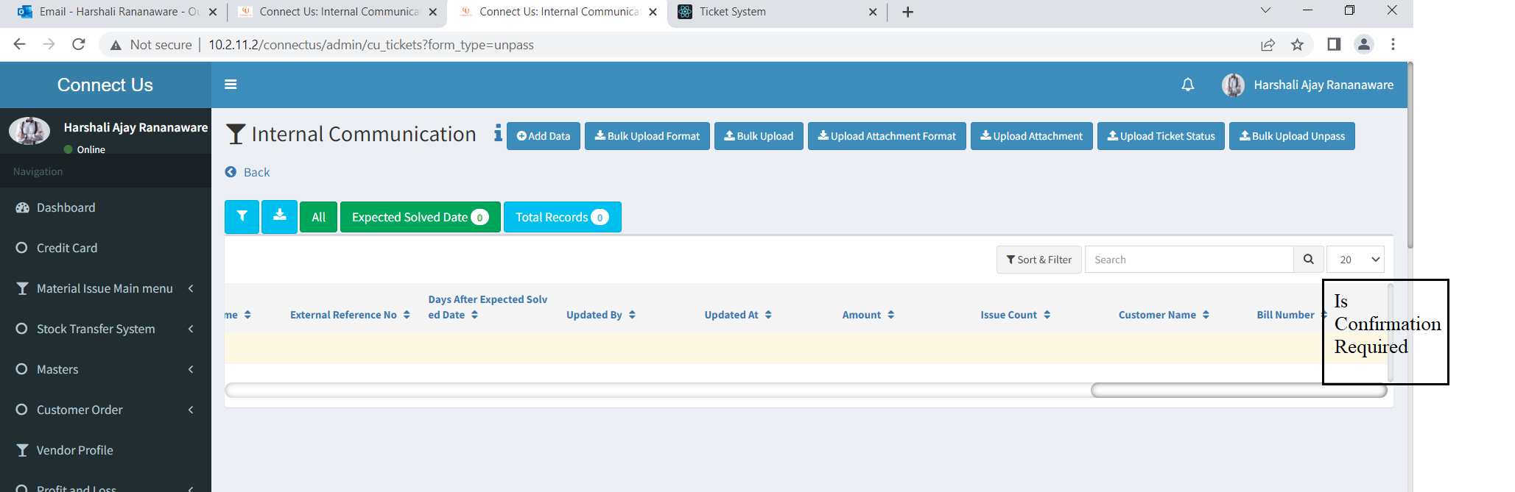

Image 4

This column set the yes the confirmation required (Refer Image 5) or set the no the confirmation not required(Refer Image 6).

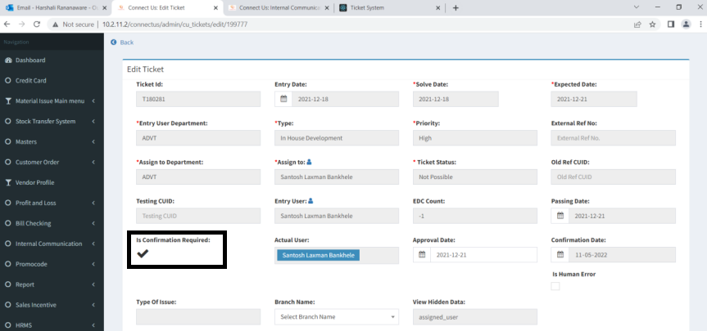

Image 5

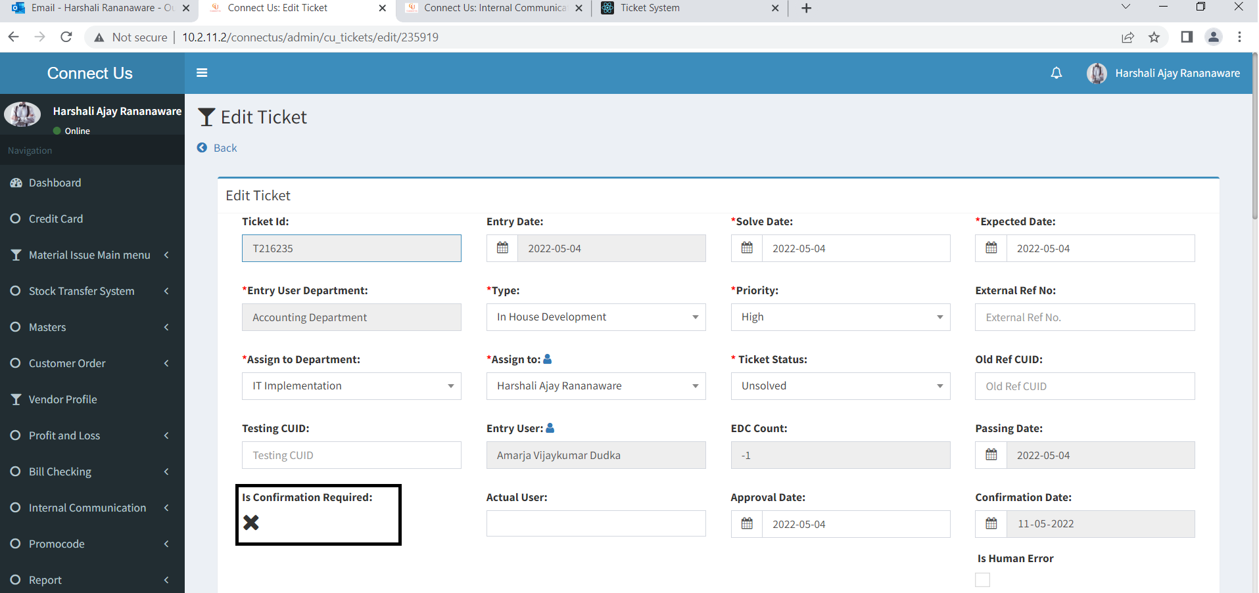

Image 6

**References of the users**

|  |  |  |  |
| --- | --- | --- | --- |
| **User** | **Name** | **Mail** | **Contact number** |
| **Actual user** | Nikita Bramhnath Darure | cctv@csjewellers.com | 2501 |
| **Assigned business analyst** | Harshali Rananaware | [harshali.rananaware@techneai.com](mailto:harshali.rananaware@techneai.com) | 8669917920 |
| **Assigned developer** | Nikhil Bhosale | nikhil.bhosale@techneai.com |  |