|  |  |
| --- | --- |
| **Ticket ID** | *TT2276* |
| **Ticket description** | *Need to add new feature in PRO Application (CSJ CRM) in which the user will be able to select options from where he/she come to know about the CS jeweller.* |
| **Created by** | *Sandeep Avchitte* |
| **Created on** | *14/04/2022* |
| **Priority** | *High* |
| **Version** | *1.0* |

**Version**

|  |  |  |  |  |
| --- | --- | --- | --- | --- |
| **Sr. No** | **Version no** | **Version Date** | **User name** | **User department** |
| *1* | *1.0* | *14/04/2022* | *Aditya Shaha* | *E-commerce* |

**Approvals**

|  |  |  |
| --- | --- | --- |
| **Field** | **Name of the User** | **Approved date by the user** |
| **Actual User Name** | *Aditya Atul Shaha* |  |
| **Actual User Department** | *E-Commerce* |  |
| **Organization Name** | *CSPL/Techne AI Pvt Ltd* |  |
| **Assigned BA** | *Sandeep Avchitte* |  |
| **Assigned Developer** | *Dipak Kulkarni* |  |
| **Assigned Tester** | *Amreen Shaikh* |  |

**Estimation**

|  |  |  |  |  |
| --- | --- | --- | --- | --- |
| **Department name** | **Estimated Time (In hr)** | **Scheduled Date (Starting date )** | **Estimated date** | **Actual delivery date** |
| **BA** |  |  |  |  |
| **Development** |  |  |  |  |
| **Testing** |  |  |  |  |

**Introduction**

*Need to add new feature in PRO Application (CSJ CRM) in which the user will be able to select options from where he/she come to know about the CS jeweller.*

**Business requirement**

*Need to add new feature in PRO Application (CSJ CRM) in which the user will be able to select options from where he/she come to know about the CS jeweller.*

**Existing system**

*Currently there is no such provision available in the PRO Application.*

**Proposed system**

*Need to add new feature in PRO Application (CSJ CRM) in which the user will be able to select options from where he/she come to know about the CS jeweller.*

***Front End***

*In the PRO application, when any customer will visit for jewellery/diamond shopping at any CS jewellers branch. The concern application operator or customer should be able to select below buttons or options.*

1. *News Paper*
2. *Hoarding*
3. *Radio*
4. *SMS / Whatsapp*
5. *Google*
6. *Social Media/Website, Theater, and TV*
7. *Old Customer*
8. *Referral from friend*

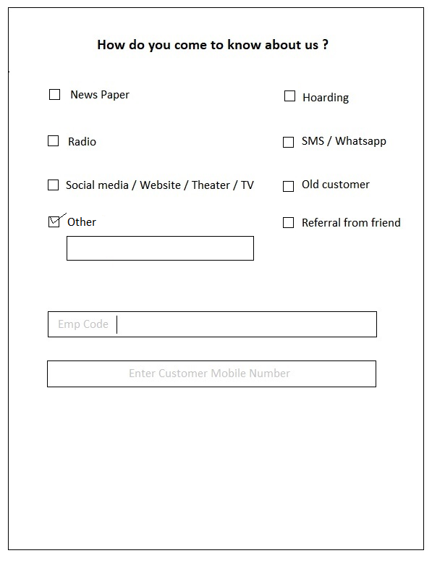

*Image 1: Customer options selection*

*The button selections should be enable customer to select his/her choice for the question* ***“How did you come to know about us?”***

*User should be able to select single or multiple choices at a time.*

*The above submission should be happsen on current functionality only I.e. after entering the emp_id and customer mobile number.*

***Back End (Connect Us)***

*In back-end I.e. at the Connect Us admin/user panel, the admin should be able to generate the report on daily basis or as per his choice I.e. by selecting from date and to date. Also, report should be export in .csv file format. The selection of from date and To date should be mandatory to generate the report.*

**References of the users**

|  |  |  |  |
| --- | --- | --- | --- |
| **User** | **Name** | **E-mail** | **Contact number** |
| **Actual user** | *Aditya Shaha* | *Adiya@techneai.com* | *2983* |
| **Assigned business analyst** | *Sandeep Avchitte* | *[Sandeep.avchitte@techneai.com](mailto:Sandeep.avchitte@techneai.com)* | *2967* |
| **Assigned developer** | *Goverdhan Bollu, Parth Patel* | *[Goverdhan.bollu@techneai.com](mailto:Goverdhan.bollu@techneai.com), parth.patel@techneai.com* | *2967* |
| **Assigned tester** | *Amreen Shaikh* | *[Amreen.shaikh@techneai.com](mailto:Amreen.shaikh@techneai.com)* | *2967* |