|  |  |
| --- | --- |
| **Ticket ID** | T183860 |

**Introduction**

Metal booking is a software which is used to buy metal like gold and silver at a particular price on spot or we can trigger the amount, so that when the price hits the same, automatically, the metal is booked at that triggered price.

**Business requirement**

Notifications on whatsapp, SMS and email when the metal is booked on spot and when the metal is booked at that triggered price both to the user and the contacts in the notification master.

**Existing system**

In the existing system, there is no provision for the notifications.

**Proposed system**

* Create a new master for the contacts to be notified in the whatsapp, SMS and email which is presented in SMS template master.
* Provision for notification, when the order is made and when the triggered order is placed.
* Creation of the SMS template master for the SMS template.

Step-1

In Metal booking, create a new master “Notification master”.

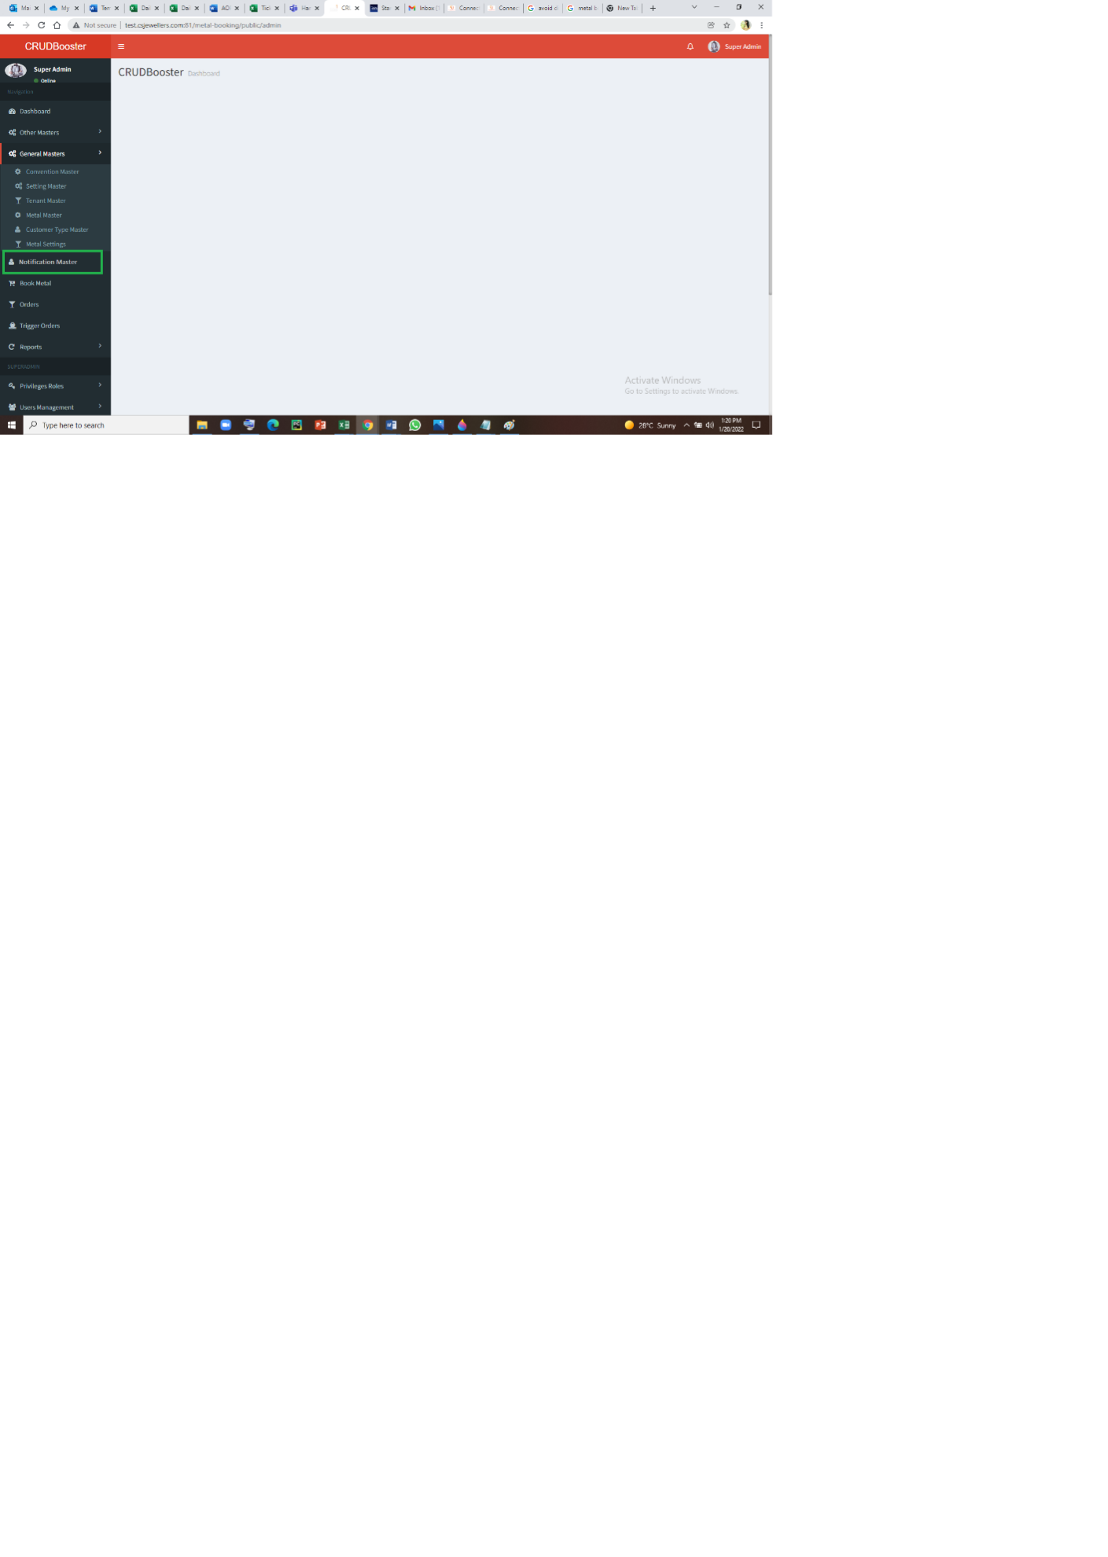

Step-2

* Notification master consists of the contacts to whom the notifications have to be sent in whatsapp, SMS and e-mail.
* The notification master consists of add button to add the data, search bar to search any specific contact and sort and filter option.
* The notification master consists of the following fields such as
  + Contact name
  + Contact number
  + Whatsapp number
  + Mail id
  + Is active
  + Updated at
  + Updated by
  + Action – view, edit and history.

**Input table**

|  |  |  |  |  |
| --- | --- | --- | --- | --- |
| **FIELDS** | **INPUT TYPE** | **EDITABLE/NO** | **DESCRIPTION** | **CONDITIONS IF ANY** |
| Contact name | Text | Yes | Name of the person |  |
| Contact number | Int | Yes | The contact number of the person | The 10 digit mobile number is taken. |
| Whatsapp number | Int | Yes | The whatsapp number of the person | The 10 digit mobile number is taken. |
| Mail id | Varchar | Yes | The mail id of the person | The validity of the mail is considered. |
| Is active | Radio button | Yes | Describes whether to notify the contact or no. | The radio button consists of 2 buttons. Yes and No.  Yes, when to notify the contact. No, when not required to notify the contact. |
| Updated at | Auto generated | No | The time and date automatically generated by system when updated. |  |
| Updated by | Auto generated | No | The person who updated is automatically generated by system when updated. |  |
| Action | Buttons | No | The action button consists of 3 buttons, namely, view, edit and history. | View: The view button is used to view the data.  Edit: The edit button is used to edit the data.  History: The history button is used to history the data. |

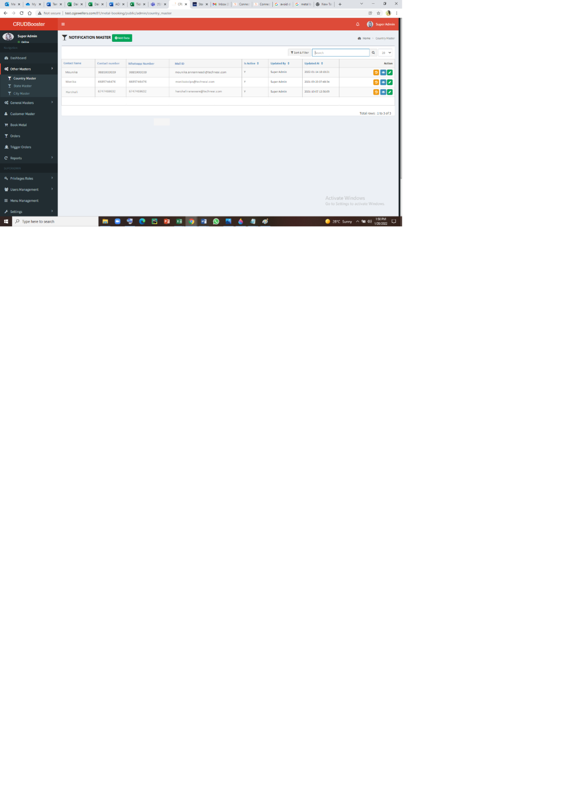

Add data:

The add data page consists of following fields.

* Contact name
* Contact number
* Whatsapp number
* Mail id
* Is active
* Back
* Save & add more
* Save

|  |  |  |  |
| --- | --- | --- | --- |
| **FIELDS** | **INPUT TYPE** | **DESCRIPTION** | **CONDITIONS IF ANY** |
| Contact name | Text | Name of the person |  |
| Contact number | Int | The contact number of the person | The 10 digit mobile number is taken. |
| Whatsapp number | Int | The whatsapp number of the person | The 10 digit mobile number is taken. |
| Mail id | Varchar | The mail id of the person | The validity of the mail is considered. |
| Is active | Radio button | Describes whether to notify the contact or no. | The radio button consists of 2 buttons. Yes and No.  Yes, when to notify the contact. No, when not required to notify the contact. |
| Back | Button | Redirects to back page |  |
| Save and add more | Button | To save the data and to add more data |  |
| Save | Button | To save the data |  |

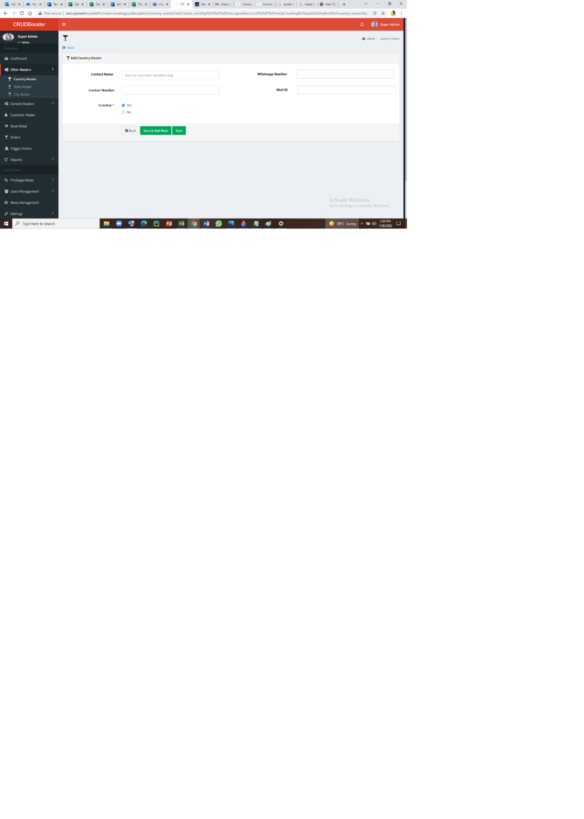

Step-3

SMS Template Master

* Creation of the SMS template master.
* SMS template master consists of the message to be sent for the ordered and when the triggered order is placed.
* The SMS template master consists of add button to add the data, search bar to search any specific contact and sort and filter option.
* The page consists of action buttons such as history, view and edit for each and every template.

|  |  |  |  |
| --- | --- | --- | --- |
| **FIELDS** | **INPUT TYPE** | **DESCRIPTION** | **CONDITIONS IF ANY** |
| Add data | Button | To add the data, this button is used |  |
| Name | Text | The action when the message to be sent is mentioned |  |
| SMS template | Text | The message to be sent | The grams, item name, vendor name, data and time are fetched when the action made. |
| Action | Button | There are 3 action buttons namely History View Edit | History : To view the history View : To view the data Edit : To edit the data. |

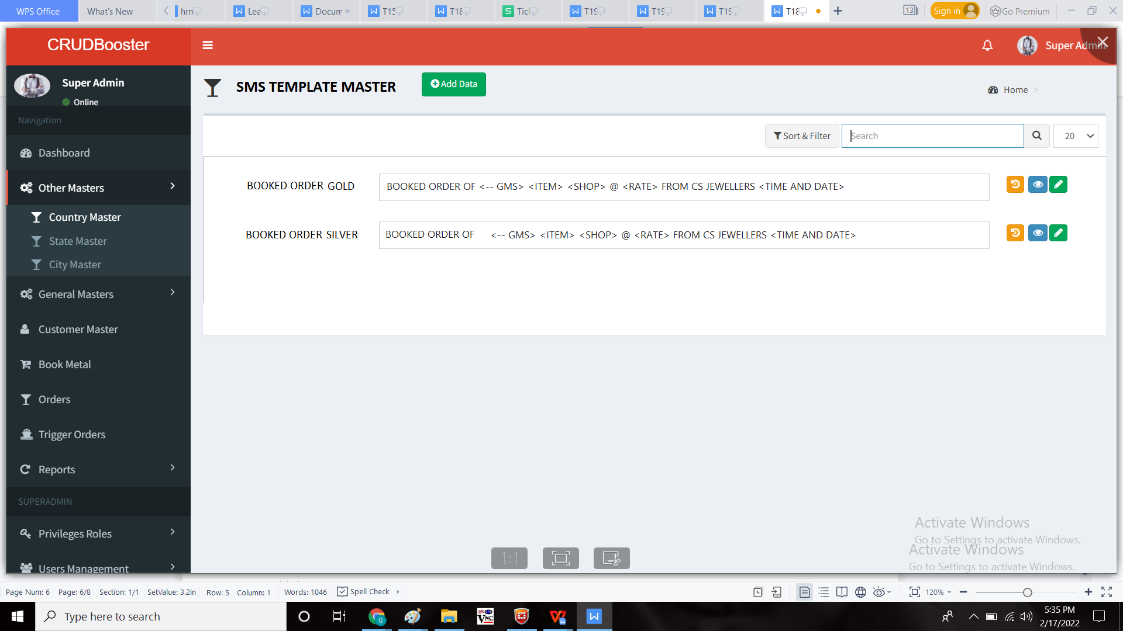

Add data:

* The add data page consists of the fields such as
  + Name
  + SMS Template
  + Back
  + Save & add more
  + Save

|  |  |  |  |
| --- | --- | --- | --- |
| **FIELDS** | **INPUT TYPE** | **DESCRIPTION** | **CONDITIONS IF ANY** |
| Name | Text | The action when the message to be sent is mentioned |  |
| SMS template | Text | The message to be sent | The grams, item name, vendor name, data and time are fetched when the action made. |
| Back | Button | Redirects to back page |  |
| Save and add more | Button | To save the data and to add more data |  |
| Save | Button | To save the data |  |

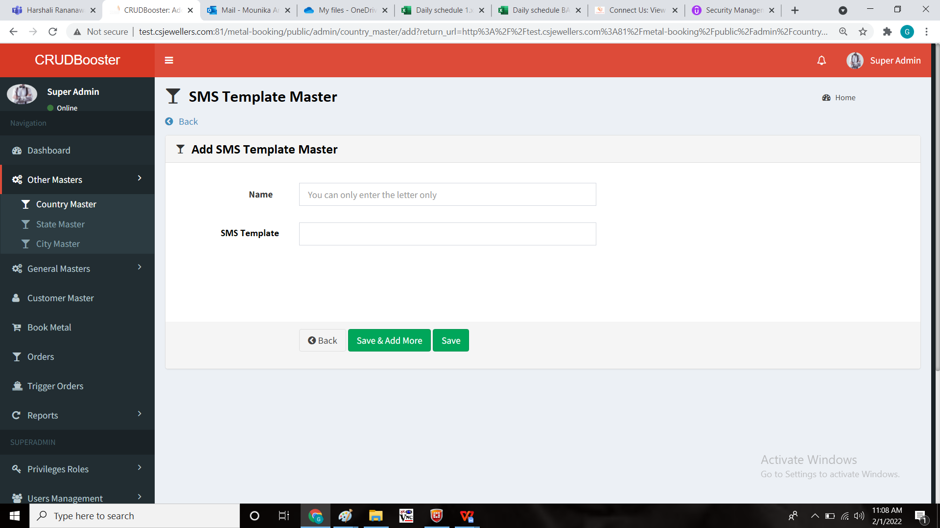

Step-4

The contacts in the notification master and the booked user (the booked user data is fetched from the customer master) has to be notified in whatsapp, SMS and mail when the order is placed and when the triggered order is placed.

Notification:

Order Confirmed  
Client: {#var#}  
Product: SILVER  
Order Wt: {#var#} GMS  
Rate: {#var#}/ 1 KG  
Date: {#var#}  
Time: {#var#} {#var#}/{#var#}  
CHANDUKAKA SARAF AND SONS PVT LTD.

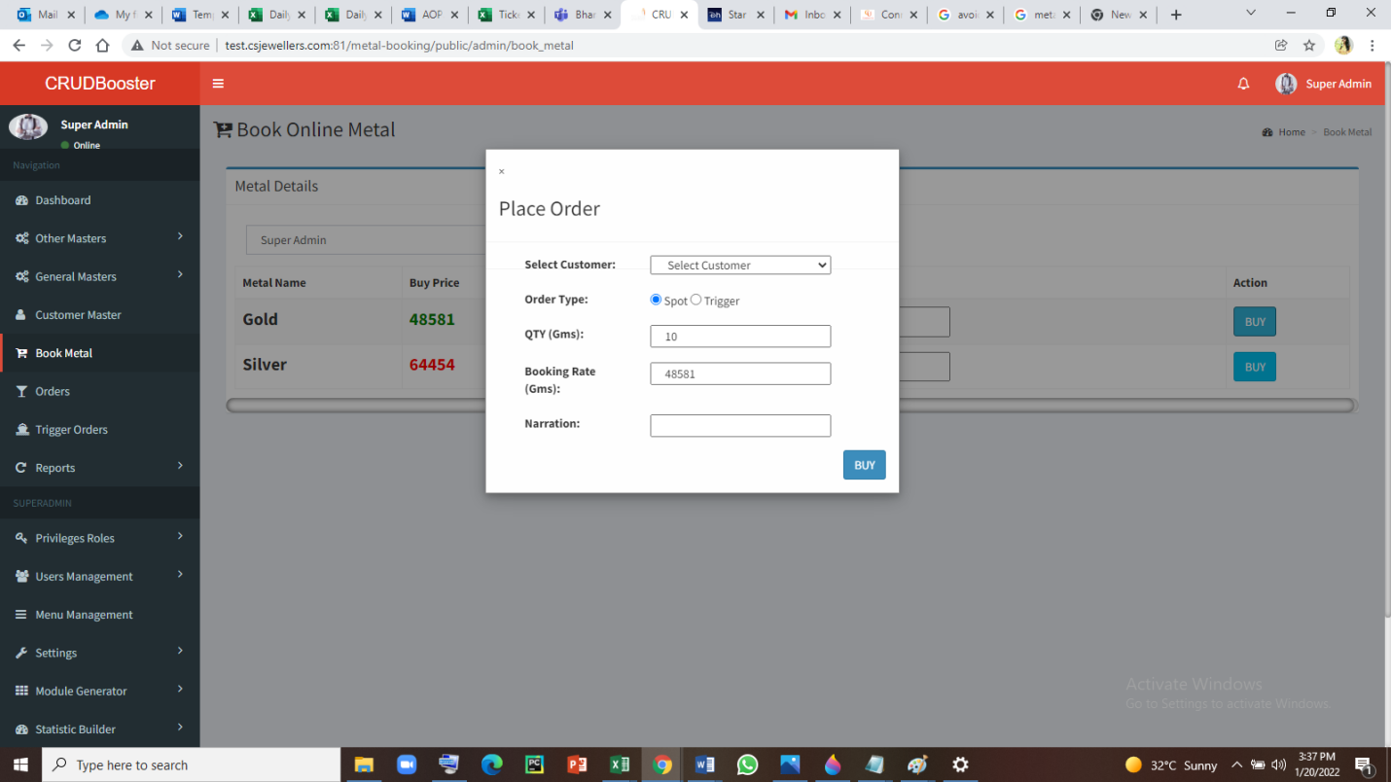

Step-5:

**Approved message templates:**

|  |  |  |  |  |  |  |  |  |  |
| --- | --- | --- | --- | --- | --- | --- | --- | --- | --- |
| **TEMPLATE ID** | **TEMPLATE NAME** | **TYPE** | **HEADER** | **REGISTERED DLT** | **REQUESTED ON** | **STATUS DATE** | **APPROVAL STATUS** | **STATUS** | **TEMPLATE MESSAGE** |
| '1507164498841342758' | Metal Booking 3 | Service-Implicit | {CSPLHO} | MTNL | 16/02/2022 10:43 | 16/02/2022 10:44 | Approved | Active | Order Confirmed Client: {#var#} Product: SILVER Order Wt: {#var#} GMS Rate: {#var#}/ 1 KG Date: {#var#} Time: {#var#} {#var#}/{#var#} CHANDUKAKA SARAF AND SONS PVT LTD. |
| '1507164498832472386' | Metal Booking 2 | Service-Implicit | {CSPLHO} | MTNL | 16/02/2022 10:42 | 16/02/2022 10:45 | Approved | Active | Order Confirmed Client: {#var#} Product: GOLD Order Wt: {#var#} GMS Rate: {#var#}/ 10 GM Date: {#var#} Time: {#var#} {#var#}/{#var#} CHANDUKAKA SARAF AND SONS PVT LTD. |

**OUTPUT**

Notification Master

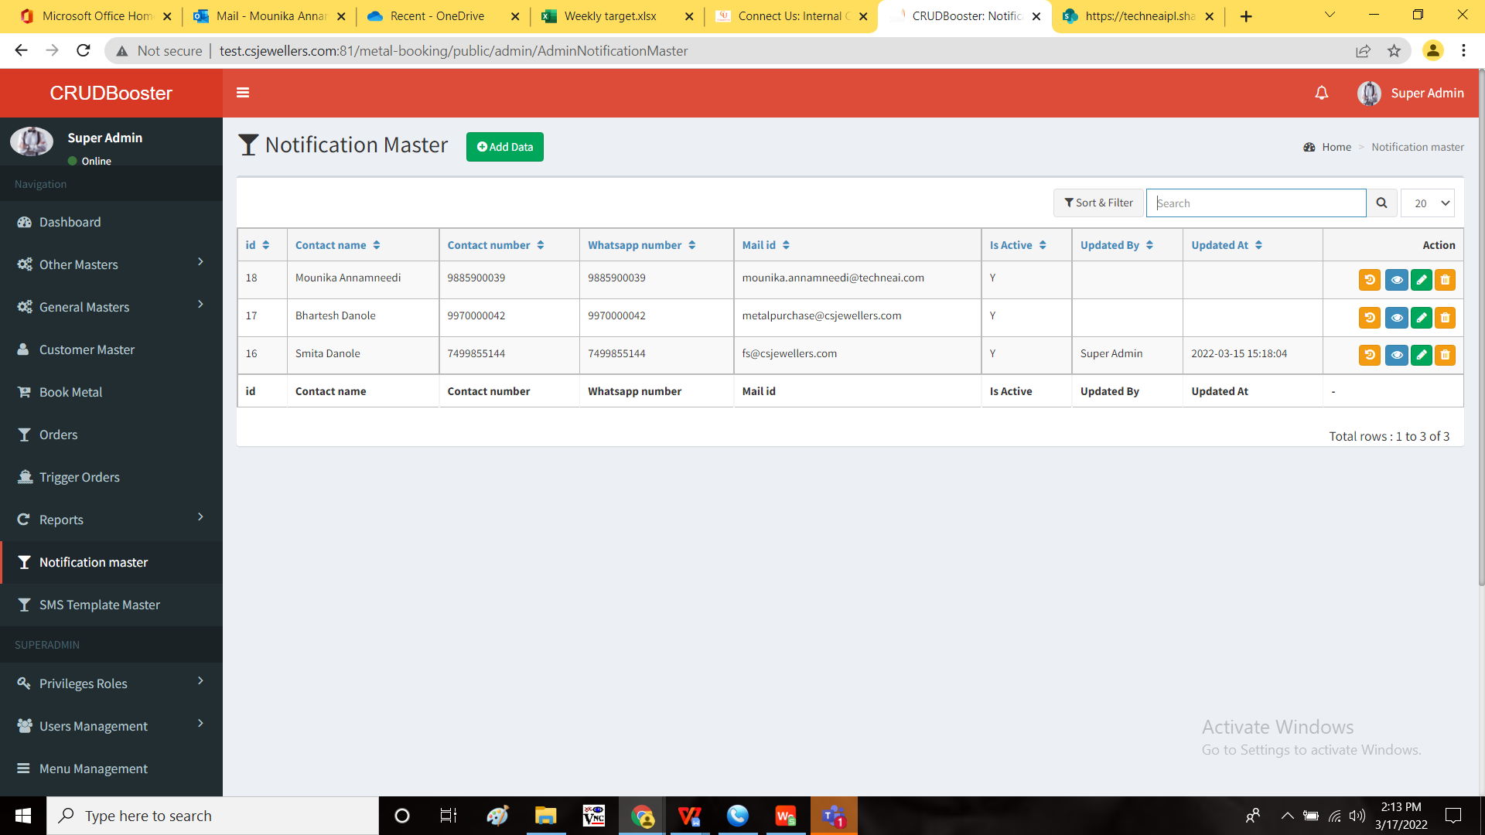

SMS Template master

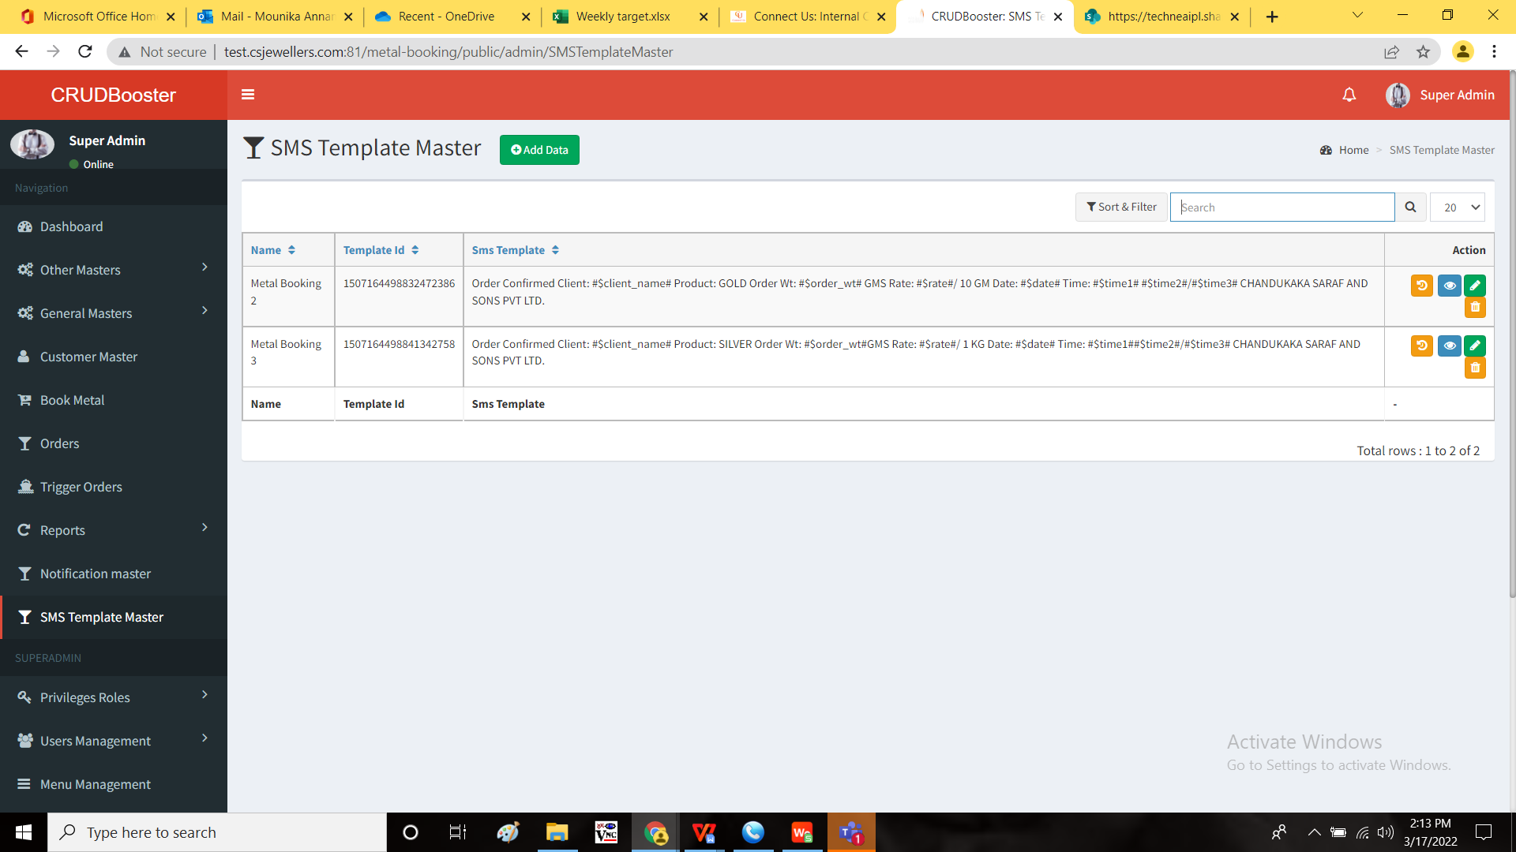

SMS Output

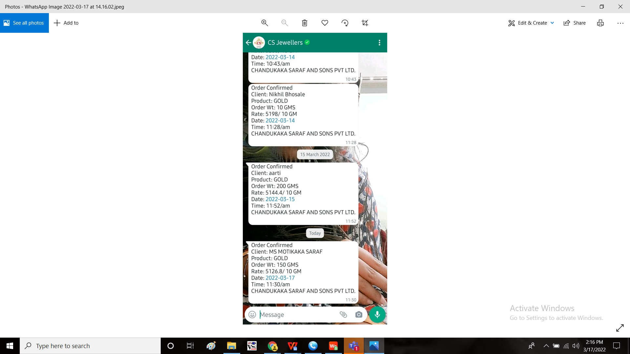

Whatsapp message output

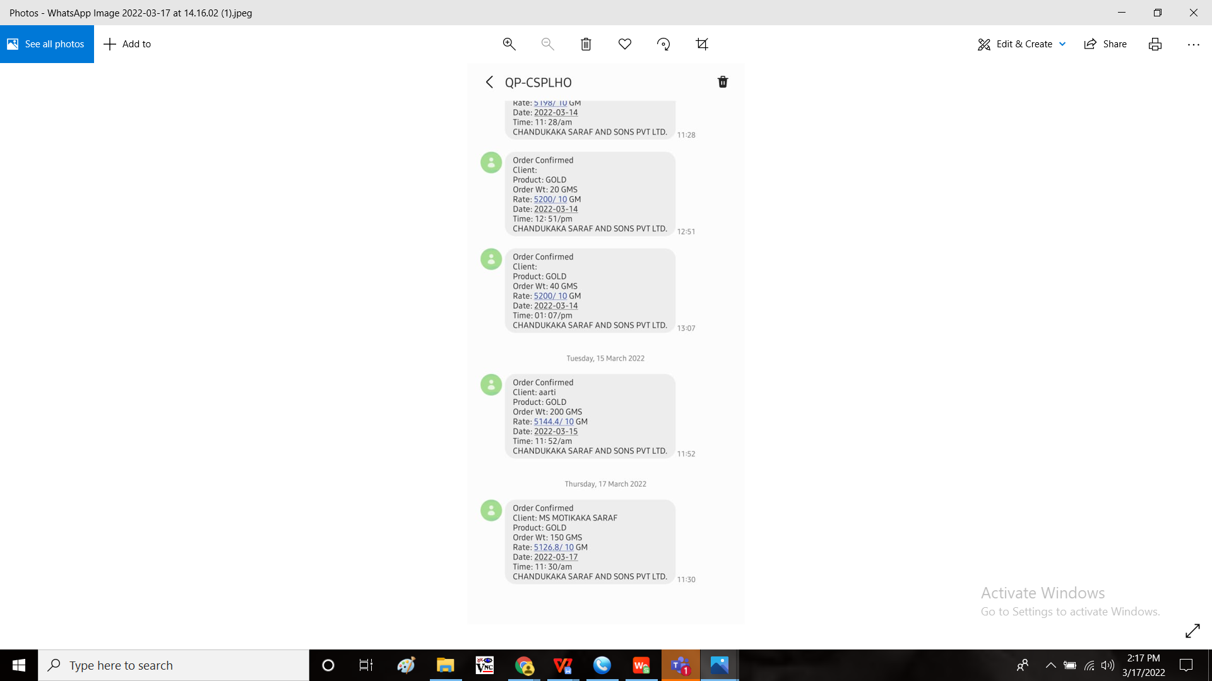

Mail output

