|  |  |
| --- | --- |
| **Ticket ID** | *T200259* |

**Business requirement**

In connect us > bill checking > bill checking master >vendor master User want to add one field “GSTR1 FILLING” give drop-down

1. Month
2. Quarter

Condition- a) If GST No is NA then field is Disabled

b) GST NO is Enter then field is Enabled

**Abbreviations & terms**

*In connect us > Cu*

**Existing system**

*In current system user don’t have “GSTR1 Filling”*

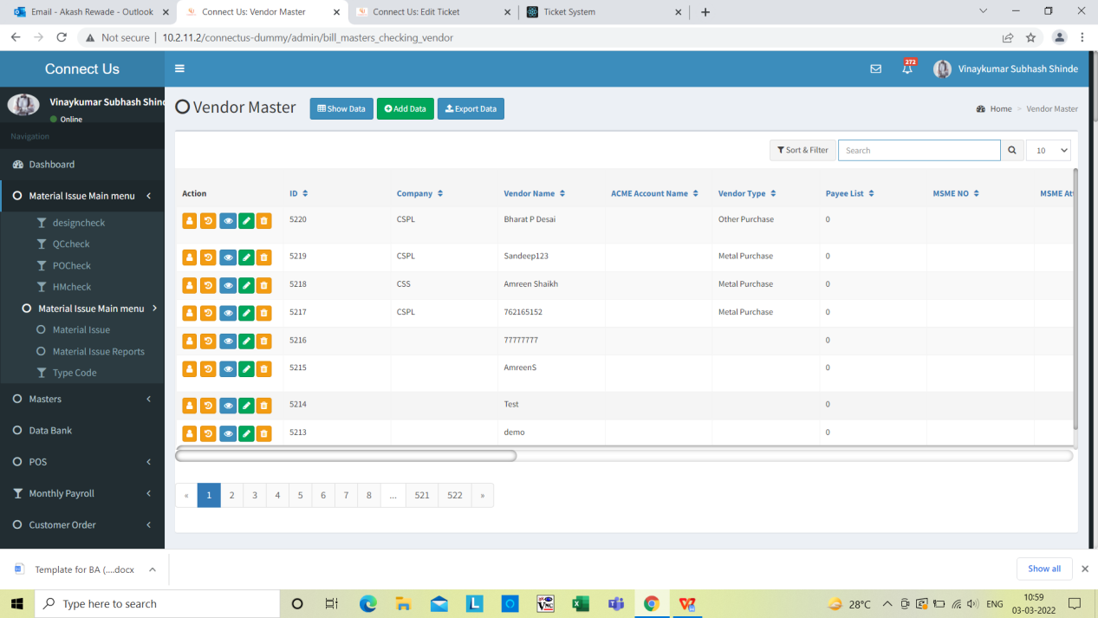

User don’t have column “GSTR 1 FILLING” IN Exsting system

**Image**

**Proposed system**

In connect us > bill checking > bill checking master >vendor master User want to add one field “GSTR1 FILLING” give drop-down

1. Month
2. Quarter

Condition- a) If GST No is NA then field is Disabled

b) GST NO is Enter then field is Enabled

User want Add “GSTR 1 Filling field” in below

1. Add data
2. History
3. View data
4. Edit
5. *Grid view*
6. Add data

In connect us > bill checking > bill checking master >vendor master > Add data User want to add one field “GSTR1 FILLING” give drop-down (refer Image 1)

1. Month
2. Quarter

Condition - a) If GST No is NA then field is Disabled

b) GST NO is Enter then field is Enabled .

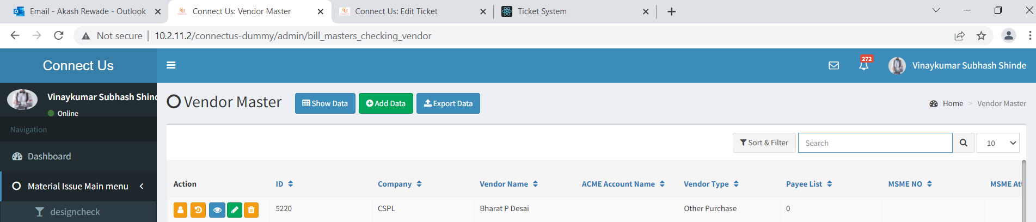

Click on Add data

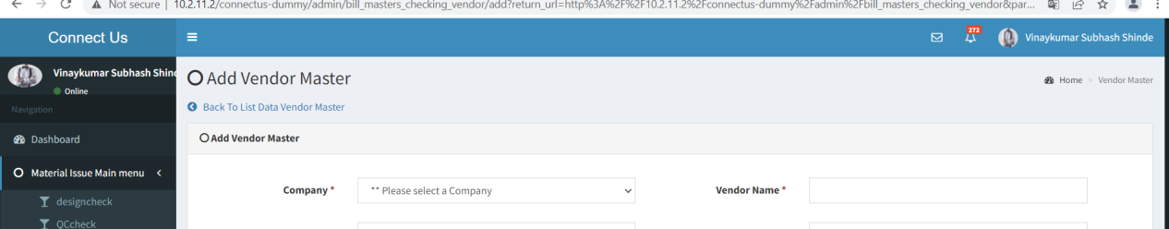

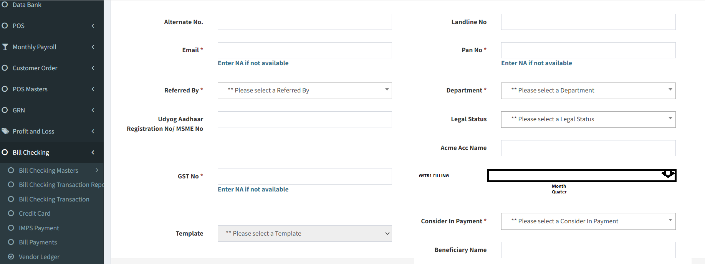

Image 1

2)View Data

In connect us > bill checking > bill checking master >vendor master > view data User want to add one field “GSTR1 FILLING” give drop-down (refer Image 2)

* Month
* Quarter

Condition - a) If GST No is NA then field is Disabled

b) GST NO is Enter then field is Enabled .



Click on view data

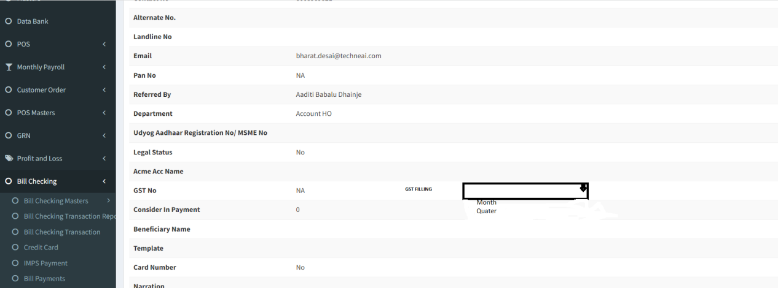

Image 2

1. Edit

In connect us > bill checking > bill checking master >vendor master > Edit User want to add one field “GSTR1 FILLING” give drop-down (refer Image 3)

* Month
* Quarter

Condition - a) If GST No is NA then field is Disabled

b) GST NO is Enter then field is Enabled .



Click on Edit

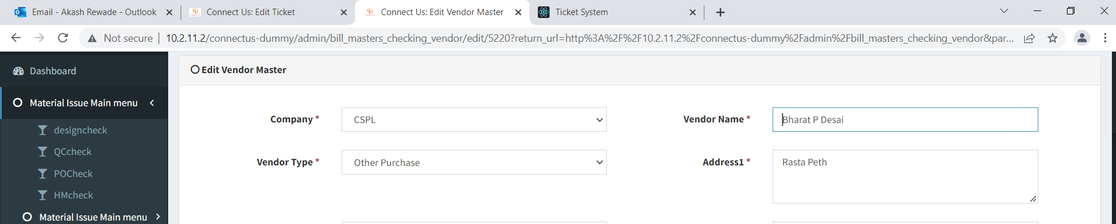



Image 3

1. History -

In connect us > bill checking > bill checking master >vendor master > History User want to add one field “GSTR1 FILLING” give drop-down (refer Image 4)

* Month
* Quarter

Condition - a) If GST No is NA then field is Disabled .

b) GST NO is Enter then field is Enabled .



Click on history

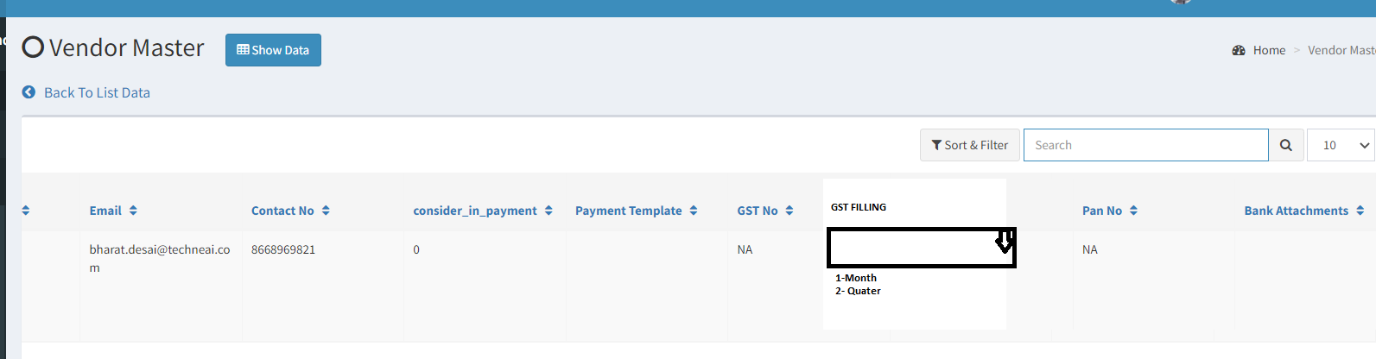

Image 4

5 ) Grid View

In connect us > bill checking > bill checking master >vendor master > Grid view User want to add one field “GSTR1 FILLING” give drop-down (refer Image 5)

* Month
* Quarter

Condition - a) If GST No is NA then field is Disabled .

b) GST NO is Enter then field is Enabled .



.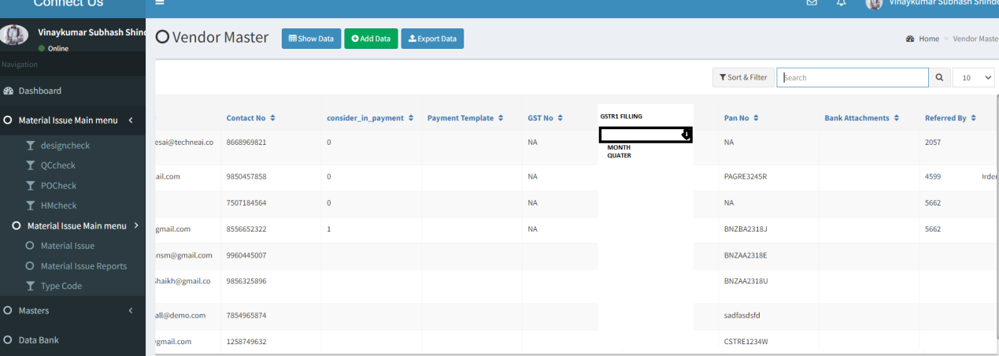

Image 5

**OUTPUT:**

As expected.