|  |  |
| --- | --- |
| **Ticket ID** | TT2061 |
| **Ticket description** | *1) In AOP now PLAN & REVISED SALES & COGS values are updated but its total is not calculated also below formula is blank. need to work all formulas correct asper Actual AOP.*  *2) require correct sequence such as PLAN, REVISED then ACTUL ( branch wise & total)*  *3) need to add new column in start of PLAN TOTAL & REVISED TOTAL like ACTUAL TOTAL* |
| **Created by** | *Harshali Rananaware* |
| **Created on** | 04 Mar 2022 |
| **Priority** | *Very high* |
| **Version** | *1* |

**Version**

|  |  |  |  |  |
| --- | --- | --- | --- | --- |
| **Sr. No** | **Version no** | **Version Date** | **User name** | **User department** |
| 1 | 1 | 04 Mar 2022 | Amarja Vijaykumar Dudka | Accounting Department |

**Approvals**

|  |  |  |
| --- | --- | --- |
| **Field** | **Name of the User** | **Approved date by the user** |
| **Actual User Name** | Amarja Vijaykumar Dudka |  |
| **Actual User Department** | Accounting Department |  |
| **Organization Name** | CSPL |  |
| **Assigned BA** | *Harshali Rananaware* |  |
| **Assigned Developer** |  |  |
| **Assigned Tester** | Parth Patel |  |

**Estimation**

|  |  |  |  |  |
| --- | --- | --- | --- | --- |
| **Department name** | **Estimated Time (In hr)** | **Scheduled Date (Starting date )** | **Estimated date** | **Actual delivery date** |
| **BA** |  |  |  |  |
| **Development** |  |  |  |  |
| **Testing** |  |  |  |  |

**Business requirement**

*1) In AOP now PLAN & REVISED SALES & COGS values are updated but its total is not calculated also below formula is blank. need to work all formulas correct asper Actual AOP.*

*2) require correct sequence such as PLAN, REVISED then ACTUL ( branch wise & total)*

*3) need to add new column in start of PLAN TOTAL & REVISED TOTAL like ACTUAL TOTAL*

**Abbreviations & terms**

Connect us - CU

**Existing system :**

1) In CU ->Profit and Loss -> AOP Report new -> column show plan actual revised.

2) In CU ->Profit and Loss -> AOP Report currently only show plan total.

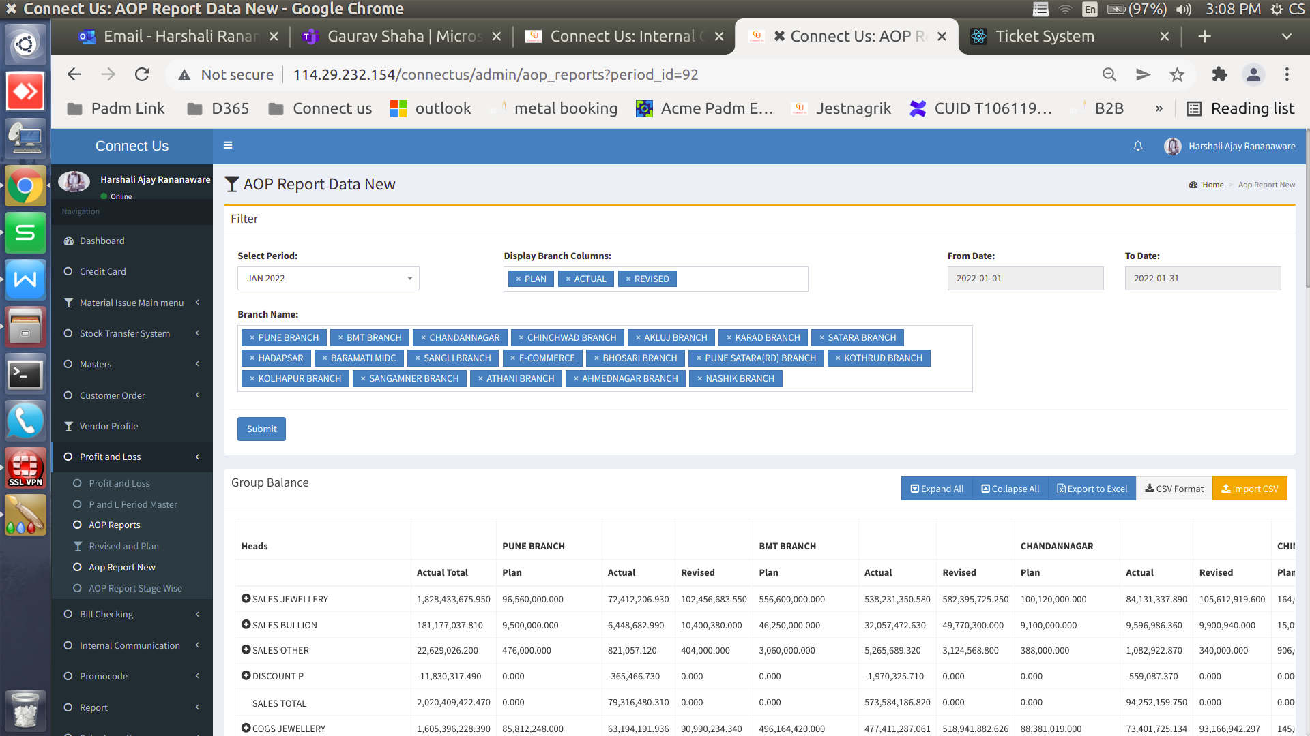

Image 1

**Proposed System :**

1. In CU ->Profit and Loss -> AOP Report new want to show the column sequence plan revised actual for all branches. (Refer Image 2) Also, this column sequence wants in the excel file.
2. In CU ->Profit and Loss -> AOP Report new want to add two new column plan total and revised total. column sequence plan total revised total actual total. (Refer Image 2) Also, this column sequence wants in the excel file.

**Plan total** - want to show all branch plan total amount.

**Revised total** - want to show all branch revised total amount.

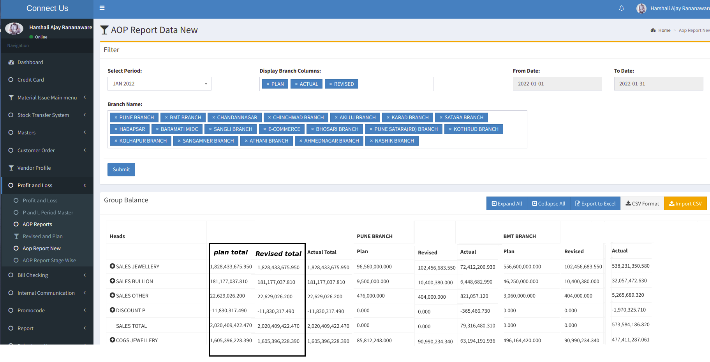

Image 2

1. In CU ->Profit and Loss -> AOP Report new want to update formula for plan and revised same as actual.

**For example** :

**Plan Sales total** = DISCOUNT P + SALES OTHER + SALES BULLION + SALES JEWELLERY

**Revised Sales total** = DISCOUNT P + SALES OTHER + SALES BULLION + SALES JEWELLERY

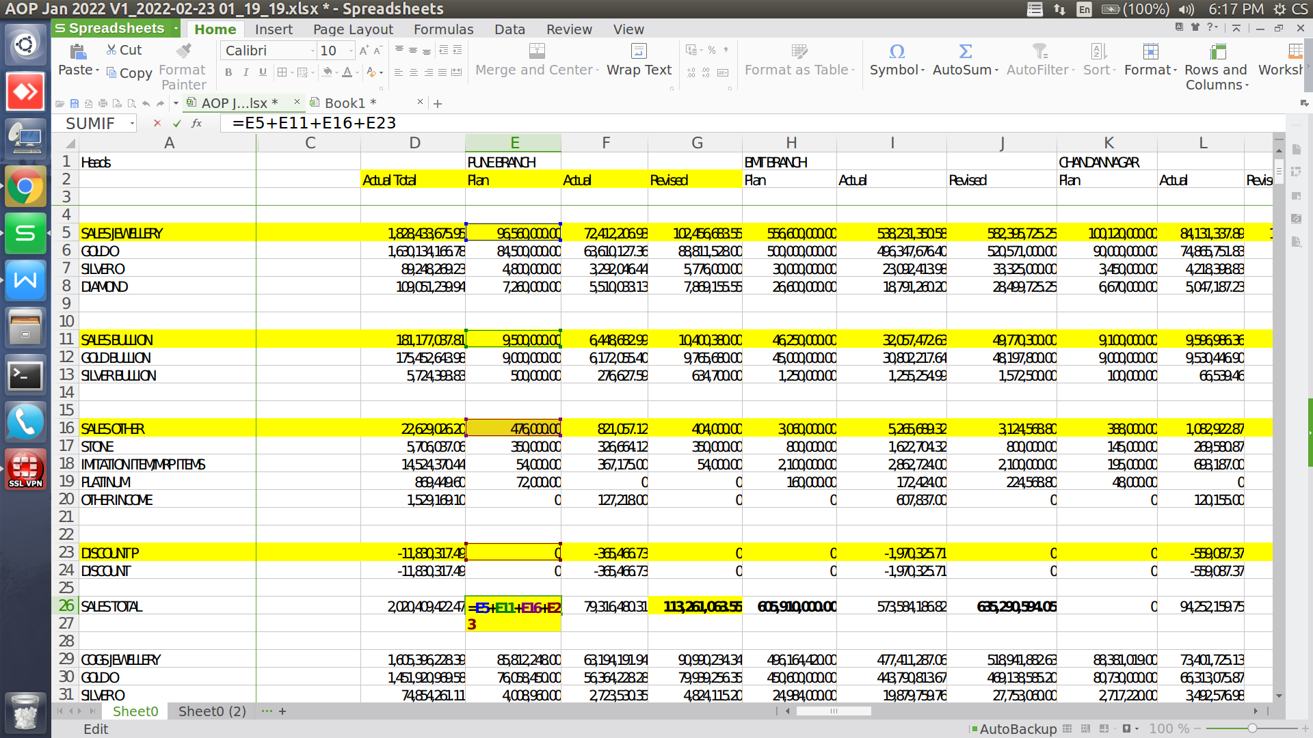

**References of the users**

|  |  |  |  |
| --- | --- | --- | --- |
| **User** | **Name** | **Mail** | **Contact number** |
| **Actual user** | Amarja Vijaykumar Dudka | hoaccountcc@csjewellers.com | 2931 |
| **Assigned business analyst** | *Harshali Rananaware* | [harshali.rananaware@techneai.com](mailto:harshali.rananaware@techneai.com) | 8669917920 |
| **Assigned developer** | Parth Patel | [parth.patel@techneai.com](mailto:parth.patel@techneai.com) |  |