|  |  |
| --- | --- |
| **Ticket ID** | T201213 |

**Existing system**

The exported data in weight checking module menu - user wise weight checking report and bar code wise weight checking report showing the wrong data.

**Proposed system**

Rectification of the errors.

**Step-1**

In Connect US -> Weight checking Module -> User wise weight checking report

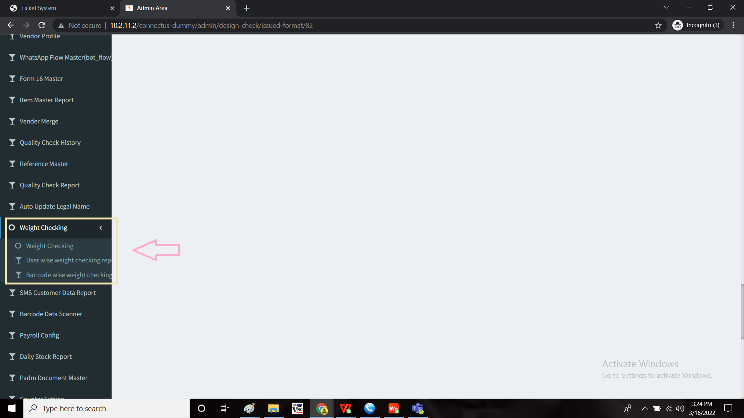

The data or the report displayed and the exported data are different. The exported data to be matched.

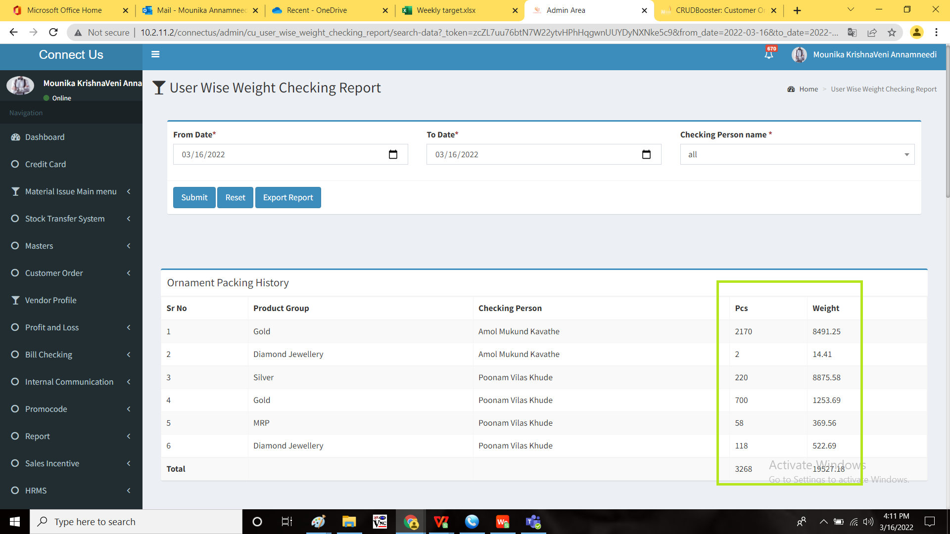

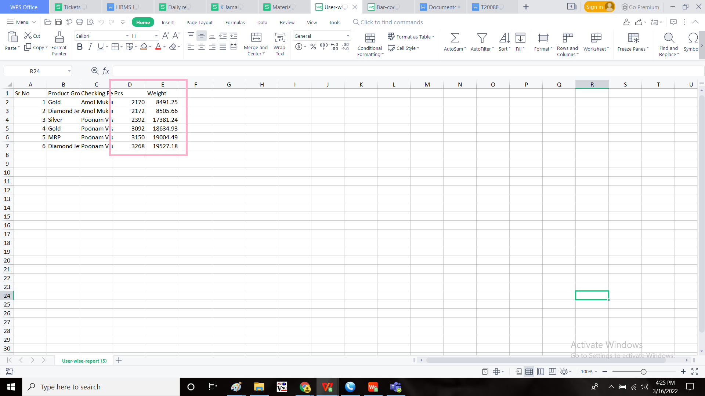

**Step-2**

In Connect US -> Weight checking Module -> Bar code wise weight checking report



The data or the report displayed and the exported data are different. The exported data to be matched.

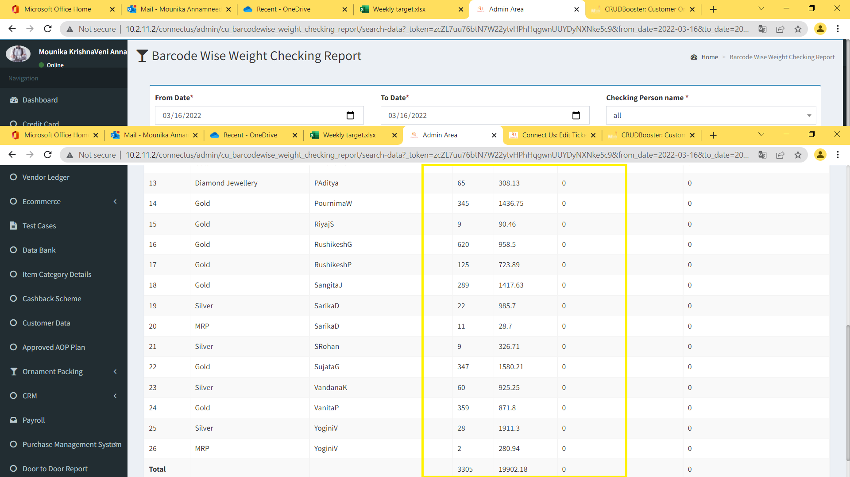

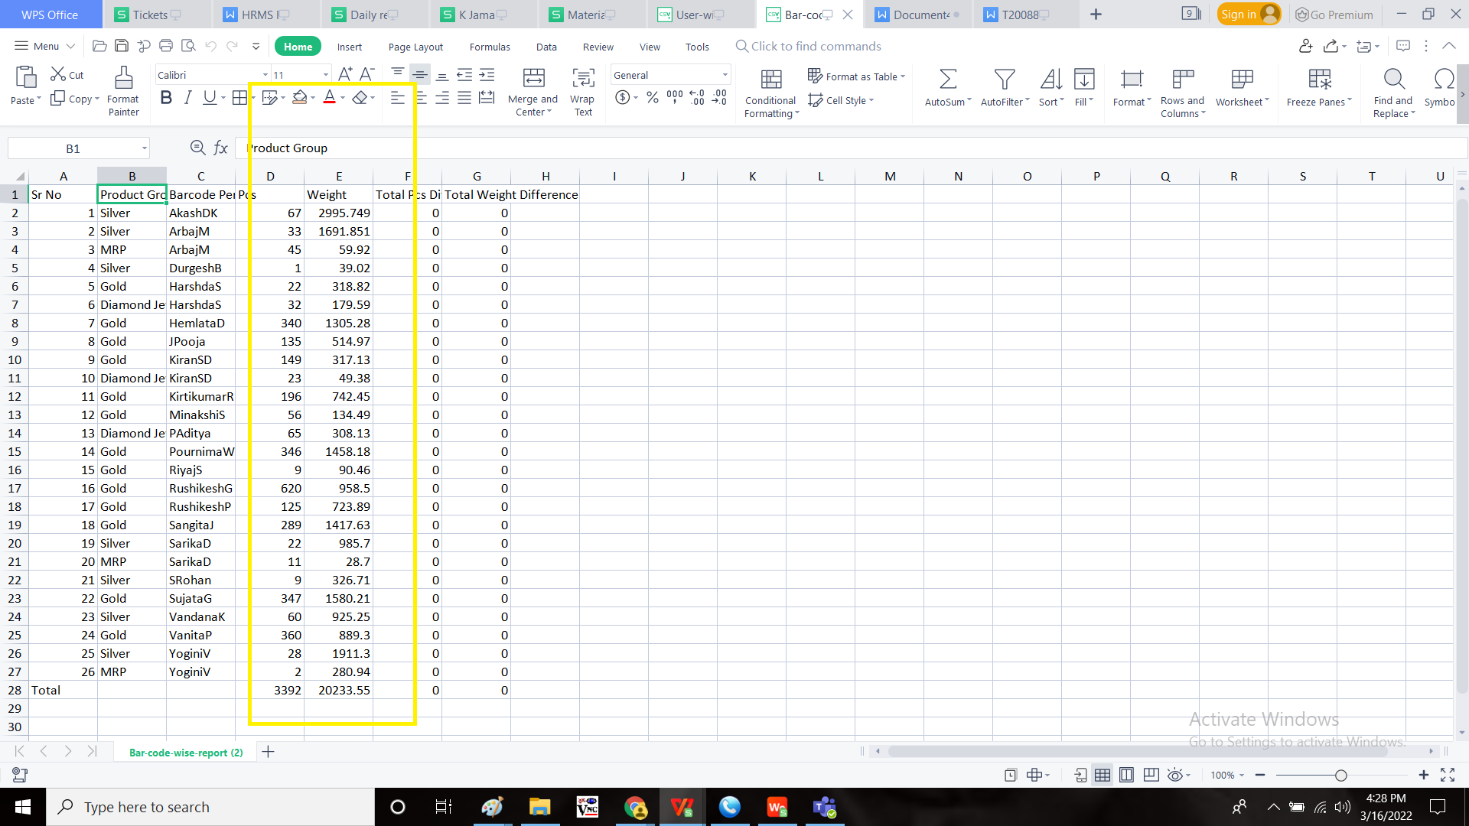

**OUTPUT:**

User wise weight checking report

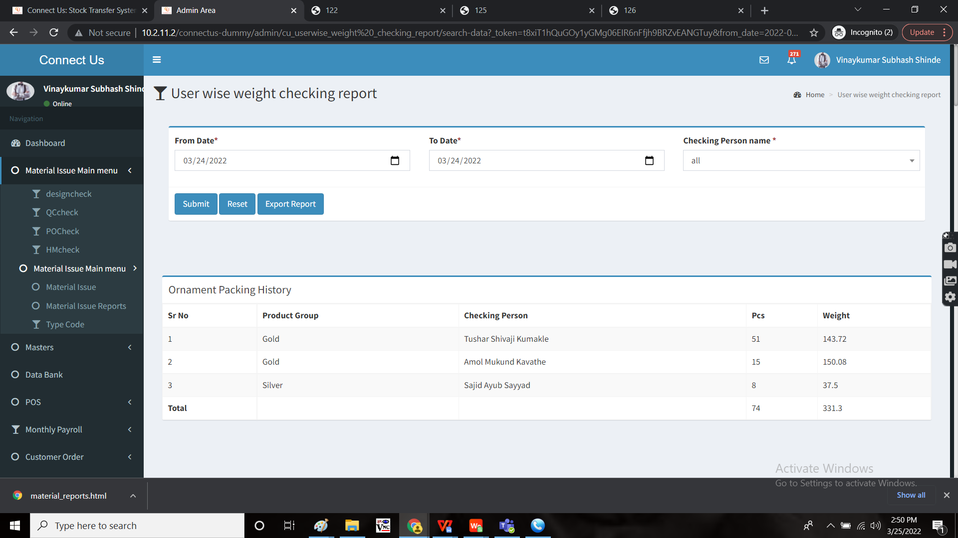

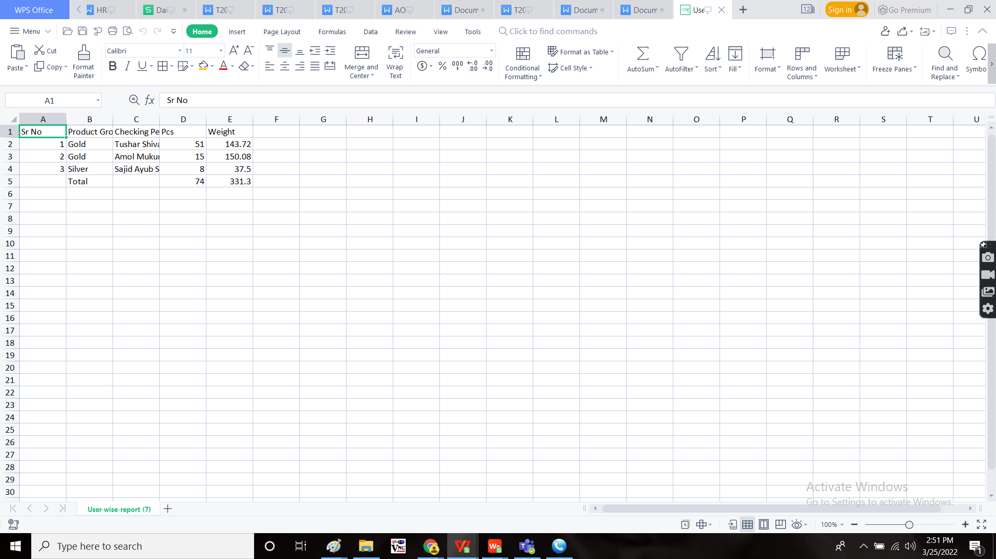

Bar code wise weight checking report

