|  |  |
| --- | --- |
| **Ticket ID** | T201590 |
| **Ticket description** | 7350250000 hya number var whatsapp sathi new tab banavane.  * Them/Offer - Attached Offer whatsapp Creative  * Monthly Scheme - Scheme T&C, enrollment, Payment  * Store Location - Go to Store locaters website page  * Toll free - If any other Details to call 18002670999 |
| **Created by** | Vishal Shantinath Patil |
| **Created on** | 28/02/2022 |
| **Priority** | High |
| **Version** | 0 |

**Version**

|  |  |  |  |  |
| --- | --- | --- | --- | --- |
| **Sr. No** | **Version no** | **Version Date** | **User name** | **User department** |
| 1 | 0 | 23.03.2022 | Vishal Shantinath Patil | Branch Operation Control |

**Approvals**

|  |  |  |
| --- | --- | --- |
| **Field** | **Name of the User** | **Approved date by the user** |
| **Actual User Name** | Vishal Shantinath Patil | 28.02.2022 |
| **Actual User Department** | Vishal Shantinath Patil |  |
| **Organization Name** | CS Jewellers |  |
| **Sign-off** |  |  |
| **Assigned BA** | Mounika KrishnaVeni Annamneedi | 23.03.2022 |
| **Assigned Developer** |  |  |
| **Assigned Tester** |  |  |

**Estimation**

|  |  |  |  |  |
| --- | --- | --- | --- | --- |
| **Department name** | **Estimated Time (In hr)** | **Scheduled Date (Starting date )** | **Estimated date** | **Actual delivery date** |
| **BA** | 3 | 23.03.2022 | 24.03.2022 |  |
| **Development** |  |  |  |  |
| **Testing** |  |  |  |  |

**Introduction**

Whatsapp application is used for CSPL promotions and information for easy access for the users.

**Business requirement**

The user want to add few more options in the whatsapp application.

**Existing system**

The existed system is having only 5 options as of now.

1. Last transaction
2. Current rate
3. Latest e-catalogue
4. Download mobile app
5. Change language

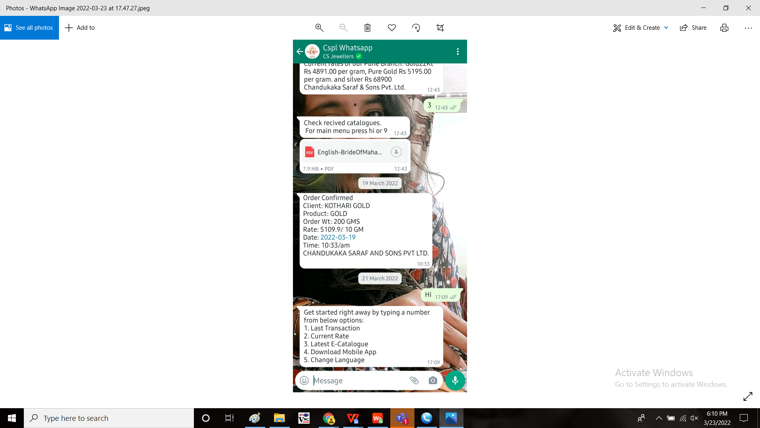

**Proposed system**

* Introduction of few more options in the Whatsapp application

1. Theme/offer
2. Monthly scheme
3. Store location
4. Toll free

OUTPUT:

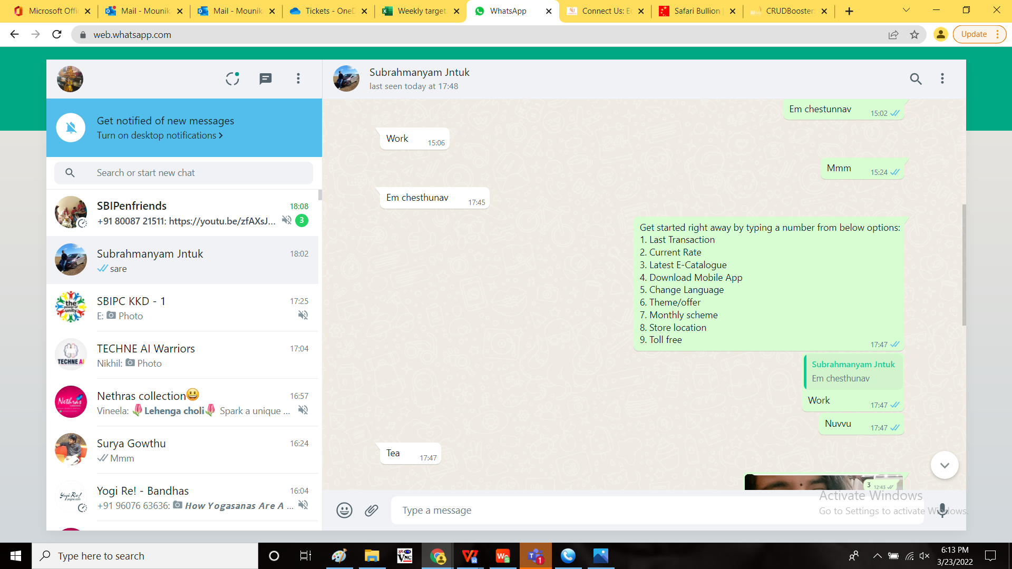

|  |  |
| --- | --- |
| **OPTION** | **DESCRIPTION** |
| Theme/ offer | Attached offer whatsapp creative |
| Monthly scheme | Scheme T&C, Enrollment and Payment |
| Store location | Go to store locators website |
| Toll free | If any other details, call to 18002670999 |

**References of the users**

|  |  |  |  |
| --- | --- | --- | --- |
| **User** | **Name** | **Mail** | **Contact number** |
| **Actual user** | Vishal Shantinath Patil |  |  |
| **Assigned business analyst** | Mounika KrishnaVeni Annamneedi | Mounika.annamneedi@techneai.com | 9885900039 |
| **Assigned developer** |  |  |  |
| **Assigned tester** | Monika Kolpe | Monika.kolpe@techneai.com |  |