|  |  |
| --- | --- |
| **Ticket ID** | T203800 |
| **Ticket description** | Connectus Madhe > Material Issue Madhe New Report Create Karne  Same As Attachment File |
| **Created by** | Tushar Shivaji Nikam |
| **Created on** | 05/03/2022 |
| **Priority** | High |
| **Version** | 1 |

**Version**

|  |  |  |  |  |
| --- | --- | --- | --- | --- |
| **Sr. No** | **Version no** | **Version Date** | **User name** | **User department** |
| 1 | 0 | 16.03.2022 | Tushar Shivaji Nikam | Inventory Silver HO |
| 2 | 1 | 23.03.2022 | Tushar Shivaji Nikam | Inventory Silver HO |

**Approvals**

|  |  |  |
| --- | --- | --- |
| **Field** | **Name of the User** | **Approved date by the user** |
| **Actual User Name** | Tushar Shivaji Nikam | 05.03.2022 |
| **Actual User Department** | Inventory Silver HO |  |
| **Organization Name** | C S Jewellers |  |
| **Sign-off** |  |  |
| **Assigned BA** | Mounika KrishnaVeni Annamneedi | 16.03.2022 |
| **Assigned Developer** |  |  |
| **Assigned Tester** |  |  |

**Estimation**

|  |  |  |  |  |
| --- | --- | --- | --- | --- |
| **Department name** | **Estimated Time (In hr)** | **Scheduled Date (Starting date )** | **Estimated date** | **Actual delivery date** |
| **BA** | 3 | 16.03.2022 | 17.03.2022 |  |
| **Development** |  |  |  |  |
| **Testing** |  |  |  |  |

**Business requirement**

In material issue main menu, material issue reports, the user requires a new report K Jama and RD report.

This report helps the user in knowing the rejected vendors and this report is helpful in reporting the higher management.

**Existing system**

In the existing system, there is no K Jama and RD report.

**Proposed system**

* Creation of the new report K Jama and RD report.

**Step-1**

In Connect US -> Material Issue Main Menu -> Material issue reports

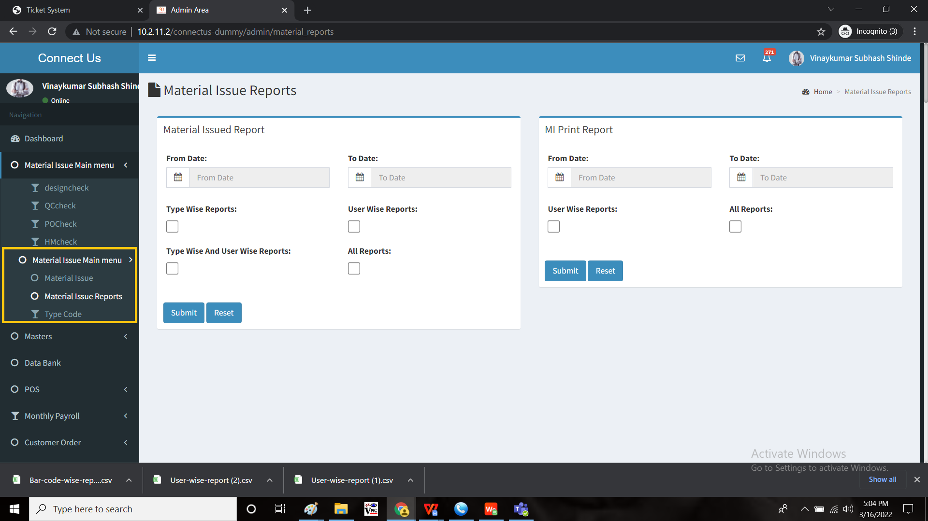

Add new report “K Jama” and “RD Reports”

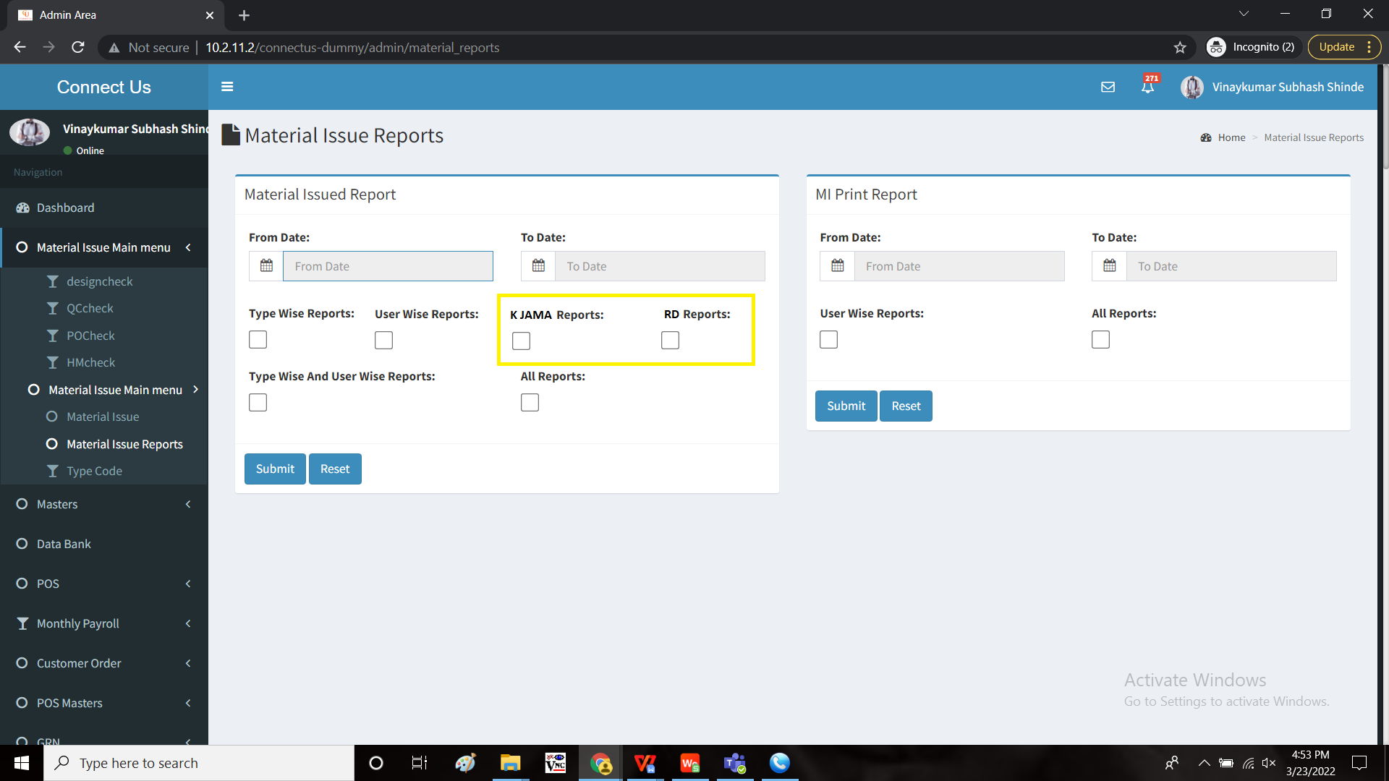

The report consists of the following fields

1. K Jama Report
   1. Karagir name
   2. Jama net weight
   3. Design net weight rejected
   4. QC net weight rejected
   5. PO net weight rejected
   6. HM net weight rejected
   7. Net weight accepted
   8. Design net weight rejected %
   9. QC net weight rejected %
   10. PO net weight rejected %
   11. HM net weight rejected %
   12. Net weight accepted %
   13. Total net weight rejected %
   14. Chart
2. RD
   1. Karagir name
   2. Jama net weight
   3. Design net weight rejected622
   4. QC net weight rejected
   5. PO net weight rejected
   6. HM net weight rejected
   7. Net weight accepted
   8. Design net weight rejected %
   9. QC net weight rejected %
   10. PO net weight rejected %
   11. HM net weight rejected %
   12. Net weight accepted %
   13. Total net weight rejected %
   14. Chart

The data is fetched from the material issue main menu - design check, QC check, PO check and HM check.

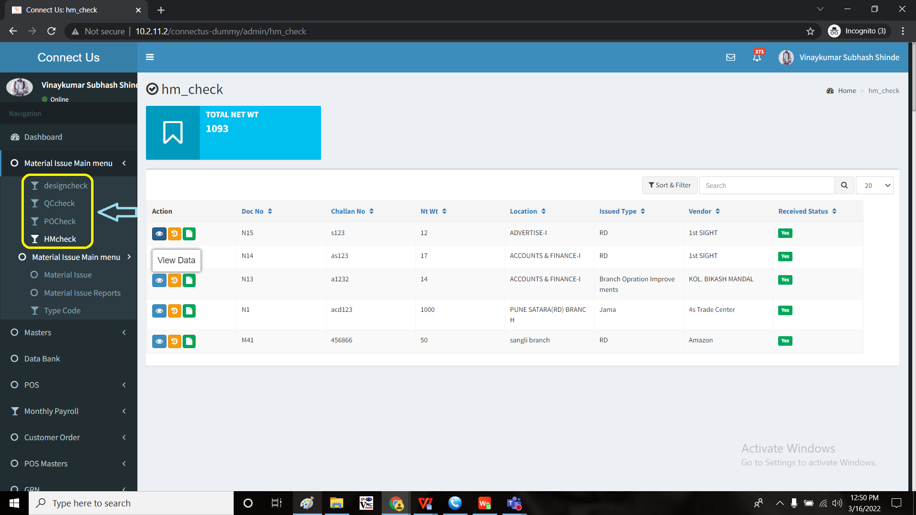

|  |  |  |  |  |  |  |  |  |  |  |  |  |
| --- | --- | --- | --- | --- | --- | --- | --- | --- | --- | --- | --- | --- |
| K jama |  |  |  |  |  |  |  |  |  |  |  |  |
| **Karagir Name** | **Jama Net Wt** | **Design Net Wt Rejected** | **QC Net Wt Rejected** | **PO Net Wt Rejected** | **HM Net Wt Rejected** | **Net Wt Accepted** | **Design Net Wt Rejected %** | **QC Net Wt Rejected %** | **PO Net Wt Rejected %** | **HM Net Wt Rejected %** | **Net Wt Accepted %** | **Total NetWt Rejected %** |
| **AMIT ASHOK BELVALKAR** | **8531.560** | **0** | **109.16** | **0** | **0** | **8391.28** | **0.0%** | **1.3%** | **0.0%** | **0.0%** | **98.4%** | **1.3%** |
| **AMIT C ADESARA AND SONS** | **20893.379** | **0** | **103.527** | **0** | **0** | **20492.859** | **0.0%** | **0.5%** | **0.0%** | **0.0%** | **98.1%** | **0.5%** |
| **ARGENTUM SILVER HOUSE LLP (GOLD KARAGIR)** | **441964.179** | **1734.02** | **4205.65** | **1259.4** | **0** | **429557.419** | **0.4%** | **1.0%** | **0.3%** | **0.0%** | **97.2%** | **1.6%** |
| **ARGENTUM SILVER HOUSE LLP (RD GOLD)** | **2202.000** | **0** | **2.67** | **0** | **0** | **2202** | **0.0%** | **0.1%** | **0.0%** | **0.0%** | **100.0%** | **0.1%** |
| **ARGENTUM SILVER HOUSE LLP(GOLD KARAGIR)** | **10133.630** | **0** | **0.2** | **0** | **0** | **10033.58** | **0.0%** | **0.0%** | **0.0%** | **0.0%** | **99.0%** | **0.0%** |
| **ARHAM NATHKING GOLD** | **59.950** | **0** | **0** | **0** | **0** | **59.95** | **0.0%** | **0.0%** | **0.0%** | **0.0%** | **100.0%** | **0.0%** |
| **Grand Total** | **1549207.568** | **5692.91** | **16421.103** | **3475.935** | **3104.74** | **1526004.2** | **0.37%** | **1.06%** | **0.22%** | **0.20%** | **98.5%** | **1.9%** |
| RD |  |  |  |  |  |  |  |  |  |  |  |  |
| **Karagir Name** | **Jama Net Wt** | **Design Net Wt Rejected** | **QC Net Wt Rejected** | **PO Net Wt Rejected** | **HM Net Wt Rejected** | **Net Wt Accepted** | **Design Net Wt Rejected %** | **QC Net Wt Rejected %** | **PO Net Wt Rejected %** | **HM Net Wt Rejected %** | **Net Wt Accepted %** | **Total NetWt Rejected %** |
| **A K SONIGARA JEWELLERS** | **4223.170** | **0.00** | **53.22** | **0.00** | **0.00** | **4223.17** | **0.0%** | **1.3%** | **0.0%** | **0.0%** | **100.0%** | **1.3%** |
| **A V GOLD** | **4095.030** | **181.24** | **315.22** | **0.00** | **0.00** | **3913.79** | **4.4%** | **7.7%** | **0.0%** | **0.0%** | **95.6%** | **12.1%** |
| **AADISH GOLD LLP** | **13516.550** | **0.00** | **994.60** | **0.00** | **0.00** | **13516.55** | **0.0%** | **7.4%** | **0.0%** | **0.0%** | **100.0%** | **7.4%** |
| **ARGENTUM SILVER HOUSE LLP (GOLD KARAGIR)** | **1449.560** | **0.00** | **0.87** | **0.00** | **0.00** | **1449.56** | **0.0%** | **0.1%** | **0.0%** | **0.0%** | **100.0%** | **0.1%** |
| **ARGENTUM SILVER HOUSE LLP (GOLD RD REPAIR)** | **64.610** | **0.00** | **0.00** | **0.00** | **3.94** | **64.61** | **0.0%** | **0.0%** | **0.0%** | **6.1%** | **100.0%** | **6.1%** |
| **ARGENTUM SILVER HOUSE LLP (RD GOLD)** | **117657.189** | **1172.00** | **7671.00** | **3636.01** | **0.30** | **116485.19** | **1.0%** | **6.5%** | **3.1%** | **0.0%** | **99.0%** | **10.6%** |
| **ARGENTUM SILVER HOUSE LLP(GOLD KARAGIR)** | **374.730** | **0.00** | **18.74** | **0.00** | **0.00** | **374.73** | **0.0%** | **5.0%** | **0.0%** | **0.0%** | **100.0%** | **5.0%** |

Sample data:

There is a extra column attached to view the data each in pie form. Extra column added chart. When we click on the link, the following chart opens.

|  |  |  |  |  |  |  |  |  |  |  |  |  |  |
| --- | --- | --- | --- | --- | --- | --- | --- | --- | --- | --- | --- | --- | --- |
| K jama |  |  |  |  |  |  |  |  |  |  |  |  |  |
| **Karagir Name** | **Jama Net Wt** | **Design Net Wt Rejected** | **QC Net Wt Rejected** | **PO Net Wt Rejected** | **HM Net Wt Rejected** | **Net Wt Accepted** | **Design Net Wt Rejected %** | **QC Net Wt Rejected %** | **PO Net Wt Rejected %** | **HM Net Wt Rejected %** | **Net Wt Accepted %** | **Total NetWt Rejected %** | **Chart** |
| **AMIT ASHOK BELVALKAR** | **8531.560** | **0** | **109.16** | **0** | **0** | **8391.28** | **0.0%** | **1.3%** | **0.0%** | **0.0%** | **98.4%** | **1.3%** |  |
| **AMIT C ADESARA AND SONS** | **20893.379** | **0** | **103.527** | **0** | **0** | **20492.859** | **0.0%** | **0.5%** | **0.0%** | **0.0%** | **98.1%** | **0.5%** |  |
| **ARGENTUM SILVER HOUSE LLP (GOLD KARAGIR)** | **441964.179** | **1734.02** | **4205.65** | **1259.4** | **0** | **429557.419** | **0.4%** | **1.0%** | **0.3%** | **0.0%** | **97.2%** | **1.6%** |  |
| **ARGENTUM SILVER HOUSE LLP (RD GOLD)** | **2202.000** | **0** | **2.67** | **0** | **0** | **2202** | **0.0%** | **0.1%** | **0.0%** | **0.0%** | **100.0%** | **0.1%** |  |
| **ARGENTUM SILVER HOUSE LLP(GOLD KARAGIR)** | **10133.630** | **0** | **0.2** | **0** | **0** | **10033.58** | **0.0%** | **0.0%** | **0.0%** | **0.0%** | **99.0%** | **0.0%** |  |
| **ARHAM NATHKING GOLD** | **59.950** | **0** | **0** | **0** | **0** | **59.95** | **0.0%** | **0.0%** | **0.0%** | **0.0%** | **100.0%** | **0.0%** |  |
| **Grand Total** | **1549207.568** | **5692.91** | **16421.103** | **3475.935** | **3104.74** | **1526004.2** | **0.37%** | **1.06%** | **0.22%** | **0.20%** | **98.5%** | **1.9%** |  |
| RD |  |  |  |  |  |  |  |  |  |  |  |  |  |
| **Karagir Name** | **Jama Net Wt** | **Design Net Wt Rejected** | **QC Net Wt Rejected** | **PO Net Wt Rejected** | **HM Net Wt Rejected** | **Net Wt Accepted** | **Design Net Wt Rejected %** | **QC Net Wt Rejected %** | **PO Net Wt Rejected %** | **HM Net Wt Rejected %** | **Net Wt Accepted %** | **Total NetWt Rejected %** |  |
| **A K SONIGARA JEWELLERS** | **4223.170** | **0.00** | **53.22** | **0.00** | **0.00** | **4223.17** | **0.0%** | **1.3%** | **0.0%** | **0.0%** | **100.0%** | **1.3%** |  |
| **A V GOLD** | **4095.030** | **181.24** | **315.22** | **0.00** | **0.00** | **3913.79** | **4.4%** | **7.7%** | **0.0%** | **0.0%** | **95.6%** | **12.1%** |  |
| **AADISH GOLD LLP** | **13516.550** | **0.00** | **994.60** | **0.00** | **0.00** | **13516.55** | **0.0%** | **7.4%** | **0.0%** | **0.0%** | **100.0%** | **7.4%** |  |
| **ARGENTUM SILVER HOUSE LLP (GOLD KARAGIR)** | **1449.560** | **0.00** | **0.87** | **0.00** | **0.00** | **1449.56** | **0.0%** | **0.1%** | **0.0%** | **0.0%** | **100.0%** | **0.1%** |  |
| **ARGENTUM SILVER HOUSE LLP (GOLD RD REPAIR)** | **64.610** | **0.00** | **0.00** | **0.00** | **3.94** | **64.61** | **0.0%** | **0.0%** | **0.0%** | **6.1%** | **100.0%** | **6.1%** |  |
| **ARGENTUM SILVER HOUSE LLP (RD GOLD)** | **117657.189** | **1172.00** | **7671.00** | **3636.01** | **0.30** | **116485.19** | **1.0%** | **6.5%** | **3.1%** | **0.0%** | **99.0%** | **10.6%** |  |
| **ARGENTUM SILVER HOUSE LLP(GOLD KARAGIR)** | **374.730** | **0.00** | **18.74** | **0.00** | **0.00** | **374.73** | **0.0%** | **5.0%** | **0.0%** | **0.0%** | **100.0%** | **5.0%** |  |

|  |  |  |  |  |  |  |  |  |  |  |  |  |
| --- | --- | --- | --- | --- | --- | --- | --- | --- | --- | --- | --- | --- |
| **Karagir Name** | **Jama Net Wt** | **Design Net Wt Rejected** | **QC Net Wt Rejected** | **PO Net Wt Rejected** | **HM Net Wt Rejected** | **Net Wt Accepted** | **Design Net Wt Rejected %** | **QC Net Wt Rejected %** | **PO Net Wt Rejected %** | **HM Net Wt Rejected %** | **Net Wt Accepted %** | **Total NetWt Rejected %** |
| **ARGENTUM SILVER HOUSE LLP (RD GOLD)** | **117657.189** | **1172.00** | **7671.00** | **3636.01** | **0.30** | **116485.19** | **1.0%** | **6.5%** | **3.1%** | **0.0%** | **90.0%** | **10.6%** |
|  |  |  |  |  |  |  |  |  |  |  |  |  |
|  |  |  |  |  |  |  |  |  |  |  |  |  |
|  |  |  |  |  |  |  |  |  |  |  |  |  |
|  |  |  |  |  |  |  |  |  |  |  |  |  |
|  |  |  |  |  |  |  |  |  |  |  |  |  |
|  |  |  |  |  |  |  |  |  |  |  |  |  |
|  |  |  |  |  |  |  |  |  |  |  |  |  |
|  |  |  |  |  |  |  |  |  |  |  |  |  |
|  |  |  |  |  |  |  |  |  |  |  |  |  |
|  |  |  |  |  |  |  |  |  |  |  |  |  |
|  |  |  |  |  |  |  |  |  |  |  |  |  |
|  |  |  |  |  |  |  |  |  |  |  |  |  |
|  |  |  |  |  |  |  |  |  |  |  |  |  |
|  |  |  |  |  |  |  |  |  |  |  |  |  |
|  |  |  |  |  |  |  |  |  |  |  |  |  |
|  |  |  |  |  |  |  |  |  |  |  |  |  |
|  |  |  |  |  |  |  |  |  |  |  |  |  |
|  |  |  |  |  |  |  |  |  |  |  |  |  |
|  |  |  |  |  |  |  |  |  |  |  |  |  |
|  |  |  |  |  |  |  |  |  |  |  |  |  |
|  |  |  |  |  |  |  |  |  |  |  |  |  |
|  |  |  |  |  |  |  |  |  |  |  |  |  |
|  |  |  |  |  |  |  |  |  |  |  |  |  |
|  |  |  |  |  |  |  |  |  |  |  |  |  |
|  |  |  |  |  |  |  |  |  |  |  |  |  |
|  |  |  |  |  |  |  |  |  |  |  |  |  |

There should be an view button when user selects the specific karagir (the details of the karagir and the chart to be viewed).

There should be an export button when user selects the specific karagir (the details of the karagir and the chart to be exported).

**References of the users**

|  |  |  |  |
| --- | --- | --- | --- |
| **User** | **Name** | **Mail** | **Contact number** |
| **Actual user** | Tushar Shivaji Nikam | designgd@csjewellers.com |  |
| **Assigned business analyst** | Mounika KrishnaVeni Annamneedi | Mounika.annamneedi@techneai.com | 8669917920 |
| **Assigned developer** |  |  |  |
| **Assigned tester** | Monika Kolpe | Monika.kolpe@techneai.com |  |