|  |  |
| --- | --- |
| **Ticket ID** | T206974 |
| **Ticket description** | BVC stock transfer ची प्रिंट काढतो त्यामध्ये Manually मधून प्रिंट काढतो त्यामध्ये PH NO / GSTN / PAN NO येत नाही ते आले पाहिजे . |
| **Created by** | Jayant Dilip Magdum |
| **Created on** | 20/03/2022 |
| **Priority** | Very high |
| **Version** | 0 |

**Version**

|  |  |  |  |  |
| --- | --- | --- | --- | --- |
| **Sr. No** | **Version no** | **Version Date** | **User name** | **User department** |
| 1 | 0 | 25.03.2022 | Jayant Dilip Magdum | Inventory Silver HO |

**Approvals**

|  |  |  |
| --- | --- | --- |
| **Field** | **Name of the User** | **Approved date by the user** |
| **Actual User Name** | Jayant Dilip Magdum | 25.03.2022 |
| **Actual User Department** | Inventory Silver HO |  |
| **Organization Name** | C S Jewellers |  |
| **Sign-off** |  |  |
| **Assigned BA** | Mounika KrishnaVeni Annamneedi | 25.03.2022 |
| **Assigned Developer** |  |  |
| **Assigned Tester** |  |  |

**Estimation**

|  |  |  |  |  |
| --- | --- | --- | --- | --- |
| **Department name** | **Estimated Time (In hr)** | **Scheduled Date (Starting date )** | **Estimated date** | **Actual delivery date** |
| **BA** | 3 | 25.03.2022 | 25.03.2022 |  |
| **Development** |  |  |  |  |
| **Testing** |  |  |  |  |

**Business Requirement**

The user wants the report to be filled with the phone no, GSTIN and PAN NO when exported, when the data filled manually by the user in stock transfer system in connect us.

**Existing system**

In connect us, in stock transfer system, if we entered the data manually, then when the stock transfer details exported, it doesn’t show any phone no, GSTIN and PAN NO.

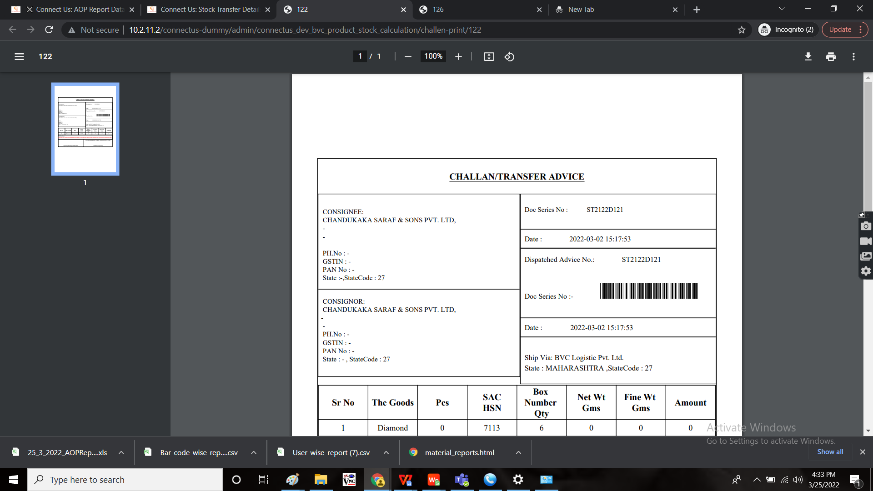

**Proposed system**

Auto update of the fields of phone no, GSTIN and PAN NO when exported though it is entered manually.

**Step-1**

In Connect US -> stock transfer system

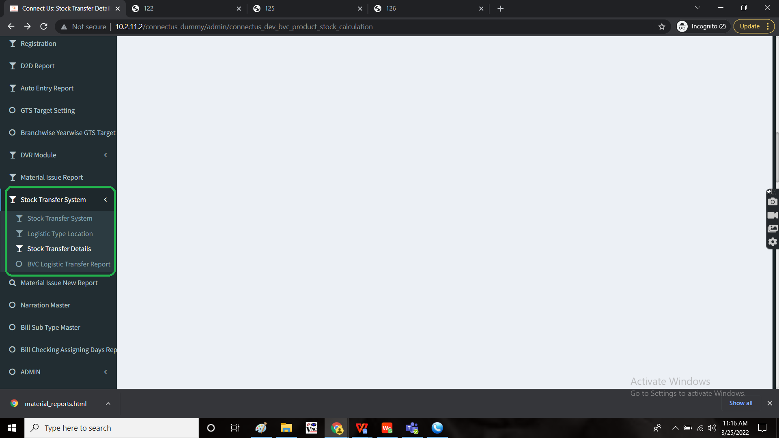

In stock transfer system, when select type is selected manually and entered the details and saved.

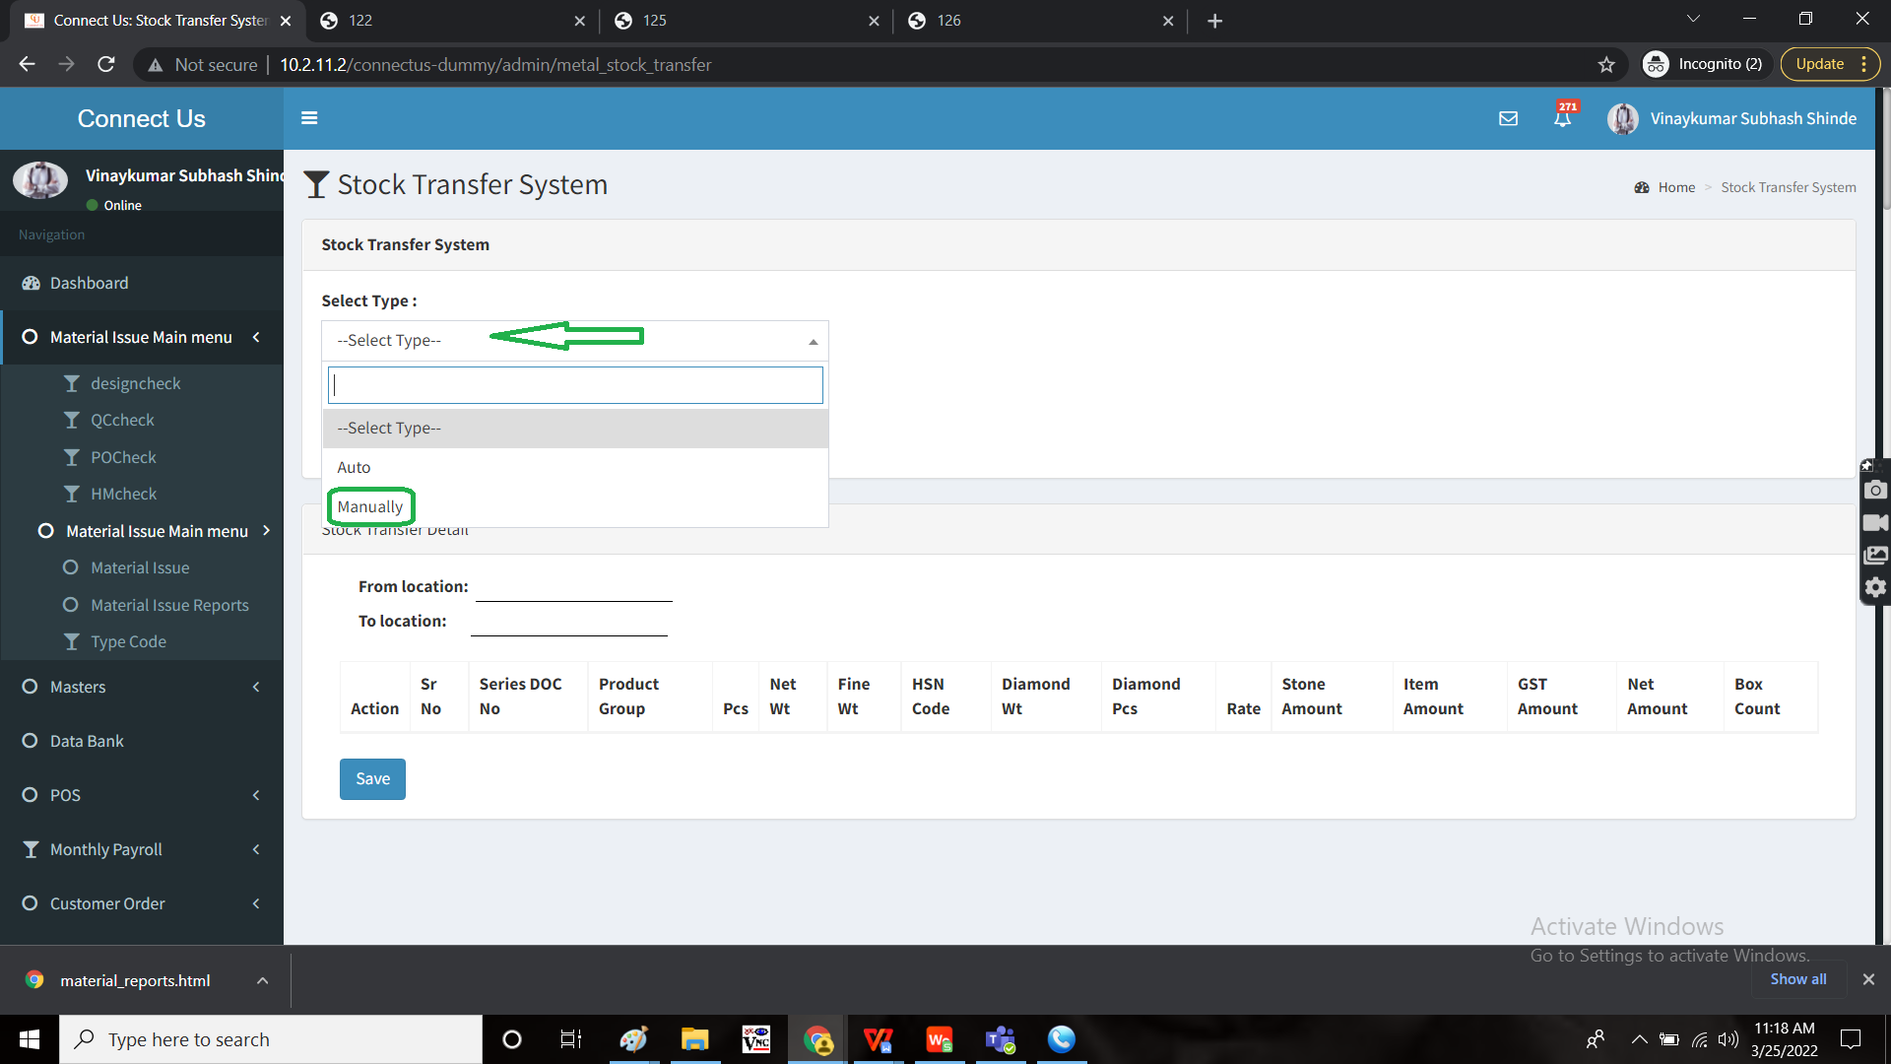

Now, in stock transfer details, when the manually entered data is exported or printed, automatically, the following fields to be updated

|  |  |
| --- | --- |
| **FIELD** | **DESCRIPTION** |
| Ph No | 2112663600 |
| GSTIN | 27AADCC0012C1ZL |
| PAN NO | AADCC0012C |

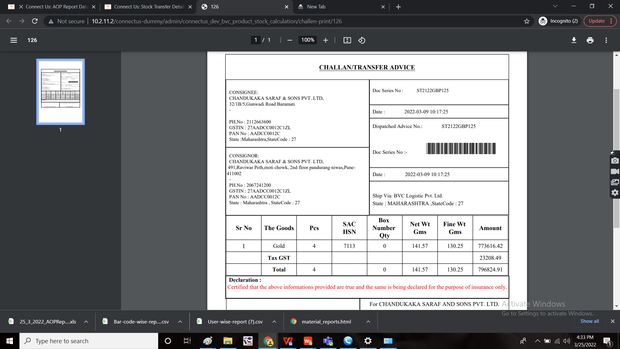

**References of the users**

|  |  |  |  |
| --- | --- | --- | --- |
| **User** | **Name** | **Mail** | **Contact number** |
| **Actual user** | Tushar Shivaji Nikam | designgd@csjewellers.com |  |
| **Assigned business analyst** | Mounika KrishnaVeni Annamneedi | Mounika.annamneedi@techneai.com | 9885900039 |
| **Assigned developer** |  |  |  |
| **Assigned tester** | Monika Kolpe | Monika.kolpe@techneai.com |  |