|  |  |
| --- | --- |
| **Ticket ID** | T207095 |
| **Ticket description** | Connect us Madhe Feedback Calling data madhe GTS ani Kalpataru cha jo tab ahe tasach "EMI Offer "Ha New Tab Add Karun dene. |
| **Created by** | Reshma Sarfraj Sayyad |
| **Created on** | 21/03/2022 |
| **Priority** | High |
| **Version** | 0 |

**Version**

|  |  |  |  |  |
| --- | --- | --- | --- | --- |
| **Sr. No** | **Version no** | **Version Date** | **User name** | **User department** |
| 1 | 0 | 28.03.2022 | Reshma Sarfraj Sayyad | Tollfree |

**Approvals**

|  |  |  |
| --- | --- | --- |
| **Field** | **Name of the User** | **Approved date by the user** |
| **Actual User Name** | Reshma Sarfraj Sayyad | 21.03.2022 |
| **Actual User Department** | Tollfree |  |
| **Organization Name** | C S Jewellers |  |
| **Sign-off** |  |  |
| **Assigned BA** | Mounika KrishnaVeni Annamneedi | 28.03.2022 |
| **Assigned Developer** |  |  |
| **Assigned Tester** |  |  |

**Estimation**

|  |  |  |  |  |
| --- | --- | --- | --- | --- |
| **Department name** | **Estimated Time (In hr)** | **Scheduled Date (Starting date )** | **Estimated date** | **Actual delivery date** |
| **BA** | 3 | 28.03.2022 | 28.03.2022 |  |
| **Development** |  |  |  |  |
| **Testing** |  |  |  |  |

**Business Requirement**

The user want to know whether the customer requires EMI option or not for the schemes when the user calls to the customer.

**Existing system**

In connect us, in reports, in feedback, when the user calls the user, there is no option for the EMI.

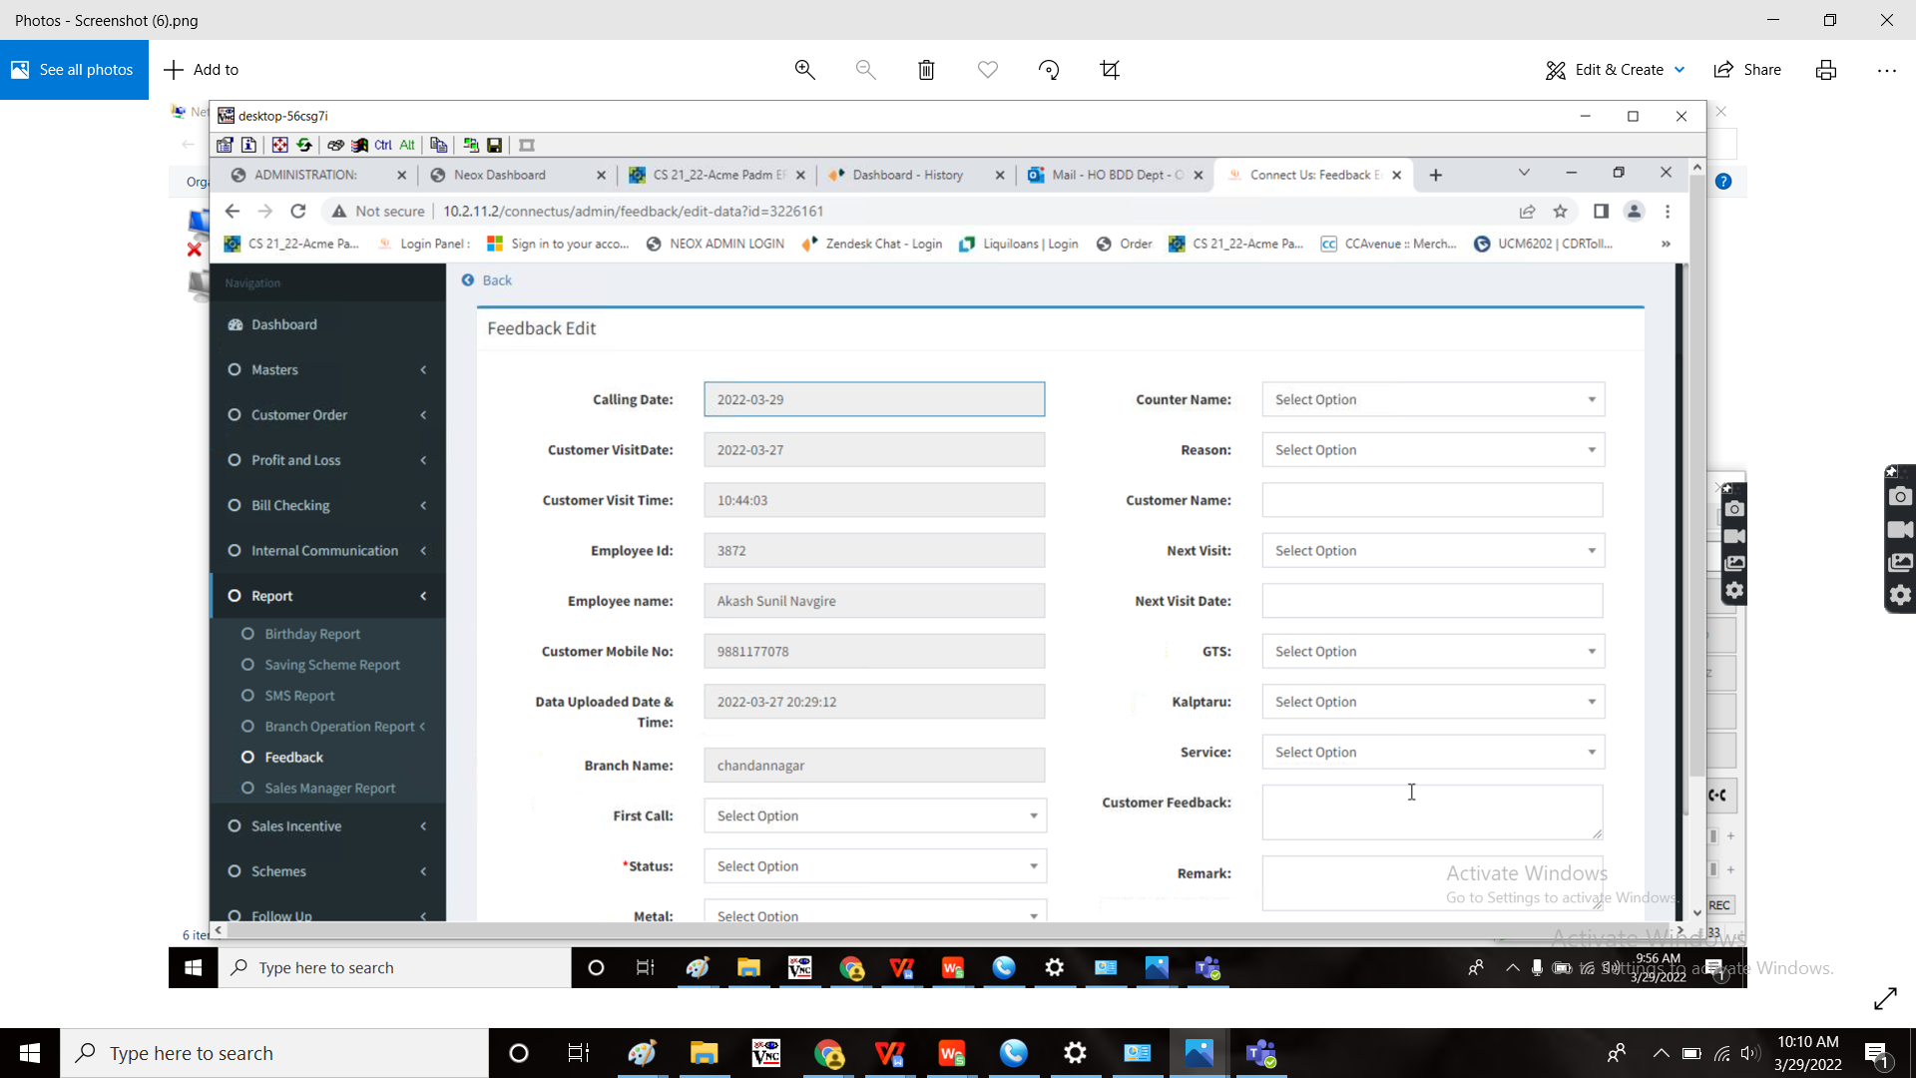

**Proposed system**

In connect us, in reports, in feedback, when the user submits, the user need an additional field “EMI” under kalptaru scheme.

**Step-1**

In Connect US -> Reports -> Feedback

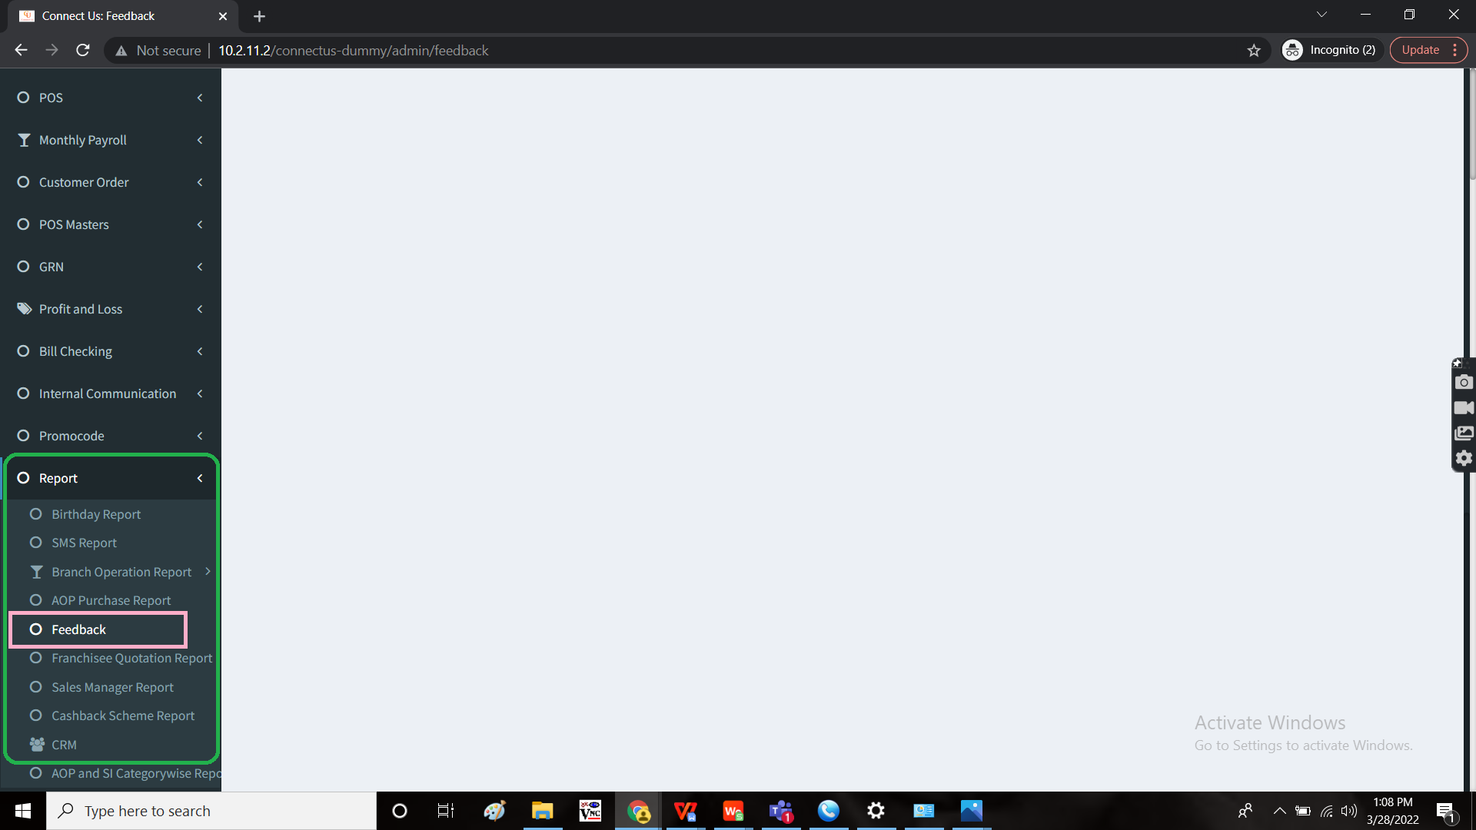

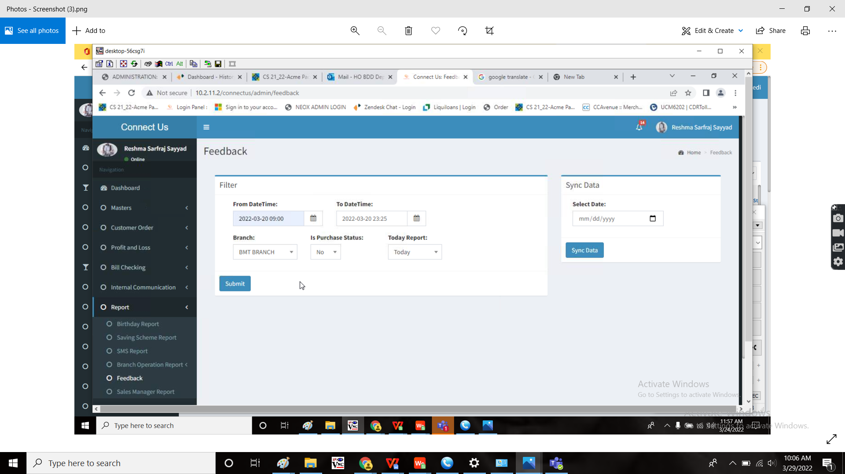

When the user fills all the fields and submit, then the following report displays.

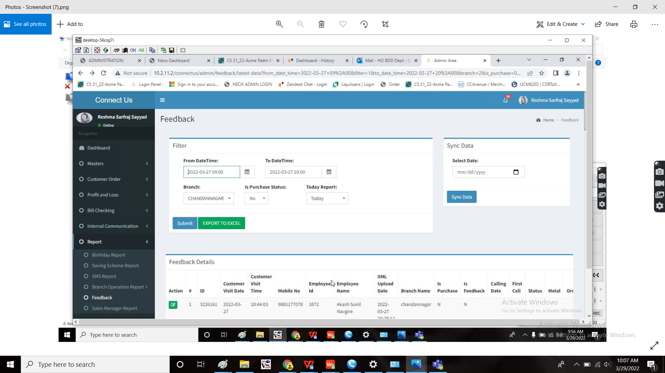

When the user clicks on the edit, the user wants to add a new field “EMI” under “Kalptaru” field with the drop down menu “yes” or “no”.

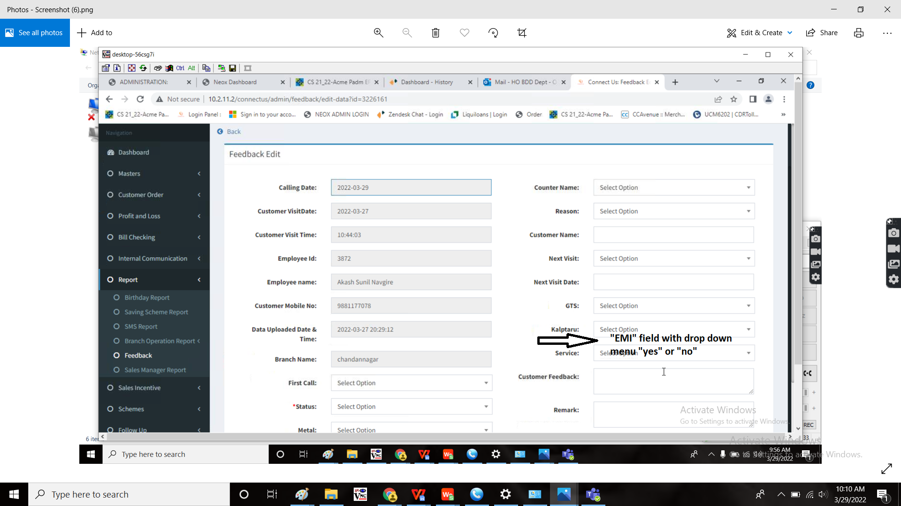

And should also represent in the report page

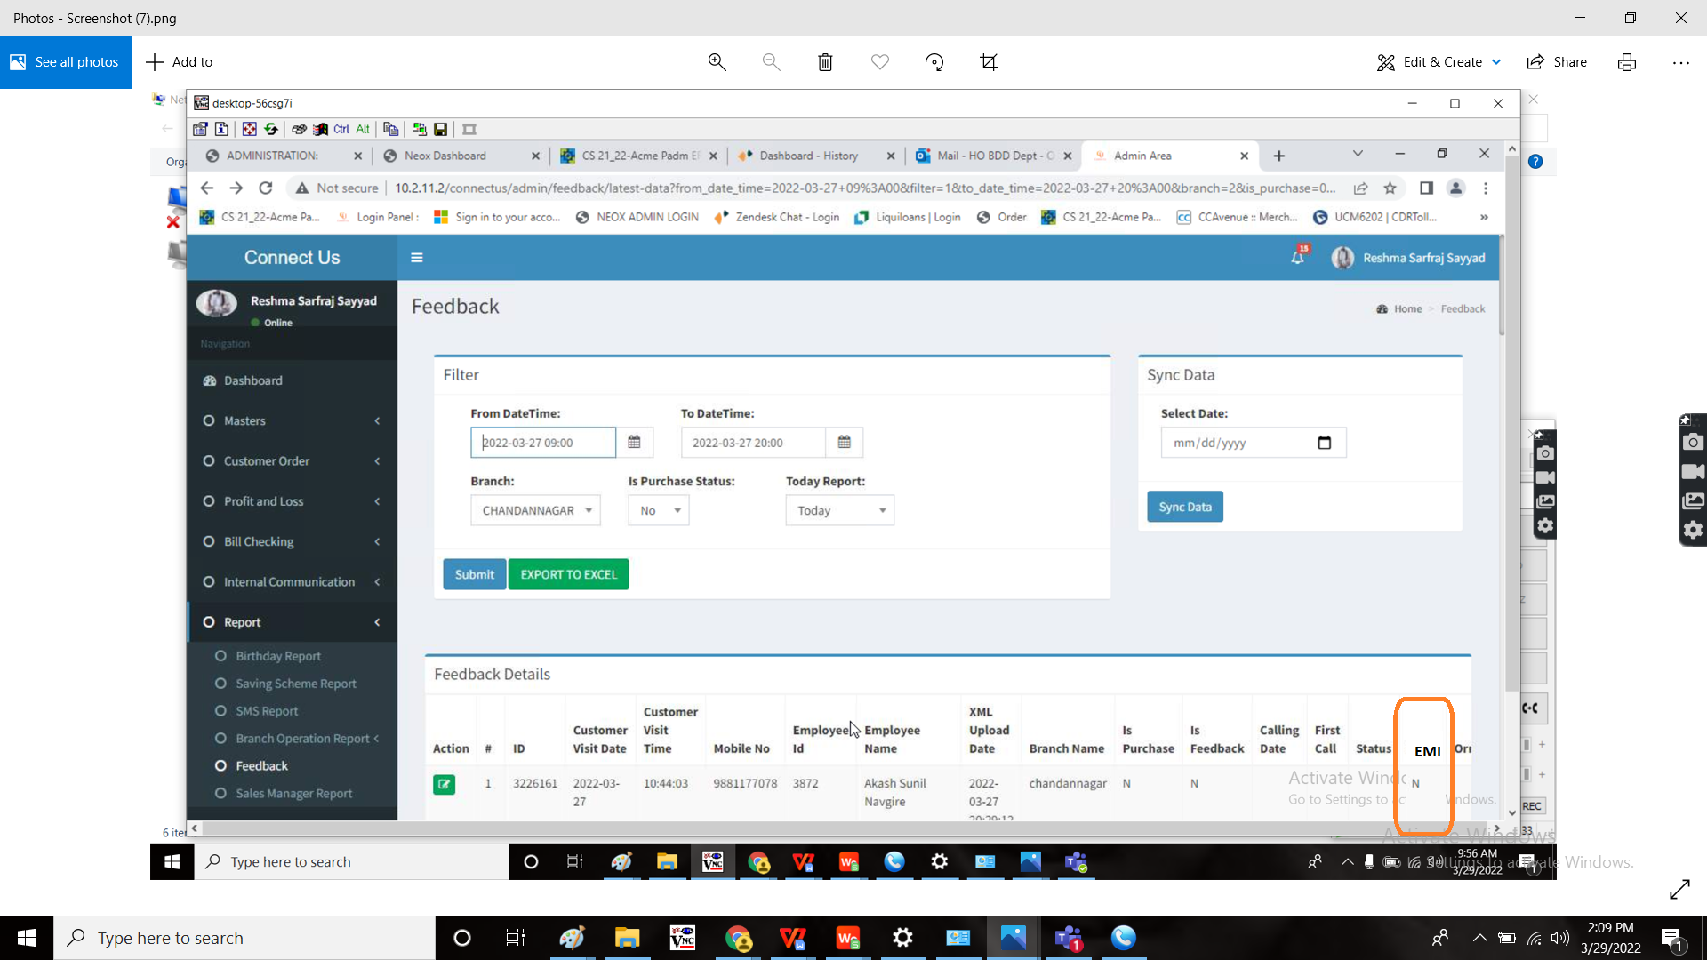

**References of the users**

|  |  |  |  |
| --- | --- | --- | --- |
| **User** | **Name** | **Mail** | **Contact number** |
| **Actual user** | Reshma Sayyed | hobdd@csjewellers.com |  |
| **Assigned business analyst** | Mounika KrishnaVeni Annamneedi | Mounika.annamneedi@techneai.com | 9885900039 |
| **Assigned developer** |  |  |  |
| **Assigned tester** | Monika Kolpe | Monika.kolpe@techneai.com |  |