|  |  |
| --- | --- |
| **Ticket ID** | TT2121 |

**Business requirement**

In metal booking, as of now, there is an issue when safari bullion and big bullion bazaar on online changes their name with space variables, then it is becoming difficult every time to change the lot names to fetch the data. So, the user want to insert the “#”, so that the variable changes like character too doesn’t effect the online rates in the metal booking.

**Existing system**

In the existing system, lot names uses the characters.

In metal booking -> General masters -> Metal master -> Add/ edit data -> lot name

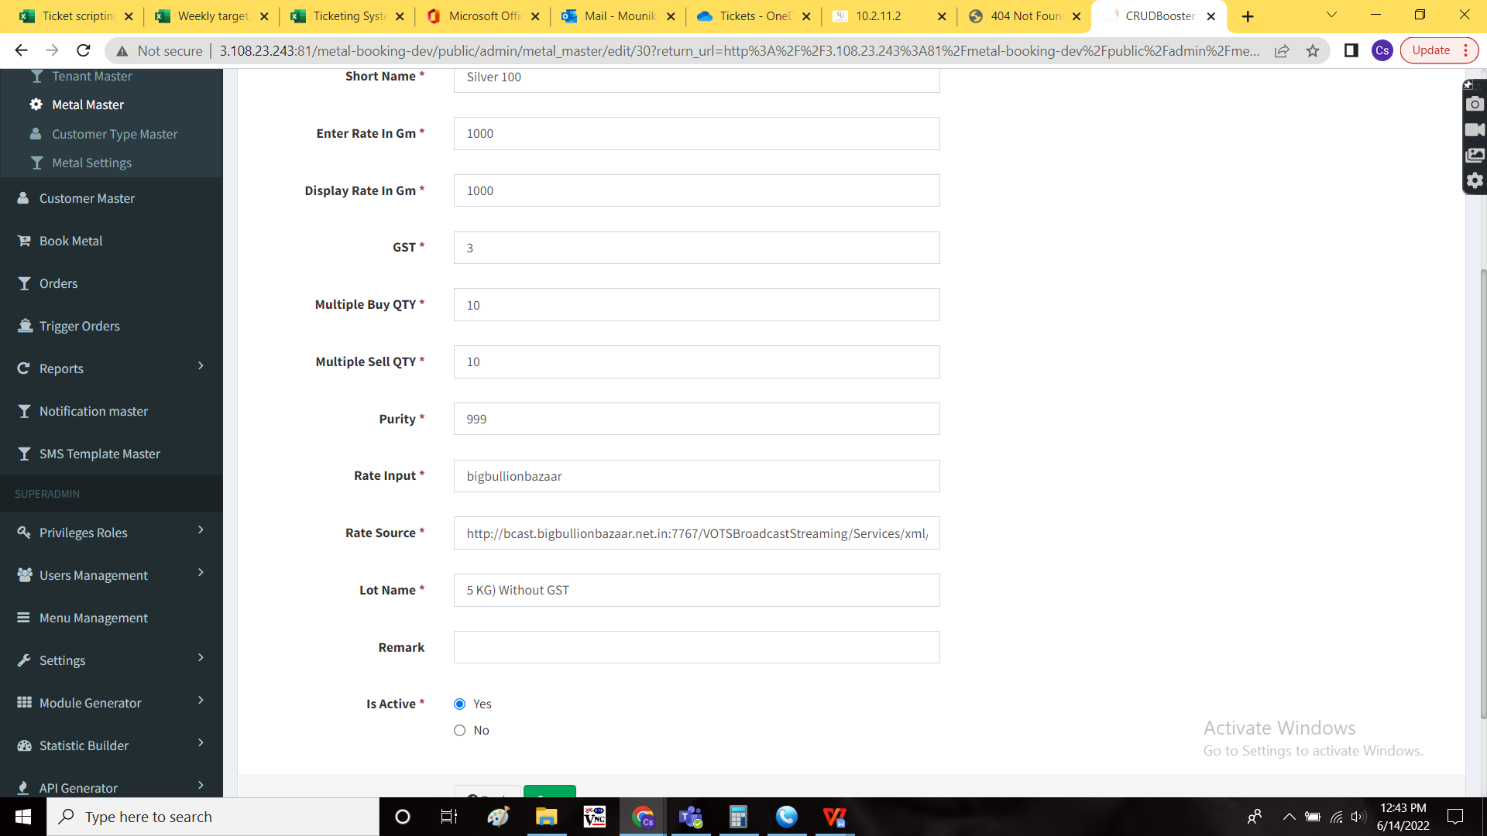

**Proposed system**

In In metal booking -> General masters -> Metal master -> Add/ edit data -> lot name

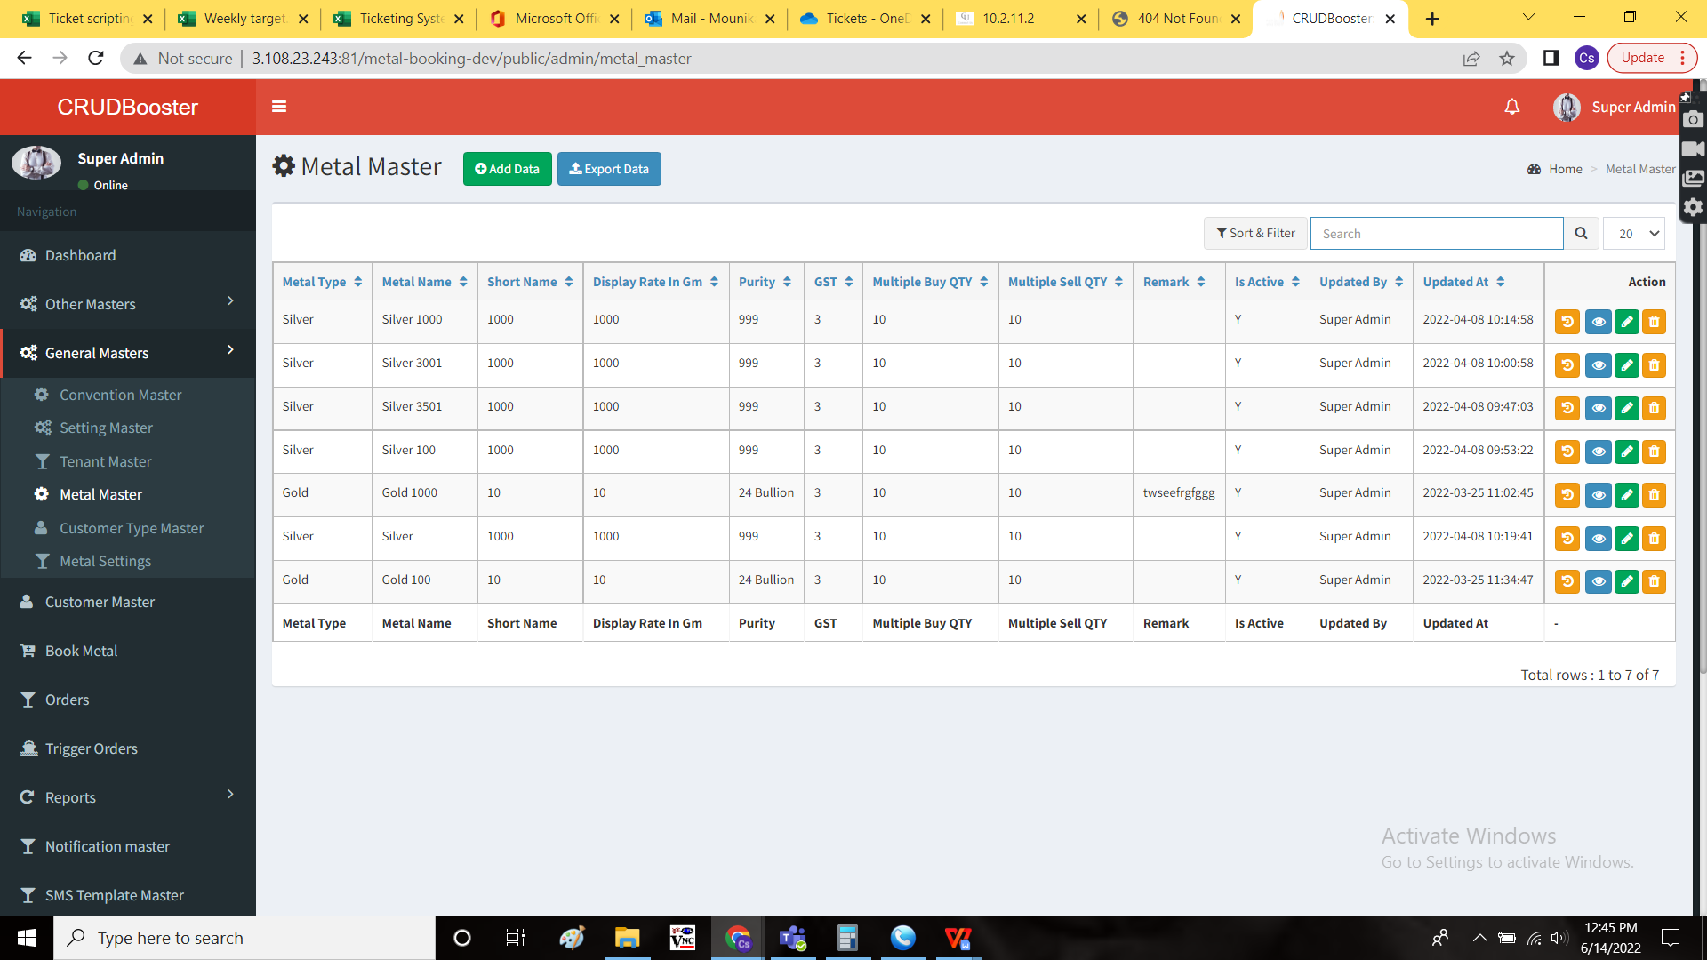

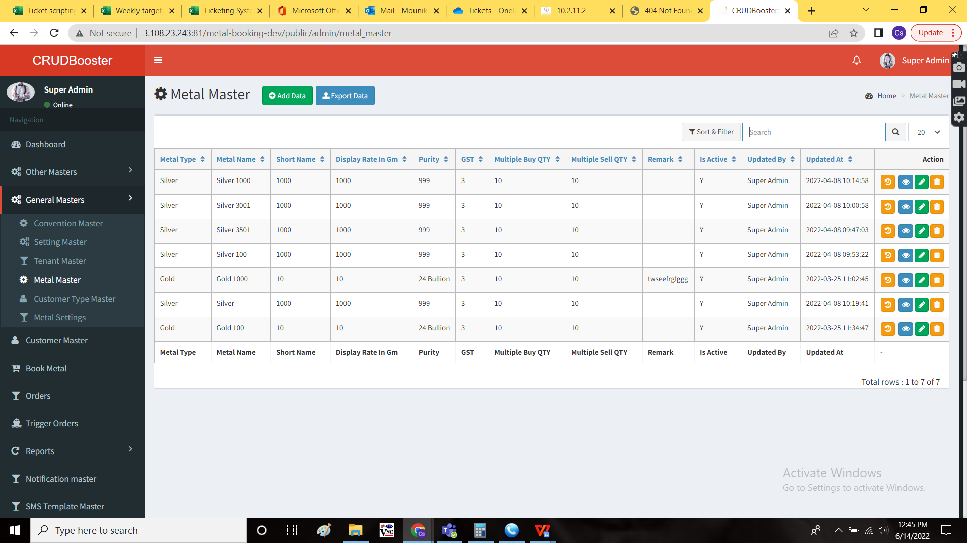



The lot names to be separated using the “#” symbol, so that the data with those variables are fetched though there any changes in the websites.

Safari bullion

Safari bullions.com

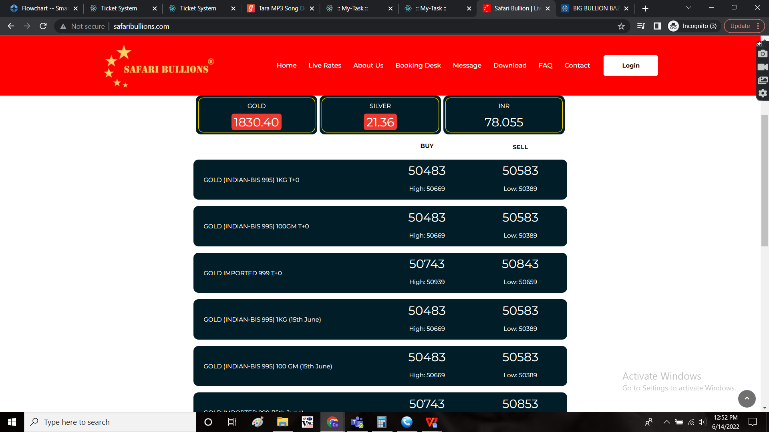

Big bullion

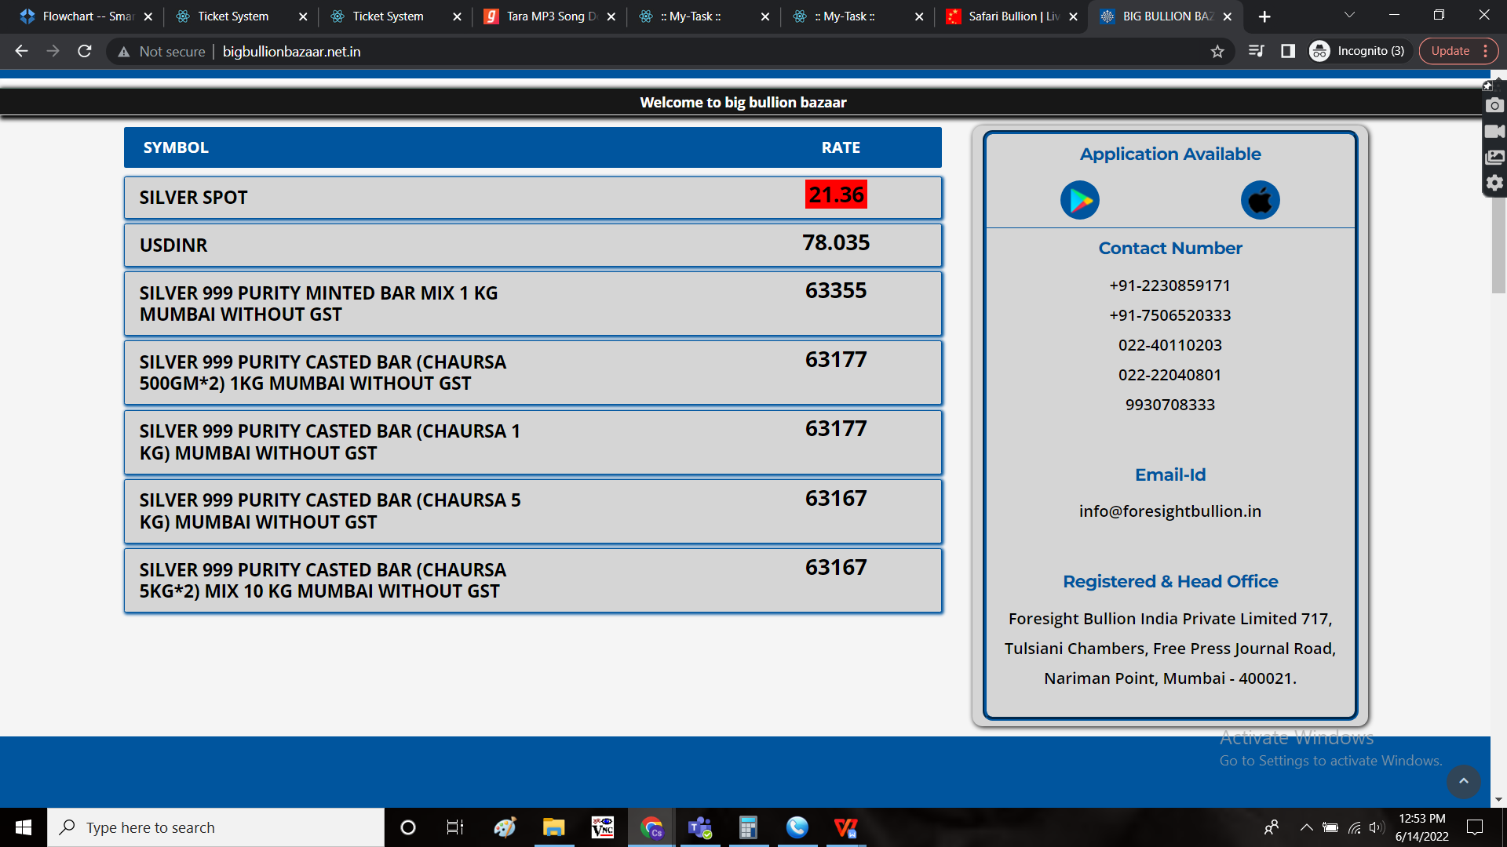

Required lot name:

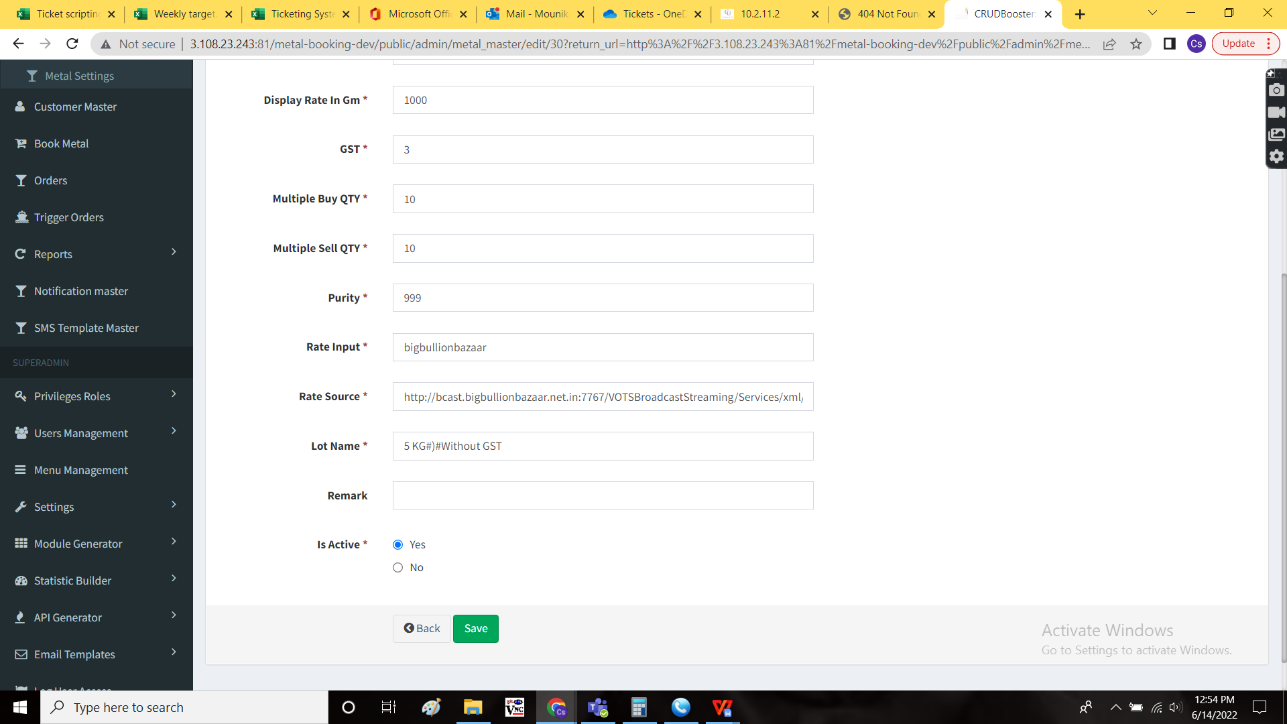

OUTPUT:

Lot name change

