|  |  |
| --- | --- |
| **Ticket ID** | T104150 |
| **Ticket description** | Kindly atomize the FD renewal process |
| **Created by** | Aasawari Ashok Kulkarni |
| **Created on** | 18/06/2021 |
| **Priority** | Very high |
| **Version** | 2 |

**Version**

|  |  |  |  |  |
| --- | --- | --- | --- | --- |
| **Sr. No** | **Version no** | **Version Date** | **User name** | **User department** |
| 1 | 0 |  | *Aasawari Ashok Kulkarni* | Treasure Department |
| 2 | 1 |  | *Aasawari Ashok Kulkarni* | Treasure Department |
| 3 | 2 | 20.12.2021 | *Aasawari Ashok Kulkarni* | Treasure Department |

**Approvals**

|  |  |  |
| --- | --- | --- |
| **Field** | **Name of the User** | **Approved date by the user** |
| **Actual User Name** | *Aasawari Ashok Kulkarni* | 18.06.2021 |
| **Actual User Department** | Treasure Department |  |
| **Organization Name** | C S Jewellers |  |
| **Sign-off** |  |  |
| **Assigned BA** | Mounika KrishnaVeni Annamneedi | 17.12.2021 |
| **Assigned Developer** |  |  |
| **Assigned Tester** |  |  |

**Estimation**

|  |  |  |  |  |
| --- | --- | --- | --- | --- |
| **Department name** | **Estimated Time (In hr)** | **Scheduled Date (Starting date )** | **Estimated date** | **Actual delivery date** |
| **BA** | 6 | 20.12.2021 | 22.12.2021 |  |
| **Development** |  |  |  |  |
| **Testing** |  |  |  |  |

**Abbreviations & terms**

CU - Connect Us

FD - Fixed Deposit

FDR - Fixed Deposit Renewal

**Introduction**

A fixed deposit, also known as an FD, is an investment instrument offered by banks, as well as non-banking financial companies (NBFC) to their customers to help them save money. With an FD account, we can invest a sizeable amount of money at a predetermined rate of interest for a fixed period.

**Business requirement**

User is maintaining the data manually in excel sheets. So they require facility for atomizing the FD renewal process.Purpose of developing the automation FD renewal process feature is to receive the notification/reminder before 5 days of maturity of FD that the FD need to be renewed on mentioned date.

**Existing system**

We don’t have any facility of atomizing the FD renewal process in current system.

**Proposed system**

* Creating of FDR master in connect us

**Step - 1**

* In CU, insert a new menu “FDR Master”

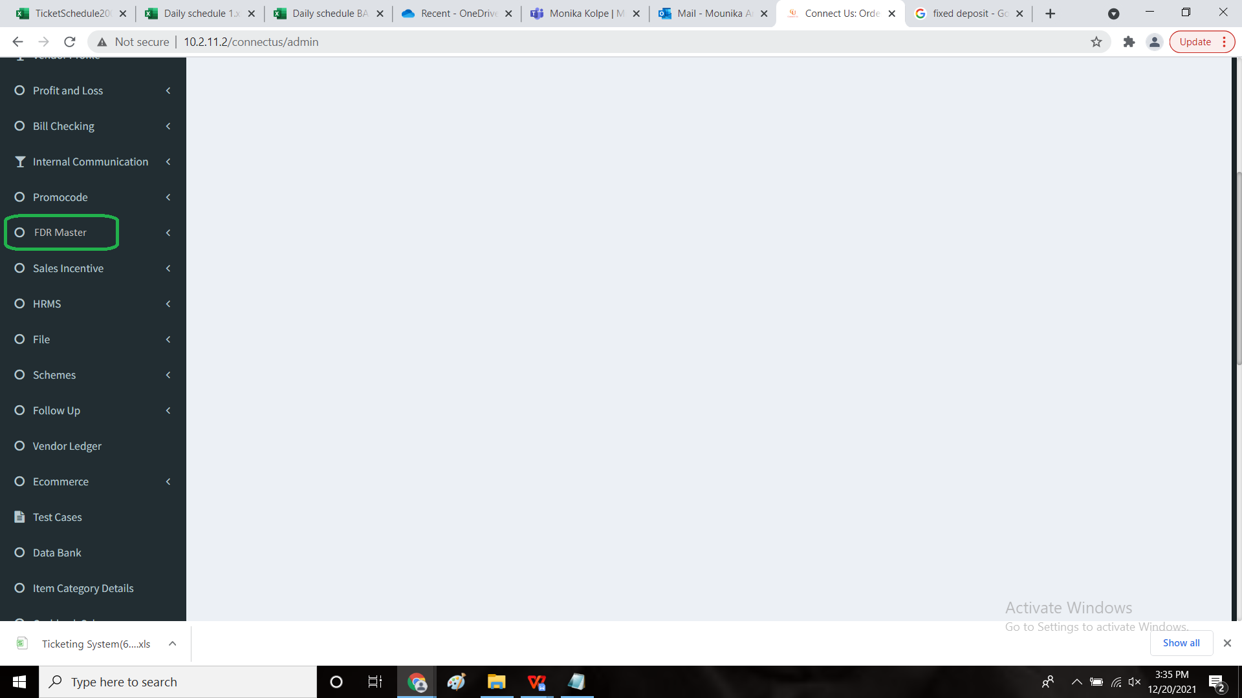

**Step - 2**

* The FDR Master consists of following fields
* Action buttons - View, Edit, History and Delete
* S.No
* Account No
* Connect Us fill-up date
* Open date
* Amount
* Rate of interest
* 1st interest
* 1st TDS
* 2nd interest
* 2nd TDS
* 3rd interest
* 3rd TDS
* 4th interest
* 4th TDS
* Total interest
* Total TDS
* Maturity date
* Maturity amount
* Days
* Status
* Lien
* Narration/ remarks
* Manual interest
* Manual accrued interest
* Manual TDS
* Manual FD amount
* Accrued interest
* Bank name
* Attachment file
* The master also consists of buttons such as follows
* Add data
* Export
* Filter
* Bulk upload format
* Bulk upload
* A search bar is even presented in this menu.
* The action menu consists of 4 buttons such as
* View
* Edit
* History
* Delete
* The buttons are explained as follows

1. **View**: User can view the data. All the data columns which are there in add data page are displayed in the view format.
2. **Edit**: User can edit the required data.
3. **History**: User can view the history, it includes Created At (Date &Time), Created by (person name), Updated At (Date & Time), Updated by (Person Name).
4. **Delete :** To delete the FD details which are entered. Confirmation window need to be displayed while deleting the details.

* Buttons:
* **Add Data button** : user can add the data.
* **Export** **button**: To export the file in excel / PDF format.
* **Filter** **button**: User can enter text in input fields to receive the output as required.
* **Search option** : User can type & search the data.
* **Bulk Upload option**: To upload bulk data.
* **Bulk upload Format**: The format for uploading the bulk FD data.

**Input table**

|  |  |  |  |  |
| --- | --- | --- | --- | --- |
| **FIELDS** | **INPUT TYPE** | **MANDATORY/ OPTIONAL** | **Editable/ No** | **DESCRIPTION** |
| Action menu | Buttons | Optional | - | The user can view, edit and view the history and delete any FD according to their requirement using the respective button |
| S.no | Numeric field | Optional | no | Display the serial numbers |
| Account no | Numeric field | Mandatory | yes | Text field |
| Connect us fill-up date | Date | Mandatory | no | Auto capture the connect us date when entry is done in add data. |
| Open date | Date (calender) | Mandatory | yes | Displays the date entered by user (FD opening date) |
| Amount | Numeric field | Mandatory | yes | Text field to display the FD amount. |
| Rate of interest | Numeric field | Mandatory | yes | user enters Rate of interest in percentage for FD |
| 1st interest | Numeric field | Optional | no | Formula (Principal Amt * Rate of Int. /100/365*days). Auto calculate. |
| 1st TDS | Numeric field | Optional | no | user enters TDS percentage. (basically 10%), Auto calculate. |
| 2nd interest | Numeric field | Optional | no | Formula (COMPOUNDED BAL AMT * Rate of Int. /100/365*days). Auto calculate. |
| 2nd TDS | Numeric field | Optional | no | user enters TDS percentage. (basically 10%). Auto calculate. |
| 3rd interest | Numeric field | Optional | no | Formula (COMPOUNDED BAL. AMT * Rate of Int. /100/365*days). Auto calculate. |
| 3rd TDS | Numeric field | Optional | no | user enters TDS percentage. (basically 10%).  Auto calculate. |
| 4th interest | Numeric field | Optional | no | Formula (COMPOUNDED BAL. AMT * Rate of Int. /100/365*days). Auto calculate. |
| 4th TDS | Numeric field | Optional | no | user enters TDS percentage. (basically 10%) , Auto calculate. |
| Total interest | Numeric field | Optional | no | Sum of Interest (1st interest + 2nd interest + 3rd interest + 4th interest).  Auto calculate & display. |
| Total TDS | Numeric field | Optional | no | Sum of TDS (1st TDS + 2nd TDS + 3rd TDS + 4th TDS).  Auto calculate & display. |
| Maturity date | Date | Mandatory | yes | Entered by user, need to accept only date.  Display calender. |
| Maturity amount | Numeric field | Optional | yes | Text field for displaying maturity amount. |
| Days | Numeric field | Mandatory | no | (maturity date-Open date). Auto calculate. |
| Status | Drop down | Mandatory | yes | Should display drop down of open & close. User will select any one option. |
| Lien | Drop down (OD, CC, Gold loan, Free) | Optional | yes | If any loan is taken by user keeping FD as security is selected here. |
| Narration/ remarks | Text | Optional | no | User can able to write the remarks if required. |
| Manual interest | Numeric field | Optional | yes | Text field for entering Interest amount. |
| Manual Accrued interest | Numeric field | Optional | yes | Text field for entering Accrued Interest amount. |
| Manual TDS | Numeric field | Optional | yes | Text field for entering TDS amount. |
| Manual FD amount | Numeric field | Optional | yes | Text field for entering Manual FD amount. |
| Accrued interest | Numeric field | Optional | no | COMPOUNDED BAL. AMT * Rate of Int. /100/365*days) |
| Bank name | Drop Down | Mandatory | yes | Display drop down   1. SBI 2. HDFC 3. Others. |
| Attachment file | CSV | Mandatory | no | Required to attach FD. |

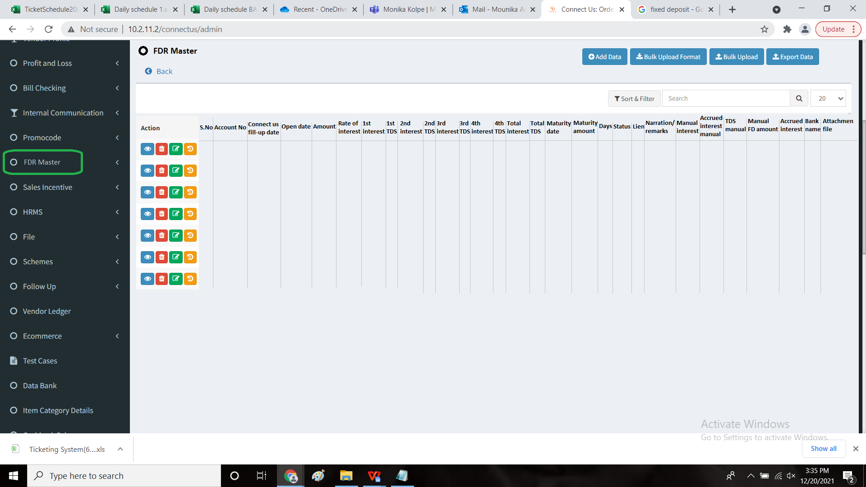

**Step - 3:**

ADD DATA:

Below screen is displayed, when clicked on Add Data option. Where user can add new FD data and save.

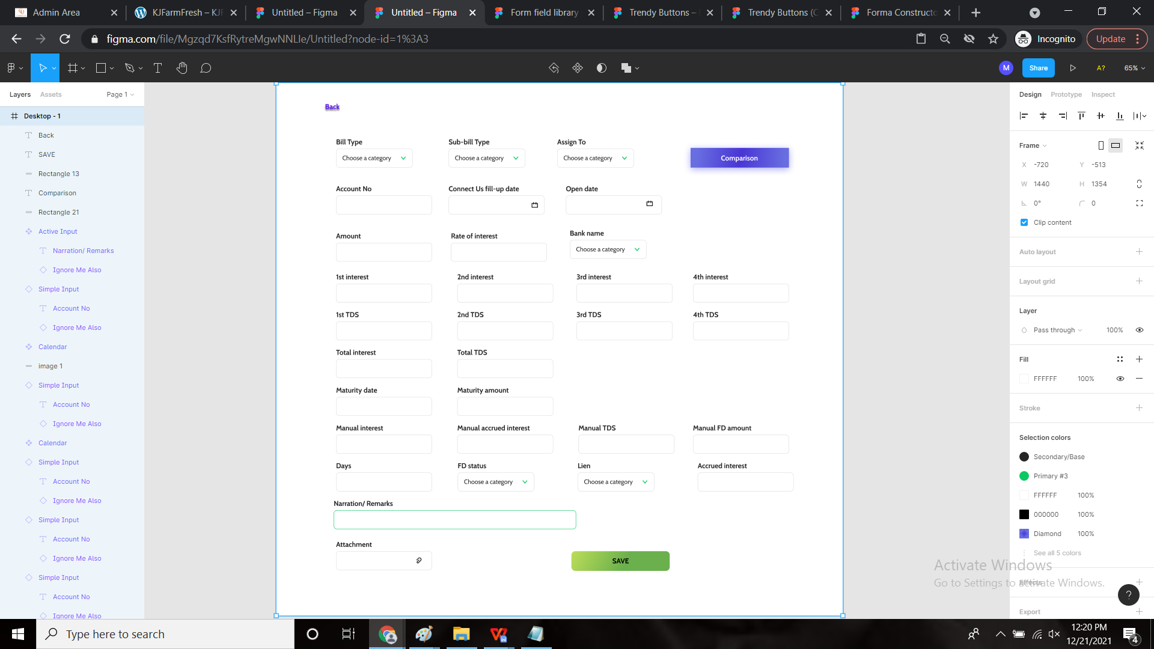

* **In Bill Type:** Type of FD option in presented in drop down. (Add the bill Type as FD in CU->Bill checking->Bill checking master-> Bill Type -> Add Bill Type)
* In **Sub Bill Type:** we need **Others** option in drop down. User can add sub bill type from (CU-> Bill Sub Type Master) OR currently display Sub bill type as Others by default when Bill type is selected as FD.
* **Assign To:** Drop down is displayed. (User is mapped in Assign To from CU-> Bill checking-> Bill checking Master->Bill Type Mapping User)
* **Calculate**: the calculate button is used to auto-calculate the interest amounts if the amount is invested in other bank.
* **Save** : finally, by clicking on the save button, the data is saved.

**Step - 4**

Comparison

* In add data, there is new button called “Comparison which is used to compare the FD, if it is deposited in other banks.
* This field is used to compare the amounts if we invested in other bank.
* This contains the following fields
* Year
* Rate of interest
* Bank name
* Years
* Amount
* Calculate button

|  |  |  |
| --- | --- | --- |
| **FIELDS** | **INPUT TYPE** | **DESCRIPTION** |
| Year | Calender | Period of which the FD is deposited |
| Rate of interest (%) | int | The percentage of the FD for the particular period is mentioned |
| Year | Default | The years are mentioned such as < 1 year, 1 year, 2 year, 3 year, 4 year and 5 year. Here, the interest rate of that particular year is mentioned. |
| Bank name | Text | The banks are mentioned. Already SBI and HDFC are in-built. If the user wants to add more banks, by clicking on the “+” button, he/she can add more banks |
| Enter amount | int | The amount is mentioned for the further calculation |
| Calculate | Button | The calculate button is used to compare the data and give the results. |

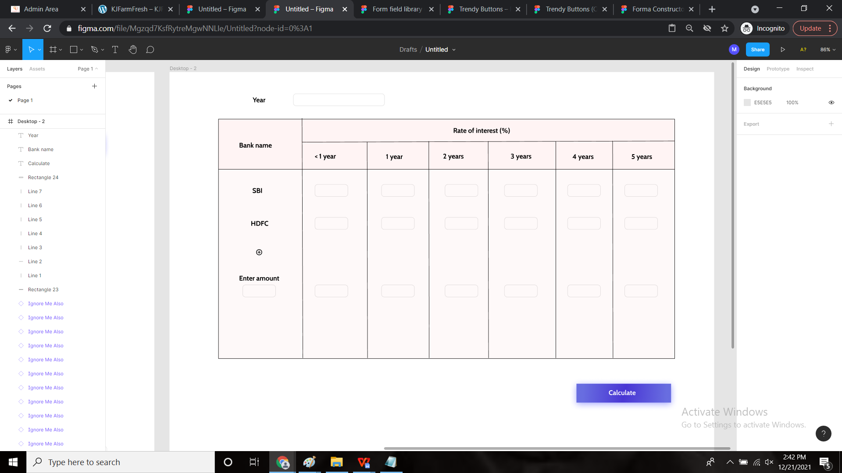

**Step - 5**

Bulk upload Format:

When we click on the bulk upload format, the following csv file is downloaded with the following fields.

* Account no
* Open date
* Amount
* Rate of interest
* Bank name
* 1st interest
* 1st TDS
* 2nd interest
* 2nd TDS
* 3rd interest
* 3rd TDS
* 4th interest
* 4th TDS
* Total interest
* Total TDS
* Accrued interest
* Maturity date
* Maturity amount
* Days
* Status
* Lien
* Remarks

Below screenshot is the format of Bulk upload of FD.

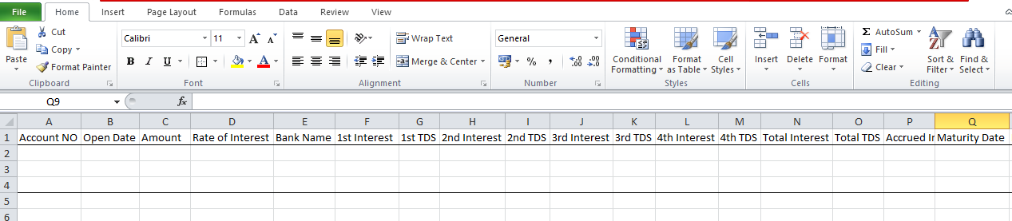

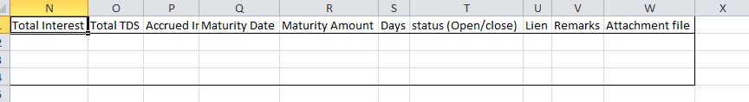

**Step-6:**

Bulk upload

* If the bulk upload file is not uploaded properly, then error file should be displayed with account number and specific column name which are not uploaded properly.

Below input fields are mentioned in detailed, which are required while uploading the **bulk** format.

|  |  |  |  |  |
| --- | --- | --- | --- | --- |
| **FIELDS** | **INPUT TYPE** | **MANDATORY/ OPTIONAL** | **DESCRIPTION** | **CONDITIONS IF ANY** |
| Account No | Numeric field | Mandatory | Text field which displays only numbers with decimals |  |
| Open Date | Date | Mandatory | Displays the date entered by user (FD opening date) | Display From and To Date option for selection |
| Amount | Numeric field or Text field | Mandatory | Text field to display the FD amount in numbers entered by user |  |
| Rate Of Interest(%) | Numeric field | Mandatory | user enters the rate of interest in percentage for FD |  |
| Bank Name | Dropdown | Mandatory | Display dropdown.   1. SBI 2. HDFC 3. Others. |  |
| 1st Interest | Numeric field (included decimals) | Optional | Enter 1st Interest amount |  |
| 1st TDS | Numeric field | Optional | Enter TDS amount |  |
| 2nd Interest | Numeric field | Optional | Enter 2nd Interest amount |  |
| 2nd TDS | Numeric field | Optional | Enter TDS amount |  |
| 3rd Interest | Numeric field | Optional | Enter 3rd Interest amount |  |
| 3rd TDS | Numeric field | Optional | Enter TDS amount |  |
| 4th Interest | Numeric field | Optional | Enter 4th Interest amount |  |
| 4th TDS | Numeric field | Optional | Enter TDS amount |  |
| Total Interest | Numeric field | Optional | Enter Total Interest Amount |  |
| Total TDS | Numeric field | Optional | Enter Total TDS Amount |  |
| Accrued Interest | Numeric field | Optional | Enter Accrued Interest Amount |  |
| Maturity Date | Date | Mandatory | Enter Maturity Date | Display From and To Date option for selection |
| Maturity Amount | Numeric field | Optional | Enter Maturity Amount |  |
| Days | Numeric field | Optional | Enter No. Of Days |  |
| FD Status(Open/ Close) | Text | Mandatory | Enter Open/ close status of FD |  |
| Lien | Drop down | Optional | If any loan is taken by user keeping FD as security is mentioned here. |  |
| Remarks | Text | Optional | User can write any remarks if necessary |  |

**Example:** Error CSV file auto downloaded, if the file is not uploaded properly.

Error file:

|  |  |  |  |  |  |  |  |  |
| --- | --- | --- | --- | --- | --- | --- | --- | --- |
| Sr no | Account no | Open Date | amount | Rate of Interest | Bank name | FD Status | Maturity date | Remarks |
| 1 | 123 | 1 june 2021 | 1000000 | 5% | SBI |  | 31 may 2022 | Please fill the status |
| 2 | 234 | 10 july 2021 | 2000000 | 5% | HDFC |  |  | Please fill the FD status an d maturity date |
| 3 | 234 |  |  |  |  |  |  | Please fill the open date, amount, rate of interest, bank name, FD status and maturity date |
| 4 | 456 | 10 oct 2021 |  | 5% | SBI | open | 9 oct 2022 | Please fill amount |

**Step-7**

Export data:

When we click on export, it should export all the data in CSV format.

**Step -8**

Filter

**FDR Filter View**:

Below screen shot is displayed for filter view.

* **Account Number:** If account number is entered, then it displays details of that particular account number.
* **Open date:** If FD open date (from and to date) is selected in filter view then related data need to be displayed.
* **Maturity date**: If FD Maturity date (from and to date) is selected in filter view then related data need to be displayed.
* **FD status:** If status is selected as open, then open FD need to be displayed. If status is selected as Close then close FD data need to be displayed.
* **Bank name:** If Bank name is selected in filter window then all FD’s data against filtered Bank name need to be displayed.
* **Reset**: When clicked on reset button it clears all given input fields information.
* **Export:** All the filtered data need to be exported after clicking on Export button. If filter is not applied then all data should be exported. (Export should be in CSV, Excel format)
* **Filter:** By clicking on Filter option it displayed all filtered data. If no data is entered in Filter then it should display all data when clicked on Filter option.

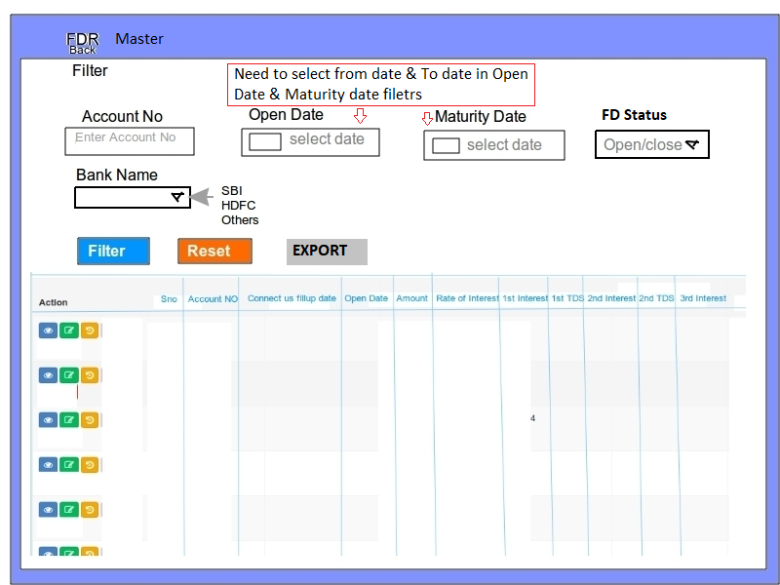

**Step-9**

Creation of new menu “FDR Closure” in Connect Us.

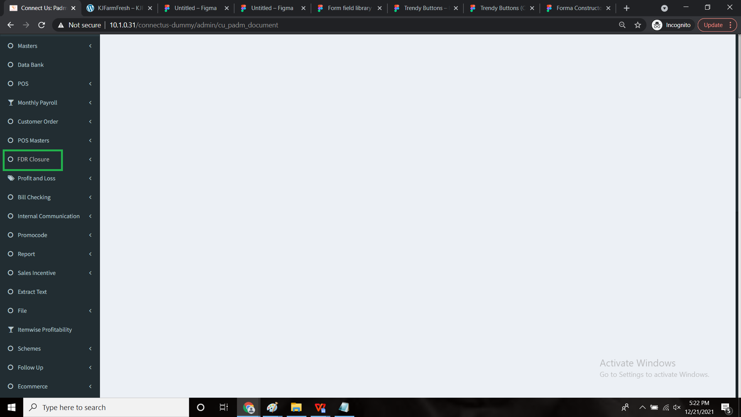

**Step - 10**

* The FD can be closed before or on or after the maturity date.
* But before closing the FD, any lien taken on the FD has to be closed such as
* OD (Overdraft)
* CC (Cash credit)
* Gold loan
* Free
* The FD is closed only when the lien is closed.
* The following are the fields in FD closure.
* Bill-type
* Sub-bill type
* Assign to
* Account no
* Connect us fill-up date
* Open date
* Amount
* Rate of interest
* Bank name
* Closure date
* No. Of days from maturity date
* Lien
* Close lien
* Amount taken
* Interest amount
* Total interest
* Total TDS
* Maturity date
* Maturity amount
* Manual interest
* Manual accrued interest
* Manual TDS
* Manual FD amount
* Days
* Accrued interest
* Narration/ remarks
* Close FD

**Input table**

|  |  |  |  |
| --- | --- | --- | --- |
| **FIELDS** | **INPUT TYPE** | **MANDATORY/ OPTIONAL** | **DESCRIPTION** |
| Bill type | Drop-down | Mandatory | The type of the bill is mentioned |
| Sub bill type | Drop-down | Optional | If any sub-bill type, then this option is selected. |
| Assign to | Drop-down | Mandatory | The person assigned is selected. |
| Account no | Numeric field | Mandatory | Text field |
| Connect us fill-up date | Date | Mandatory | Auto capture the connect us date when entry is done in add data. |
| Open date | Date (calender) | Mandatory | Displays the date entered by user (FD opening date) |
| Amount | Numeric field | Mandatory | Text field to display the FD amount. |
| Rate of interest | Numeric field | Mandatory | user enters Rate of interest in percentage for FD |
| Bank name | Drop Down | Mandatory | Display drop down   1. SBI 2. HDFC 3. Others. |
| Closure date | Date (calender) | Mandatory | The closure date of the FD |
| No. Of days from maturity date | int | Mandatory | Auto-calculate the days.  (closure date - maturity date) |
| Lien | Drop down (OD, CC, Gold loan, Free) | Optional | If any loan is taken by user keeping FD as security is selected here. |
| Close lien | Drop-down | Mandatory | The drop-down have 2 options   1. Open 2. close |
| Amount taken | Int | Mandatory | The amount taken on lien against FD |
| Interest amount | Int | Mandatory | The interest amount on the lien amount taken. |
| Total interest | Numeric field | Optional | Sum of Interest (1st interest + 2nd interest + 3rd interest + 4th interest).  Auto calculate & display. |
| Total TDS | Numeric field | Optional | Sum of TDS (1st TDS + 2nd TDS + 3rd TDS + 4th TDS).  Auto calculate & display. |
| Maturity date | Date | Mandatory | Entered by user, need to accept only date.  Display calender. |
| Maturity amount | Numeric field | Optional | Text field for displaying maturity amount. |
| Manual interest | Numeric field | Optional | Text field for entering Interest amount. |
| Manual Accrued interest | Numeric field | Optional | Text field for entering Accrued Interest amount. |
| Manual TDS | Numeric field | Optional | Text field for entering TDS amount. |
| Manual FD amount | Numeric field | Optional | Text field for entering Manual FD amount. |
| Days | Numeric field | Mandatory | (maturity date-Open date). Auto calculate. |
| Accrued interest | Numeric field | Optional | COMPOUNDED BAL. AMT * Rate of Int. /100/365*days) |
| Narration/ remarks | Text | Optional | User can able to write the remarks if required. |
| Close FD | Button | Optional | Finally, to close the FD, the button is used.  FD can be closed only when the lien is closed.  This is automatically closes the FD in FDR Master. |

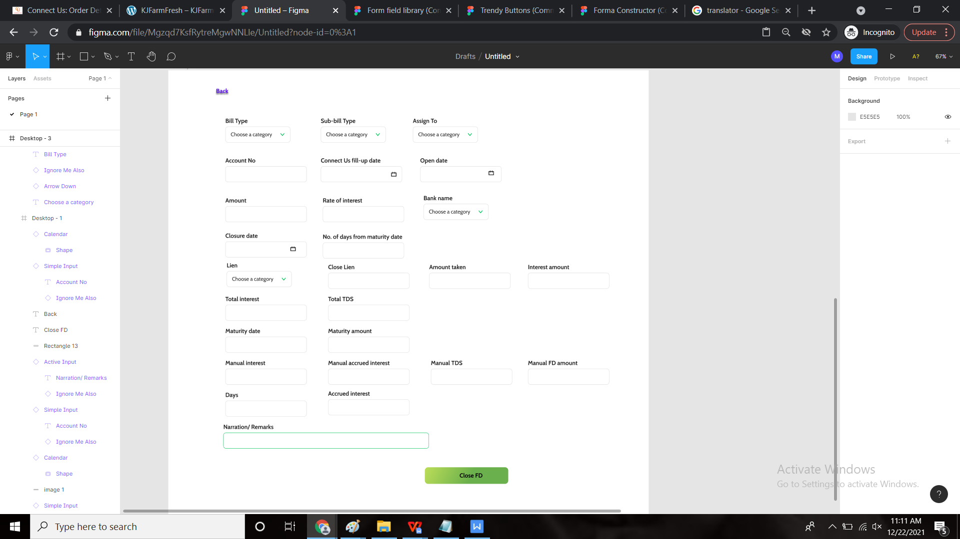

**Step - 11**

**Notifications**:

* User should receive the notifications in connect us before 5 days of maturity date of each FD.

**Formula: (Maturity date( –minus) 5 days )**

**“The FD bearing the Account number : ____ will be expired on Maturity date : ____”**

* Notification should be received on Email ID, watsapp number and in Connect us Notification option of User.
* **Email ID** for notification: [finance@csjewellers.com](mailto:finance@csjewellers.com), [finance1@csjewellers.com](mailto:finance1@csjewellers.com), [bracc@csjewellers.com](mailto:bracc@csjewellers.com).
* Mobile number for **watsapp**:  **9766305004**
* The user should even get the notification when the FD is closing against the lien that the lien to be closed.

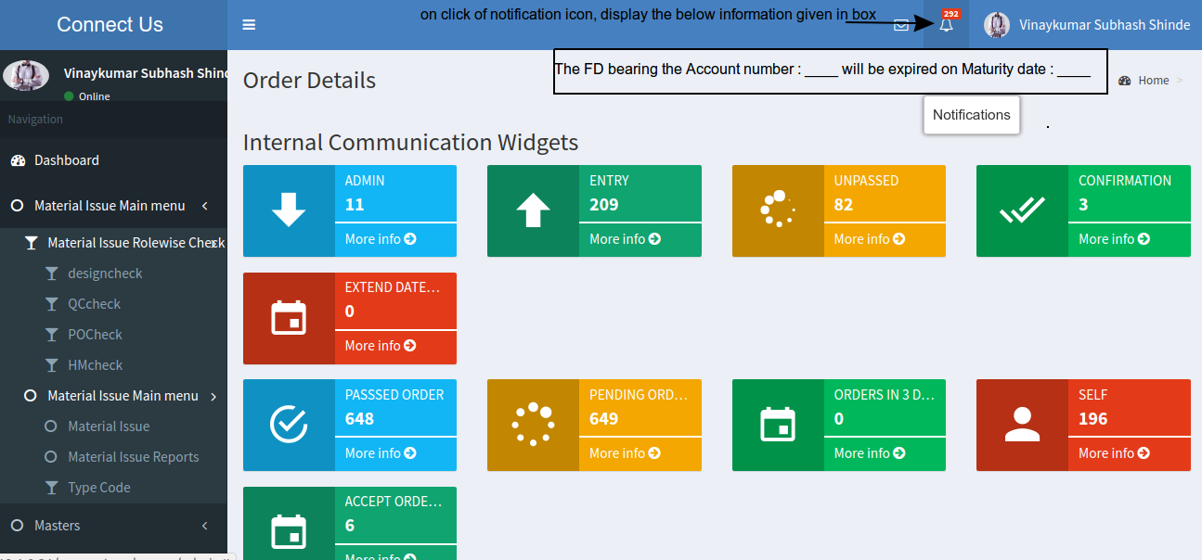

**References of the users**

|  |  |  |  |
| --- | --- | --- | --- |
| **User** | **Name** | **Mail** | **Contact number** |
| **Actual user** | Pritam Mehta |  |  |
| **Ticket created by (if any)** | Aasawari Ashok Kulkarni |  |  |
| **Assigned business analyst** | Mounika KrishnaVeni Annamneedi | Mounika.annamneedi@gmail.com | 8669917920 |
| **Assigned developer** |  |  |  |
| **Assigned tester** |  |  |  |