|  |  |
| --- | --- |
| **Ticket ID** | T127308 |
| **Ticket description** | Promotional sms send kelyananter tya paiki kiti customer ne branch visit kiva sale bill zali ahet ti provision connect us madhe karun dene. |
| **Created by** | Vishal Shantinath Patil |
| **Created on** | 04/08/2021 |
| **Priority** | Very high |
| **Version** | 1 |

**Version**

|  |  |  |  |  |
| --- | --- | --- | --- | --- |
| **Sr. No** | **Version no** | **Version Date** | **User name** | **User department** |
| 1 | 0 | 09.08.2021 | Vishal Shantinath Patil | Branch Operation Control |
| 2 | 1 | 15.12.2021 | Vishal Shantinath Patil | Branch Operation Control |

**Approvals**

|  |  |  |
| --- | --- | --- |
| **Field** | **Name of the User** | **Approved date by the user** |
| **Actual User Name** | Vishal Shantinath Patil | 04.08.2021 |
| **Actual User Department** | Vishal Shantinath Patil |  |
| **Organization Name** | CS Jewellers |  |
| **Sign-off** |  |  |
| **Assigned BA** | Mounika KrishnaVeni Annamneedi | 15.12.2021 |
| **Assigned Developer** | Parth Patel |  |
| **Assigned Tester** | Amreen |  |

**Estimation**

|  |  |  |  |  |
| --- | --- | --- | --- | --- |
| **Department name** | **Estimated Time (In hr)** | **Scheduled Date (Starting date )** | **Estimated date** | **Actual delivery date** |
| **BA** | 5 | 15.12.2021 | 17.12.2021 |  |
| **Development** |  |  |  |  |
| **Testing** |  |  |  |  |

**Introduction**

This is the kind of SMS message, we send to promote our brand, the products or services we offers. Promotional SMS includes marketing and sales messages. Additionally, any text message that contains an offer or a sales coupon is considered as a promotional.

**Business requirement**

The user want to know how many customers are purchasing the specific item through the promotional SMS sent to the user during a particular campaign.

**Existing system**

This point is not existed in the current system.

**Proposed system**

* Initially, we need to create the campaign page, so that the user enters all the details related to the campaign such as campaign name, contact numbers of the customers, ornament item name, branch, from date, to date and the message of the SMS.
* Then the user can directly shoot the SMS to all the users by filling all the details and by clicking the button (create & send).
* There exists an another menu which creates reports of these promotional SMS sent.
* In this reports menu, the user can get the data of the customers to purchased the particular item in the period and from the particular branch by sending the promotional SMS to the customers.
* There are some conditions such as
  + If the customer purchases the different ornament from the store, then that information is not going to be considered and not displayed in the reports
  + If the customer purchases the item from other branch I.e., branch other than in SMS, then that information is not going to be considered and not displayed in the reports.

**Process flow**

Step-1

* Creation of new menu for promotional SMS in Connect Us.

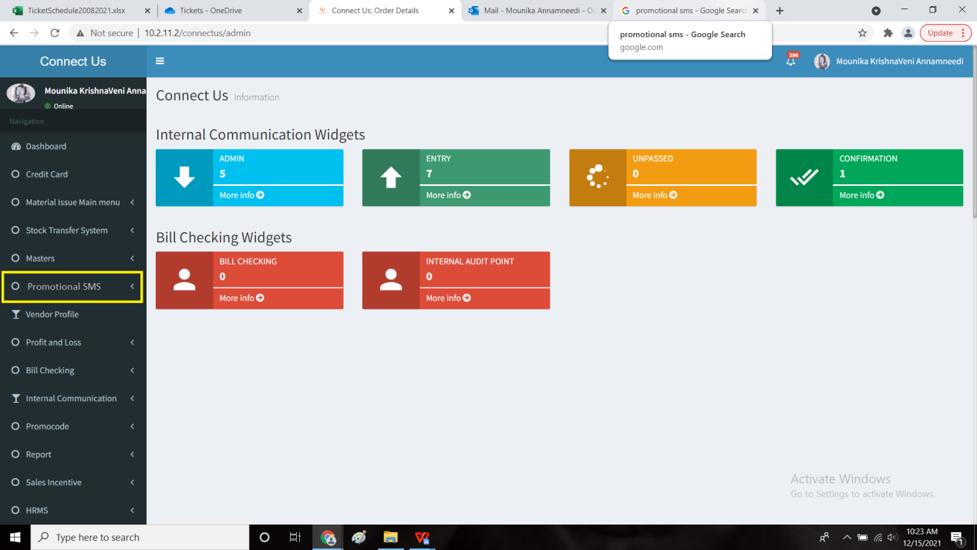

Step-2

* Create 2 sub-menu’s under promotional SMS such as
  + Create campaign
  + Generate report

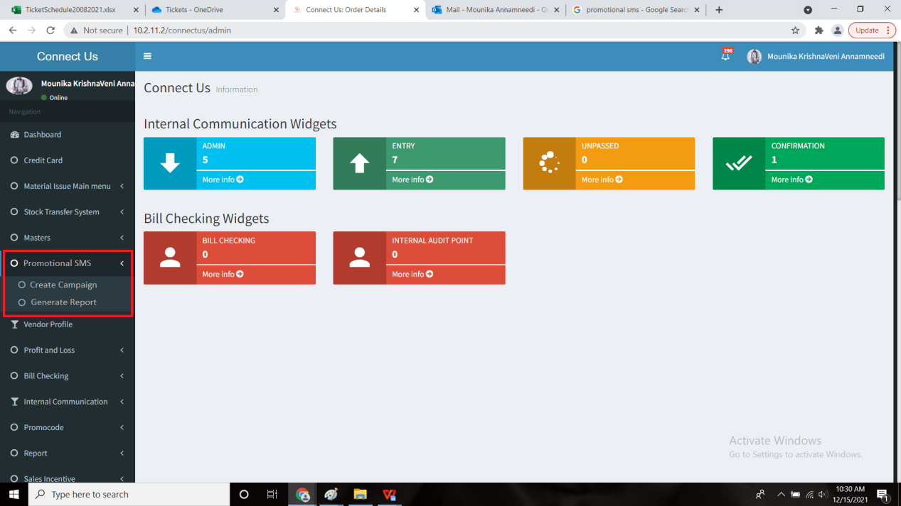

Step-3

* “Create campaign” page
* The create campaign consists of fields such as
  + Name
  + Contacts
  + Item name
  + Branch
  + From date
  + To date
  + Message
* There will be a button at the end to create the campaign and send the SMS to the customers.

**Input table**

|  |  |  |  |
| --- | --- | --- | --- |
| **FIELDS** | **INPUT TYPE** | **DESCRIPTION** | **CONDITIONS IF ANY** |
| Name | Text box | The name of the campaign | - |
| Contacts | File attachment | The customers contacts for shooting the SMS | The file should be in .csv format |
| Item name | Drop down | The name/ type of the ornament | The user can select more than one ornament item if required |
| Branch | Drop down | Branch name | The user can select more than one branch if required and an option to select all |
| From date | Calender | The date of the campaign when it is going to start | - |
| To date | Calender | The date of the campaign when it is going to end | - |
| Message | Text box | The text message of the promotional SMS | - |
| Create & send | Button | For creating the campaign and sending the SMS to the customers |  |

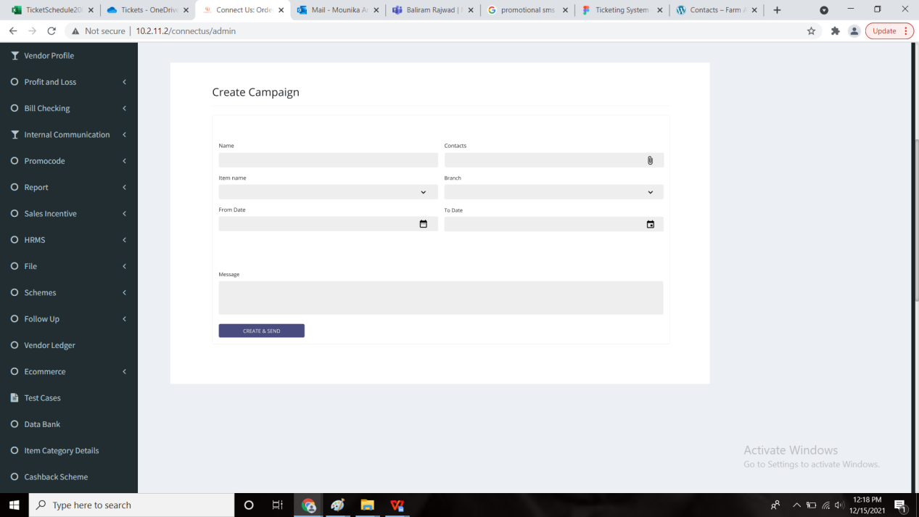

Step-4

* “Generate Report” page
* The generate report generates the reports of the customers who purchased the items (ornaments) from the particular branch at the particular time period for the SMS sent.
* The generate report page consists of field “select campaign”.
* When the user selects the campaign and selects the “get data” to fetch all the data of the remaining fields.
* The user can edit the data if required.

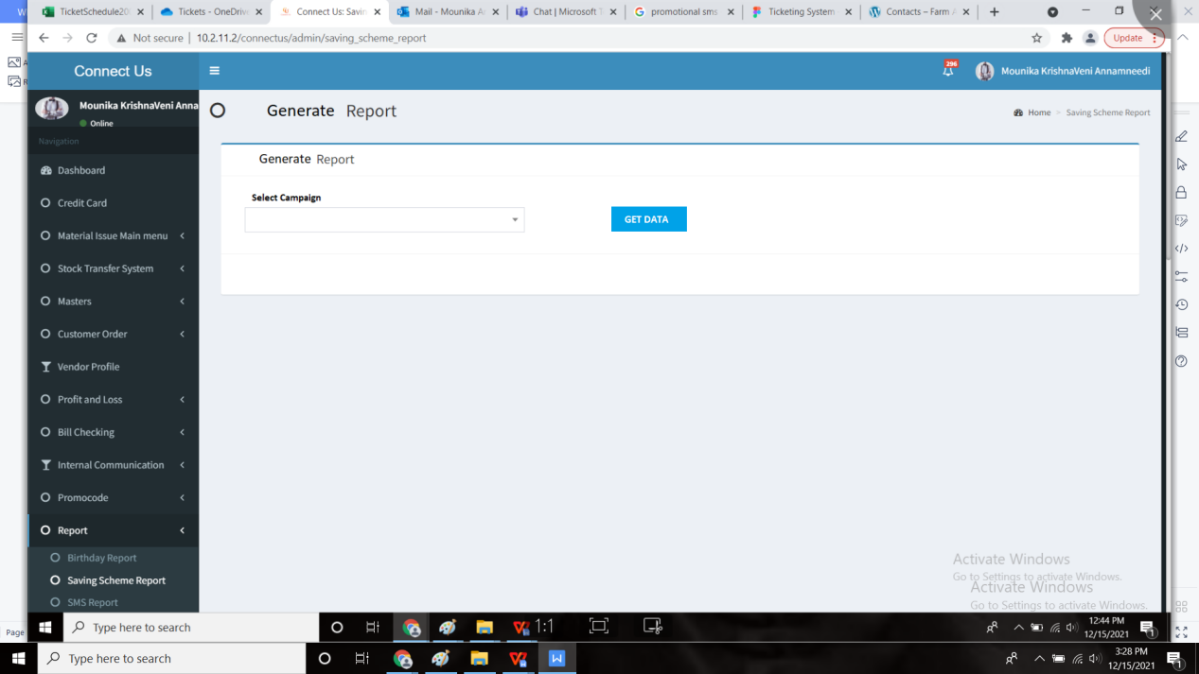

Step-5

* When the user clicks on “get data”, then automatically the data of the other fields are filled.
* But the fields can be customized by the user.
* The generate report page consists of the following fields such as
  + Branch
  + Item name
  + Campaign
  + From date
  + To date
* By clicking on the report, the report is generated.

**Input table**

|  |  |  |  |
| --- | --- | --- | --- |
| **FIELDS** | **INPUT TYPE** | **DESCRIPTION** | **CONDITIONS IF ANY** |
| Branch | Drop down | The name of the branch | Filtering option for the branch. Can select multiple or all if required. |
| Item name | Drop down | The name/ type of the ornament | The user can select more than one ornament item if required |
| Campaign | Drop down | Name of the campaign |  |
| From date | calender | The date from when the user needs the data | The date cannot be before the campaign date |
| To date | calender | The date up to when the user needs the data | The date cannot be changed to after the end of campaign date |
| Submit | Button | For generating the report |  |

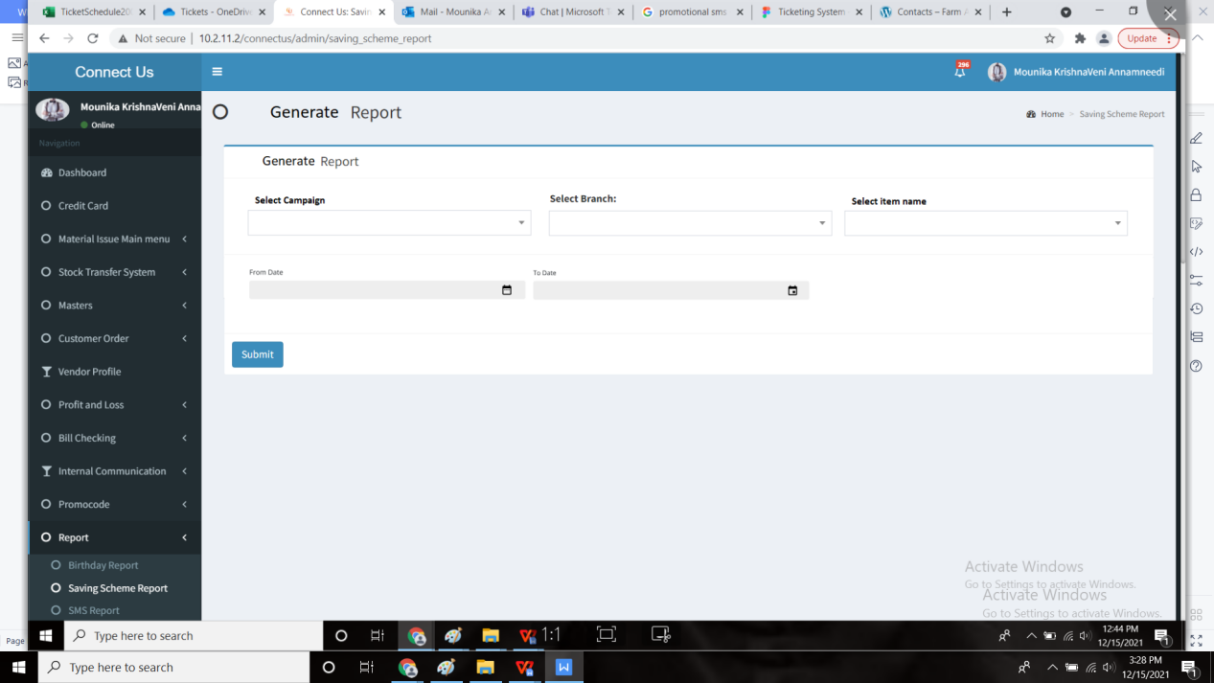

Step-6

* Report of the customers to whom the promotional SMS sent and details of the customers who purchased it and not purchased the particular item from the particular branch and at the particular period.
* Export button is available for exporting the report.
* The report should be displayed in the following format

|  |  |  |  |  |  |  |
| --- | --- | --- | --- | --- | --- | --- |
| **Branch name** | **Customer name** | **Mobile no** | **Doc number** | **Doc date** | **Item name** | **Is purchase** |
| Satara branch | Vishal Shantinath Patil | 8965471236 | HXSG-1167 | 7/8/2021 | ganthan | yes |
| Satara branch | Vishal Shantinath Patil | 8965471236 | HXSG-1167 | 7/8/2021 | vedhee | yes |
| Pune branch | Sudhir Gurunath Khandare | 5478965123 | HBSG-500 | 7/9/2021 | vedhee | yes |
|  |  | 7743883125 |  |  |  | no |

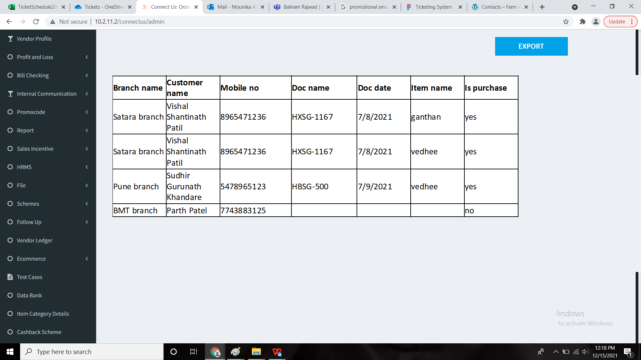

CONDITIONS:

* The promotional SMS is sent for the particular ornament promotion. Therefore, the report consists of the customers only who purchased that particular ornament. Though the customer purchased other ornament, it is not considered.
  + Example: if the promotional SMS sent for promotion of diamonds and if the customer purchased gold ornaments, then it is not considered.
* The promotional SMS is sent from the particular branch. Therefore, only the customers purchased from that branch is only considered.

**References of the users**

|  |  |  |  |
| --- | --- | --- | --- |
| **User** | **Name** | **Mail** | **Contact number** |
| **Actual user** | Vishal Shantinath Patil |  |  |
| **Assigned business analyst** | Mounika KrishnaVeni Annamneedi | Mounika.annamneedi@techneai.com | 8669917920 |
| **Assigned developer** | Parth Patel |  |  |
| **Assigned tester** | Monika Kolpe |  |  |