|  |  |
| --- | --- |
| **Ticket ID** | T180966 |
| **Ticket description** | Connect Us Madhe Auto Update Legal Name ya madhe fakt 2 lakh varil bill aale paheje.  Gross Amount Vr |
| **Created by** | Annappa Dhulappa Thikane |
| **Created on** | 31.12.2021 |
| **Priority** | High |
| **Version** | 0 |

**Version**

|  |  |  |  |  |
| --- | --- | --- | --- | --- |
| **Sr. No** | **Version no** | **Version Date** | **User name** | **User department** |
| 1. | 0 | 31.12.2021 | Annappa Dhulappa Thikane | I and O Audit |

**Approvals**

|  |  |  |
| --- | --- | --- |
| **Field** | **Name of the User** | **Approved date by the user** |
| **Actual User Name** | Annappa Dhulappa Thikane | 31.12.2021 |
| **Actual User Department** | I and O Audit |  |
| **Organization Name** | CSPL |  |
| **Sign-off** |  |  |
| **Assigned BA** | Mounika KrishnaVeni Annamneedi | 31.12.2021 |
| **Assigned Developer** |  |  |
| **Assigned Tester** |  |  |

**Estimation**

|  |  |  |  |  |
| --- | --- | --- | --- | --- |
| **Department name** | **Estimated Time (In hr)** | **Scheduled Date (Starting date )** | **Estimated date** | **Actual delivery date** |
| **BA** | 1 | 31.12.2021 | 31.12.2021 |  |
| **Development** |  |  |  |  |
| **Testing** |  |  |  |  |

**Abbreviations & terms**

CU -> ConnectUs

URD - Unregistered dealer

**Introduction**

In CU -> user require to auto update legal name of customer above 2 lakhs transactions. The KYC (Pan card) details should be auto updated in CU -> Auto update legal name, the details should be fetched Padm -> customer transaction History.

**Business requirement**

* In CU -> user require to auto update legal name of customer above 2 lakhs transactions.
* In CU-> Admin -> Auto update legal name -> select from date and To Date and submit. The Report should display customer details only above 2 Lakhs transactions.
* Consider the gross amount in the bill as the customers may have amounts such as the URD amount, scheme amounts etc which will be reduced from the bill. Therefore, net amount is not considered.

**Existing system:**

In Existing System, Cu-> Admin -> Auto Update Legal Name, after selecting the Date and on click of submit button it displays the data of customer transaction of all amount.(Below 2 lakhs and above 2 lakhs)

**Proposed system:**

* In CU-> Admin -> Auto update legal name -> select From Date and To Date and click on Submit.
* The Report should **display** customer transaction details with Old Legal Name and New Legal Name, Doc series, Doc number, Image Name, update status which is only **above 2 Lakhs.**
* **Below 2 Lakhs** amount Customer Transaction History **should not be displayed**.
* The KYC (pan) details which are attached in Padm -> customer transaction History, is fetched and displayed in CU -> Admin -> Auto update legal Name.
* Consider the gross amount in the bills for the filtering the amount.ss
* In case if there are any details which has different name in “Old legal Name” and “New legal name” then user can select by clicking on check box under “Select Records” column in below image and click on “Update Legal Name” option.
* Create a menu “Padm Document Master” so that the documents are selected which are presented in that master.

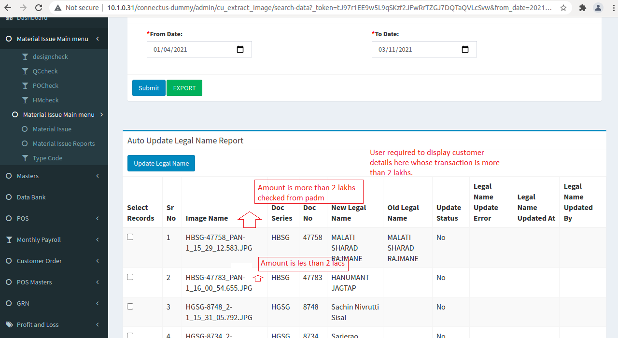

* After updating the status by selecting the Records then “Update Status” column in Report will change to “Yes”.
* If there is any error while updating the record then it displays “Error message(reason for not updating)” in “Legal Name Update Error” Column.
* After updating the status from CU-> Admin -> Auto update legal name, it is auto updated in Padm.

**EXPORT:**

On click on Export option, Report should be exported in .csv format as shown below.

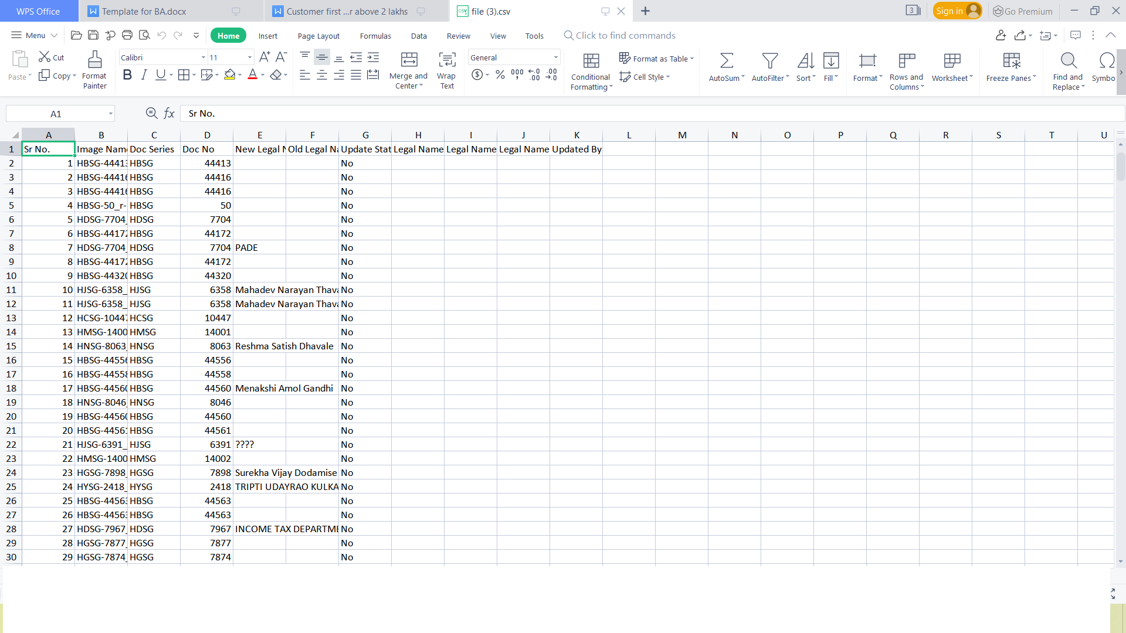

**Padm Document Master:**

Creation of new menu “Padm document master” in connect us.

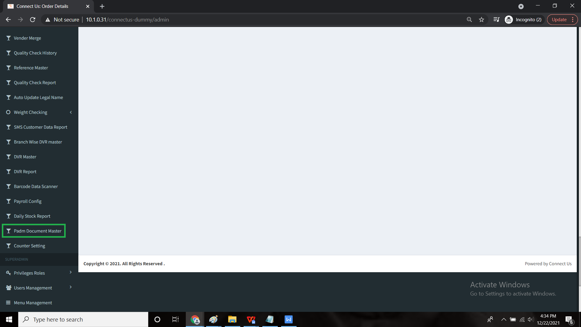

The padm document master contains all the details of the of the bills to be fetched from padm.

The following are the fields

* Add data
* Action with view, edit and delete buttons
* Name
* Is active
* Created by

**Input table**

|  |  |  |  |
| --- | --- | --- | --- |
| **FIELDS** | **INPUT TYPE** | **EDITABLE/ NO** | **DESCRIPTION** |
| Add data | Button | - | To add new document |
| Action | Button | - | Action consists of 3 buttons namely view, edit and delete.  The view button is used to view the data.  The edit button is used to edit the data.  The delete button is used to delete the existing record. |
| Name | Text | Yes | The name of the document or bill to be fetched |
| Is active | Radio button | Yes | The status of the document whether it is active or no |
| Created by | In-built | No | The user name who created it. |

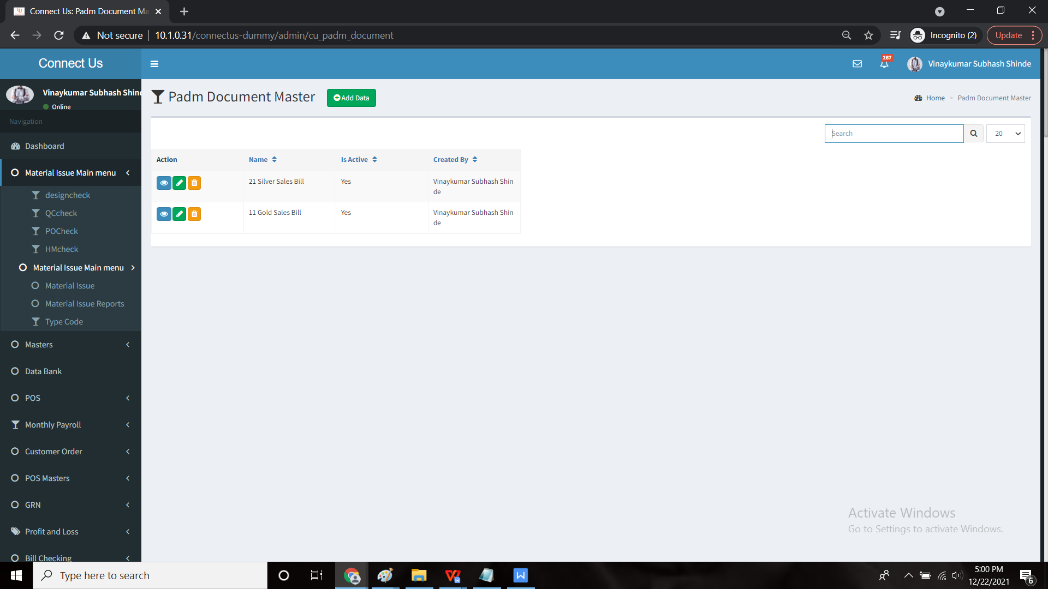

**Add data:**

The add data is used to add data into the master.

The add data consists of following fields

* Name
* Is active
* Back
* Save & add more
* Save

**Input table**

|  |  |  |
| --- | --- | --- |
| **FIELDS** | **INPUT TYPE** | **DESCRIPTION** |
| Name | Text | Name of the document |
| Is active | Radio button | Consists of yes and no. Tells the status of the document whether it is active or no |
| Back | Button | To redirect to back page |
| Save & add more | Button | To save the current and to add more data |
| Save | Button | To save the data |

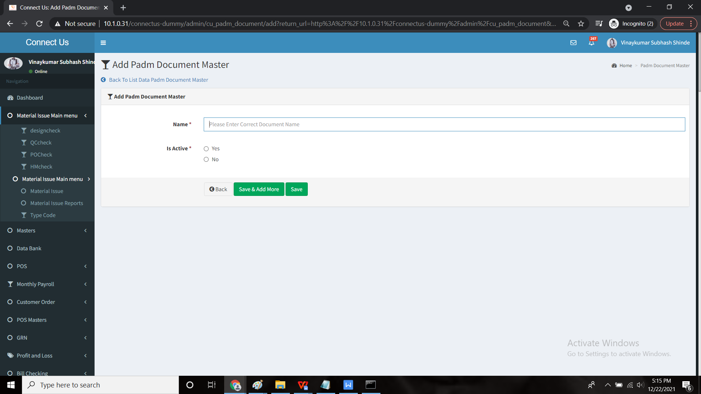

***FLOW CHART:***

