|  |  |
| --- | --- |
| **Ticket ID** | T211236 |
| **Ticket description** | *1) In connects document 'save ' position near add option.*  *2) Entry save in zero , edit in zero document, scan new document then save & print .* |
| **Created by** | *Harshali Rananaware* |
| **Created on** | 20 Apr 2022 |
| **Priority** | *Very high* |
| **Version** | *1* |

**Version**

|  |  |  |  |  |
| --- | --- | --- | --- | --- |
| **Sr. No** | **Version no** | **Version Date** | **User name** | **User department** |
| 1 | 1 | 20 Apr 2022 | PRALHAD MOHAN MULIK | Inventory Gold HO |

**Approvals**

|  |  |  |
| --- | --- | --- |
| **Field** | **Name of the User** | **Approved date by the user** |
| **Actual User Name** | PRALHAD MOHAN MULIK |  |
| **Actual User Department** | Inventory Gold HO |  |
| **Organization Name** | CSPL |  |
| **Assigned BA** | *Harshali Rananaware* |  |
| **Assigned Developer** |  |  |
| **Assigned Tester** |  |  |

**Estimation**

|  |  |  |  |  |
| --- | --- | --- | --- | --- |
| **Department name** | **Estimated Time (In hr)** | **Scheduled Date (Starting date )** | **Estimated date** | **Actual delivery date** |
| **BA** | 4 | 20 Apr 2022 | 23 Apr 2022 |  |
| **Development** |  |  |  |  |
| **Testing** |  |  |  |  |

**Business requirement**

*1) In connects document 'save ' position near add option.*

*2) Entry save in zero , edit in zero document, scan new document then save & print .*

**Abbreviations & terms**

Connect us - CU

**Existing system**

In connect us -> stock transfer system -> stock transfer system save the document then this document show in “Stock Transfer Details”.

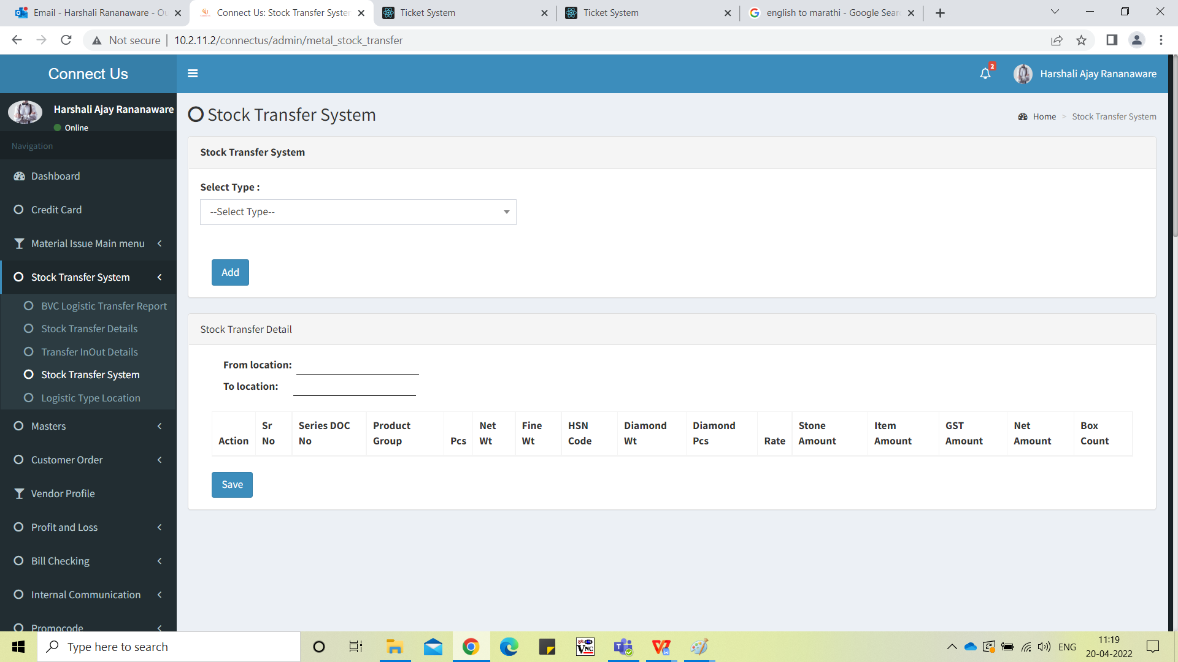

Image 1

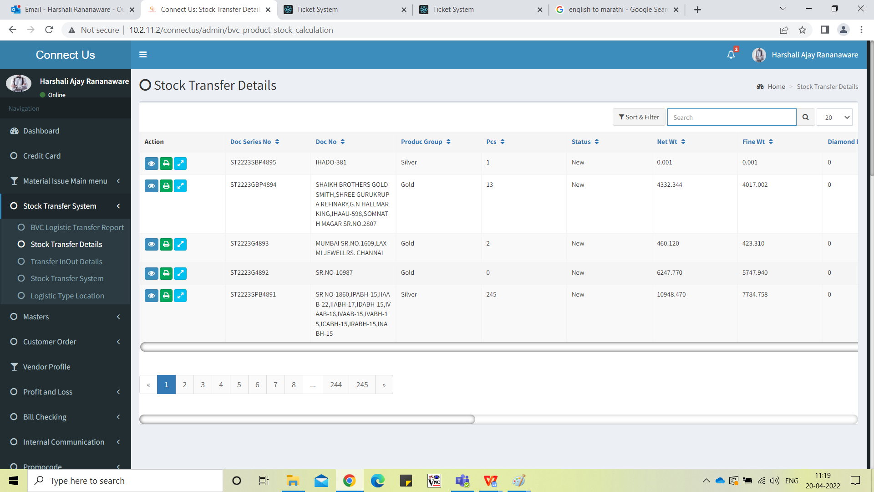

Image 2

**Proposed System :**

In connect us -> stock transfer system -> stock transfer system when any document save then this document save in zero.

In connect us -> stock transfer system -> stock transfer system click on “ADD” button then open the new page (Refer image 2)

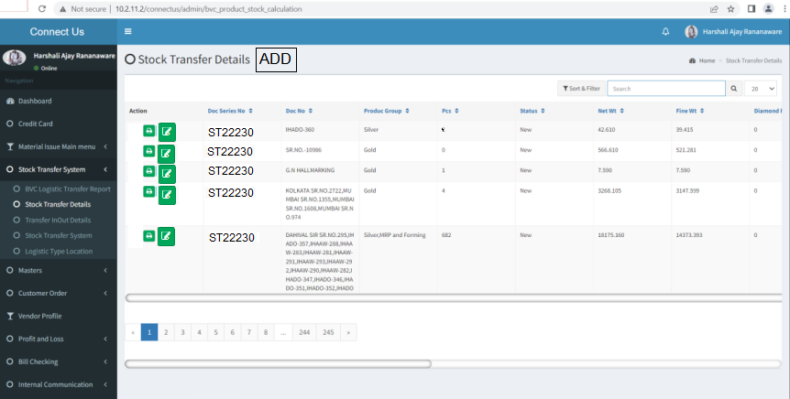

Image 1 - stock transfer system

Select type - auto or manually then click on “**save**” button then this document save in zero. .

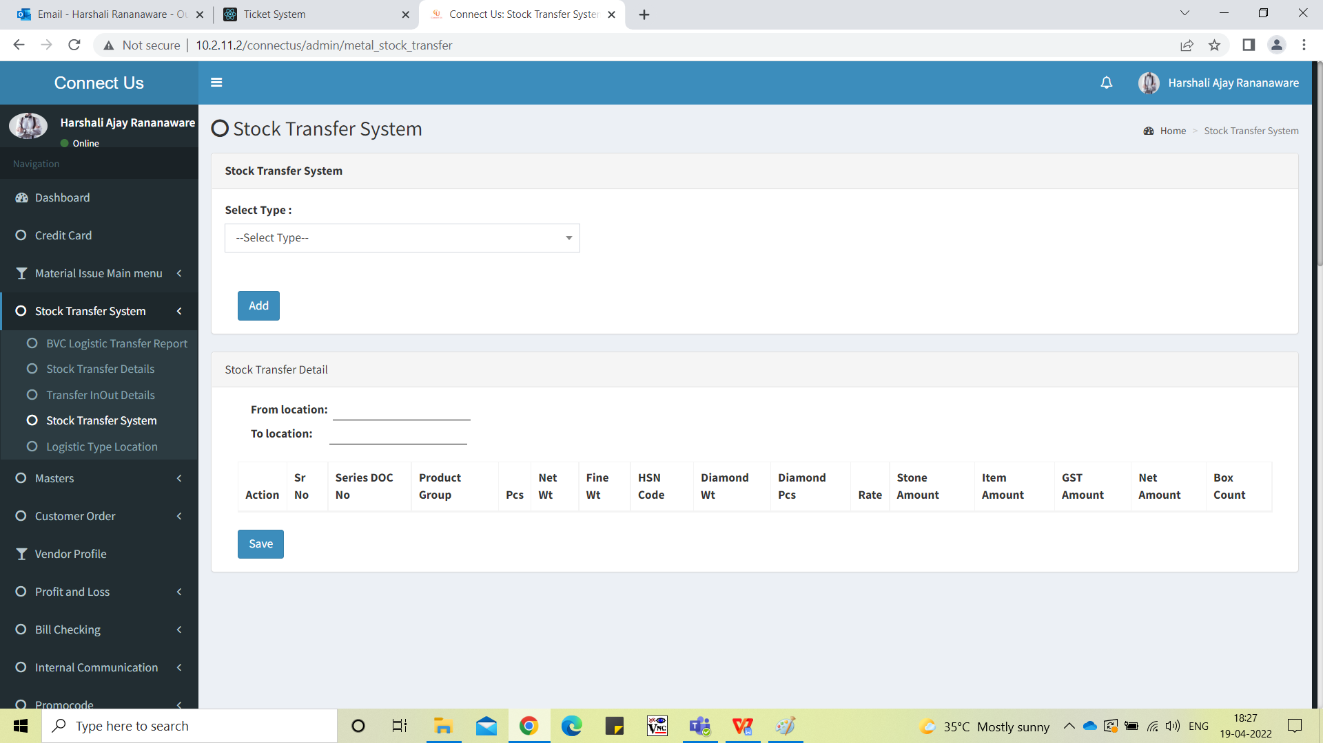

Image 2 - Add data

**Edit** - Edit data “select type” is disable. (Refer image 3) We can add records only. After that we can edit the document multiple times. we want document number then we click on “Print” button.

After document number generate then this document show in the “Stock Transfer Details” menu. (Refer image 4 and Refer image 5)

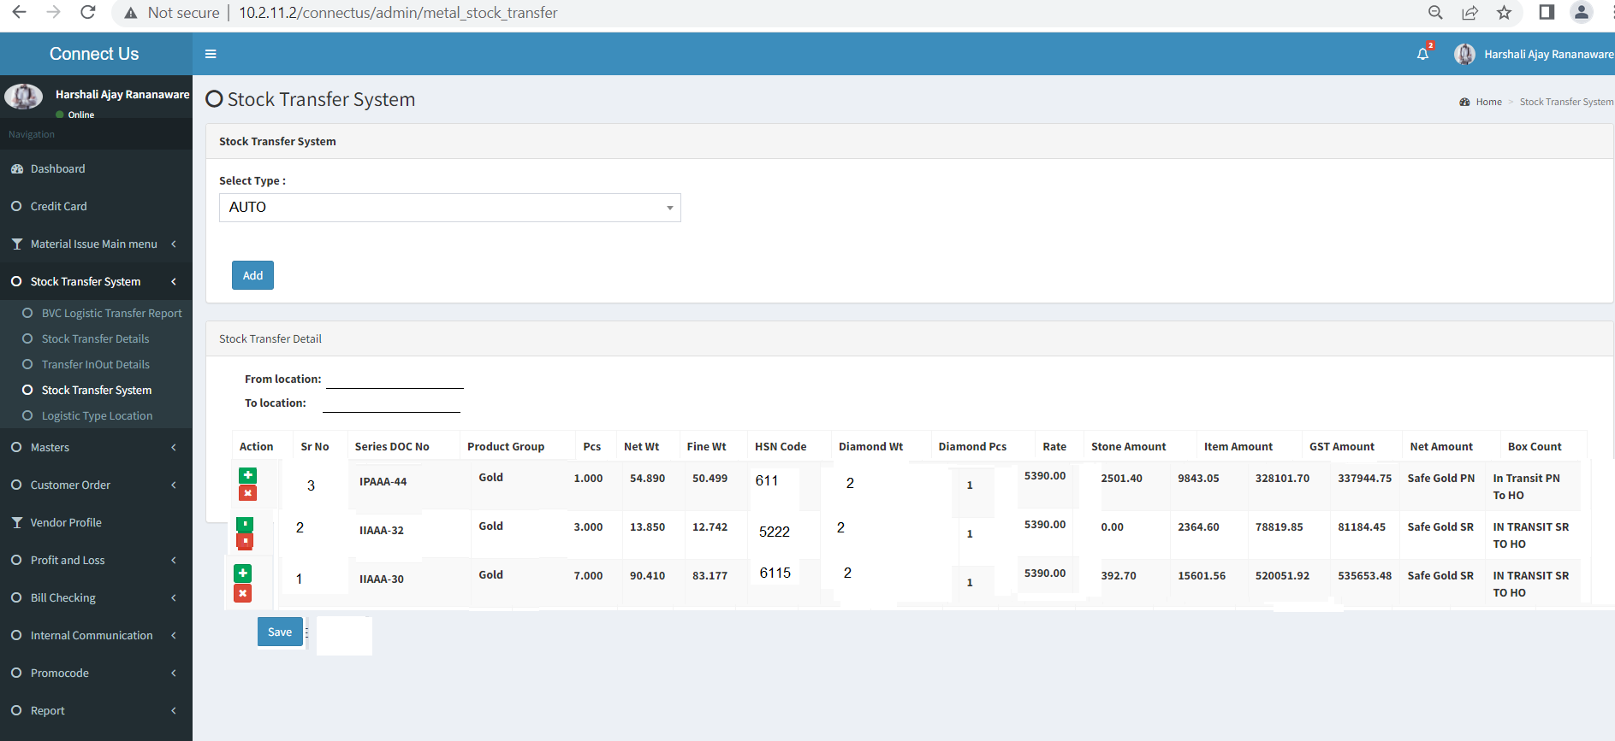

Image 3 - edit data

After document number generate then this document show in the “Stock Transfer Details” menu.

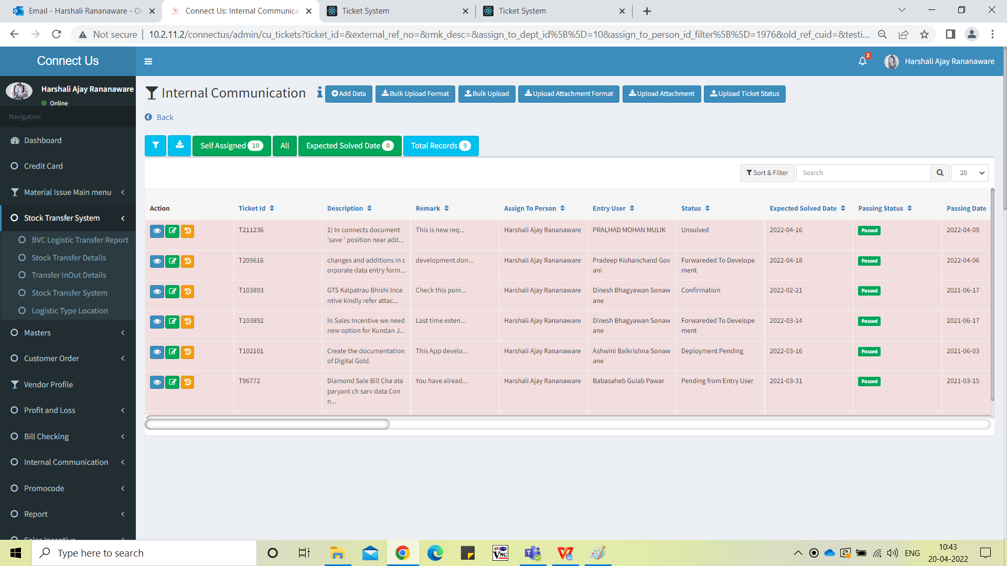

Image 4 - menu

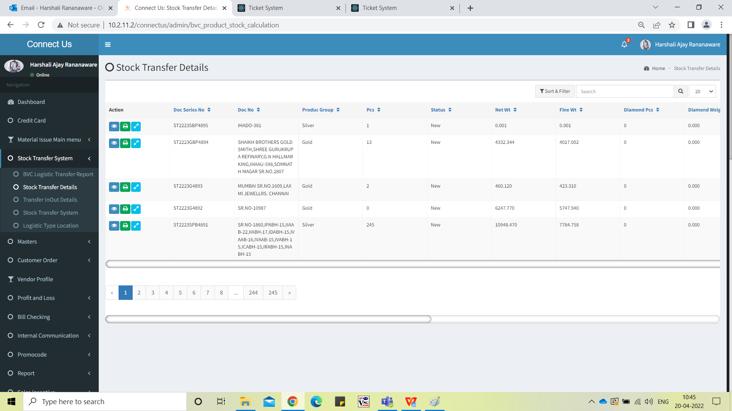

Image 5 - Stock Transfer Details

**Note** :

* The user save document in zero then this document show the particulate user login.
* If same document is already save then show the notification.

For single document - “The document "HIPAA-45" is already used in "ST2223GPB4889" this document.”

For multiple documents - “The document "HIPAA-45,IPAAA-43,HIPAA-44" is already used in "ST2223GPB4889" this document.”

**References of the users**

|  |  |  |  |
| --- | --- | --- | --- |
| **User** | **Name** | **Mail** | **Contact number** |
| **Actual user** | PRALHAD MOHAN MULIK |  |  |
| **Assigned business analyst** | *Harshali Rananaware* | [harshali.rananaware@techneai.com](mailto:harshali.rananaware@techneai.com) | 8669917920 |
| **Assigned developer** |  |  |  |