**Introduction:**

With the increasing use of the traveling services and requirements, the new application is created. The Cs car will help the users to book the car knowing the availability instantly and receive the driver’s information once approved.

There is a provision to track the location and the number of kilometers travelled in the car which is helpful to the organization in auditing and tracking the details for the better implementation.

**Requirements:**

* Need Field Of first Pick up location, Time and Drop location.
* We can use this menu and with the help of this driver will get notification of Trip and till the time he the trip is started he won’t get the details of drop location.
* At the time of raising the ticket person who is requesting should get the details is vehicle is free on that day or not. If Vehicle is not free on the day he wish to travel in that case system should show him message that is it possible to change the travel date if he select Yes then option to select next trip date should be available if he select NO then Admin will assign third party vehicle for that staff.
* If A dept. is travelling with 4 passenger and B dept. wanted to travel on same date and same location with 3 passenger then system should accept the same so that both the dept. can travel on same date.
* Provision to track live location of vehicle should be there.
* OTP for confirmation of trip , At the time of starting of trip and the time of end of trip.

**Process:**

**LOGIN**

The users and admins will use their connect us login ID and passwords to login into the application.

There are 3 types of login,

1. Admin login
2. Employee login
3. Driver login

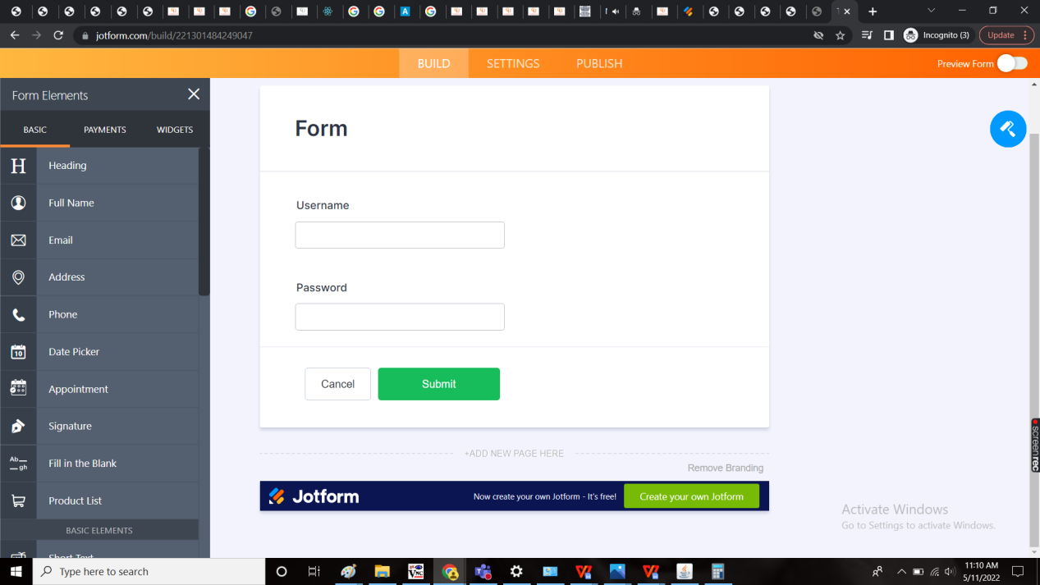

**MENU’S IN ADMIN SIDE**

* Masters
* Book a car
* Approval
* Rides

**MENU’S IN EMPLOYEE SIDE**

* Book a car
* Rides

**MENU’S IN DRIVER SIDE**

* Current Ride
* Rides

**ADMIN SIDE**

**Masters**

The following are the masters required.

1. Car master
2. Driver master
3. User/ employee master
4. Location master

CAR MASTER

The car master is used to add the details of the car. The following are the fields of the car master.(Need provision to Attach images to this so that admin can assign required documents to this point , also provision to attach Insurance copy should be there)

* Car RC number
* Capacity
* Model
* Attachment
* Active/ De-active
* Action to view, edit
* Add data

|  |  |
| --- | --- |
| Field | Description |
| Car RC number | The car registration certificate number to identify the car uniquely |
| Capacity | The capacity of the car excluding the driver seat |
| Model | The model name of the car |
| Attachment | We can add multiple images here. Like Insurance , RC NUMBER |
| Active/ De-active | The car is in active mode or no |
| Action | The action button to view and edit |
| Add data | The add data button to add more data |

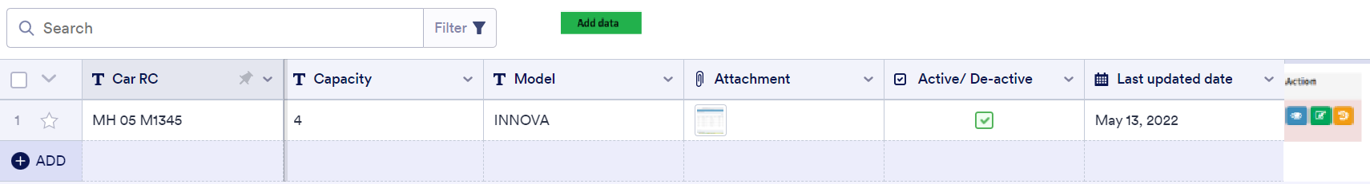

Add data:

When the user clicks on the edit button in the action field, the following fields are added.

* Car RC number
* Capacity
* Model
* Attachment
* Active/ De-active
* Back
* Add

|  |  |  |  |
| --- | --- | --- | --- |
| **FIELDS** | **INPUT TYPE** | **MANDATORY/ OPTIONAL** | **DESCRIPTION** |
| Car RC No | Text | Mandatory | The car registration certificate number is mentioned |
| Capacity | Int | Mandatory | The capacity of the car is entered excluding the driver |
| Model | Text | Mandatory |  |
| Attachment | File | Mandatory | We can add multiple attachment. |
| Active or deactive | Radio Button | Mandatory | The car is in use or not is selected |
| Back | Button | Optional | The back button is used to navigate to the back page |
| Add | Button | Optional | The add button is used to add the data |

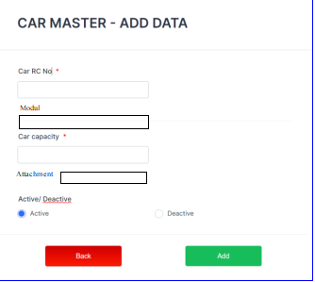

View page:

When the user clicks on the view button in the action field, the following fields are viewed.

* Car RC No
* Capacity
* Module
* Attachment
* Active or deactive
* Back

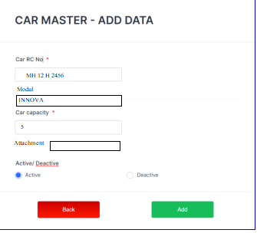

Edit page:

When the user clicks on the edit button in the action field, the following fields are edited.

* Car RC No
* Capacity
* Module
* Attachment
* Active or Deactive



DRIVER MASTER

The driver master is used to add the details of the driver. The following are the fields of the driver master. (Need provision to Attach images to this so that admin can assign required documents to this point , also provision to attach Insurance copy should be there)

* Name
* License No.
* Phone number
* Attachment
* Active/ De-active
* Action to view, edit
* Add data

|  |  |
| --- | --- |
| Field | Description |
| Name | The name of the driver |
| License No. | The driving license number of the driver |
| Phone number | The phone number of the driver |
| Attachment | We can add attachment here. |
| Active/ De-active | The car is in active mode or no |
| Action | The action button to view and edit |
| Add data | The add data button to add more data |

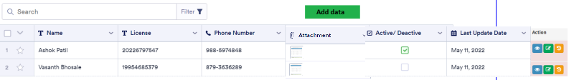

Add data:

When the user clicks on the edit button in the action field, the following fields are added.

* Name
* License
* Phone number
* Attachment
* Active or deactive
* Back
* Add

|  |  |  |  |
| --- | --- | --- | --- |
| **FIELDS** | **INPUT TYPE** | **MANDATORY/ OPTIONAL** | **DESCRIPTION** |
| Name | Text | Mandatory | The name of the driver |
| License | Text | Mandatory | The driving license number of the driver |
| Phone number | Int | Mandatory | The phone number of the driver |
| Attachment | File | Mandatory |  |
| Active or deactive | Radio Button | Mandatory | The car is in use or not is selected |
| Back | Button | Optional | The back button is used to navigate to the back page |
| Add | Button | Optional | The add button is used to add the data |

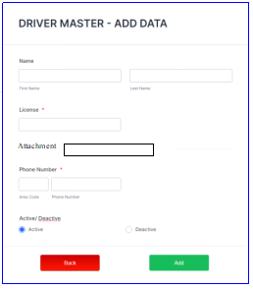

View page:

When the user clicks on the view button in the action field, the following fields are viewed.

* Name
* License No.
* Phone number
* Attachment
* Active or deactive
* Back

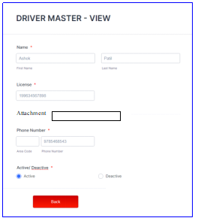

Edit page:

When the user clicks on the edit button in the action field, the following fields are edited.

* Name
* License No.
* Phone number
* Active or Deactive



USER/ EMPLOYEE MASTER

The employee master is fetched from the Connect Us - employee masters (Connect US -> General Master -> Employee master)

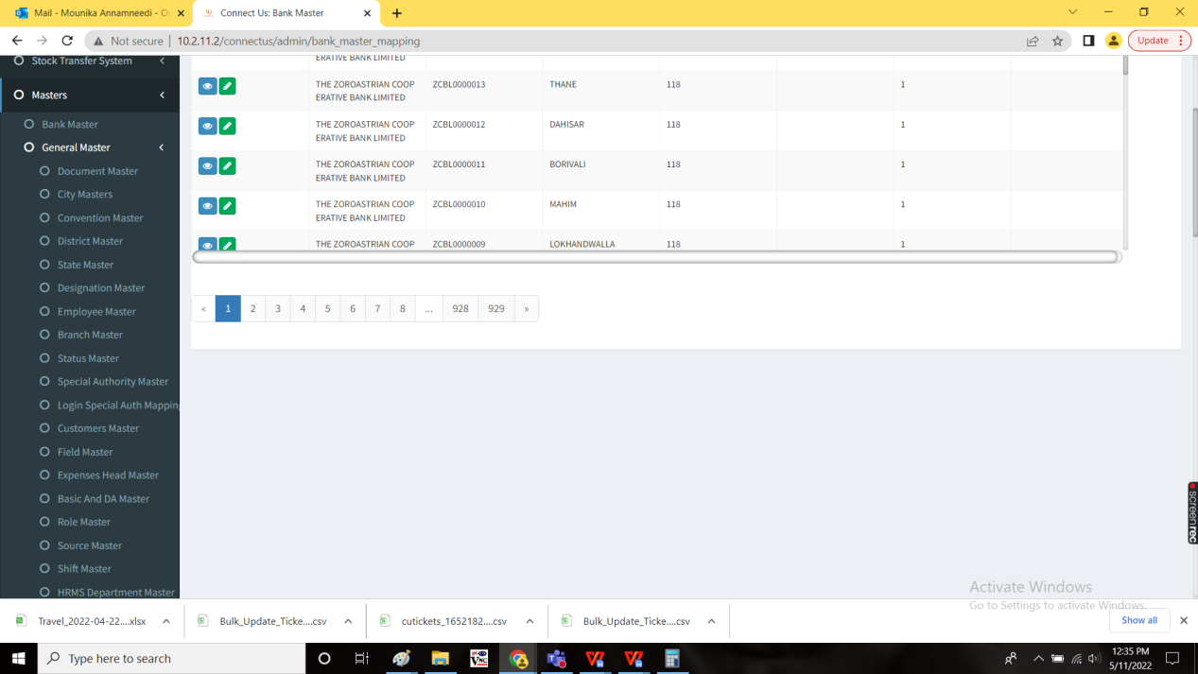

Based on the designation, the privileges were given.

LOCATION MASTER

The location consists of the locations where the car can travel. The following are the fields required for the location master

* Location
* Active/ Deactive
* Updated by
* Updated at
* Action to view and edit
* Add data

|  |  |
| --- | --- |
| Field | Description |
| Location | The location is entered |
| Active/ De-active | The location is in active mode or no |
| Action | The action button to view and edit |
| Add data | The add data button to add more data |

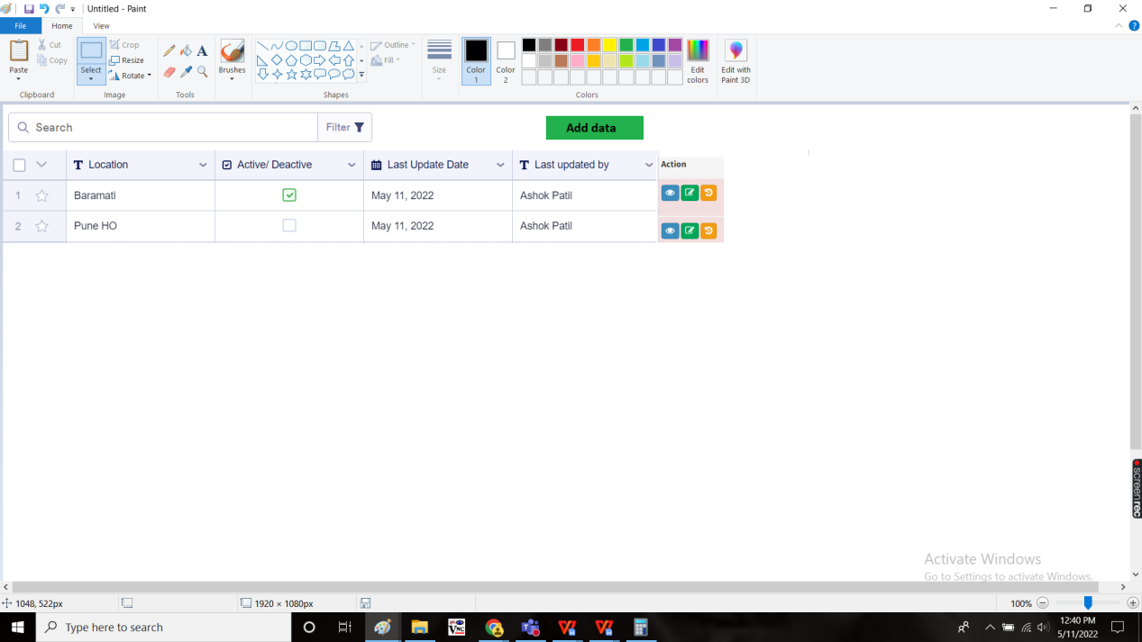

Add data:

The add data button is used to add the new data. The following are the fields in the add data page.

* Location
* Active/ Deactive
* Add
* Back

|  |  |  |  |
| --- | --- | --- | --- |
| **FIELDS** | **INPUT TYPE** | **MANDATORY/ OPTIONAL** | **DESCRIPTION** |
| Location | Text | Mandatory | The location is entered |
| Active or deactive | Radio Button | Mandatory | The car is in use or not is selected |
| Back | Button | Optional | The back button is used to navigate to the back page |
| Add | Button | Optional | The add button is used to add the data |

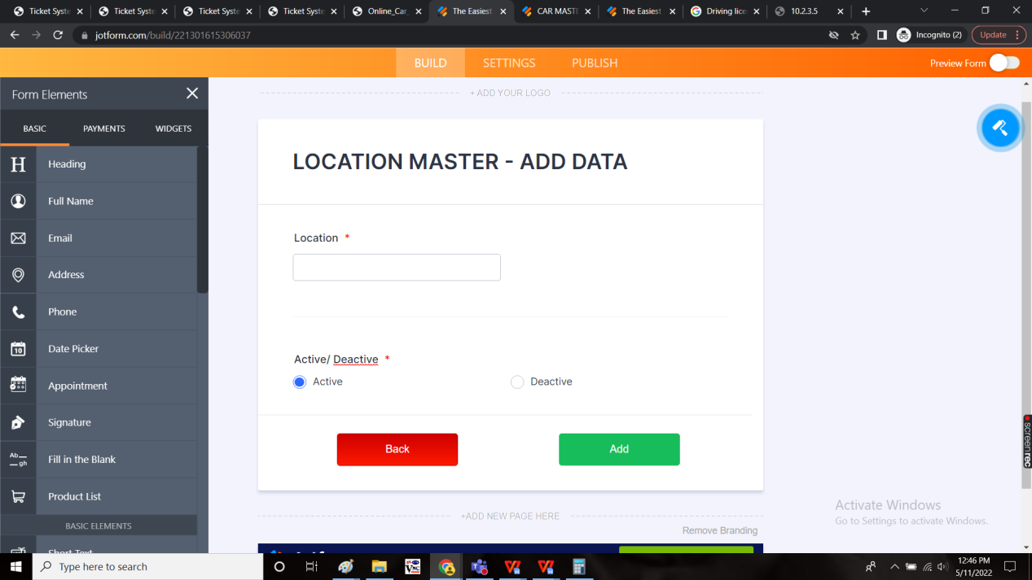

View page:

When the user clicks on the view button in the action field, the following fields are viewed.

* Location
* Active or deactive
* Back

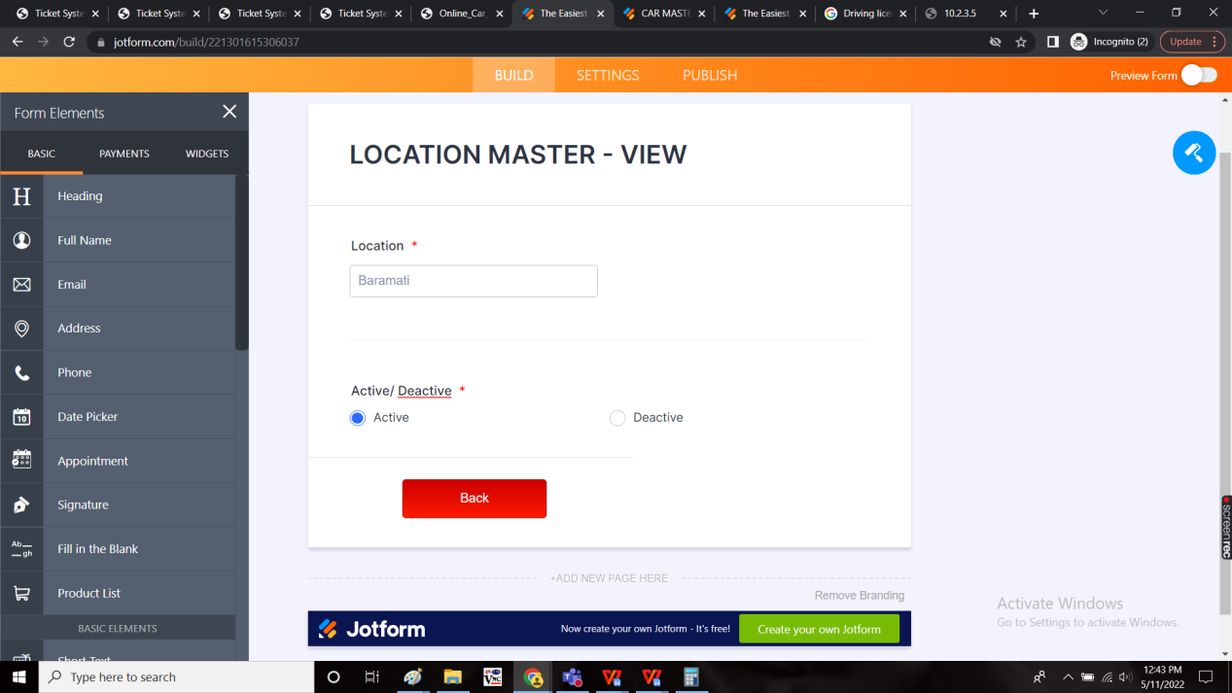

Edit page:

When the user clicks on the edit button in the action field, the following fields are edited.

* Location
* Active or Deactive

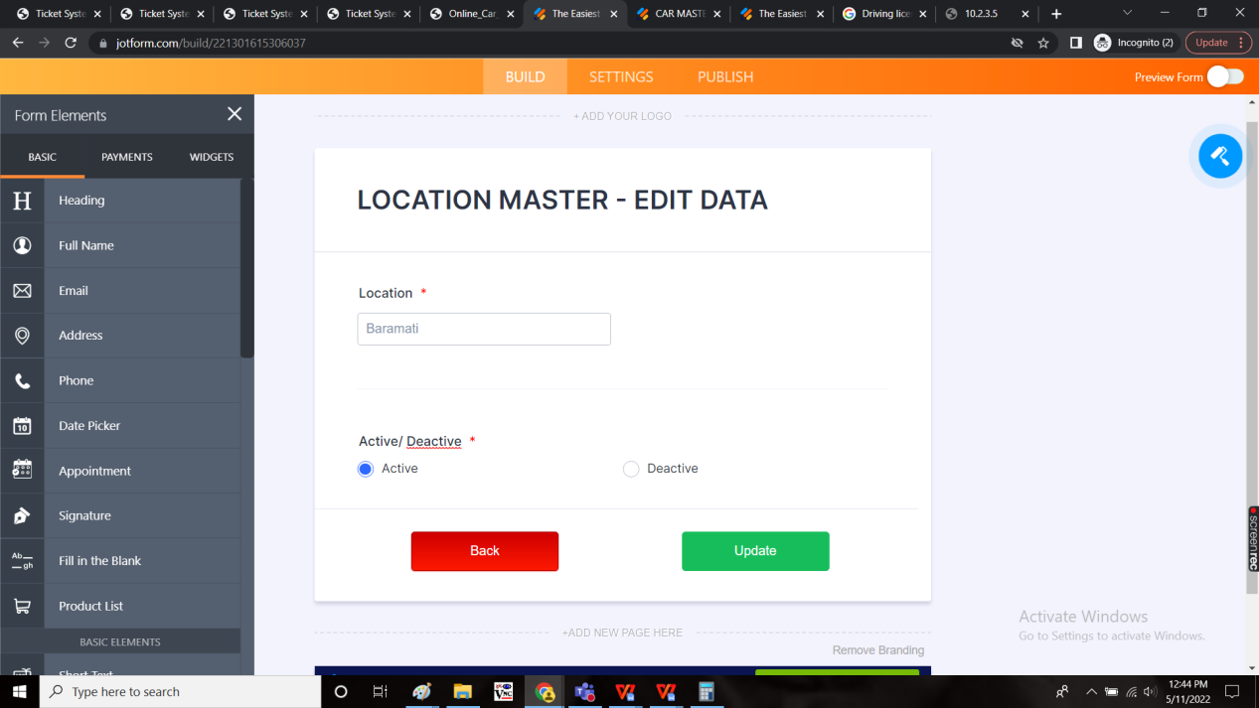

**BOOK A CAR**

The user have “book a car” menu in the application where the user can book the car using this menu.

In this menu, the following fields were presented.

* Date
* Trip Date
* Start time
* From place
* To place
* No. Of passengers
* Name of passenger
* Remark
* Availability
* Submit
* Cancel

|  |  |  |
| --- | --- | --- |
| FIELD | TYPE | DESCRIPTION |
| Date | Calender | The date on which the trip is booked |
| Trip date | Calender | The date on when the trip to be booked |
| Start time | Timer | The time on when the trip to be booked |
| From place | Drop-down | The from location |
| To place | Drop-down | The to location |
| No. Of passengers | Int | The no. Of passengers travelling |
| Name of Passenger | Drop-down | Data Should be fetch from employee master. We can select multiple employee. |
| Remark | Text | Optional, if any can be entered |
| Availability | Text | The user when booking, if the slot is not available, then the availability shows the available slots available on that particular date or the dates available |
| Submit | Button | To submit the details |
| Back | Button | To navigate to back page |

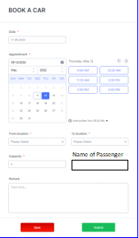

**APPROVAL**

The details will be sent to the admin for the approval. The admin will find the details in the “Approval” menu. The admin have the right to approve or reject the request.

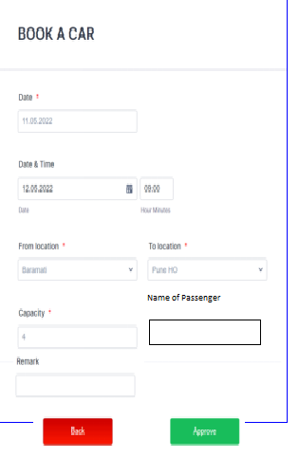

When the admin clicks on the approve, dialogue box opens to select the car and the driver. The dialogue box consists of the following fields

* Select car
* Select driver
* Back
* Submit

|  |  |  |
| --- | --- | --- |
| FIELD | TYPE | DESCRIPTION |
| Select car | Drop-down | The car allocated have to be selected. The details to be fetched from car master. |
| Select driver | Drop-down | The driver allocated have to be selected. The details to be fetched from driver master. |
| Submit | Button | To submit the details |
| Back | Button | To navigate to back page |

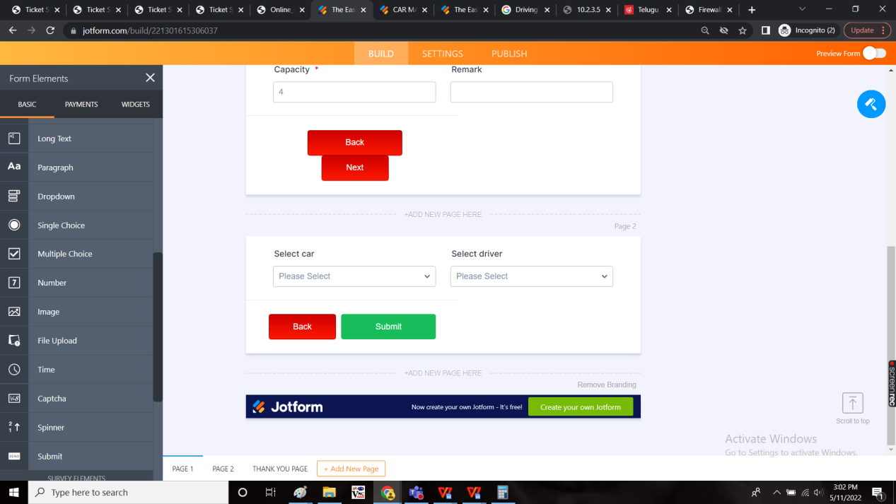

So that, the driver details (driver name, driver phone no., car number) are sent to the all the passengers who are going to travel/ concerned user and the concerned user details (concerned user name, phone no., start location and the start time at the location, car no.) will be sent to the driver through in app and whatsapp notifications.

Notification to the employee:

|  |
| --- |
| Hello <Employee Name>,  As requested, your trip have been approved.  <Car RC> is assigned to you on <date>, <time>, from <from location> to <to location> for <capacity in number> people.  First Pick up Person Name  Driver details:  <Driver Name>  <Phone number of the driver>  Please do share the OTP at the beginning of your trip with the driver.  Happy Journey,  CSPL. |

Notification to the driver:

|  |
| --- |
| Hello <Driver name>,  A trip is booked from <from location> to <to location> on <date><time> for <capacity in number> people.  Car details:  <Car RC>  Employee details:  <Employee who booked the car>  <Phone number of the employee who booked the car>  Happy Journey,  CSPL. |

**RIDES:**

The rides menu available for all the people based on their respective ride details. The following are the fields. (For the employees and the driver)

* Application date
* Trip date
* Trip time
* From location
* To location
* No. Of passengers
* Name of Passenger
* Status
* Kms travelled

|  |  |
| --- | --- |
| Field | Description |
| Application date | The date on which the trip is booked |
| Trip date and time | The date and time of the trip |
| From location | The from location of the trip |
| To location | The to location of the trip |
| No. Of passengers | The no. Of passengers in the trip |
| Name of Passenger |  |
| Status | The status of the trip whether it is pending, on going or completed |
| Kms travelled | The kms travelled in the trip. This will be shown only when the trip is completed. |

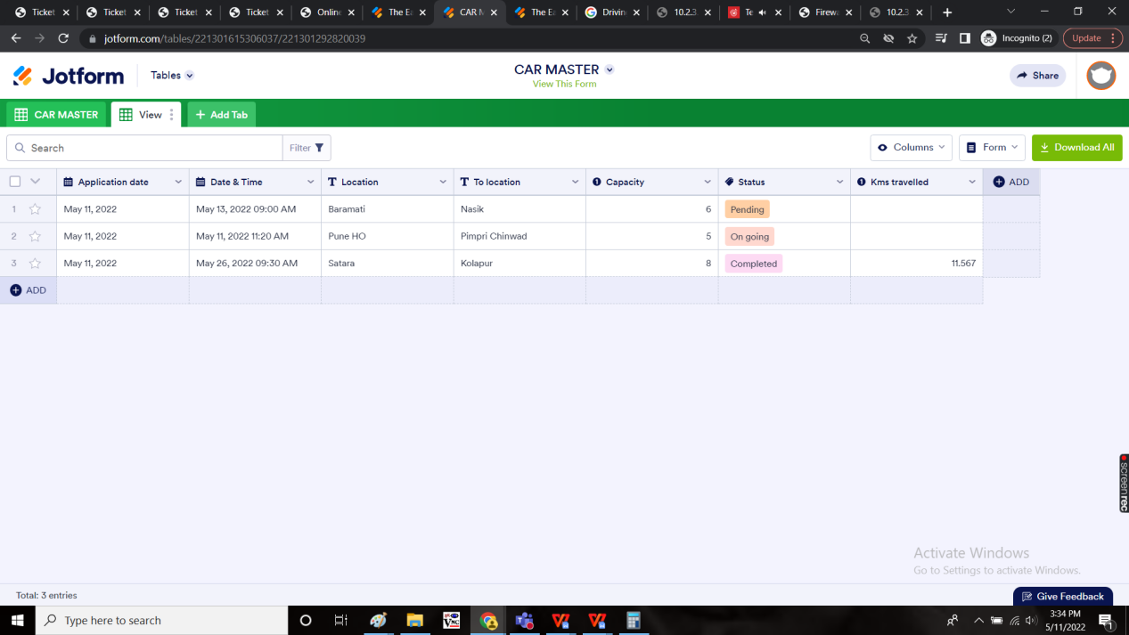

To admin:

The admin will have an extra fields such as employee details and the driver and car details.

The fields in admin side:

* Application date
* Trip date
* Trip time
* From location
* To location
* No. Of passengers
* Name of Passenger
* Status
* Kms travelled
* Employee name
* Driver name
* Car RC

|  |  |
| --- | --- |
| Field | Description |
| Application date | The date on which the trip is booked |
| Trip date and time | The date and time of the trip |
| From location | The from location of the trip |
| To location | The to location of the trip |
| No. Of passengers | The no. Of passengers in the trip |
| Name of Passenger |  |
| Status | The status of the trip whether it is pending, on going or completed |
| Kms travelled | The kms travelled in the trip. This will be shown only when the trip is completed. |
| Employee name | The name of the employee |
| Driver name | The name of the driver |
| Car RC | The car RC |

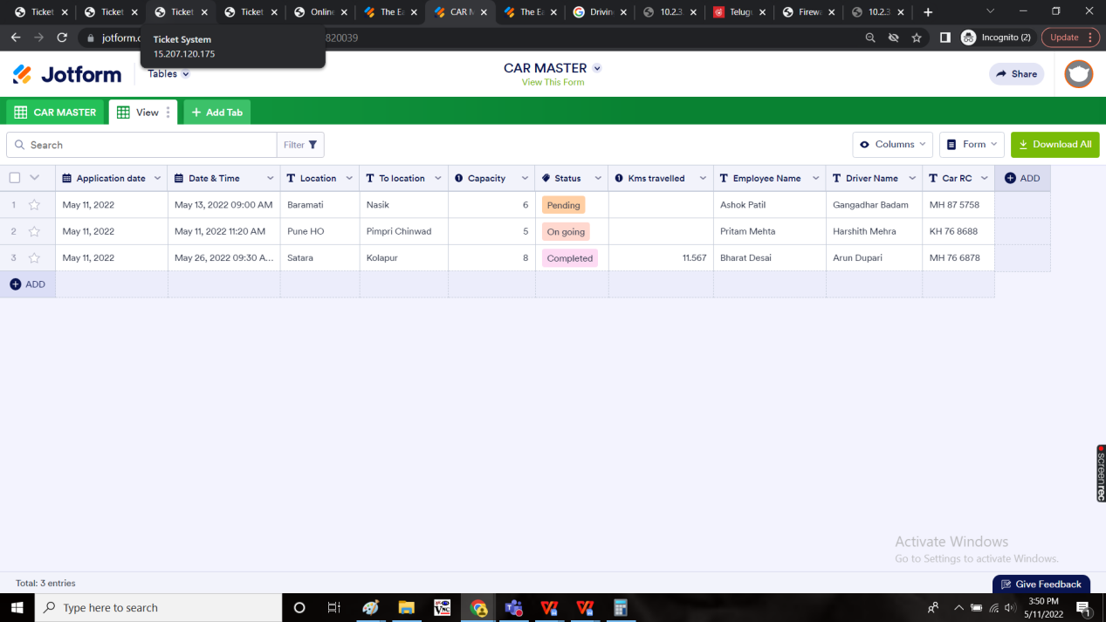

**TIME OF JOURNEY**

When the driver starts the journey, an OTP is sent to the user in app notifications and whatsapp notifications.

Notification:

|  |
| --- |
| Hello <Employee Name>,  The driver have reached at your place and waiting for you. Share the OTP <OTP> with the driver to start your trip.  Happy Journey!  Thank you,  CSPL. |

When the driver enters that OTP, the journey begins. The start time is noted and location will be tracked until the trip ends.

The kms, location details of that trip will be sent to the admin.

CURRENT RIDE

The current ride menu is presented to the driver. Before 30min of the trip begins, the trip will be shown in the current ride.

The following fields are displayed

* Date and time
* From location
* To location
* Capacity
* Back
* Send OTP

|  |  |
| --- | --- |
| Field | Description |
| Date and time | The date and time of the trip to be started |
| From location | The from location of the trip |
| To location | The to location of the trip |
| Capacity | The total no of passengers travelling excluding the driver |
| Back | The back button to navigate back |
| Send OTP | The send OTP button is used when the driver arrived at the place. So that the OTP is sent to the user to start the trip. |

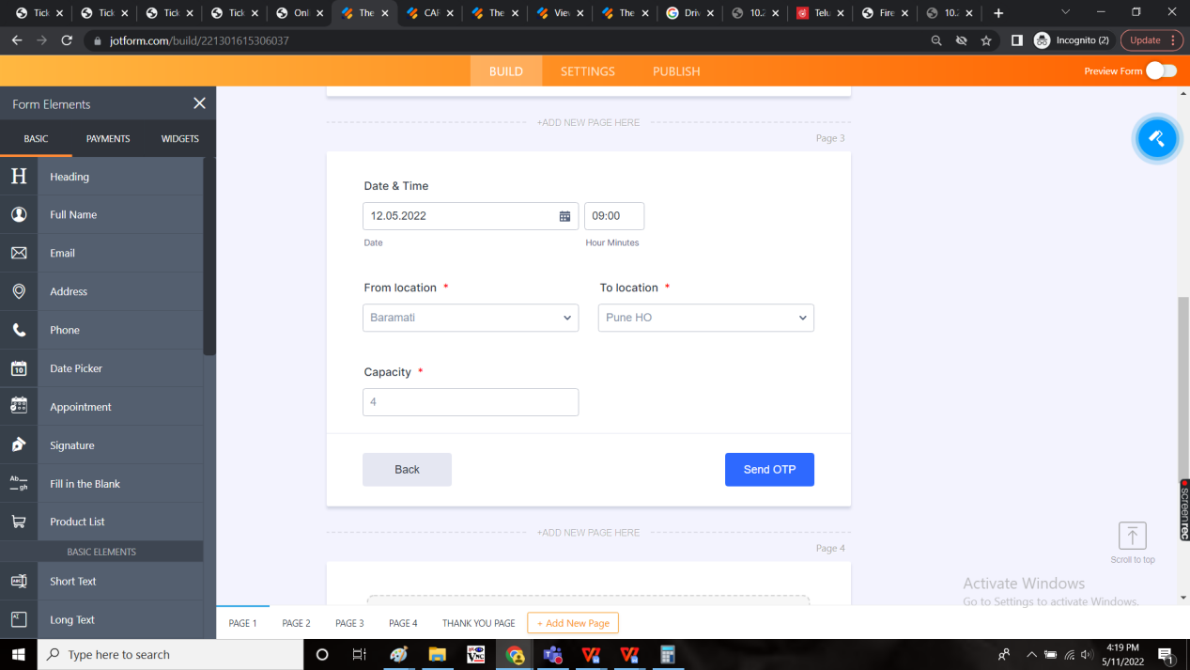

Then the following page displays. The OTP is entered by the driver and submits.

The following are the fields

* Enter OTP
* Back
* Submit

|  |  |
| --- | --- |
| Field | Description |
| Enter OTP | The OTP is entered. |
| Back | The back button to navigate to the back page |
| Submit | The submit button to submit the OTP entered |

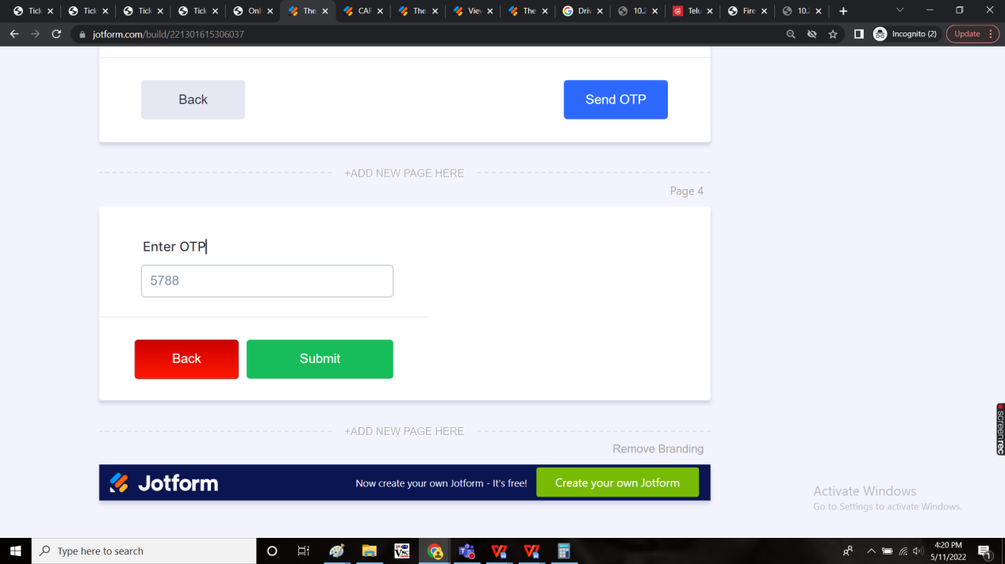

Then the location is tracked and the number of kms travelled is entered by the driver manually with the picture of the car driven display at the beginning and at the end of the trip.

The drivers clicks on end trip when the trip is completed.

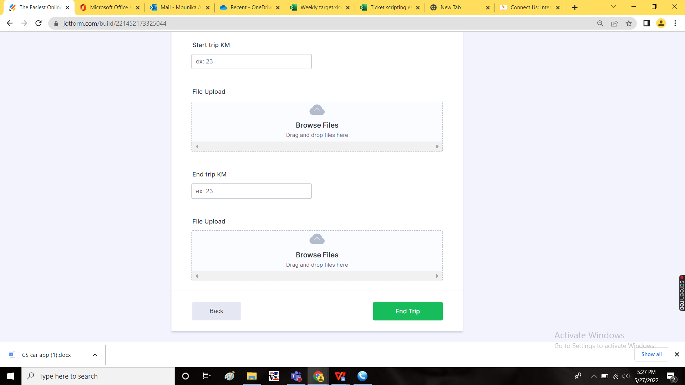

**CONDITIONS**

* When there are 2 or more users travelling on the same date and same places, the trip can be shared among them for the optimum utilization of the resources.

Also once the trip is started rest of the passengers should get message that driver is started the journey(From Location) be there on you pick up point

**Report**

1. Travelling Detail Report
2. Trip Details

* Travelling Detail Report

**Input :**

1. From date
2. To date
3. Submit
4. Export
5. Rest

|  |  |  |  |  |  |  |  |  |  |  |  |  |  |
| --- | --- | --- | --- | --- | --- | --- | --- | --- | --- | --- | --- | --- | --- |
| **Sr No** | **Date** | **Trip Start Date** | **Trip End Date** | **Pick Up Location** | **Drop Location** | **No Of Person Travelled** | **Trip Start KMS** | **Trip End KMS** | **Total Travel** | **Trip Start Time** | **Trip End Time** | **Total Hrs** | **Name of Driver** |
| 1 | 01st May 2022 | 01st May 2022 | 01st May 2022 | 01st May 2022 | Baramati Shop | 4 | 15001 | 15300 | 299 | 6.30 AM | 9.00 PM | 14.5 Hrs | ABC |
|  |  |  |  |  |  |  |  |  |  |  |  |  |  |

* Trip Details

**Input :**

1. From date
2. To date
3. Submit
4. Export
5. Rest

|  |  |  |  |  |  |  |  |  |  |  |
| --- | --- | --- | --- | --- | --- | --- | --- | --- | --- | --- |
| **Sr No** | **Trip Date** | **Start Time** | **1 st Stop time** | **Location** | **Time (In Hrs)** | **2nd Stop Time** | **Location** | **Time (In Hrs)** | **Trip End Time** | **Location** |
| 1 | 01st May 2022 | 6.30 AM | 6.45 am | KEM Hospital | 20 Mins | 7.25 AM | Balaji Nagar | 30 min | 9.30 pm | Rasta Peth |
|  |  |  |  |  |  |  |  |  |  |  |