|  |  |
| --- | --- |
| **Ticket ID** | *TT2385* |
| **Ticket description** | *DAYODAY GOSHALA DONATE* |
| **Created by** | *Harshali Rananaware* |
| **Created on** | 26 Apr 2022 |
| **Priority** | *Very high* |
| **Version** | *2* |

**Version**

|  |  |  |  |  |
| --- | --- | --- | --- | --- |
| **Sr. No** | **Version no** | **Version Date** | **User name** | **User department** |
| 1 | 1 | 26 Apr 2022 | Siddharth Shah sir | management |
| 2 | 2 | 20 May 2022 | Siddharth Shah sir | management |

**Approvals**

|  |  |  |
| --- | --- | --- |
| **Field** | **Name of the User** | **Approved date by the user** |
| **Actual User Name** | Siddharth Shah |  |
| **Actual User Department** | management |  |
| **Organization Name** | CSPL |  |
| **Assigned BA** | Harshali Rananaware |  |
| **Assigned Developer** | Nikhil Bhosale |  |
| **Assigned Tester** | Amreen Shaikh |  |

**Business requirement :** User want to know the how many customer donate the donation for goshala in a month/year. After one year complete then send the reminder to the customer.Any new changes done in goshala then this information send on wahtsapp to customer.

**Proposed System :**

**DAYODAY GOSHALA DONATE** -

**For admin side** - admin can login through web. Admin login through username and password.

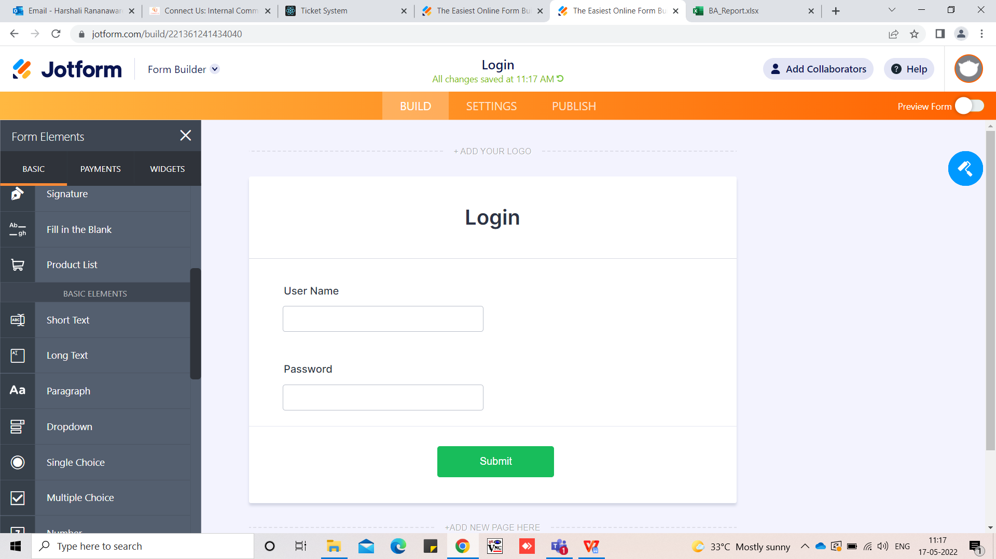

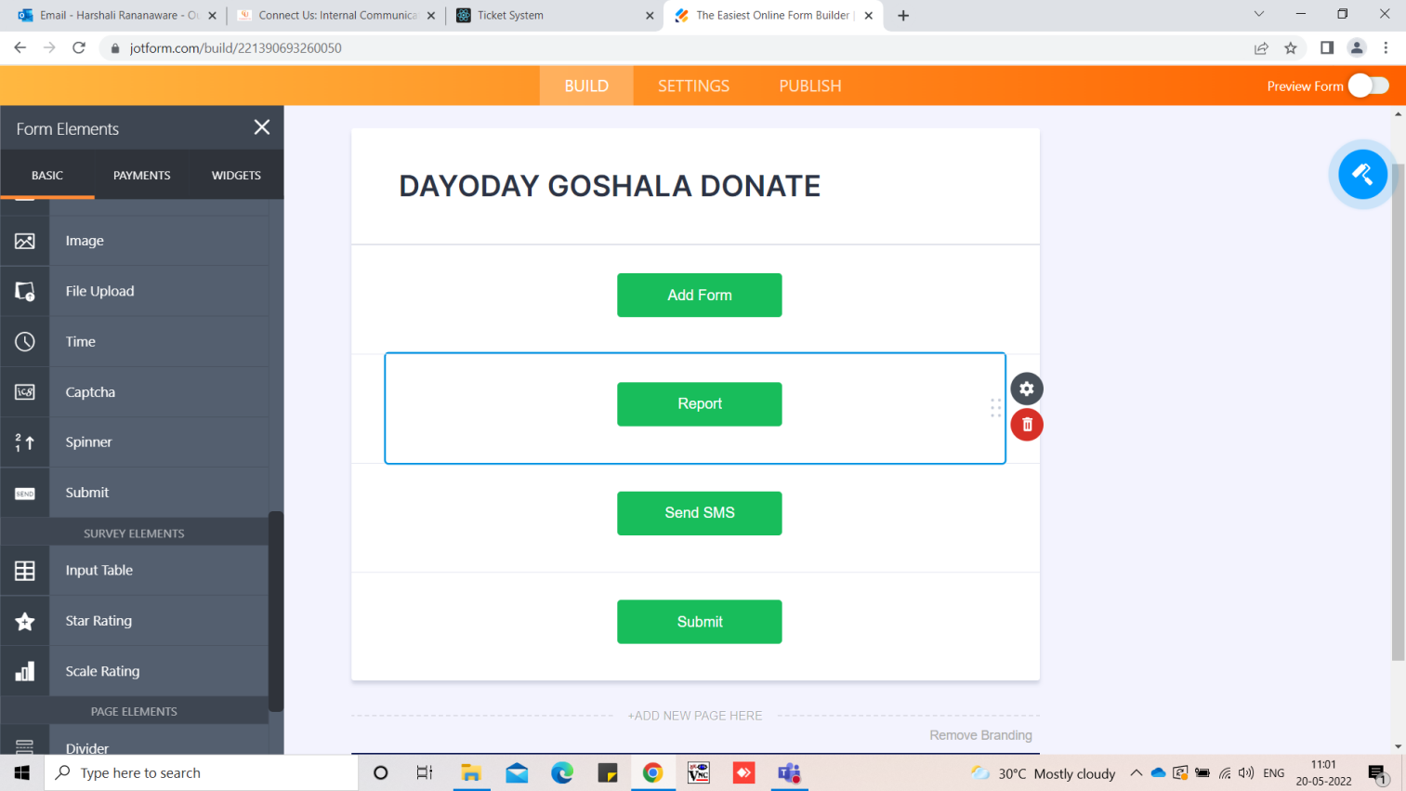

**Donation form** :

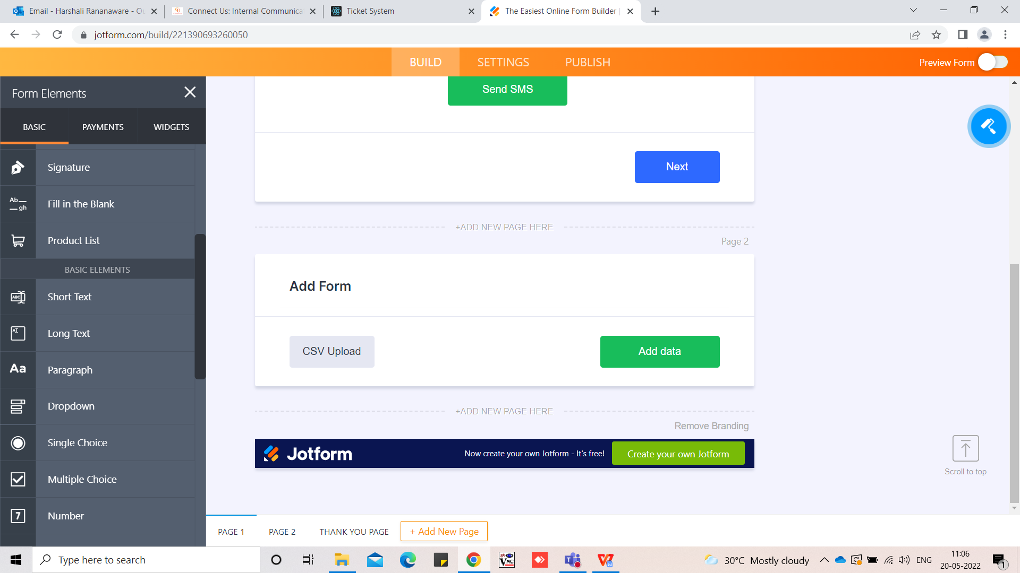

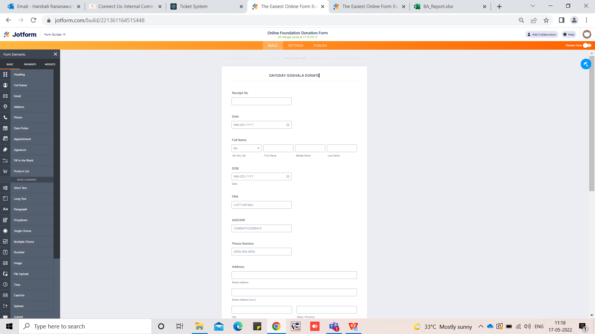

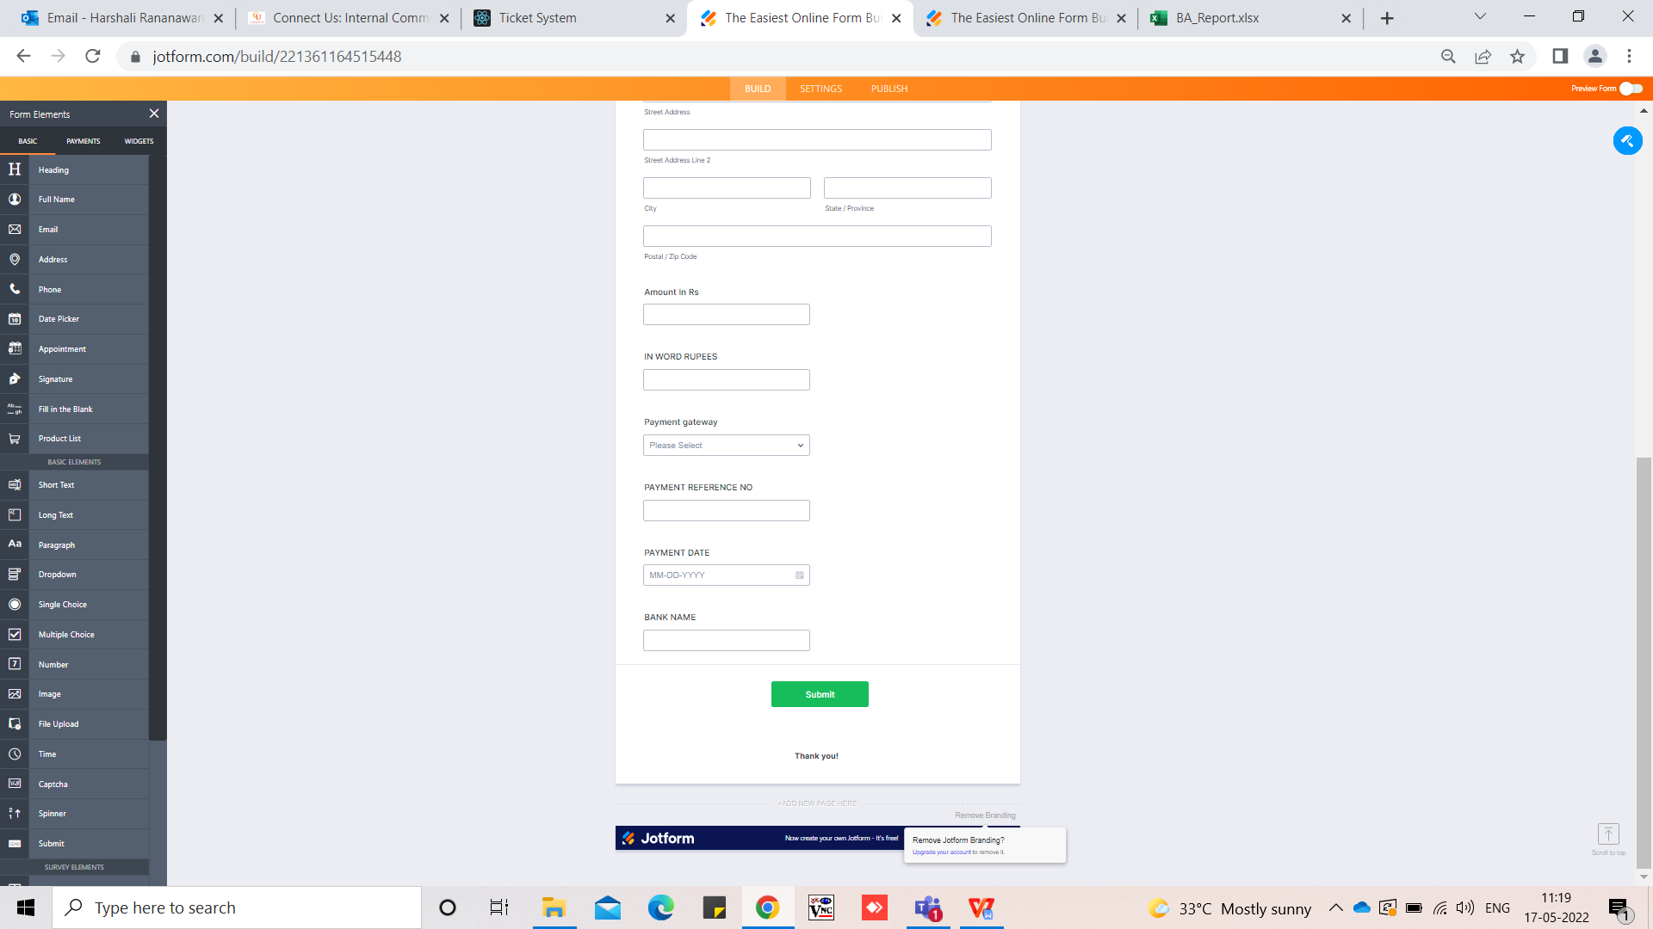

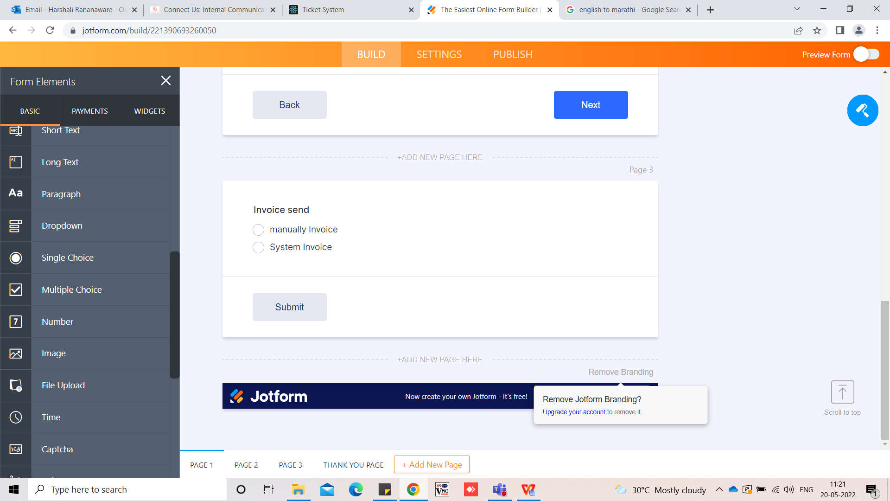

After click on submit button then ask for sending option 1) manually invoice 2) System Invoice.

In that form add the below fields.

1. Sr no - this is auto generated.
2. Date - Today's date should be entered automatically. We can edit the date. Click on this dield open a calender.
3. Receipt No - We can enter receipt no manually.
4. Received name- Enter the customer name. Digits should not be accepted.
5. DOB-
6. PAN no - We can enter PAN No. Want pan no validation will be first 5 should be character. Next 4 should be digit and last 1 character.
7. Aadhar no - We can enter adhhar no. Adhar no accept only 16 digits.
8. Contact no - contact no enter 10 digits.
9. Address
10. PIN - accept 6 digits only.
11. Amount in RS -
12. Amount in word RS - This is disable field and when we enter amount then this is convert into word.
13. Bank name - accept only alphabet.
14. Payment gateway - here is drop-down menu “by cash/ by cheque/UPI” we can select the option.
15. Payment Reference No - Here we add cheque/UTR number.
16. Payment date - Click here then open a calender we can select a date.
17. Invoice Upload -
18. Save - click on save the data should be save.
19. Cancel - Click on this redirect in main page.

Want to edit form -

|  |  |
| --- | --- |
| **Field name** | **Editable** |
| Sr no | No |
| Date | No |
| Receipt No | No |
| Received name | Yes |
| DOB | Yes |
| PAN no | Yes |
| Aadhar no | Yes |
| Contact no | Yes |
| Address | Yes |
| PIN | Yes |
| Amount in RS | Yes |
| IN WORD RUPEES | No |
| Bank name | Yes |
| Payment gateway | Yes |
| Payment Reference No | Yes |
| Payment date | Yes |
| Invoice Upload | NO |

After click on save button then send the invoice on whats app. Check the below format:

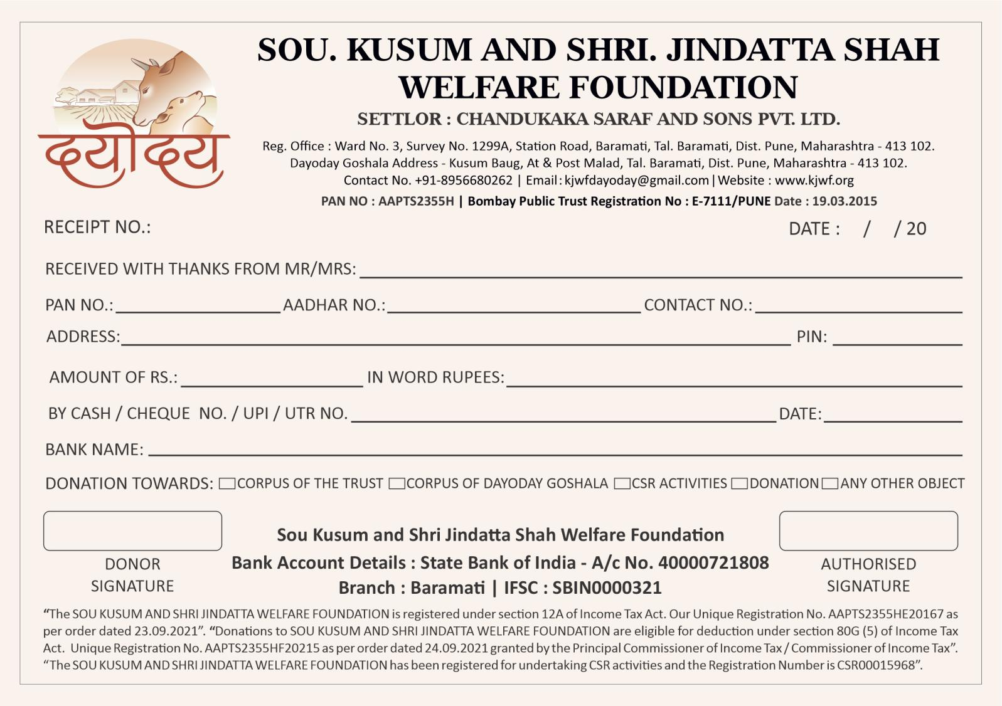

**CSV Upload** - In add data want to provision add CSV file through record. After click on submit then show the notification “CSV Upload successful”.



In CSV file consider following fields :

1. Sr no
2. Date
3. Receipt No
4. Received name
5. DOB
6. PAN no
7. Aadhar no
8. Contact no
9. Address
10. PIN
11. Amount in RS
12. Amount in word RS
13. Bank name
14. Payment gateway
15. Payment Reference No
16. Payment date
17. Invoice Upload

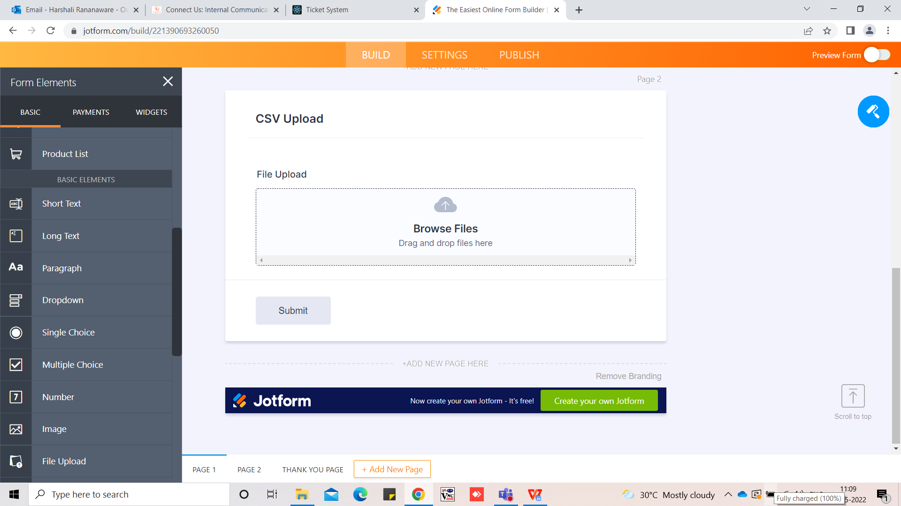

**Report “Donate Report”** in this report following column should be shown. Report Export in csv , excel and pdf.

**Input :**

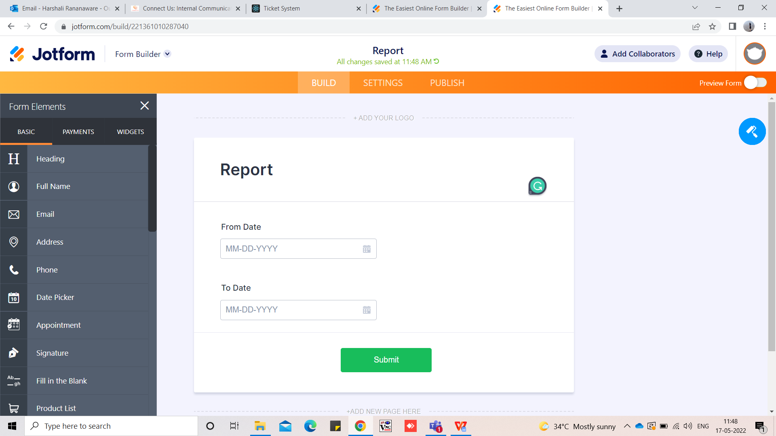

Select from date and to date then so the following fields.

1. Sr no
2. Date
3. Receipt No
4. Received name
5. DOB
6. PAN no
7. Aadhar no
8. Contact no
9. Address
10. PIN
11. Amount in RS
12. Amount in word RS
13. Bank name
14. Payment gateway
15. Payment Reference No
16. Payment date

**Output :**

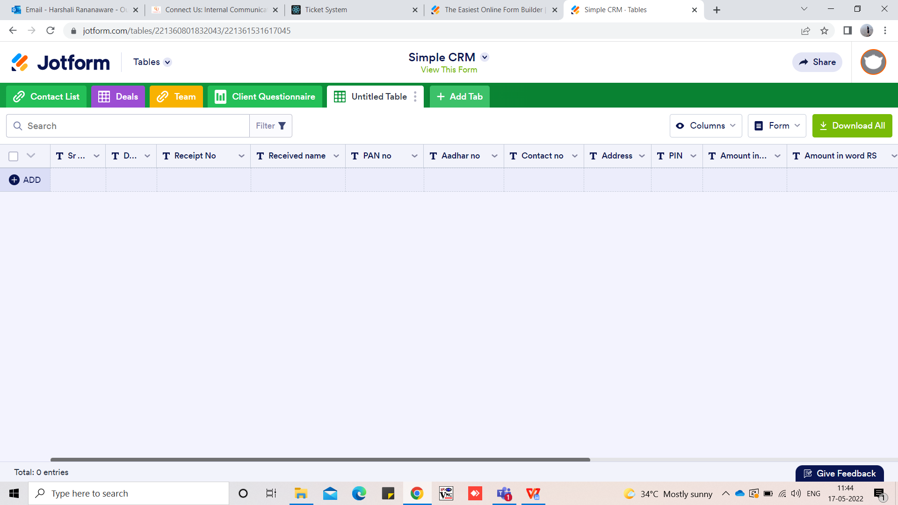

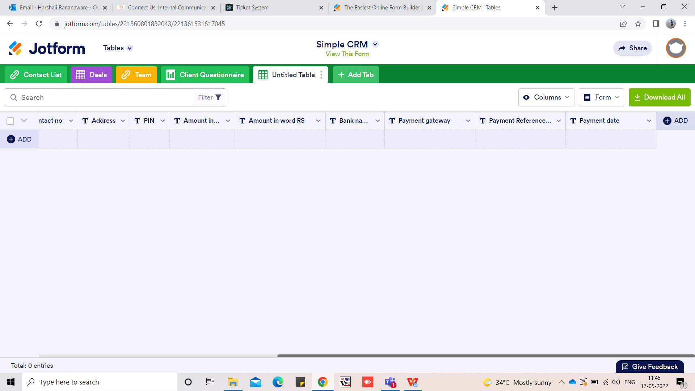

**SMS / Whatsapp Master :**

* Want provision to send SMS and Whatsapp in bulk.
* Before 5 days reminder send to the customer after one year.
* Birthday message auto send before 5 days.

**Bulk Upload Format:** We can upload up to 1000 mobile number at a time.

|  |
| --- |
| Mobile No |
| 7756332158 |
| 7852147963 |
| 8523697411 |
| 8523697412 |
| 1542158653 |
| 8563162562 |

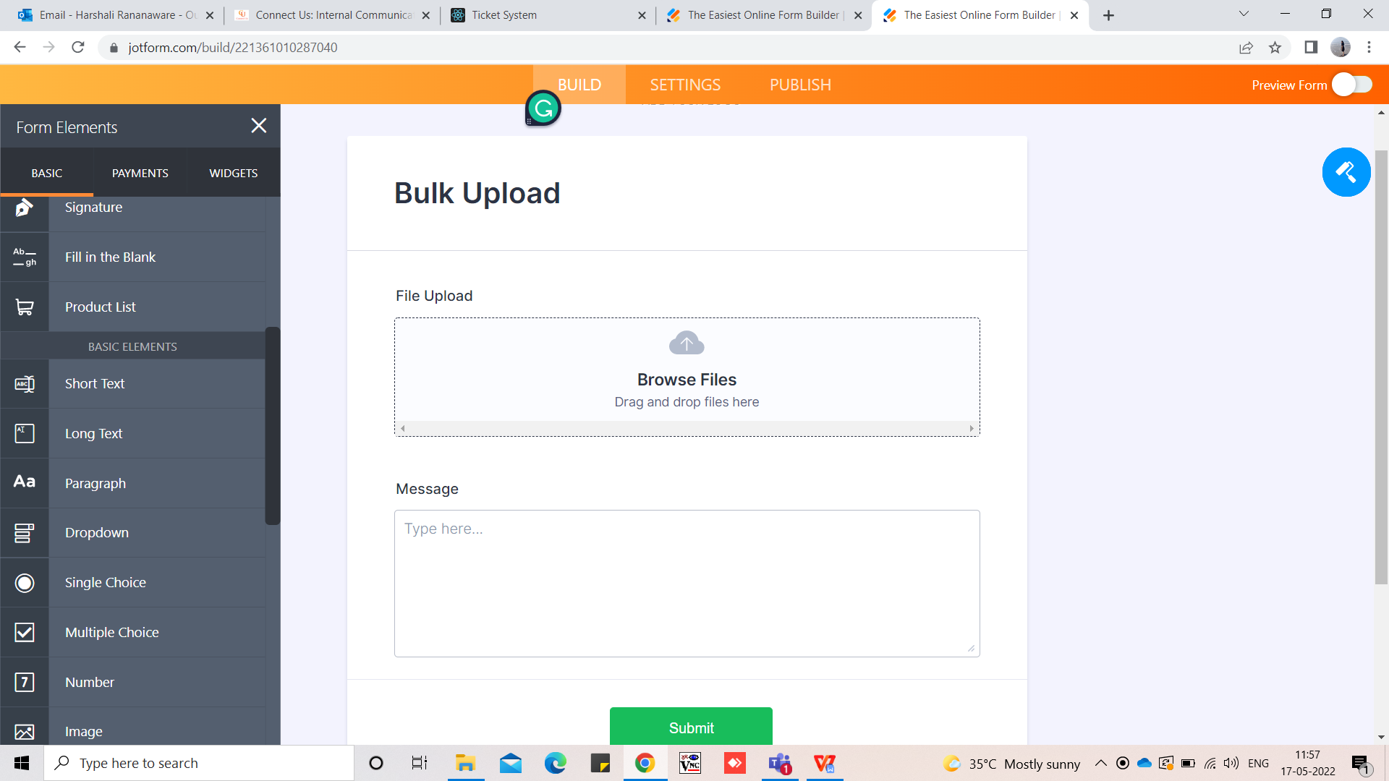

**App view :** <https://www.figma.com/file/enLOoFzOp7kcDkZdYOExOl/Goshala-Donation-App?node-id=135%3A712>

First page of app.

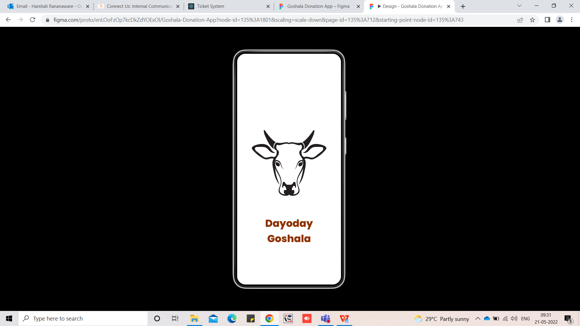

**First page**

**Login page :** We can enter user name and password here.

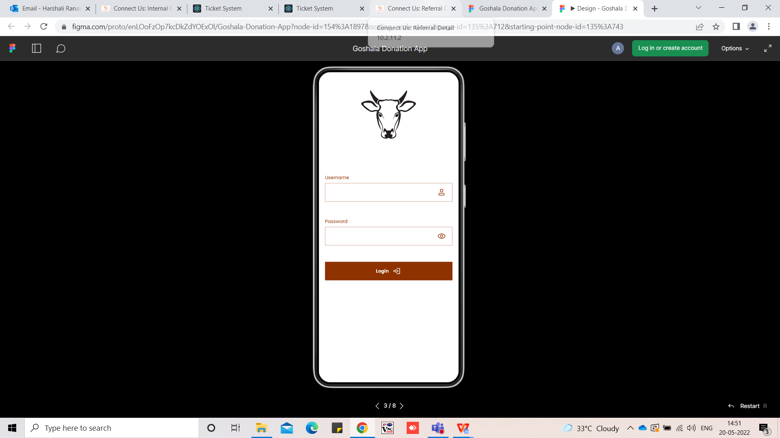

**Login page**

**Main page** : After Login open the below page. In this page show the old transaction.

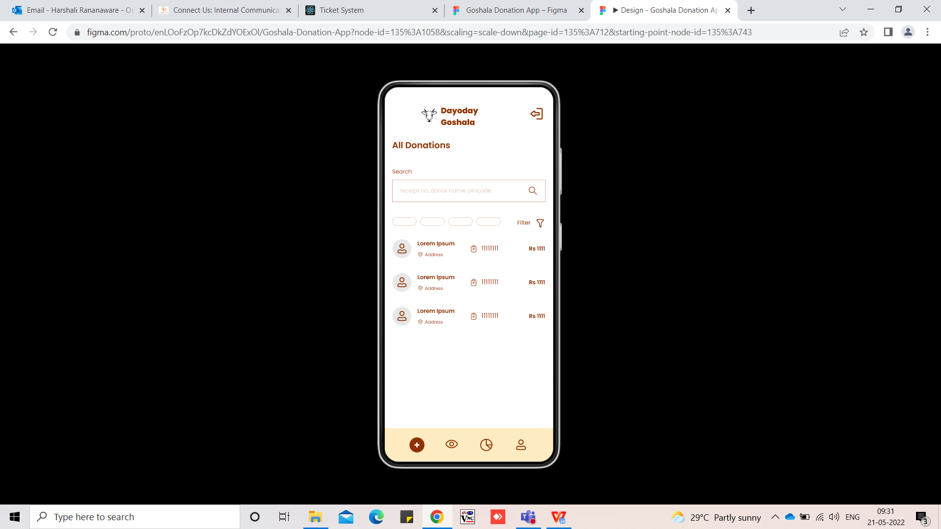

**Old Transaction**

**Add Form** : “+” click on this this page is open. We can add the form here.

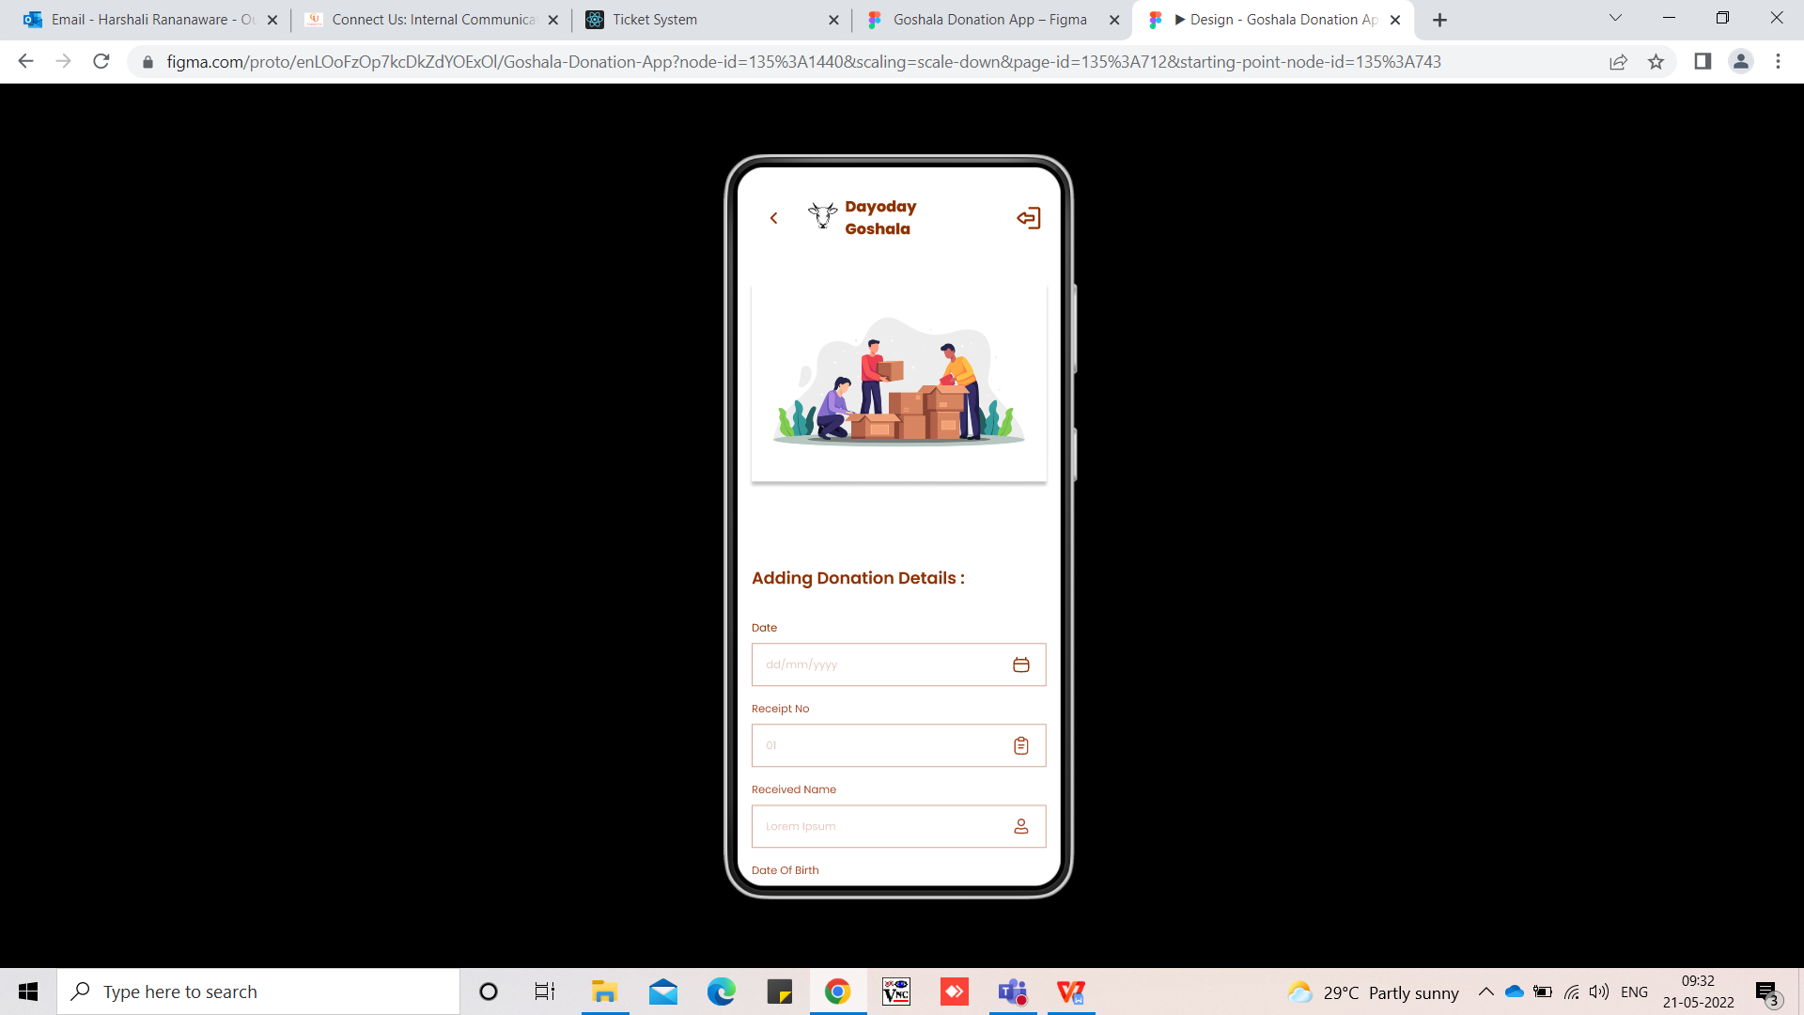

**Add Form**

**Report** : Select From date and to date click on “Get Report” then report generate.

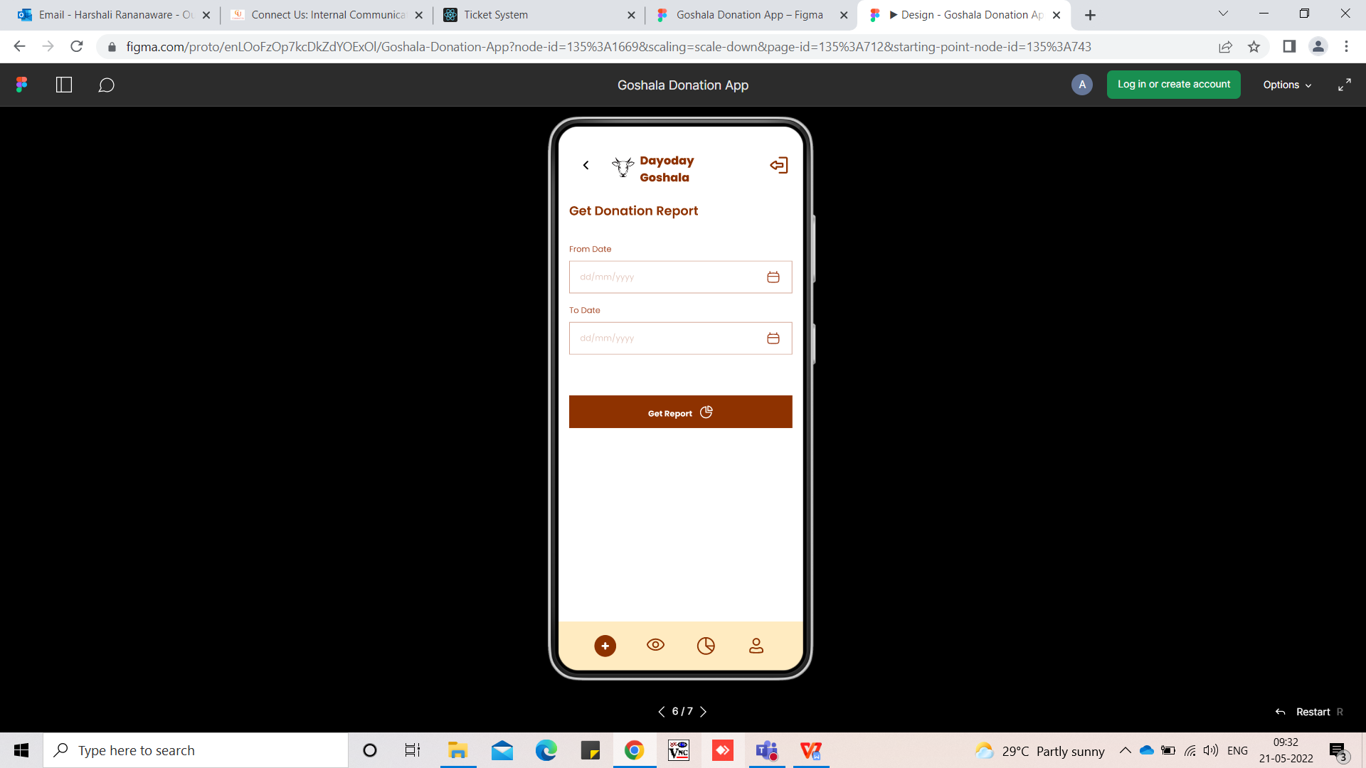

**Report**

**Report** : Click on “Get Report” then report generate.and show in the below format.

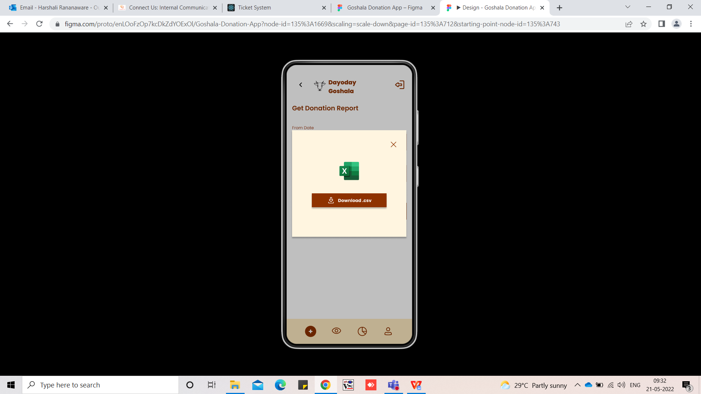

**Download Report**

**Profile** : Here we can rest the password.

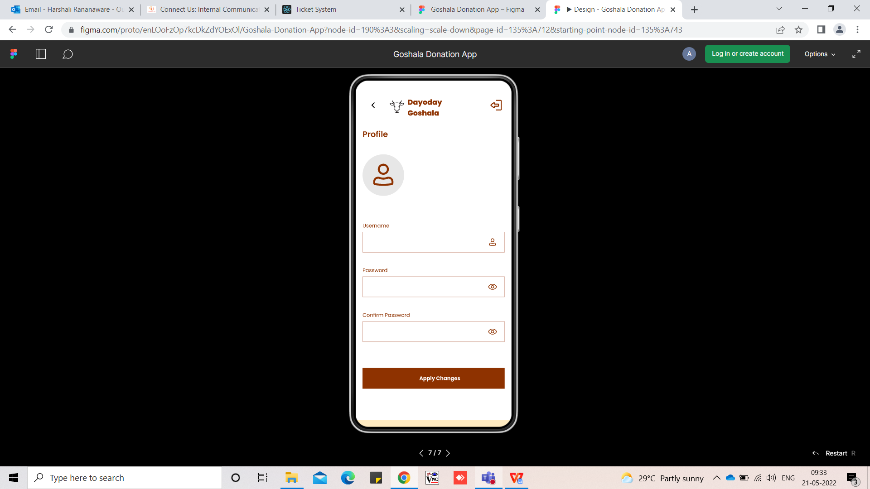

**Profile**

**User wise login add send receipt**

**View name date**

**Farming booking**

**Summer camp booking**

**References of the users**

|  |  |  |  |
| --- | --- | --- | --- |
| **User** | **Name** | **Mail** | **Contact number** |
| **Actual user** | Siddharth Shah | sidshah@csjewellers.com |  |
| **Assigned business analyst** | Harshali Rananaware | [harshali.rananaware@techneai.com](mailto:harshali.rananaware@techneai.com) | 8669917920 |
| **Assigned developer** | Nikhil Bhosale | nikhil.bhosale@techneai.com |  |