|  |  |
| --- | --- |
| **Ticket ID** | T101831 |
| **Ticket description** |  |
| **Created by** | Harshali Rananaware |
| **Created on** | 06 Jun 2022 |
| **Priority** | Very high |
| **Version** | 1 |

**Terminologies :** Connect us - CU , Bill checking - BC

**Proposed System :**

In CU -> BC -> Bill payments -> download payment. In bill payment add two option.

**1) Utility Bill Payment**

**2) Auto update payment**

In CU -> BC -> Bill checking Transaction.

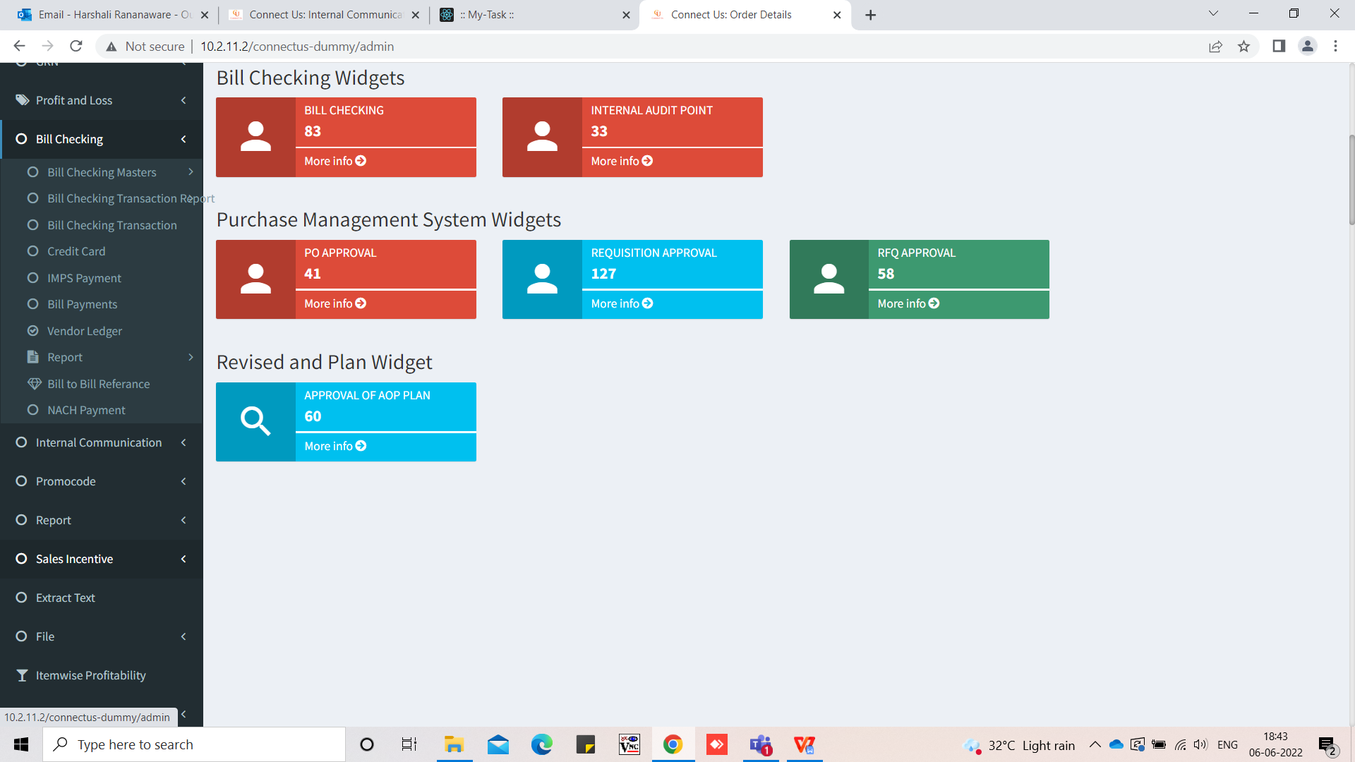

Image 1

In CU -> BC -> Bill checking Transaction click on “Add Data” ( Refer Image 2 ) open a form ( Refer Image 3 ) if we select bill type - “Light bill” then branch name is mandatory. Bill type is release then this bill show in the “Utility Bill Payment”. Click on “Payment Details” then we can change a payment status.

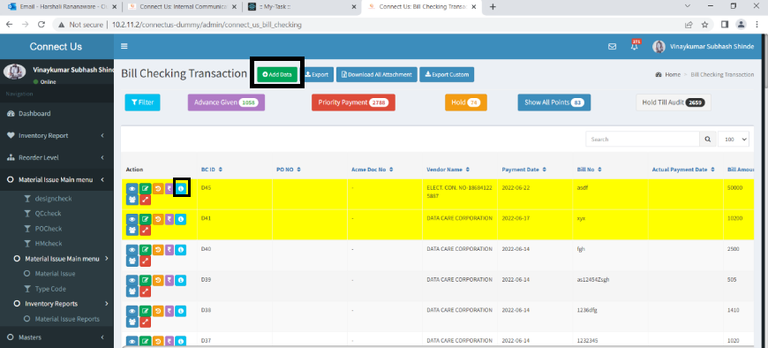

Click on this refer Image 4

Image 2

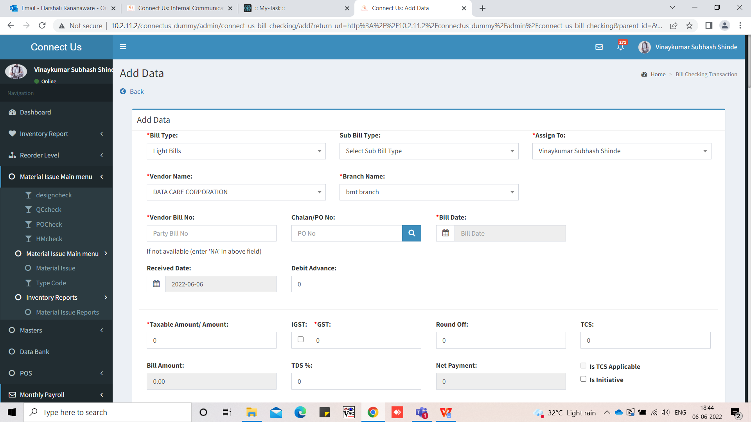

Image 3

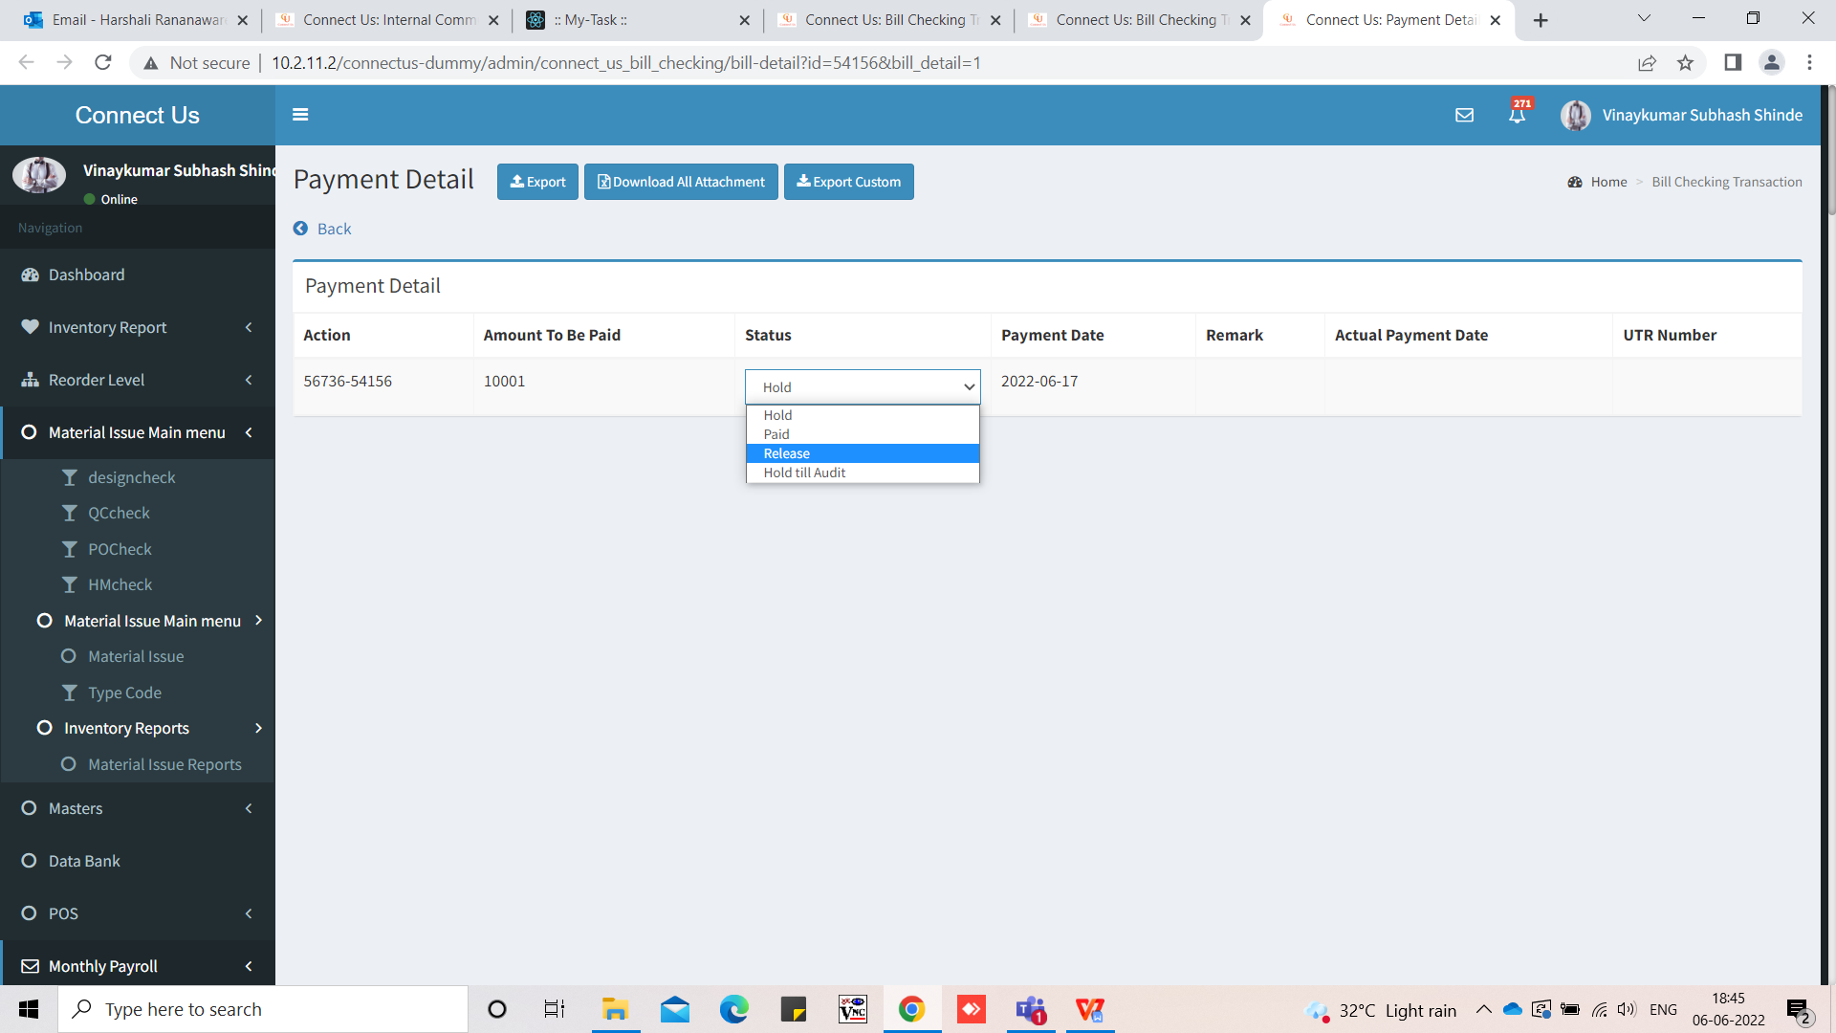

Image 4

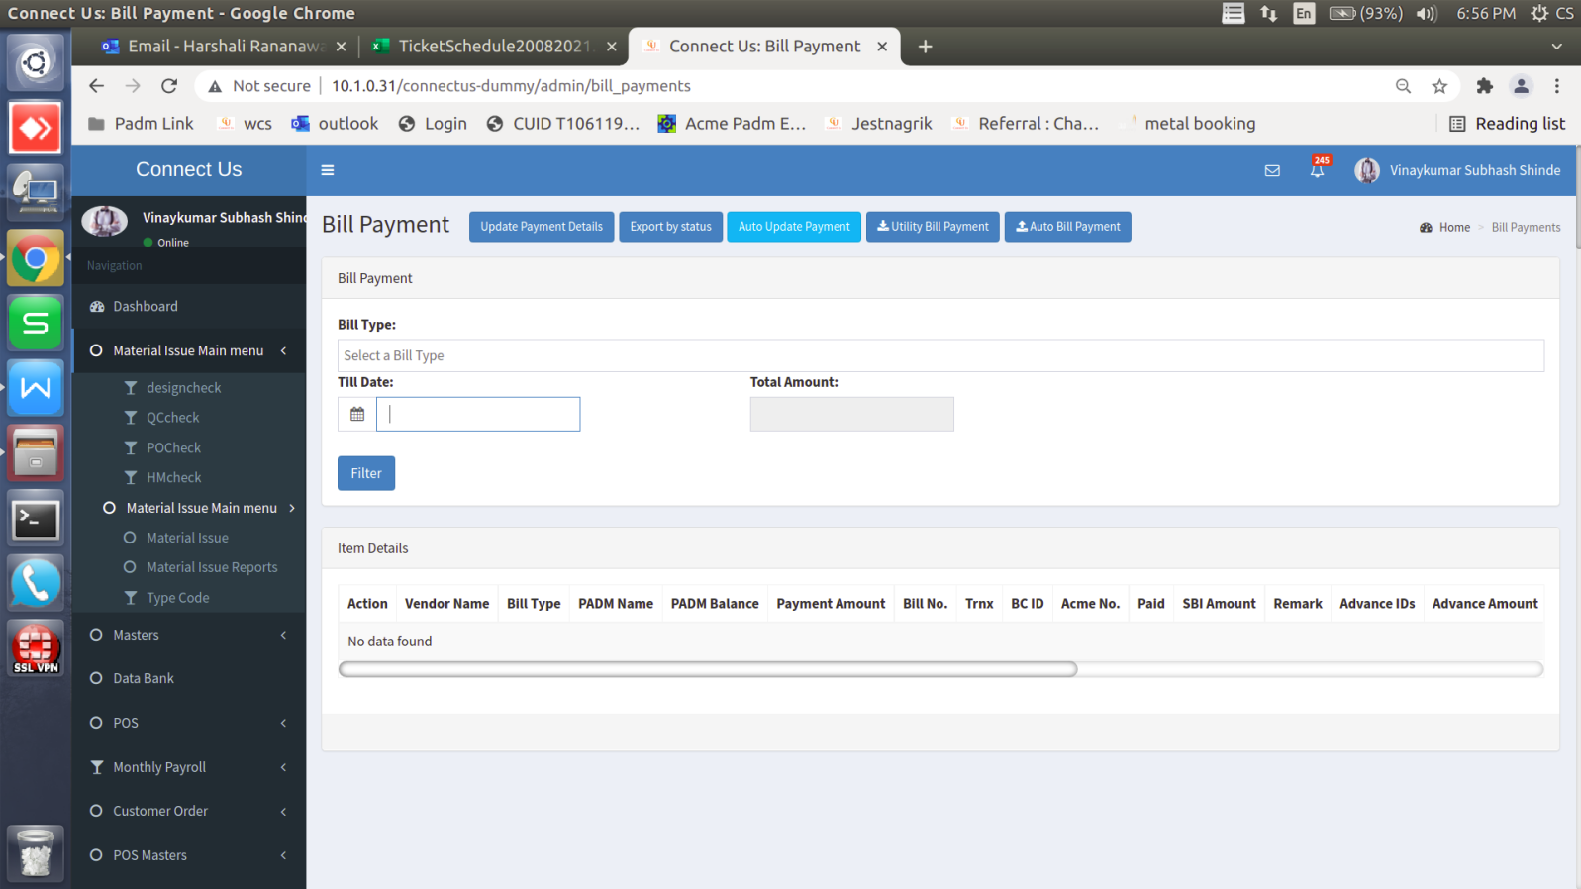

New option

Image 5

**1) download payment** - Click on download payment then enter till date then bill type lights bills and telephone bills show ( Refer Image 6 ) . Click on download payment list then file download in text format ( Refer Image 7 ). Any filed is blank then show in different color. After download file then point status auto change “ confirmation pending ”.

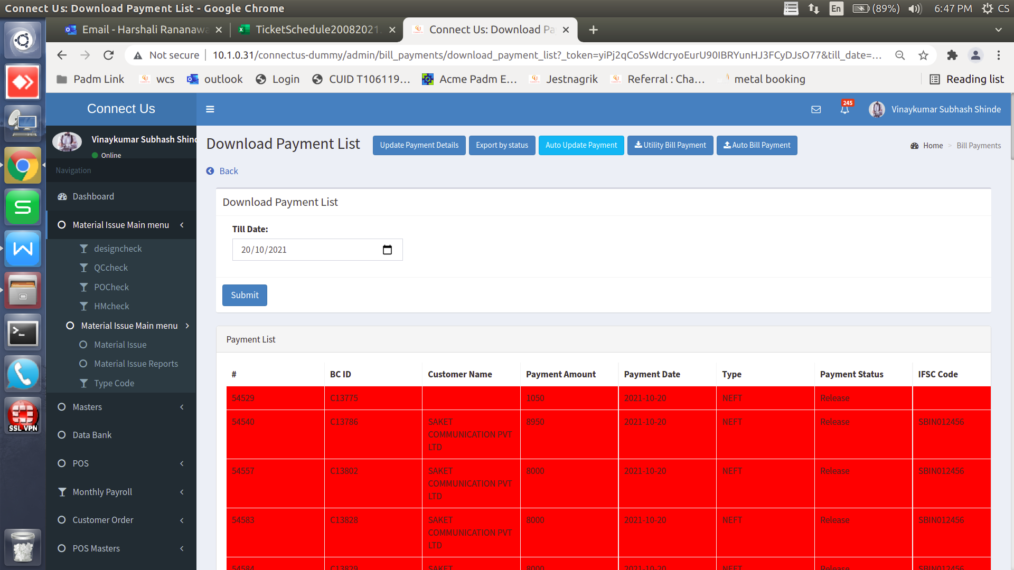

Click here to view this window

Image 6

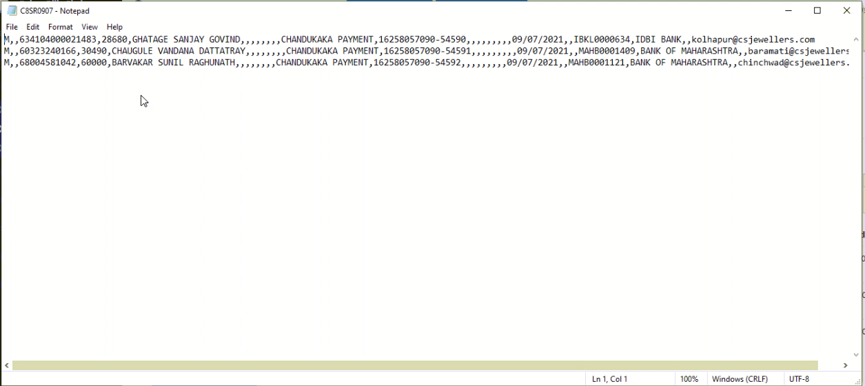

Image 7

1. **Auto update payment** - Receive bank file then the user can upload this file by using “Auto Update payment” ( Refer Image 9 ) .

The user can add text file and after click on update button then and upload successfully.

CU -> BC -> Bill checking transaction point against point status change auto confirmation pending” to “paid”.

If any issue from bank side then status is bank reject. Give cancel option. Click on cancel then the show main window ( Refer Image 5 ).



Click here to refer img 9

Image 8

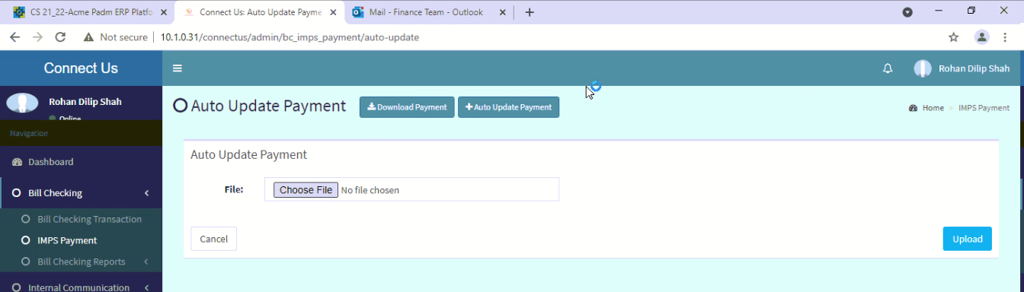

Image 9

“ Auto update payment ” Auto update in padm bank payment HO.

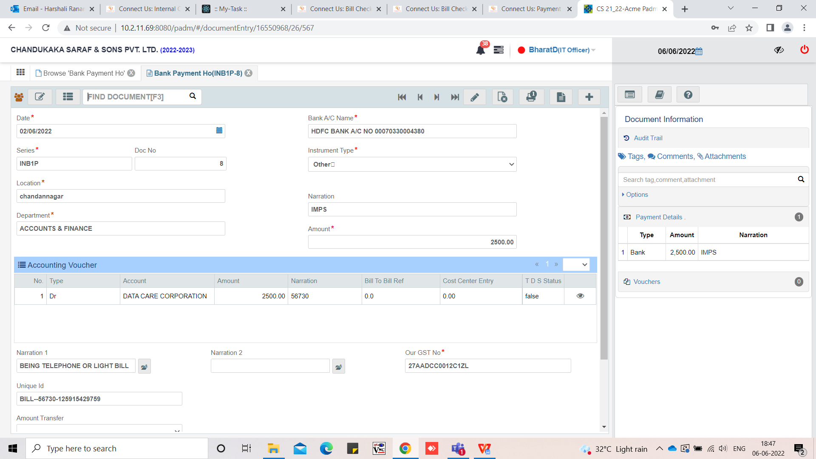

Image 10