**Ticket Id :** T110068

**Project Name :** Connect Us

**Terminologies :** Connect us - CU sales incentive - SI

**Proposed System :**

In connect us -> SI -> sales transaction -> periodwise targets and achievement Image 1

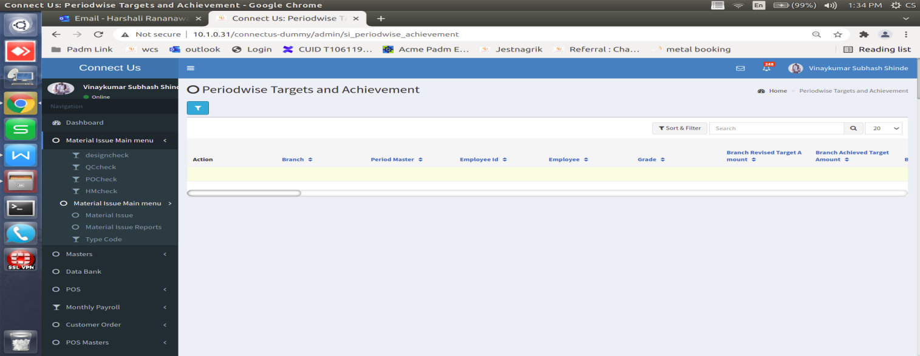

Click here to show image 2

Image 1

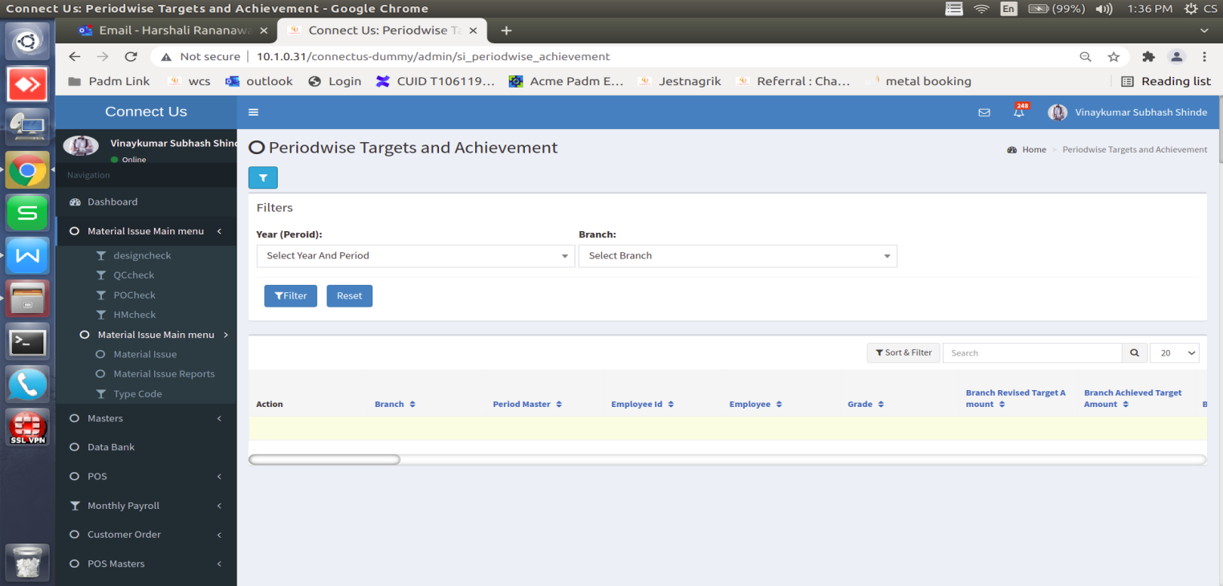

Image 2

|  |  |  |  |  |
| --- | --- | --- | --- | --- |
| Sr. No | Field name | Input type | Description |  |
| 1 | Year (period) | Drop-down | Select year. | SI -> Sales master -> year master. |
| 2 | Branch | Drop-down | Select branch name here. | SI -> Sales master -> branch location master. |
| 3 | Filter | Button | Click on this report generated. |  |
| 4 | Reset | Button | Reset the input. |  |
| 5 | Export | Button | Export data in CSV file. |  |

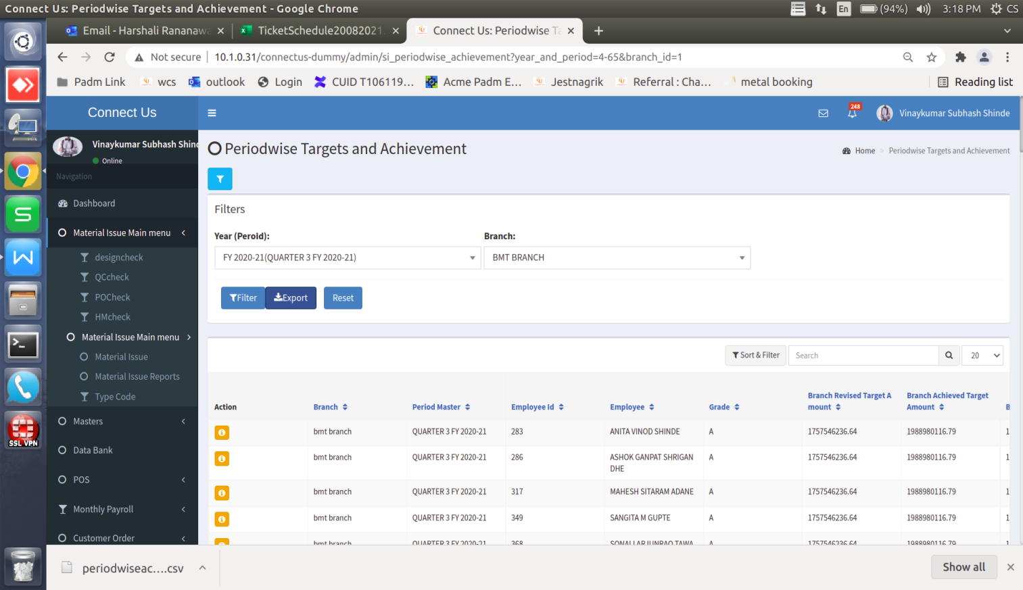

Image 3

|  |  |  |  |  |  |
| --- | --- | --- | --- | --- | --- |
| Sr. No | Field name |  | Data fetch | Formula | Attachment |
| 1 | Branch | Branch | SI -> Sales master -> branch location master. |  |  |
| 2 | Period master | Branch | SI -> Sales master -> year master. |  |  |
| 3 | Employee Id | Branch | Master -> Generakl master -> Employee Master. |  |  |
| 4 | Employee | Branch | Master -> Generakl master -> Employee Master. |  |  |
| 5 | Grade | Branch | Master -> Generakl master -> Employee Master. |  |  |
| 6 | Branch revised Target Amount | Branch | SI -> Sales transaction -> period target ( generate this report -> Revised Total ) |  | Image 7 |
| 7 | Branch Achieved Target Amount | Branch | SI -> Sales transaction -> period target ( generate this report -> Actual Total ) |  | Image 7 |
| 8 | Branch Achieved % | Branch | SI -> Sales transaction -> period target ( generate this report -> Achievement Show Detail ) | Branch Achieved % = ( Branch Achieved Target Amount / Branch revised Target Amount ) * 100 | Image 7 |
| 9 | Branch Diamond Carat Target | Branch | SI -> Sales transaction -> period target ( generate this report -> Proposed Target ) | period target ( generate this report -> diamond Proposed Target ) | Image 6 |
| 10 | Branch Diamond Carat Achieved % | Branch | SI -> Sales report (geneate this report Sales report) | Branch Diamond Carat Achieved % = Sales Net Wt. -(minus) Sales Return Net Wt. | Image 9 |
| 11 | Branch Diamond Carat Achieved | Branch |  | Branch Diamond Carat Achieved = Branch Diamond Carat Achieved % / Branch Diamond Carat Target * 100 |  |
| 12 | Branch Sterling Silver Revised Target Amount | Branch | SI -> Sales transaction -> period target ( generate this report -> Revised Amount ) | period target ( generate this report )  Targt group - silver o group Revised Amount * 5 % | Image 7 |
| 13 | Branch Sterling Silver Achieved Amount | Branch |  |  |  |
| 14 | Branch Sterling Silver Achieved % | Branch |  | Branch Sterling Silver Achieved % = Branch Sterling Silver Achieved Amount / Branch Sterling Silver Revised Target Amount * 100 |  |
| 15 | Revised Contribution Margin Target Amount (Branch Level) | Branch |  |  |  |
| 16 | Achieved Contribution Margin Amount (Branch Level) | Branch | Profit and loss -> AOP report | CONTRIBUTION MARGIN branch wise actual amount show. | Image 8 |
| 17 | Achieved Contribution Margin % | Branch |  |  |  |
| 18 | Bhishi 2x Conversion target In Amount | Branch |  |  |  |
| 19 | Bhishi 2x Conversion Achieved In Amount | Branch |  |  |  |
| 20 | Bhishi 2x Conversion Achievement % | Branch |  | Bhishi 2x Conversion Achievement % = Bhishi 2x Conversion Achieved In Amount / Bhishi 2x Conversion target In Amount |  |
| 21 | Revised sales Target Amount | Employee | SI -> sales trnsaction -> employee wise target settings | Revised amount | Image 10 |
| 22 | Sales Achieved Target Amount | Employee | SI -> sales trnsaction -> employee wise target settings | Sales amount - sales return amount |  |
| 23 | Sales Achieved % | Employee |  | Sales Achieved % = Sales Achieved Target Amount / Revised sales Target Amount * 100 |  |
| 24 | Remaining Sales Achieved Target Amount | Employee | In month 26 days cosider. |  |  |
| 25 | Remaining Days | Employee | Remaing days calculated as per 26 days inculding sat sunday. |  |  |
| 26 | Per Day Sales Target | Employee |  |  |  |
| 27 | Diamond Target In Carat | Employee |  |  |  |
| 28 | Diamond Achieved In Carat | Employee |  |  |  |
| 29 | Diamond Achieved % | Employee |  |  |  |
| 30 | Incremental Diamond In Carat | Employee |  |  |  |
| 31 | Revised sterling silver target In Amount | Employee |  |  |  |
| 32 | sterling silver sales Achieved In Amount | Employee |  |  |  |
| 33 | sterling silver Achivement % | Employee |  |  |  |
| 34 | Gram wise Sterling Silver Net Weight | Employee |  |  |  |
| 35 | Scheme Quantity | Employee |  |  |  |
| 36 | Scheme Achieved Target | Employee |  |  |  |
| 37 | Sales Incentive Amount | Employee |  |  |  |
| 38 | Contribution Margin Incentive Amount | Employee |  |  |  |
| 39 | Diamond Weightage Incentive Amount | Employee |  |  |  |
| 40 | Diamond Incremetal Incentive Amount | Employee |  |  |  |
| 41 | Sterling Silver Weightage Incentive Amount | Employee |  |  |  |
| 42 | Sterling Silver Gram wise Incentive Amount | Employee |  |  |  |
| 43 | Bhishi 2X Conversion Incentive Amount | Employee |  |  |  |
| 44 | Bhishi Incentive Amount | Employee |  |  |  |
| 45 | Total Incentive Amount | Employee |  |  |  |
| 46 | Bhishi Collction | Employee |  |  |  |
| 47 | Bhishi Payoff | Employee |  |  |  |
| 48 | Payoff Percentage | Employee |  |  |  |
| 49 | Kundan Target Acheivement | Employee |  |  |  |
| 50 | Kundan Target Payoff | Employee |  |  |  |

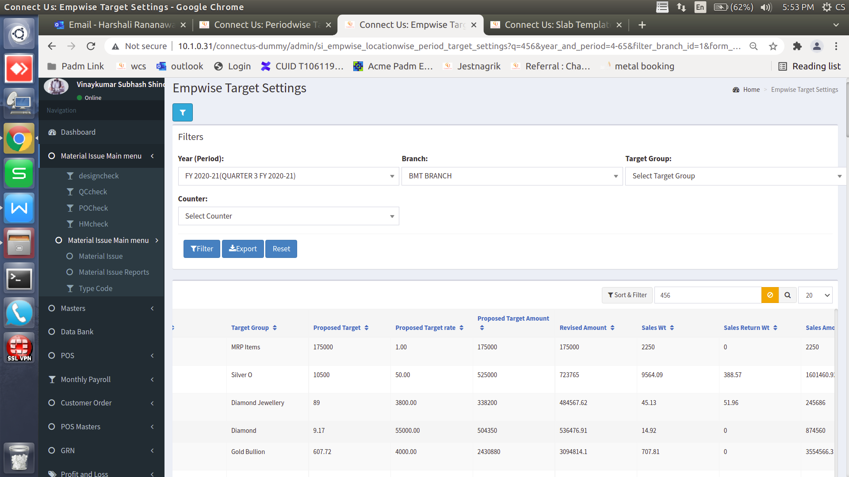

Image 4

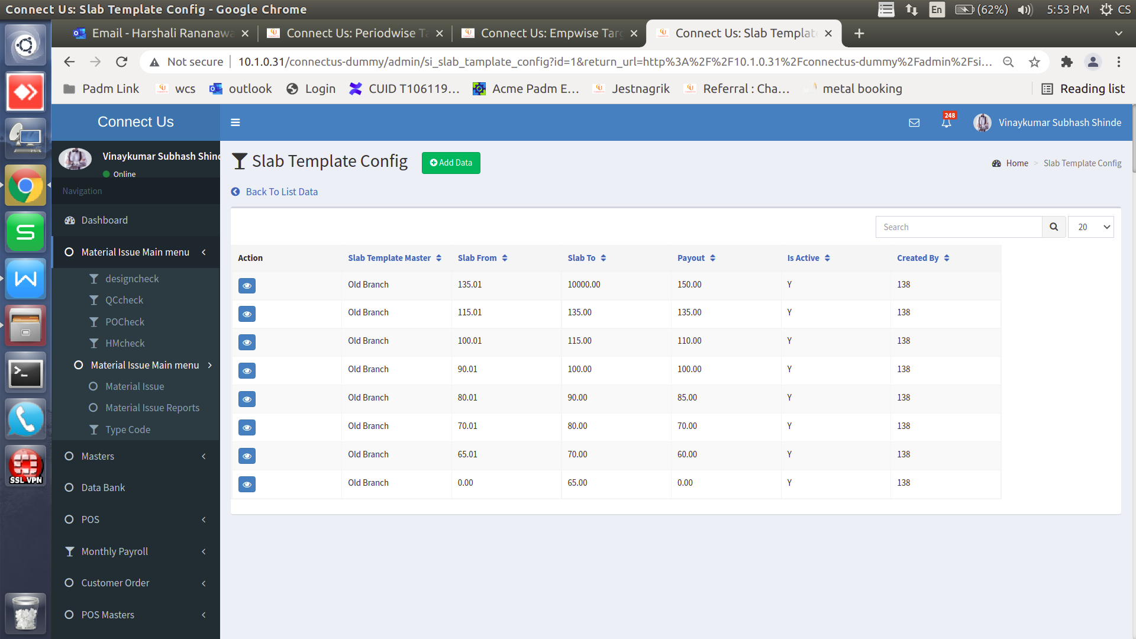

Image 5

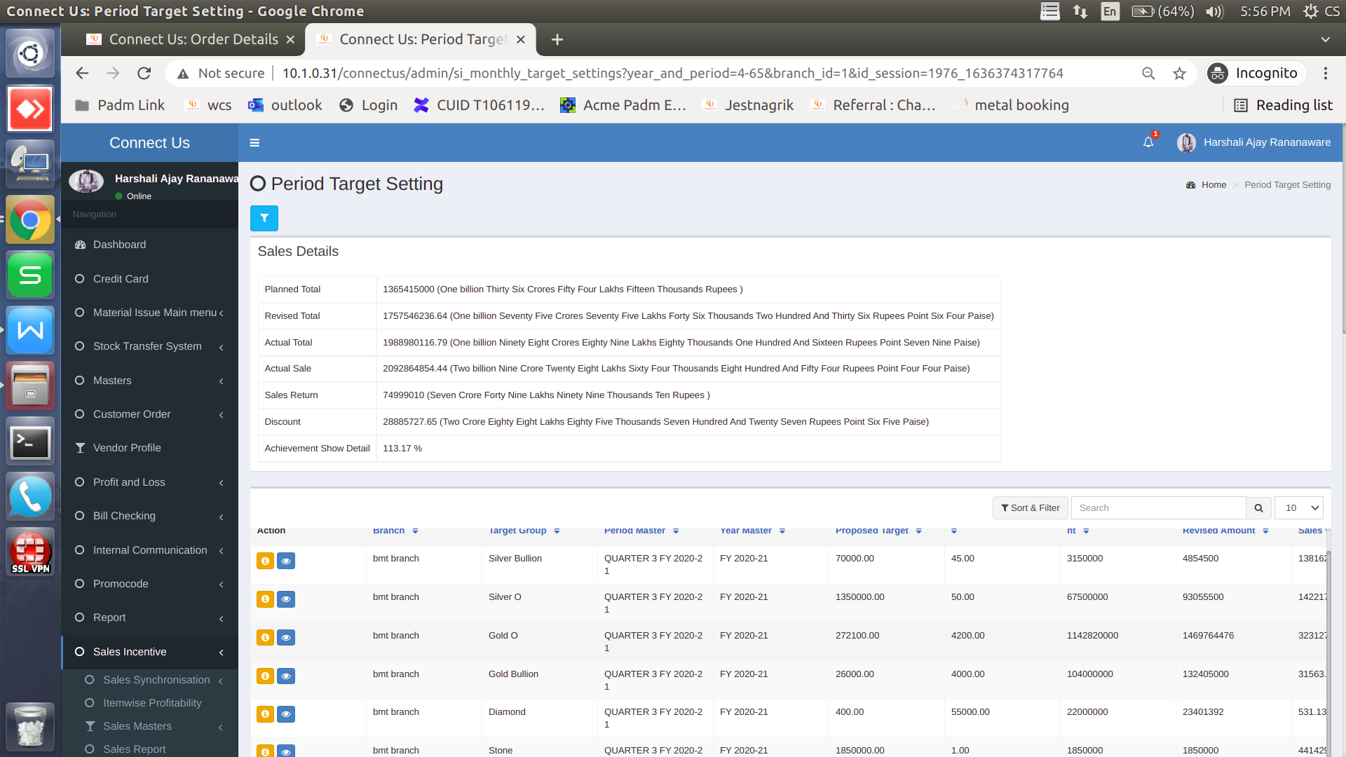

Image 6

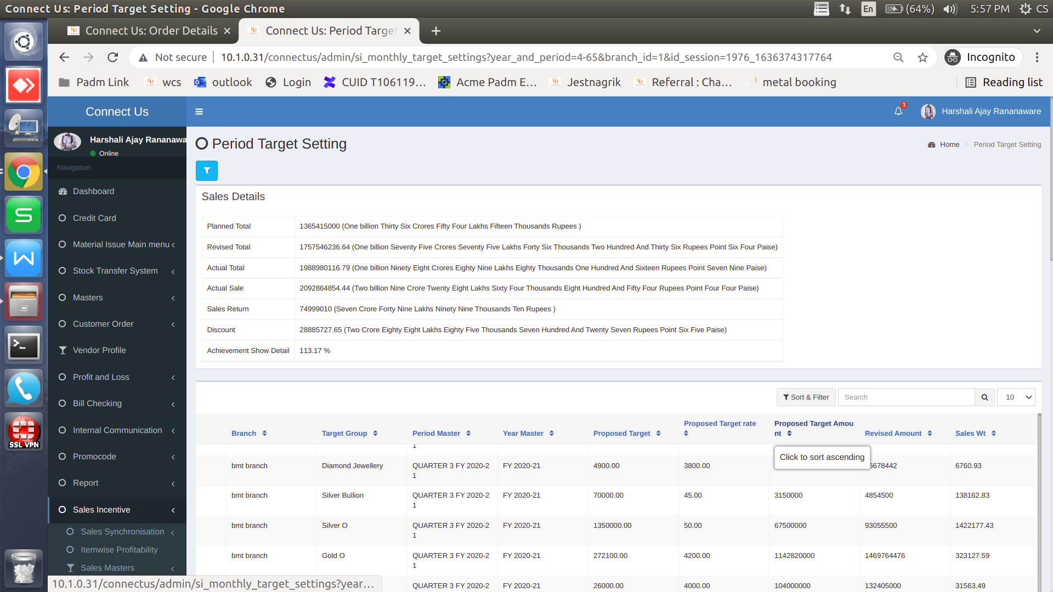

Image 7

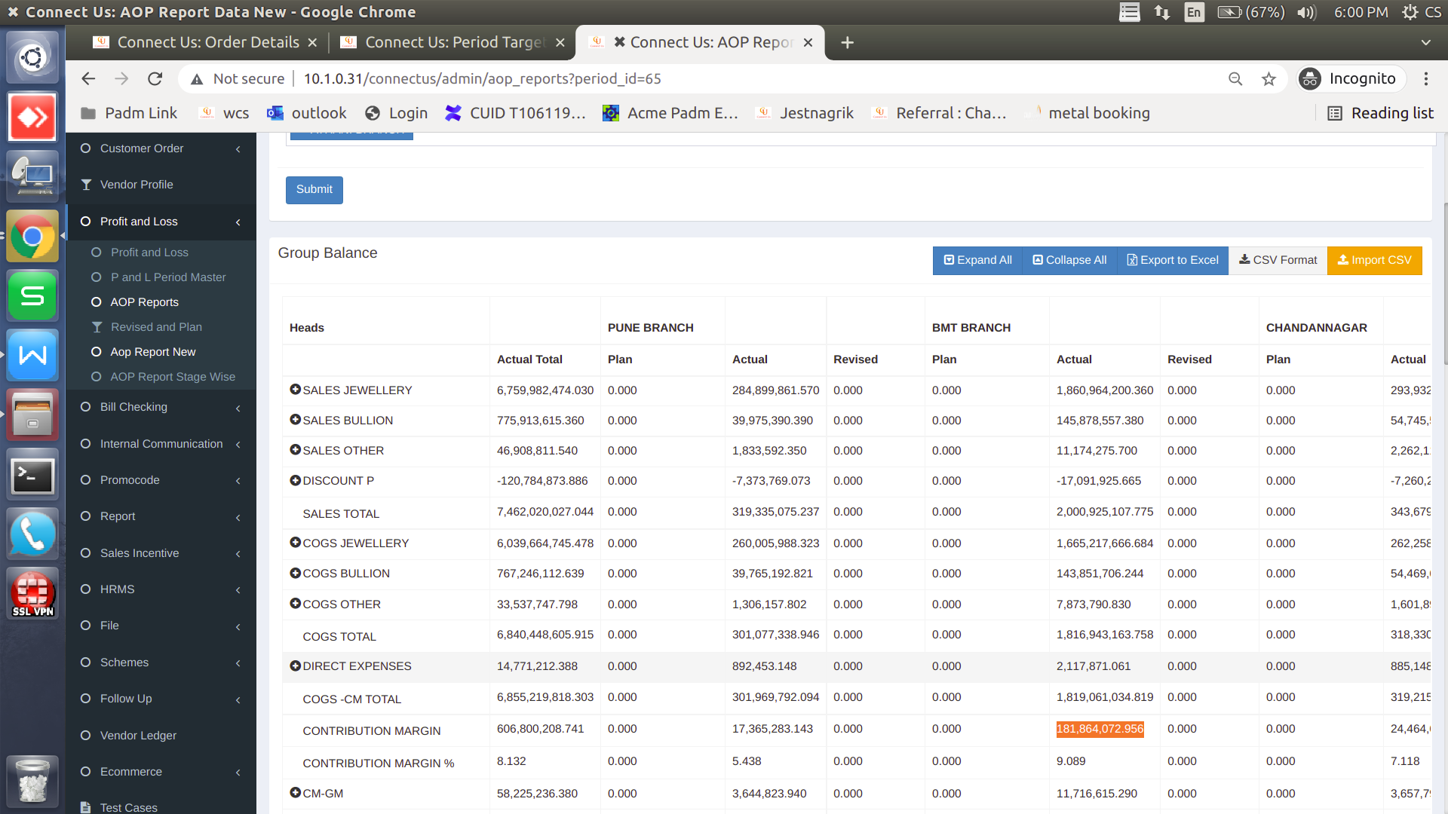

Image 8

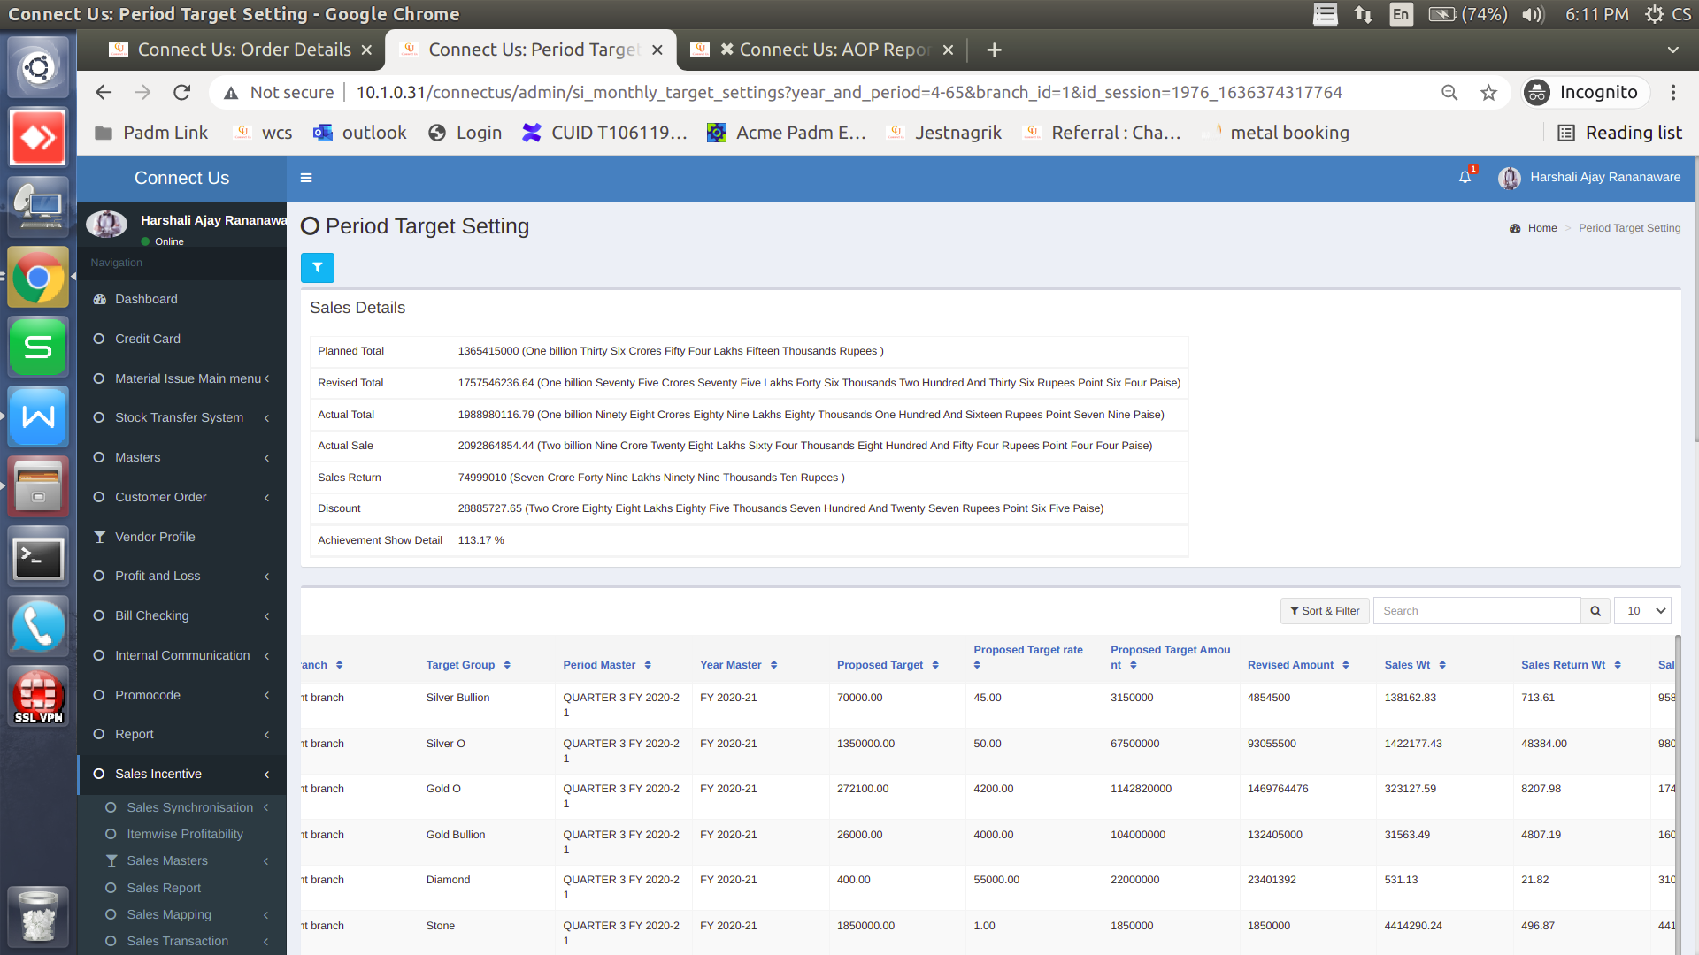

531.13 - 21.82 = 509.31

Image 9

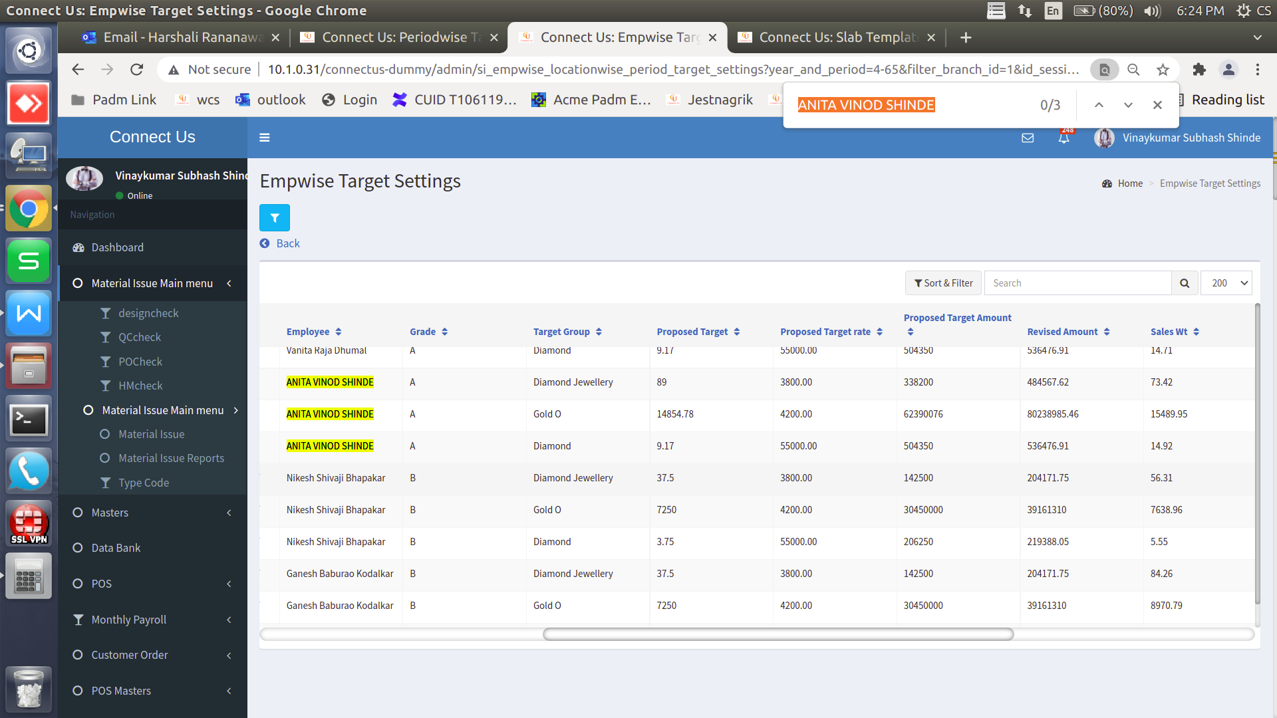

Image 10