|  |  |
| --- | --- |
| **Ticket ID** | T214135 |
| **Ticket description** | *In Sales incentive - Payout Slab We require Sales employee slab and payout %and also Branch level payout slab and payout %* |
| **Created by** | *Harshali Rananaware* |
| **Created on** | 28 Apr 2022 |
| **Priority** | *Very high* |
| **Version** | *1* |

**Version**

|  |  |  |  |  |
| --- | --- | --- | --- | --- |
| **Sr. No** | **Version no** | **Version Date** | **User name** | **User department** |
| 1 | 1 | 28 Apr 2022 | Dinesh Bhagyawan Sonawane | Accounting Department |

**Approvals**

|  |  |  |
| --- | --- | --- |
| **Field** | **Name of the User** | **Approved date by the user** |
| **Actual User Name** | Dinesh Bhagyawan Sonawane |  |
| **Actual User Department** | Accounting Department |  |
| **Organization Name** | CSPL |  |
| **Assigned BA** | *Harshali Rananaware* |  |
| **Assigned Developer** |  |  |
| **Assigned Tester** |  |  |

**Estimation**

|  |  |  |  |  |
| --- | --- | --- | --- | --- |
| **Department name** | **Estimated Time (In hr)** | **Scheduled Date (Starting date )** | **Estimated date** | **Actual delivery date** |
| **BA** | 4 | 28 Apr 2022 | 03 May 2022 |  |
| **Development** |  |  |  |  |
| **Testing** |  |  |  |  |

**Business requirement**

*In Sales incentive - Payout Slab We require Sales employee slab and payout %and also Branch level payout slab and payout %*

**Abbreviations & terms**

Connect us - CU

**Existing system:**  In CU -> Sales incentive -> sales master -> slab template master set the slab for employee and branch in one setting.

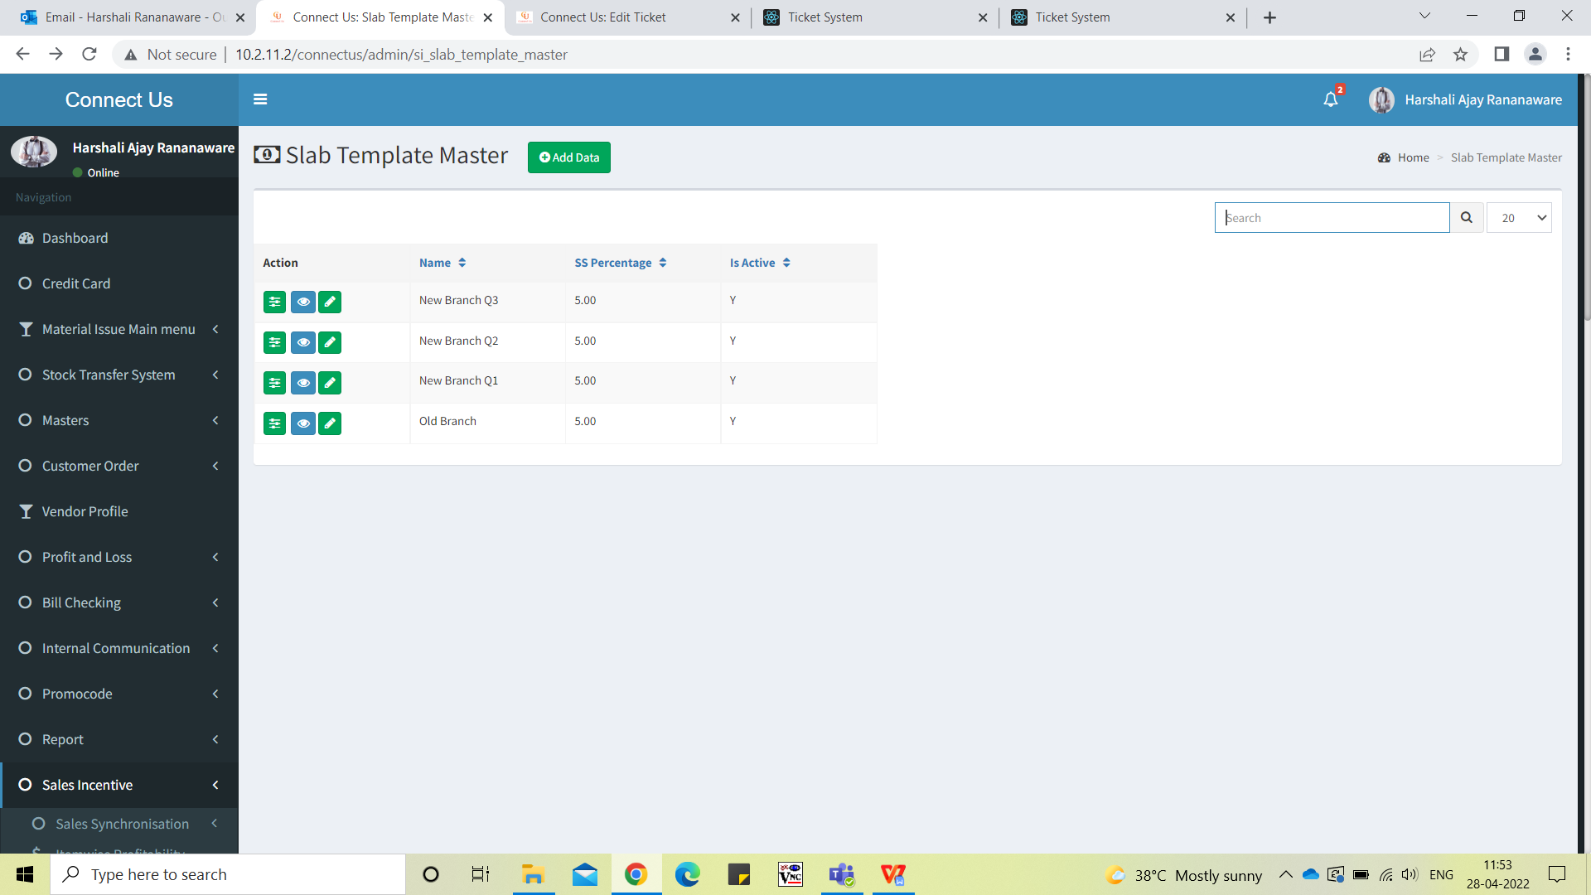

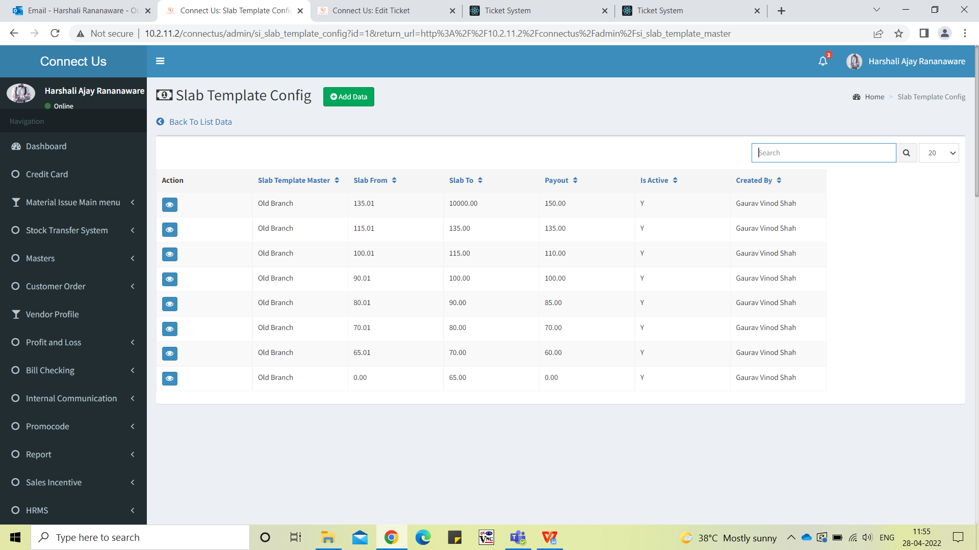

**Proposed System :** We want to set the slab for branch and employee separately. Branch target is achieved then employee slab will be applicable.

In CU -> Sales incentive -> sales master -> slab template master click on “add data”(Refer image 1) then add new field “branch target” we can set the branch target here.(Refer image 2) Click on view then branch target field should be shown.

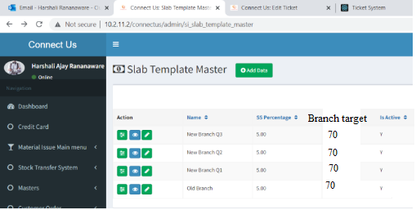

Image 1

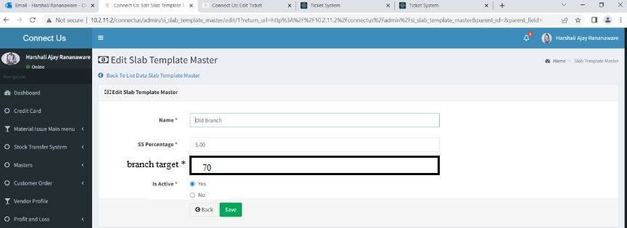

Image 2

Click on view then branch target field should be shown. (Refer Image 3)

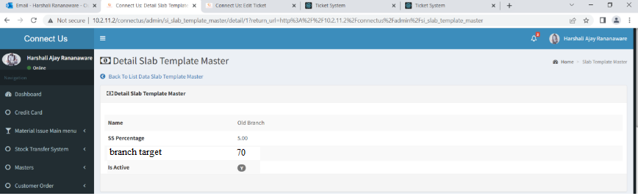

Image 3

Click on “slab template config” then branch target field should be shown. (Refer Image 4)



Image 4

In sales incentive -> sales transaction -> periodwise target and achievement in this report amount should be reflected as per setting.

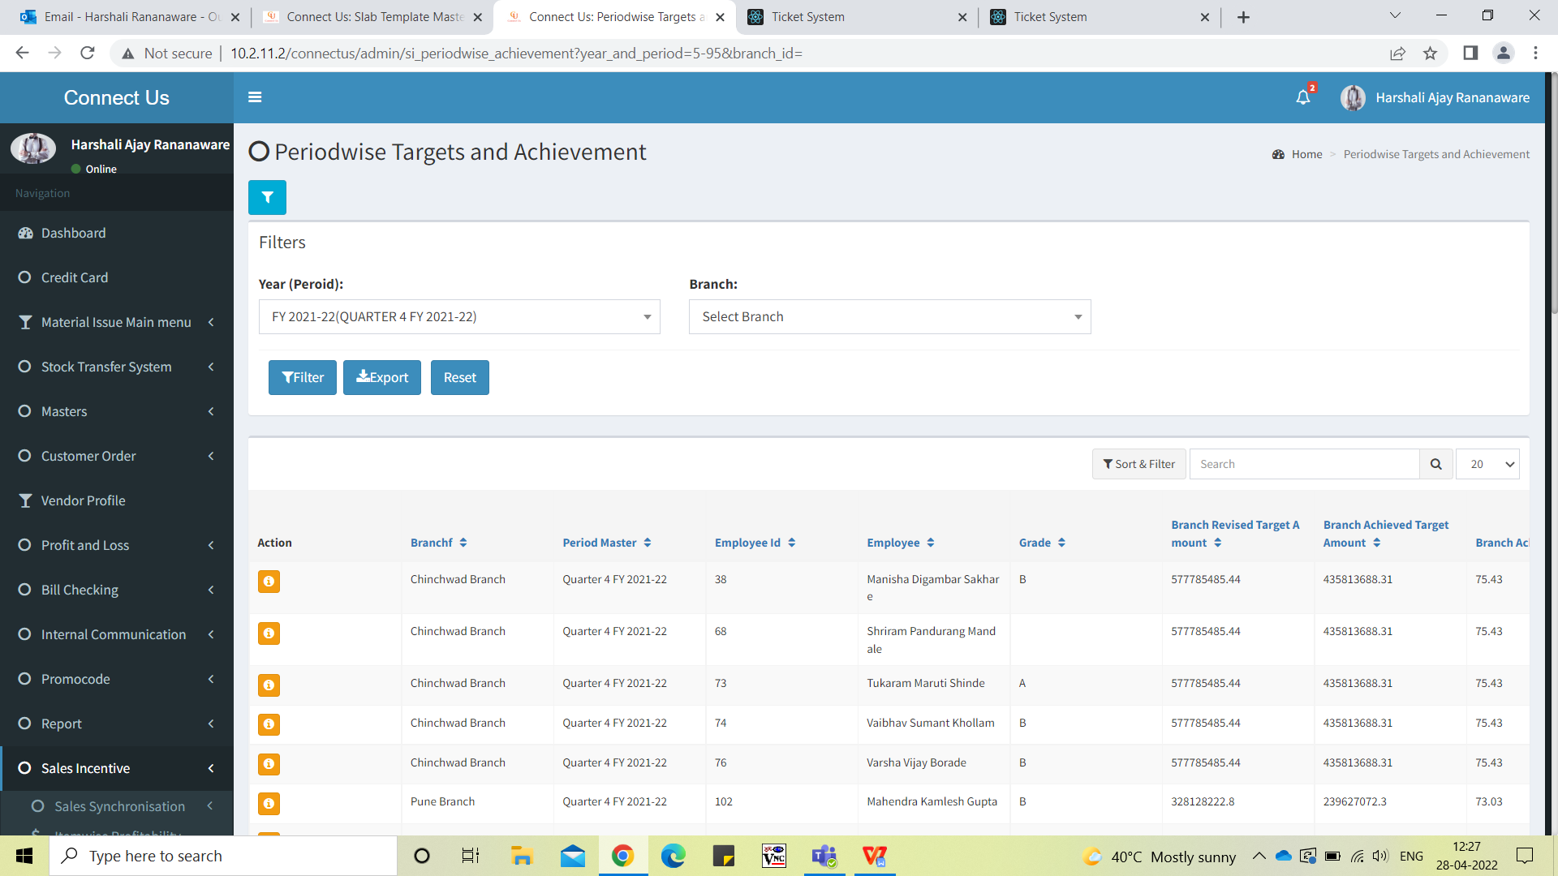

**References of the users**

|  |  |  |  |
| --- | --- | --- | --- |
| **User** | **Name** | **Mail** | **Contact number** |
| **Actual user** | Dinesh Bhagyawan Sonawane | hoaccountcc@csjewellers.com | 2931 |
| **Assigned business analyst** | *Harshali Rananaware* | [harshali.rananaware@techneai.com](mailto:harshali.rananaware@techneai.com) | 8669917920 |
| **Assigned developer** |  |  |  |