|  |  |
| --- | --- |
| **Ticket ID** | TT2552 |
| **Ticket description** |  |
| **Created by** | Harshali Rananaware |
| **Created on** | 24 May 2022 |
| **Priority** | Very high |
| **Version** | 1 |

**Version**

|  |  |  |  |  |
| --- | --- | --- | --- | --- |
| **Sr. No** | **Version no** | **Version Date** | **User name** | **User department** |
| 1 | 1 | 24 May 2022 |  |  |

**Approvals**

|  |  |  |
| --- | --- | --- |
| **Field** | **Name of the User** | **Approved date by the user** |
| **Actual User Name** |  |  |
| **Actual User Department** |  |  |
| **Organization Name** | CSPL |  |
| **Assigned BA** | Harshali Rananaware |  |
| **Assigned Developer** |  |  |
| **Assigned Tester** |  |  |

**Business requirement :** we have to create a new system to add delivery note and sales bill.

**Proposed System :**

We create a web base system to enter delivery note and sales bill.

* Employee login then their is show below menu

1. Master
2. Rate master (gold, silver ,platinum)
3. Branch master
4. Wastage master
5. Employee master
6. Customer master
7. Role master
8. Delivery note
9. Sales bill
10. Report

**Login:** Enter username and password.

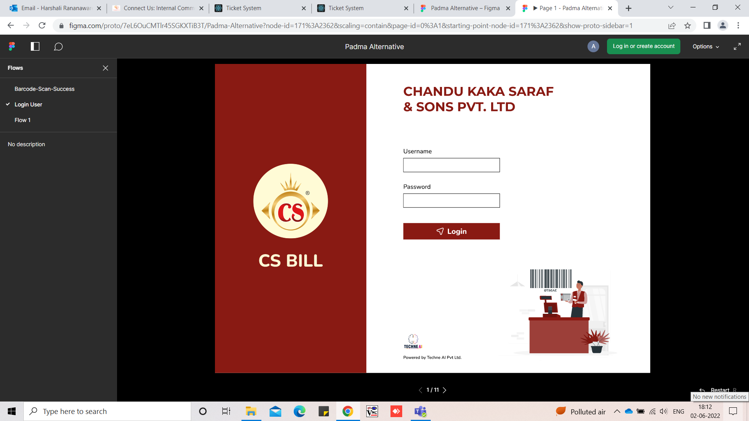

**Delivery note** :

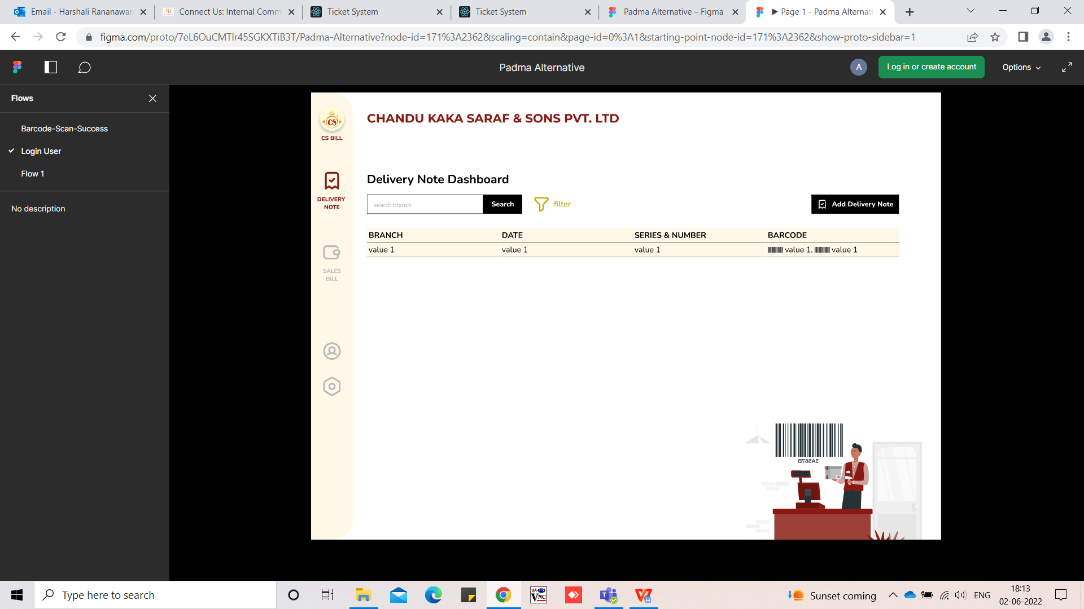

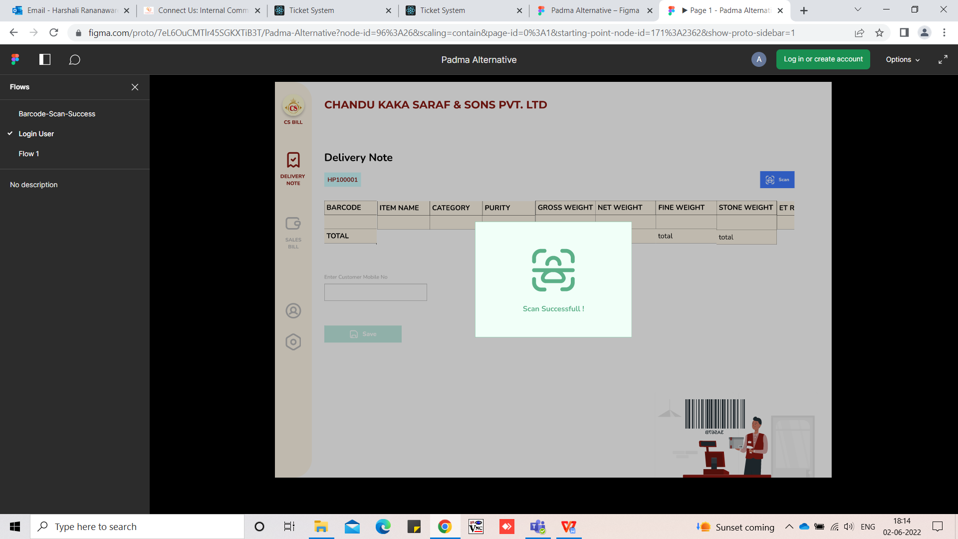

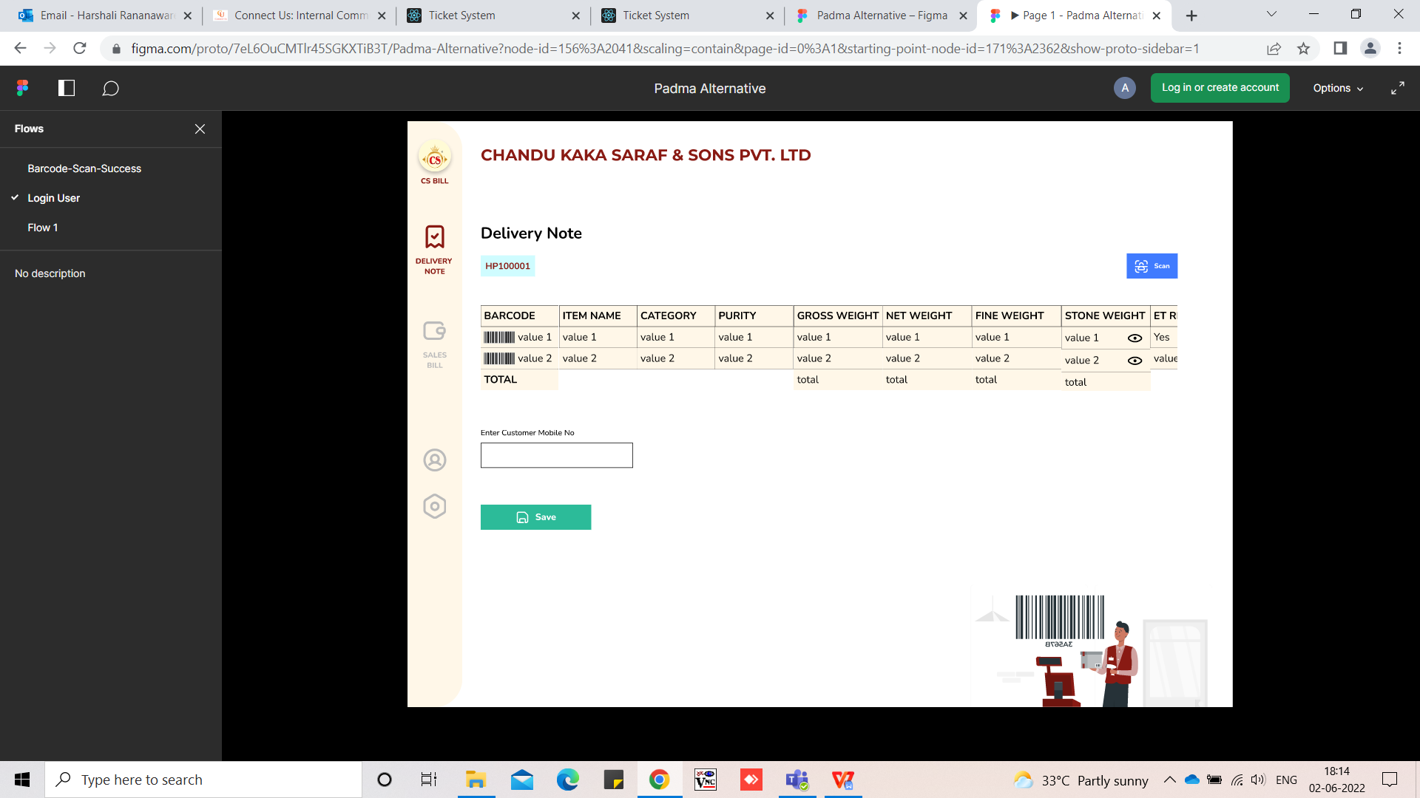

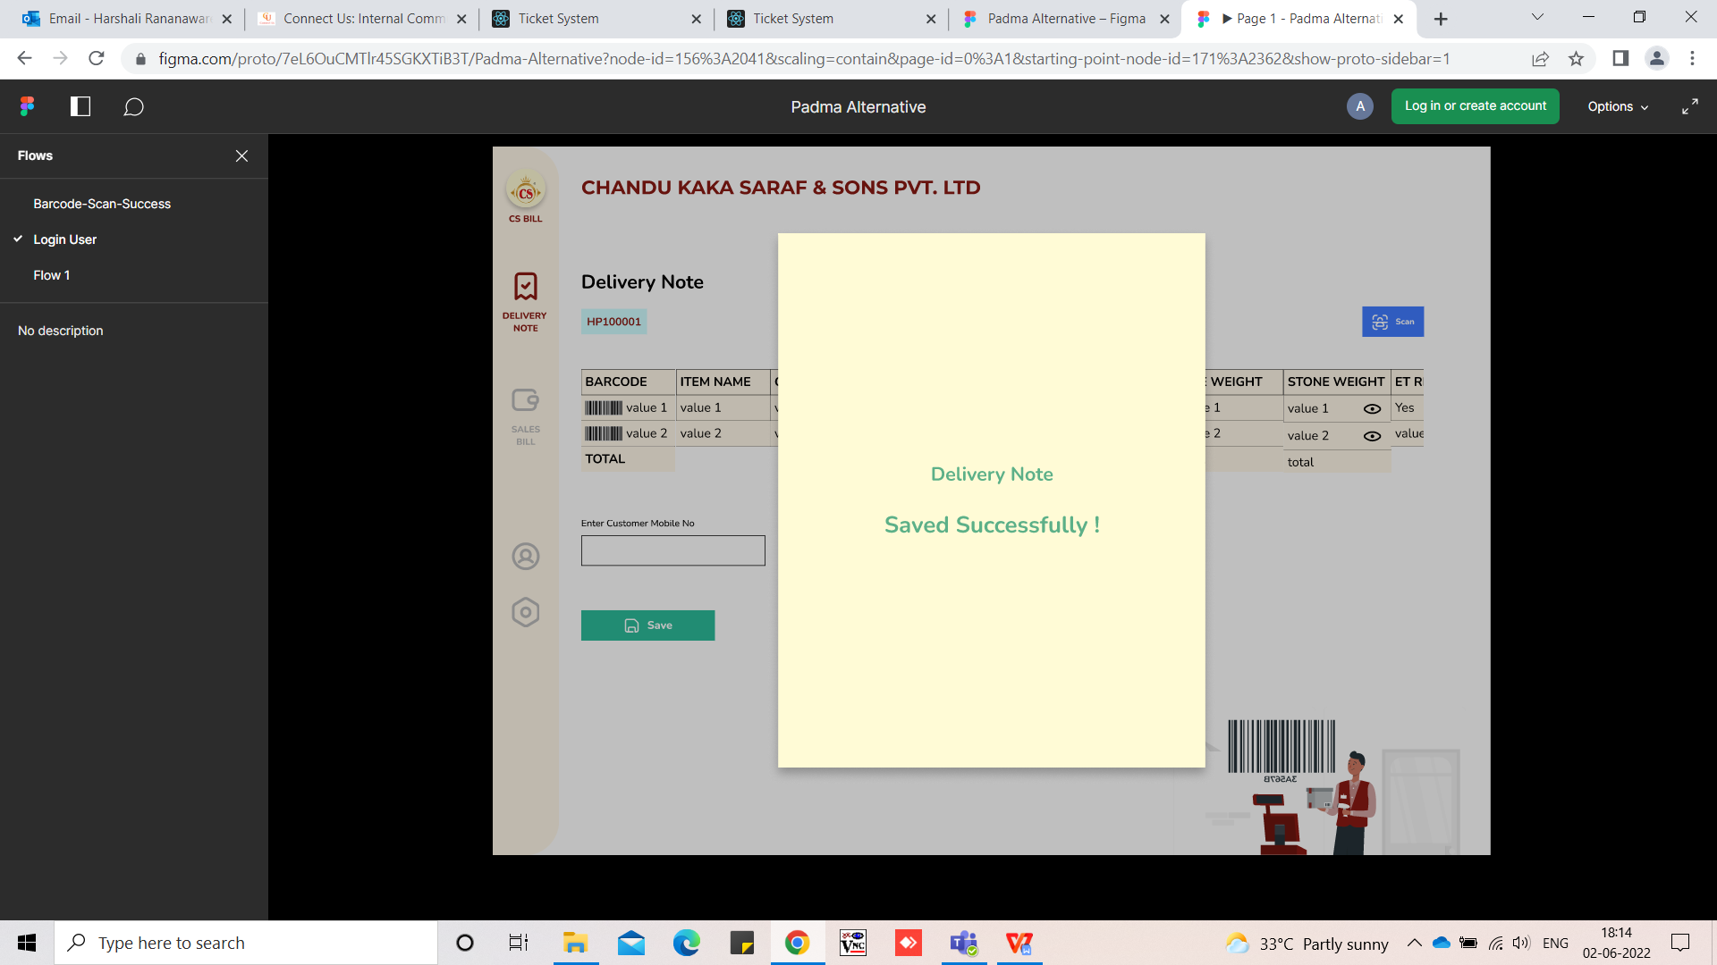

* For gold , silver , MRP , Forming and diamond we scan the bar-code in one delivery note.
* Delivery note series generated by branch-wise and document number start with 1 for each branch.
* After print delivery not cancel option want. If bar-code cancel then this bar-code again scan. If sales bill done then bar-code does not scan.
* Bar-code scan in delivery note then again bar-code not scan show the notification “ Already scan bar-code”.

1. Branch - assign branch show here.
2. Date - Today's date show here.
3. Series -
4. Customer Mobile No - should be accept 10 digits.
5. Sales person name -
6. Scan - scan the bar-code and press enter then

* In delivery note all details are mandatory. In Delivery note we can scan the bar-code then fetch the following details:

1. Bar-code
2. Item name
3. Category
4. Purity
5. PCs
6. Gross weight
7. Net weight
8. Fine weight
9. Stone weight
10. Stone
11. Pcs
12. Wt
13. Rate
14. amount
15. RNG - if “yes” then show the field . other wise not showing
16. RNG Pcs
17. Gross RNG Weight
18. Remove stone weight
19. Net weight
20. New RNG Pcs
21. New Gross RNG Weight
22. New Remove stone weight
23. New Nweight
24. Stone amount
25. Hallmarking Charges
26. Gross amount
27. Tax amount
28. Net amount
29. Sales person name - Sales person name copy from the header.

Line item want remove option also.

After “**ADD More**” this details we can add another bar-code in the save delivery note.

After add all bar-code then show the total below gross weight , net weight , fine weight , stone weight , stone amount , gross amount , net amount , tax amount , hallmarking charges.

1. Narration 1 -
2. Narration 2 -

We can enter narration 1 and narration 2 here.

**Save** - click on “**save**” button.

**Reset** - Click on reset then remove the details.

**QR Code** - customer mobile no , delivery note no , bar-code(all details)

Delivery note Generate 4 copy 1) Customer copy 2) Delivery copy 3) Runner copy

Hallmarking value applicable then show “yes”. And amount add in gross amount.

Delivery Note printing format :

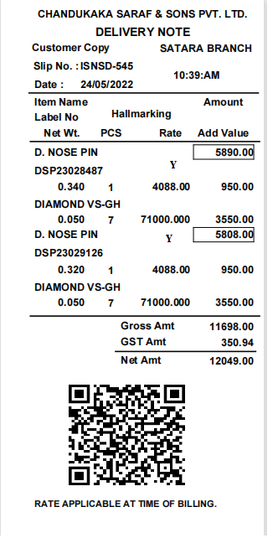

* **View** - Branch wise delivery note should be shown. This is authority base In view format show the following field:

1. Branch
2. Date
3. Series and number
4. Bar-code - If multiple then show “,” Separate.

**sales bill** :

* Sales bill document series generate as per branch wise and document number start with 1 for each branch.
* Sales bill save then delivery not add sale bill number.
* Save the sale bill then save the cashier name. In sales bill we have three option

1. QR Scan
2. Add delivery note
3. Add manually

**QR Scan** - First scan the QR then all details show on the screen:

1. Bar-code
2. Item name
3. Category
4. Purity
5. Pcs
6. Gross weight
7. Net weight
8. Fine weight
9. Stone weight
10. Stone
11. Pcs
12. Wt
13. Rate
14. amount
15. RNG - if “yes” then show the field . other wise not showing
16. RNG Pcs
17. Gross RNG Weight
18. Remove stone weight
19. Net weight
20. New RNG Pcs
21. New Gross RNG Weight
22. New Remove stone weight
23. New Net weight
24. Stone amount
25. Hallmarking Charges
26. Gross amount
27. Tax amount
28. Net amount
29. Sales person name

**Customer master** : If customer mobile no is added in system then show all customer details. If not added then add new customer details.

In customer details we can add following details:

|  |  |  |
| --- | --- | --- |
| **Field name** | **Validation** | **Mandatory** |
| Customer Name | We can enter up to 80. | Yes |
| Mobile No | should be accept 10 digits. | No |
| Address | We can enter up to 500. | Yes |
| Area | We can enter up to 30. | Yes |
| City | We can enter up to 20. | Yes |
| State | We can enter up to 20. | Yes |
| Pin code | should be accept 6 digits. | Yes |
| GST no |  | No |
| PAN no | should be accept 10 digits. | No |
| Submit |  |  |

**PAN Number** - Gross amount is above 2lack then ask PAN number.

**Round off** - 1) Net amount is 20154.01 then show 20155

1. Net amount is 20154 then show 20150.
2. Net amount is 20159.02 then show 20160.

**Less other** - 1) if we add “-5” then amount amount should less in net amount.

1. if we add “5” then amount amount should add in net amount.

**Narration** -

**Payment mode -**

1. **Cash -** accept only 1,95,000
2. Amount
3. **Credit -**
4. Amount
5. Reference person
6. **Bank -**
7. Amount
8. Type
9. Cheque no
10. MICR code or branch name
11. Bank name
12. Cheque date
13. Narration
14. **Card -**
15. Amount
16. Card
17. Card type
18. Card number
19. **Online -**
20. Amount
21. Type
22. Transaction id
23. Narration
24. **Gift voucher -**
25. Gift voucher code
26. Amount

**Attachment -** Add multiple attachment here. After save the bill they can add the attachment. Attachment save in folder wise date wise. Attachment name as document series and number. If multiple attachment then abc-1_1 , abc-1_2.

* **Add delivery note -**

**Delivery note no -** we can enter delivery note number then show below details:

1. Bar-code
2. Item name
3. Category
4. Purity
5. PCs
6. Gross weight
7. Net weight
8. Fine weight
9. Stone weight
10. Stone
11. Pcs
12. Wt
13. Rate
14. amount
15. RNG - if “yes” then show the field . other wise not showing
16. RNG Pcs
17. Gross RNG Weight
18. Remove stone weight
19. Net weight
20. New RNG Pcs
21. New Gross RNG Weight
22. New Remove stone weight
23. New Net weight
24. Stone amount
25. Hallmarking Charges
26. Gross amount
27. Tax amount
28. Net amount
29. Sales person name

**Customer master** : If customer mobile no is added in system then show all customer details. If not added then add new customer details.

In customer details we can add following details:

|  |  |  |
| --- | --- | --- |
| **Field name** | **Validation** | **Mandatory** |
| Customer Name | We can enter up to 80. | Yes |
| Mobile No | should be accept 10 digits. | No |
| Address | We can enter up to 500. | Yes |
| Area | We can enter up to 30. | Yes |
| City | We can enter up to 20. | Yes |
| State | We can enter up to 20. | Yes |
| Pin code | should be accept 6 digits. | Yes |
| GST no |  | No |
| PAN no | should be accept 10 digits. | No |
| Submit |  |  |

**PAN Number** - Gross amount is above 2lack then ask PAN number.

**Round off** - 1) Net amount is 20154.01 then show 20155

1. Net amount is 20154 then show 20150.
2. Net amount is 20159.02 then show 20160.

**Less other** - 1) if we add “-5” then amount amount should less in net amount.

1. if we add “5” then amount amount should add in net amount.

**Narration** -

**Payment mode -**

1. **Cash -** accept only 1,95,000
2. Amount
3. **Credit -**
4. Amount
5. Reference person
6. **Bank -**
7. Amount
8. Type
9. Cheque no
10. MICR code or branch name
11. Bank name
12. Cheque date
13. Narration
14. **Card -**
15. Amount
16. Card
17. Card type
18. Card number
19. **Online -**
20. Amount
21. Type
22. Transaction id
23. Narration
24. **Gift voucher -**
25. Gift voucher code
26. Amount

**Attachment -** Add multiple attachment here. After save the bill they can add the attachment. Attachment save in folder wise date wise. Attachment name as document series and number. If multiple attachment then abc-1_1 , abc-1_2.

* **Add manually -**

**Bar-code scan -** we can scan bar-code then show below details:

1. Bar-code
2. Item name
3. Category
4. Purity
5. PCs
6. Gross weight
7. Net weight
8. Fine weight
9. Stone weight
10. Stone
11. Pcs
12. Wt
13. Rate
14. amount
15. RNG - if “yes” then show the field . other wise not showing
16. RNG Pcs
17. Gross RNG Weight
18. Remove stone weight
19. Net weight
20. New RNG Pcs
21. New Gross RNG Weight
22. New Remove stone weight
23. New Net weight
24. Stone amount
25. Hallmarking Charges
26. Gross amount
27. Tax amount
28. Net amount
29. Sales person name

**Customer master** : If customer mobile no is added in system then show all customer details. If not added then add new customer details.

In customer details we can add following details:

|  |  |  |
| --- | --- | --- |
| **Field name** | **Validation** | **Mandatory** |
| Customer Name | We can enter up to 80. | Yes |
| Mobile No | should be accept 10 digits. | No |
| Address | We can enter up to 500. | Yes |
| Area | We can enter up to 30. | Yes |
| City | We can enter up to 20. | Yes |
| State | We can enter up to 20. | Yes |
| Pin code | should be accept 6 digits. | Yes |
| GST no |  | No |
| PAN no | should be accept 10 digits. | No |
| Submit |  |  |

**PAN Number** - Gross amount is above 2lack then ask PAN number.

**Round off** - 1) Net amount is 20154.01 then show 20155

1. Net amount is 20154 then show 20150.
2. Net amount is 20159.02 then show 20160.

**Less other** - 1) if we add “-5” then amount amount should less in net amount.

1. if we add “5” then amount amount should add in net amount.

**Narration** -

**Payment mode -**

1. **Cash -** accept only 1,95,000
2. Amount
3. **Credit -**
4. Amount
5. Reference person
6. **Bank -**
7. Amount
8. Type
9. Cheque no
10. MICR code or branch name
11. Bank name
12. Cheque date
13. Narration
14. **Card -**
15. Amount
16. Card
17. Card type
18. Card number
19. **Online -**
20. Amount
21. Type
22. Transaction id
23. Narration
24. **Gift voucher -**
25. Gift voucher code
26. Amount

**Attachment -** Add multiple attachment here. After save the bill they can add the attachment. Attachment save in folder wise date wise. Attachment name as document series and number. If multiple attachment then abc-1_1 , abc-1_2.

After print save the sales bill in PDF format.

For gold ,diamond, silver , and forming

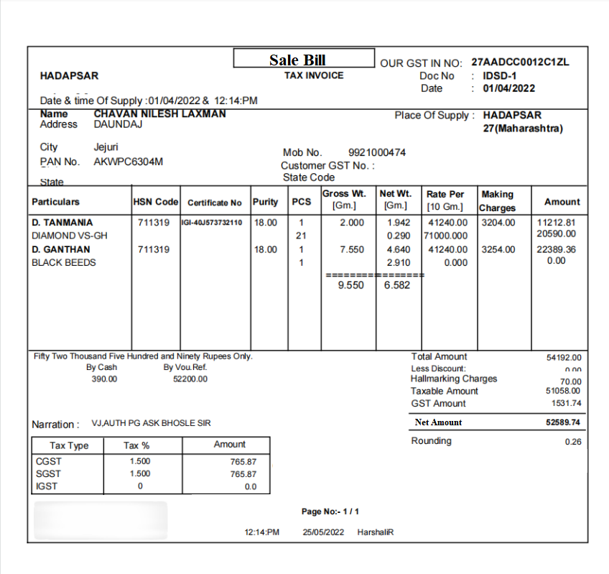

* **Sales bill View** - Branch wise Sales bill should be shown. In view format show the following field:

1. Branch
2. Date
3. Series and number
4. Bar-code - If multiple then show “,” Separate.
5. Amount
6. **Rate Master :** we want to set branch wise rate. We can click on add data then following fields are shown.

|  |  |  |
| --- | --- | --- |
| **Sr. No** | **Field name** | **Validation** |
| 1 | Type | Drop-down |
| 2 | Default formula | Text box |
| 3 | Purity | Drop-down |
| 4 | Branch | Drop-down |
| 5 | Sales Formula | Text box |
| 6 | Purchase Formula | Text box |

1. **Type** - gold silver platinum
2. **Default Formula** - If any branch against rate formula not added then this formula applicable.
3. **Purity** -

Gold - multiple purity ( 100, 99.99 , 18 ,14 ,16 ,23 , 23.50 , 24 , 22 )

Silver - A and B

Platinum - disable

1. **Branch** -

For gold , silver and platinum - select all or single or multiple

Here we set the sales formula and purchase formula. We can add multiple rows.

|  |  |  |  |
| --- | --- | --- | --- |
| **Sr. No** | **Branch** | **Sales Formula** | **Purchase Formula** |
| 1 | Satara | STDRate*0.97 | STDRate*0.97 |
| 2 | Pune | STDRate | STDRate*0.97 |
| 3 | Sangli | STDRate | STDRate*0.97 |

**Rate set** : Set standard rate here. Then apply for all purity for sell and URD rate is calculated auto for Gold , Silver and Platinum

1. **Role master -** We can add role here. Duplicate role should not be add here.

|  |  |
| --- | --- |
| **Field name** | **Mandatory** |
| Role name | Yes |
| Description | No |
| Is active | No |
| Submit |  |

1. **Branch master -** We can add branch here. Duplicate branch should not be add here.

|  |  |
| --- | --- |
| **Field name** | **Mandatory** |
| Branch name | Yes |
| Series | No |
| Is active | No |
| Submit |  |

1. **Employee master -** We can add employee here. Duplicate employee should not be add here.

|  |  |
| --- | --- |
| **Field name** | **Mandatory** |
| Employee name | Yes |
| Branch | No |
| User name | No |
| Password | Yes |
| Is active |  |
| submit |  |

1. **Customer master** : In customer details we can add following details:

|  |  |  |
| --- | --- | --- |
| **Field name** | **Validation** | **Mandatory** |
| Customer Name | We can enter up to 500. | Yes |
| Mobile No | should be accept 10 digits. | No |
| Address | We can enter up to 500. | Yes |
| Area | We can enter up to 30. | Yes |
| City | We can enter up to 20. | Yes |
| State | We can enter up to 20. | Yes |
| Pin code | should be accept 6 digits. | Yes |
| GST no |  | No |
| PAN no | should be accept 10 digits. | No |
| Submit |  |  |

* In view show the following fields :

1. Customer Name
2. Mobile No
3. Address
4. Area
5. City
6. State
7. Pin code
8. GST no
9. PAN no
10. **Wastage master** : In wastage master we can set the wastage. Wastage against set the multiple branch-wise wastage.

|  |  |  |
| --- | --- | --- |
| **Field Name** | **Field Type** | **Validation** |
| Wastage name | Text box |  |
| Labour charges rate | Text box |  |
| Labour charges rate calculate on | Drop-down | Net weight , Gross weight and PCs |
| Wastage rate | Text box |  |
| Wastage rate calculate on | Drop-down | Net weight , Gross weight and PCs |
| Branch-wise | Drop-down | All branch name |

|  |  |  |  |  |  |
| --- | --- | --- | --- | --- | --- |
| **Sr No** | **Branch name** | **Labour charges rate** | **Wastage rate** | **Labour charges rate calculate on** | **Wastage rate calculate on** |
| 1 | Satara | 0 | 11.00 | Net weight | Net weight |
| 2 | Pune | 0.1 | 0 | Net weight | Net weight |

* **Report -**

1. **Sales bill report -** Report export in excel and CSV.

**Input** -

From date

To date

Branch - we can select single or all or multiple branch. If user assign one branch the this branch report should be generated.

**Output**-

Sr no

Date

Branch name

Series and number

Delivery note no

Bar-code

Item name

Category

Purity

PCs

Rate

Gross weight

Net weight

Fine weight

Stone weight

Stone name

Stone Pcs

Stone Wt

Stone Rate

Stone amount

Hallmarking Charges

Gross amount

Tax amount

Net amount

Sales person name

Round off

Less other

Narration

PAN

Payment mode

Payment amount

Created by

Created at

1. **Delivery note report -** Report export in excel and CSV.

**Input** -

From date

To date

Branch - we can select single or all or multiple branch. If user assign one branch the this branch report should be generated.

**Output**-

Sr no

Date

Branch name

Series and number

Bar-code

Item name

Category

Gross weight

Net weight

Fine weight

Purity  
Pcs

Sales bill no

Created by

Created at

**Questions :**

Item against how to define gst % ?

For diamond rate how to apply?

Signature pad?

Delivery note narration 2

Sales bill narration 2

URD exchange & purchase

**References of the users**

|  |  |  |  |
| --- | --- | --- | --- |
| **User** | **Name** | **Mail** | **Contact number** |
| **Actual user** |  |  |  |
| **Assigned business analyst** | Harshali Rananaware | [harshali.rananaware@techneai.com](mailto:harshali.rananaware@techneai.com) | 8669917920 |
| **Assigned developer** | Nikhil Bhosale | nikhil.bhosale@techneai.com |  |