|  |  |
| --- | --- |
| **Ticket ID** | T209616 |
| **Ticket description** | *changes and additions in corporate data entry format* |
| **Created by** | *Harshali Rananaware* |
| **Created on** | 20 Apr 2022 |
| **Priority** | *Very high* |
| **Version** | *1* |

**Business requirement**

*changes and additions in corporate data entry format*

**Abbreviations & terms**

Connect us - CU

**Proposed System :**

In connect us-> corporate data -> Enter data want to add “lead status” column after “company name”.

In connect us-> corporate data -> Enter data want to add “Contact Again” column after “lead status”.

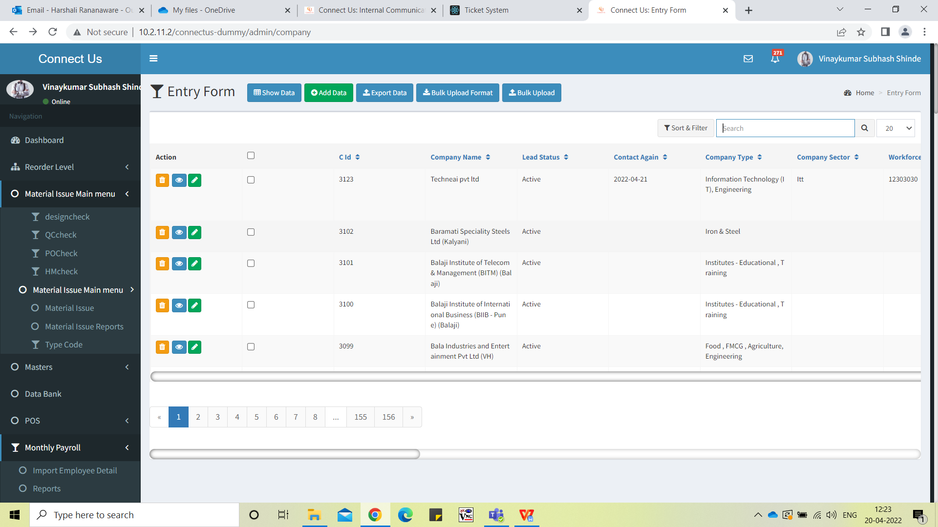

connect us-> corporate data -> Lead status add below status in drop-down:

1. Hot
2. Warm
3. Cold

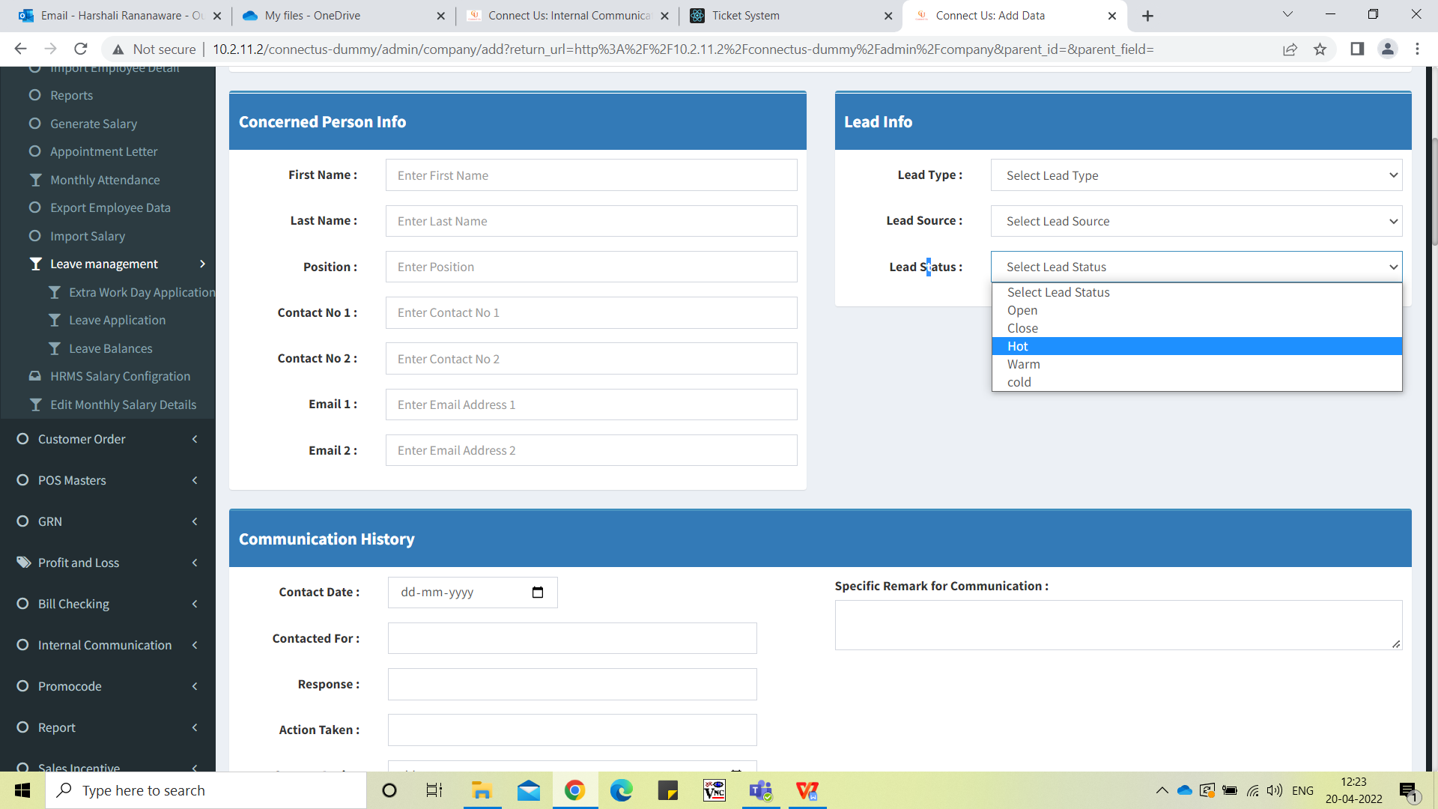

connect us-> corporate data -> Enter data add the “Communication History” against “Contact Again” field.

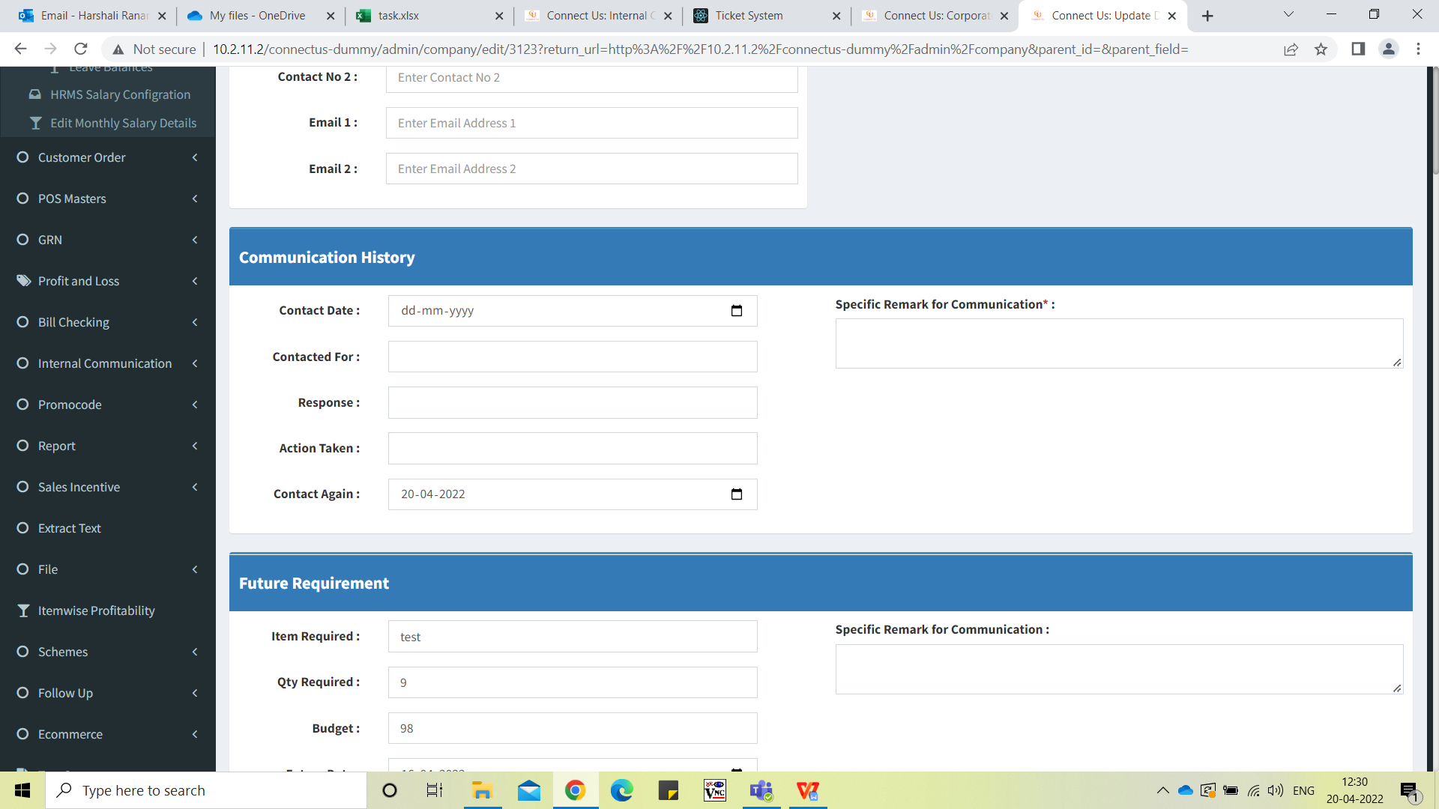

connect us-> corporate data -> Enter data add the “Communication History” against “Contact Again” field.

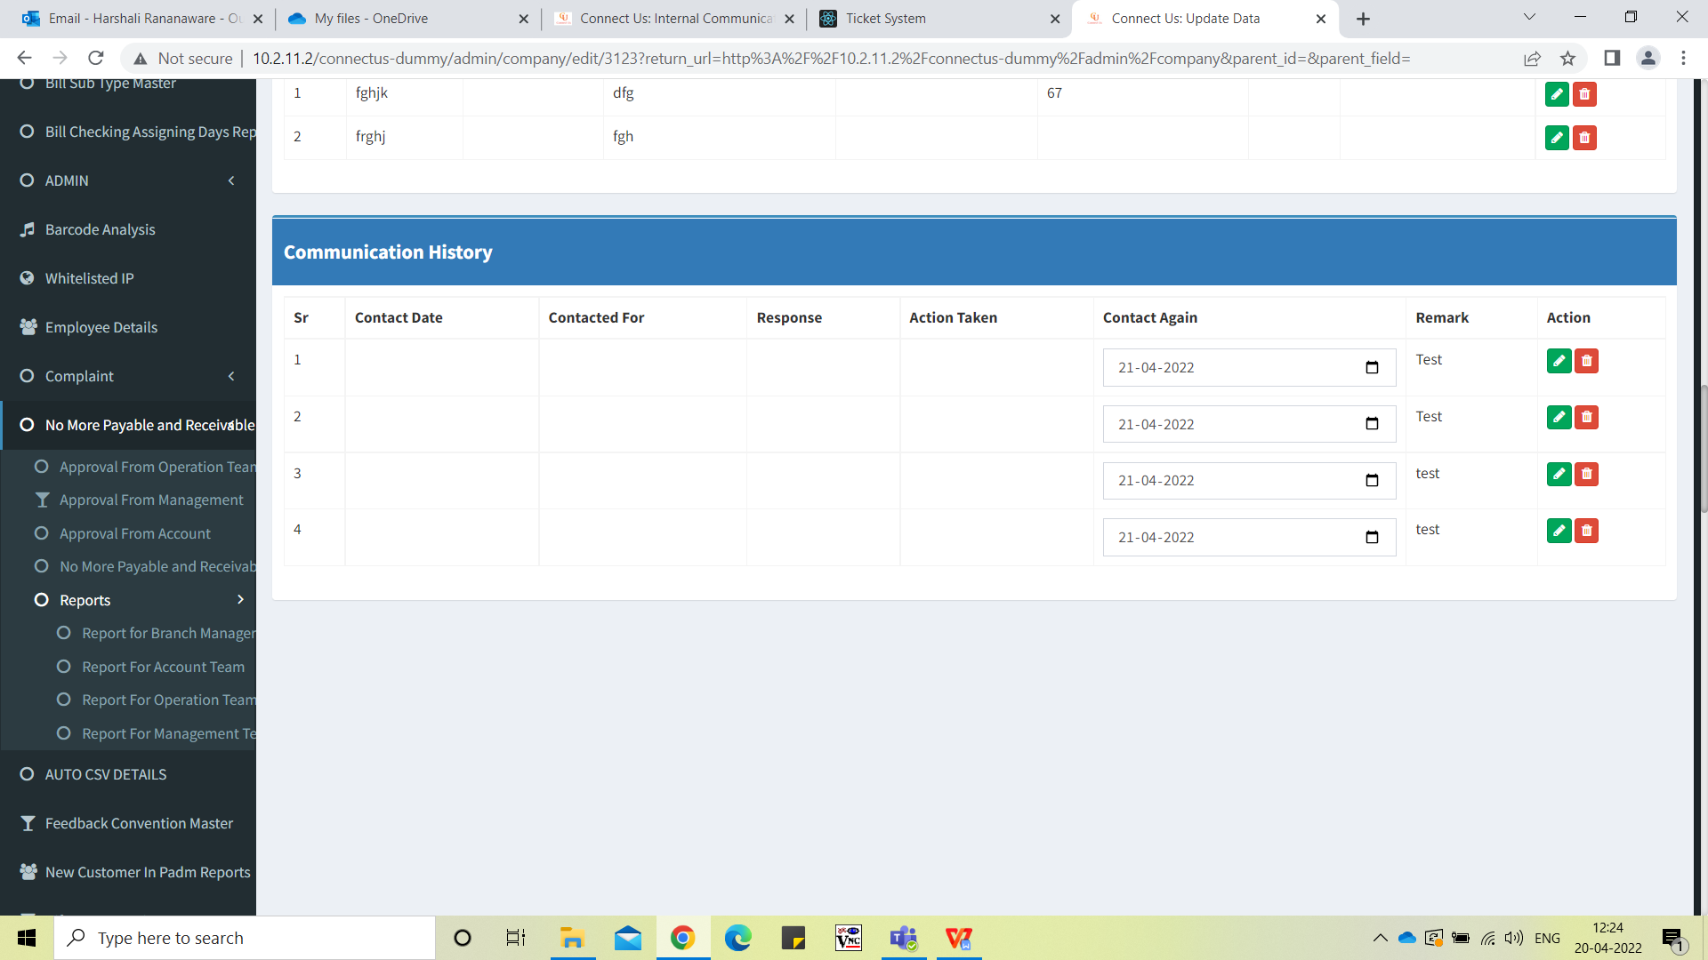

connect us-> corporate data -> Corporate Followup add new report. In this report want to show the today's followup record.

If lead status is close then this record should not be shown here.

If followup not taken then show this record in light pink color.

Example : If today is 07 Apr 22 we click on report then data should be shown up to 07 Apr 22.

If 01 Apr 22 not take followup then this record should be shown in light pink color.

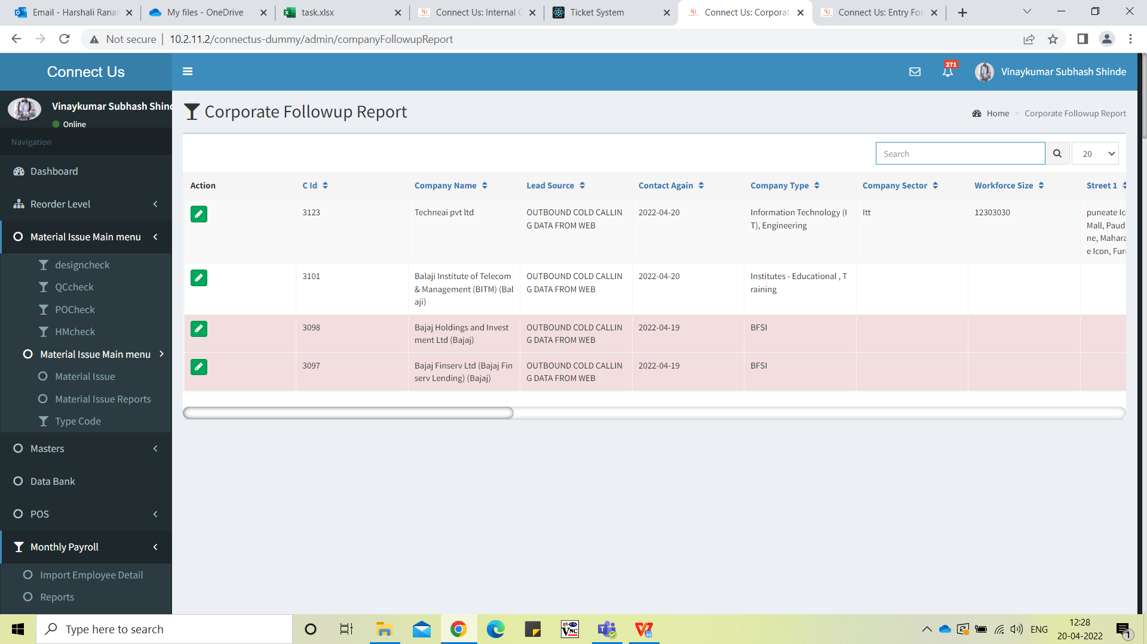

**References of the users**

|  |  |  |  |
| --- | --- | --- | --- |
| **User** | **Name** | **Mail** | **Contact number** |
| **Actual user** | Pradeep Kishanchand Govani | corpsales@csjewellers.com |  |
| **Assigned business analyst** | *Harshali Rananaware* | [harshali.rananaware@techneai.com](mailto:harshali.rananaware@techneai.com) | 8669917920 |
| **Assigned developer** |  |  |  |